FB Outlet Conditions Housekeeping
Executive Summary
Version: 1.1
Date: 2026-10-08
Project Owner: Leon Small
Prepared by: Claude Code

Contents
This document uses Word heading styles for its sections, listed below in order. Page numbers are not reproduced here since this list was generated independently of Word's pagination; open the document in Word and use References → Table of Contents → Update if a live, paginated Table of Contents is required.
- 1. Executive Overview
- 2. Business Problem
- 3. Current State
- 4. Implemented Solution
- 5. Business Benefits
- 6. Process Flow
- 7. Solution Architecture
- 8. Key Screens
- 9. Security
- 10. Implementation Status
- 11. Testing Summary
- 12. Risks and Considerations
- 13. Next Steps

1. Executive Overview
FB Outlet Conditions Housekeeping is an automated, scheduled Azure Function that keeps SharePoint's “Report Log” list and its associated Cloudinary-hosted images from growing without bound. Once per day, it identifies Report Log entries that have passed a configurable retention period and removes them — but only after every image that entry referenced in Cloudinary has itself been confirmed deleted.
The function runs unattended; there is no user interface. Its consumers are the system administrators who configure it and who receive its daily email summary of what was cleaned up, or notified immediately if a run fails.

2. Business Problem
Report Log entries and the Cloudinary images attached to them accumulate indefinitely. There was no existing automated process to remove aged entries or their images, so storage in both SharePoint and Cloudinary grows without limit, and outdated operational data is retained well beyond its useful life.
Manually cleaning up old entries is time-consuming and risks leaving orphaned images in Cloudinary if an entry is deleted before its images are — images that can no longer be traced back to the SharePoint item that referenced them.

3. Current State
Prior to this project, Report Log entries and their Cloudinary images were retained permanently, with cleanup (if performed at all) handled manually and without a guaranteed deletion order.
Known facts and assumptions distinguished explicitly:
- Fact: no automated cleanup process existed prior to this project.
- Assumption: the exact current volume of Report Log entries and Cloudinary storage consumed was not available to measure in this development environment — no quantified current-state metric is claimed.

4. Implemented Solution
A new .NET 10 Azure Function, triggered daily at 02:30, was implemented with the following behavior:
- Reads the SharePoint “Report Log” list via Microsoft Graph and identifies entries older than a configurable number of days (EntryAgeDays).
- For each eligible entry, deletes every Cloudinary image it references — up to five per entry — before taking any action on the SharePoint item itself.
- Deletes the SharePoint list item only once all of its images are confirmed deleted (or it had none); if any image deletion fails, that entry is left in place and recorded as a failure, while the rest of the run continues.
- Supports a Dry Run mode that evaluates and reports everything it would do without deleting anything — used to safely validate behavior before enabling real deletions.
- Sends a formatted summary email after every run (and a separate failure email if the run itself breaks), when email notifications are enabled.
Every one of these behaviors is controlled by configuration (EntryAgeDays, DryRun, EmailEnabled, EmailRecipients, EmailFromAddress, and related settings) rather than being fixed in code — see docs/SETUP-GUIDE.md for the full configuration reference.

5. Business Benefits

Confirmed Benefits
- The deletion ordering rule (Cloudinary images before the SharePoint item) is enforced in code and verified by automated tests, eliminating the orphaned-image risk inherent in unordered manual cleanup.
- A Dry Run mode exists and was verified by automated tests to issue zero delete calls, giving administrators a safe way to validate behavior against real data before enabling deletions.

Expected Benefits
- Bounded, predictable SharePoint list and Cloudinary storage growth going forward.
- Reduced administrative time spent on manual cleanup.

Assumptions
- Actual storage savings and administrative time saved have not yet been measured in production and are not claimed as confirmed figures in this document.

6. Process Flow
The daily cleanup process, at a management level:
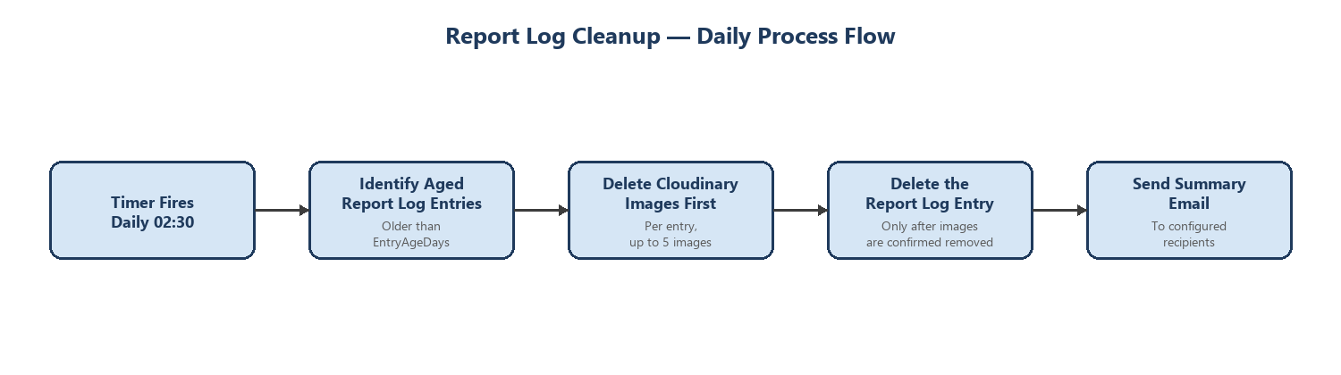
Figure 1 — Report Log Cleanup daily process flow.

7. Solution Architecture
A simplified view of how the function connects to the systems it manages:
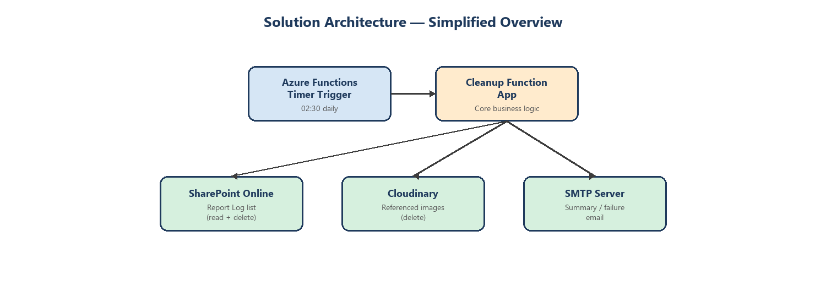
Figure 2 — Simplified solution architecture.
Full technical architecture detail — including technology choices, security architecture, and configuration — is documented in docs/ARCHITECTURE.md.

8. Key Screens
Not applicable. This solution has no user interface; it is a headless, timer-triggered Azure Function with no screens to capture. Its only outward-facing output is the summary/failure email described in Section 4.

9. Security
- Authentication to SharePoint uses an Azure AD App Registration (client credentials) — no end-user ever signs in.
- The App Registration is granted only the Microsoft Graph permission needed to read and delete the target list's items (least privilege).
- Cloudinary and SMTP access use their own dedicated API key/secret and account credentials respectively.
- All three external connections use HTTPS/TLS.
- All credentials are stored in Azure Function App configuration, with Key Vault references recommended for production — never in source control.
- No secrets of any kind are logged; only identifiers (item IDs, image IDs) and non-sensitive error messages are logged.

10. Implementation Status
Area | Status
Core functionality (ordered cleanup, dry run, email notifications) | Complete
Automated testing (Core business logic) | Complete — 23/23 unit tests passing
Documentation (Architecture, Specification, Setup Guide, Schema) | Complete
CI/CD pipeline (GitHub Actions build/test/deploy) | Complete — not yet executed against a live Azure subscription, see Section 12
Deployment to a live Azure environment | Not performed in this environment — see Section 12

11. Testing Summary
23 automated unit tests were written and actually executed against the cleanup business logic, using mocked SharePoint, Cloudinary, and email interfaces so no live external system was required. All 23 passed.
Coverage includes, among others:
- Age-based eligibility (entries both older and not older than the configured threshold).
- The Cloudinary-images-before-SharePoint-item deletion ordering rule.
- A failed Cloudinary image deletion correctly blocking the SharePoint item delete.
- Dry Run mode issuing zero delete calls.
- Summary email content accuracy and the email-disabled/enabled switch.
- A run-level failure triggering the failure email and correctly propagating so the Azure Functions host marks the run as failed.
Not yet performed: end-to-end verification against a live SharePoint tenant, Cloudinary account, and SMTP server — no such credentials were available in this development environment. See docs/SPECIFICATION.md Section 23 for full detail.

12. Risks and Considerations
- The Azure AD client secret used for SharePoint access will expire and must be rotated before it does, or every run will fail (a failure email will be sent if notifications are enabled).
- A GitHub Actions CI/CD pipeline now exists (build, test, then deploy only if tests pass, authenticated via Azure AD OIDC — no stored credential), but it has not yet been run against a live Azure subscription in this environment, so it is unverified in practice.
- Only a single (production) environment is described; no separate Dev/Test/Staging environment currently exists for this function.
- Live testing against the real SharePoint list, Cloudinary account, and SMTP server has not yet been performed — required before the function is enabled for real (non-dry-run) deletions in production.

13. Next Steps
- Provision the Azure AD App Registration, Cloudinary credentials, and SMTP account in the target environment, per docs/SETUP-GUIDE.md.
- Create the Azure resources (Resource Group, Storage Account, Function App) via the Azure Portal, per docs/SETUP-GUIDE.md Section 16.2, then configure the GitHub Actions secrets/variables per Section 16.3 and run the pipeline for the first time.
- Deploy with DryRun enabled and verify the summary email against real data for at least one run before disabling Dry Run.
- Set up monitoring/alerting on Azure Function failures in Application Insights.

