NODE JS

# PRACTICAL-1

**Aim : Perform the REPL in Node.js**

To perform the REPL (Read-Eval-Print Loop) in Node.js :

1. Open Command Prompt
2. Write command ‘node’ : To launch the Node.js REPL, where you can write JavaScript code and execute it interactively.
3. Use the REPL by typing JS expression or functions

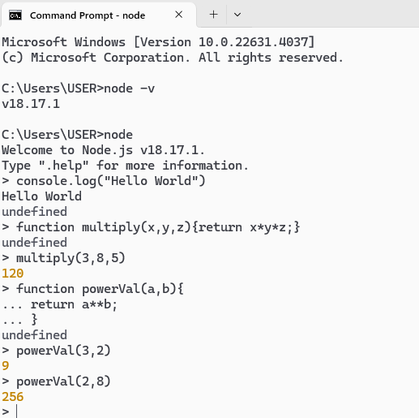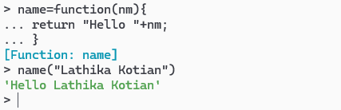

# PRACTICAL – 2

**Aim : Using modules, perform the Arithmetic Operations allFunc :**

function add(a,b){ return a+b;

}

function sub(a,b){ return a-b ;

}

function div(a,b){ return a/b ;

}

function mul(a,b){ return a*b ;

}

//exports.add=function(a,b){return a+b}; exports.add=add;

exports.sub=sub; exports.div=div; exports.mul=mul;

**callFunc**

var req=require('./allFunc'); let a=10;

let b=20;

console.log("Given number are "+a+" and "+ b) var resAdd=req.add(a,b);

console.log("Addition :"+resAdd);

var resSub=req.sub(a,b); console.log("Subtraction :"+resSub);

var resDiv=req.div(a,b); console.log("Division :"+resDiv);

var resMul=req.mul(a,b);

console.log("Multiplication :"+resMul);

**OUTPUT :**

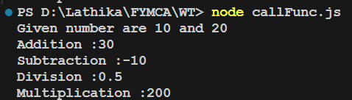

# PRACTICAL-3

**Aim : Using modules, find the Area of a Circle, Rectangle, Square CODE :**

**areaFunc.js**

function areaCircle(r){ let a1=3.142*r**2

return "Area of circle is "+ a1;

}

function areaSquare(s){ let a2=s**2;

return "Area of Square is "+ a2;

}

function areaRec(l,b){ let a3=l*b;

return "Area of Rectangle is "+ a3;

}

exports.areaCircle=areaCircle; exports.areaRec=areaRec; exports.areaSquare=areaSquare;

**callFunc.js**

var request=require('./areaFun');

var result1=request.areaCircle(8); var result2=request.areaSquare(5); var result3=request.areaRec(10,20); console.log(result1); console.log(result2); console.log(result3);

**OUTPUT** :

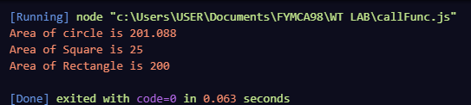

**Aim : Write a program to print the Prime Numbers from 1 to 50 CODE** :

function isPrime(num) {

if (num <= 1) return false;

for (let i = 2; i <= Math.sqrt(num); i++) { if (num % i === 0) {

return false; // Not a prime number

}

}

return true; // It's a prime number

}

function printPrimeNo(start, end) {

for (let num = start; num <= end; num++) { if (isPrime(num)) {

console.log(num);

}

}

}

printPrimeNo(1, 50)

**OUTPUT :**

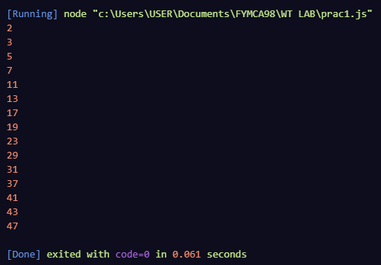

function reverseNum(number){ let result = 0; while(number>0){

rightmost = number%10; result = result*10 + rightmost;

number = Math.floor(number/10);

}

return "Reversed number for is : " + result;

}

let n=2394;

console.log(reverseNum(n));

**OUTPUT :**

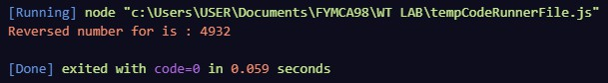

function checkEvenOdd(a){ if(typeof a!=='number'){

return "Provide valid number";

}

else{

if(a%2==0){

return "Given Number "+ a+" is Even number";

}

else{

return "Given Number "+ a+" is Odd number";

}

}

}

console.log(checkEvenOdd(67)); console.log(checkEvenOdd(346)); console.log(checkEvenOdd("D"));

**OUTPUT :**

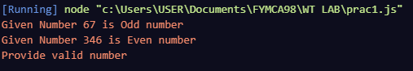

**Aim : Write a program to check if the entered number is Armstrong or not CODE** :

//taking input from user

const prompt=require('prompt-sync')();

//ARMSTRONG NUMBER

let sum=0;

const number=parseInt(prompt("Enter the number :"));

let temp=number; while(temp>0){

let remainder=temp%10; sum+=remainder*remainder*remainder; temp=parseInt(temp/10);

}

if(sum==number){

console.log(`${number} is an Armstrong number.`)

}

else{

console.log(`${number} is not an Armstrong number.`)

}

**OUTPUT** :

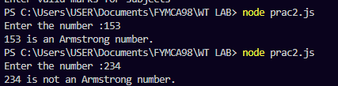

**Aim : Write a program to take the marks of four subjects from user and check if the student has passed the examination or not, calculate percentage and grade**

**CODE :**

const mk1=parseInt(prompt("Enter the marks in ADBMS out of 100:"));

const mk2=parseInt(prompt("Enter the marks in Web technology out of 100:")); const mk3=parseInt(prompt("Enter the marks in Java out of 100:"));

const mk4=parseInt(prompt("Enter the marks in Data Structure out of 100:"));

if((mk1>100 || mk1<0) ||(mk2>100 || mk2<0)||(mk3>100 || mk3<0)||(mk4>100 || mk4<0)){ console.log("Enter valid marks for subjects");}

else{

if(mk1>=45 && mk2>=45 && mk3>=45 && mk4>=45){ console.log("You have passed the examination"); const sum=mk1+mk2+mk3+mk4;

const perc=(sum/400)*100; console.log(`Percentage : ${perc} %`); if(perc>=80){

console.log("Grade : A");

}

else if(perc<80 && perc>=60 ){ console.log("Grade : B");

}

else if(perc<60 && perc>=35){ console.log("Grade : C"); } }

else{

console.log("You have failed the examination"); console.log("Grade : F");}

}

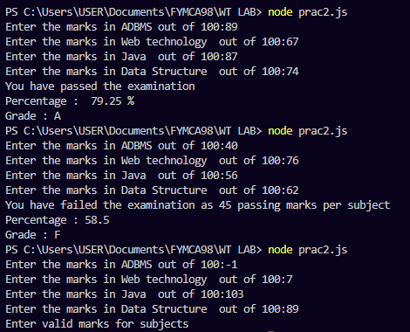**OUTPUT** :

**Aim : Write a program to print the Fibonacci series CODE** :

function recursiveFibo(num){ if (num == 1)

return 0; if (num == 2)

return 1;

return recursiveFibo(num - 1) + recursiveFibo(num - 2);

}

function fibonacci(nth){

let n1=0,n2 = 1, nextTerm;

for (let i = 1; i <= number; i++) { console.log(n1);

nextTerm = n1 + n2; n1 = n2;

n2 = nextTerm;

}

}

const number = parseInt(prompt('Enter the number of terms: ')); console.log('Fibonacci Series:');

fibonacci(number);

**OUTPUT** :

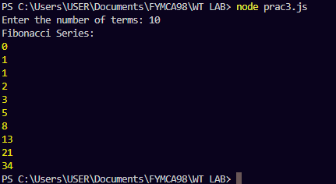

**Aim : Write a program to convert the temperature entered by the user CODE** :

const prompt=require('prompt-sync')();

function celsiusToFahrenheit(celsius){ const f=(celsius*9/5)+32;

return `Fahrenheit : ${f}`;

}

function fahrenheitTocelsius(fahrenheit){ const c=(fahrenheit-32)*(5/9);

return `Celcius : ${c}`;

}

let degree1=parseFloat(prompt("Enter temp in celsius : ")); console.log(celsiusToFahrenheit(degree1));

let degree2=parseFloat(prompt("Enter temp in Fahrenheit : ")); console.log(fahrenheitTocelsius(degree2));

**OUTPUT** :

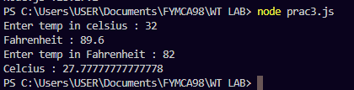

**Aim : Write a program to demonstrate the factorial of a number using Anonymous Functions CODE** :

const factorial=(num)=>{ if(num<0){

console.log("Cannot perform operation for negative number :" + num);

}

else if(num===0){ console.log("Factorial for 0 : 0");

}

else{

var fact=1;

for(var i=1;i<=num;i++){ fact= fact*i;

}

return fact;

}

}

let n=5;

console.log("Factorial of "+n+": "+factorial(n));

**OUTPUT** :



**Aim : Write a program to demonstrate the Pattern using Anonymous Functions CODE** :

// Write a program to display pattern using anonymous function. const pattern=function(){

for(let i=0;i<=3;i++){ console.log("* ".repeat(i))

}

}

process.stdout.write("PATTERN USING ANONYMOUS FUNCTION"); pattern()

**OUTPUT** :

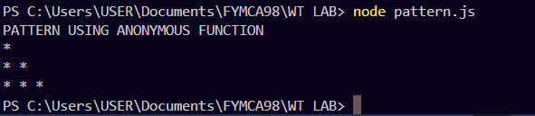

**Aim : Write a program to demonstrate the arithmetic operations using Callback Functions CODE :**

var add=function(a,b){ return a+b;

}

var sub=function(a,b){ return a-b;

}

var div=function(a,b){ return a/b;

}

var multiply=function(a,b){ return a*b;

}

let n1=4; let n2=8;

console.log("Given number are "+ n1 +" and "+n2); function addCall(add){

console.log("\nAddition of given numbers : "+add(n1,n2));

}

function subCall(sub){

console.log("\Subtraction of given numbers : "+sub(n1,n2));

}

function multiplierCall(multiply){

console.log("\Multiplication of given numbers : "+multiply(n1,n2));

}

function divCall(multiply){

console.log("\Division of given numbers : "+div(n1,n2));

}

addCall(add); subCall(sub);

multiplierCall(multiply); divCall(div);

**OUTPUT :**

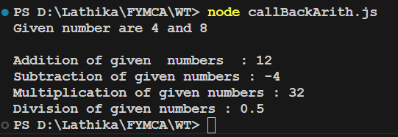

**Aim : Write a program to demonstrate the setTimeout function CODE** :

const message=function(){ console.log("Hello LATHIKA ");

}

console.log("Print hi lathika after 5 sec delay using setTime function") setTimeout(message,5000)

setTimeout(()=>{

console.log("Calling arrow function after 8 sec");

},8000);

**OUTPUT** :

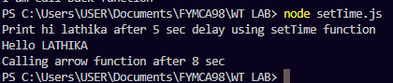

**Aim : Write a program to place the order for a pizza using Events CODE :**

const EventEmitter=require('node:events'); const emitter =new EventEmitter();

emitter.on("order-pizza",(size,topping,price)=>{ if(size=="Large"){

let discount=price*0.30; let p=price-discount;

console.log(`Order received Baking ${size} pizza with ${topping}`); console.log(`You got discount of 30% on this order.\nAMOUNT = ${p}`)

}

else if(size=="Medium"){ let discount=price*0.20; let p=price-discount;

console.log(`Order received Baking ${size} pizza with ${topping}`); console.log(`You got discount of 20% on this order.\nAMOUNT = ${p}`);

}

else if(size=="Small"){

let discount=price*0.10; let p=price-discount;

console.log(`Order received Baking ${size} pizza with ${topping}`); console.log(`You got discount of 10% on this order.\nAMOUNT = ${p}`);

}

else{

console.log(`Order received Baking ${size} pizza with ${topping}`); console.log(`AMOUNT = ${price}`);

}

});

emitter.emit("order-pizza","Medium","Mushrooms",320)

**OUTPUT** :

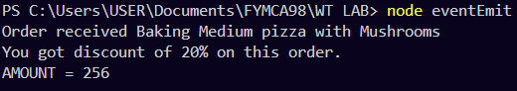

**Aim : Write a program to demonstrate EventEmitters functions. CODE :**

const events = require("events");

const eventEmitter = new events.EventEmitter();

function listner1(){

console.log("Event received by Listner 1");

}

function listner2(){

console.log("Event received by Listner2");

}

eventEmitter.addListener("Write",listner1); eventEmitter.on("Write2",listner2); eventEmitter.emit("Write2"); console.log("Write Event count : ");

console.log(eventEmitter.listenerCount("Write")); eventEmitter.removeListener("Write",listner1); console.log("Listner1 is removed"); eventEmitter.emit("Write");

console.log("Write2 Event count : "); console.log(eventEmitter.listenerCount("Write2")); console.log("program Ended")

**OUTPUT** :

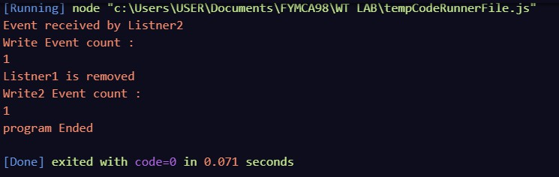

**Aim : Write a program to calculate the salary using EventEmitters class.**

**Write an event emitter code to design an event called as "calculate Salary" which is used to calculate the salary of an employee by passing some arguments like BasicSalary, HRA(20% of Basic) , DA(100% of Basic), TA, and deduction like Income Tax(30% of Basic) and Professional Tax of 200.**

**CODE** :

const EventEmitter=require('events');

class SalaryCalculator extends EventEmitter{ calculateSalary(basic,ta){

const hra=0.2*basic; const da =basic;

const incomeTax=0.3*basic; const professionalTax=200;

const salary=basic+hra+da+ta-incomeTax-professionalTax; this.emit('calculateSalary',salary);

}

}

const salaryCalculator=new SalaryCalculator();

salaryCalculator.on('calculateSalary',(salary)=>{ console.log(`The calculated salary is : ${salary}`);

});

salaryCalculator.calculateSalary(60000,7500);

**OUTPUT** :

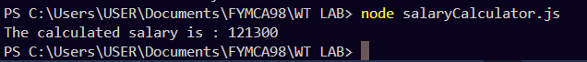

**Aim : Write a program to create an event to print the sum of odd and even numbers from an array.**

**CODE** :

//ARRAY

class ArraySum extends EventEmitter{ calcSumEvenOdd(array){

let sumEven=0; let sumOdd=0;

for(let i=0;i<array.length;i++){ if(array[i]%2==0){

sumEven+=array[i];

// console.log(sumEven);

}

sumOdd+=array[i]

}

this.emit('calcSumEvenOdd',sumEven,sumOdd);

}

}

const array=[1,2,3,4,5,6,7,8,9]

const calculateSum=new ArraySum(); calculateSum.on('calcSumEvenOdd',(sumEven,sumOdd)=>{

console.log(`Sum of even number in array is : ${sumEven}`); console.log(`Sum of odd number in array is : ${sumOdd}`);

});

calculateSum.calcSumEvenOdd(array);

**OUTPUT** :

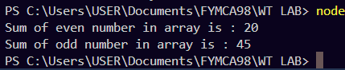

# PRACTICAL – 19

**Aim : Write a program to demonstrate File handling in Node.js CODE :**

const fs=require("fs");

fs.writeFile("abc.txt","Hello World.",function(er,data)

{

console.log("Writing file");

});

fs.appendFile("abc.txt","\nLathika Kotian \nGive ThumbsUp",function(err,data){ console.log("Append File");

});

fs.readFile("abc.txt","utf8",function(err,data){ console.log("Reading File"); console.log(data);

});

fs.unlink("abc.txt",function(err,data){ console.log("Deleting File"); console.log("File deleted successfully");

});

**OUTPUT** :

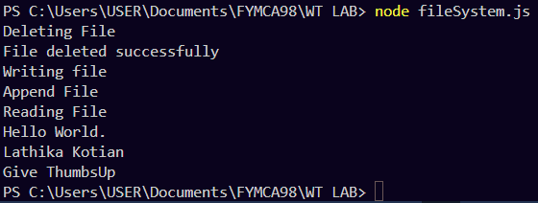

**CODE** :

const fd=fs.openSync("name.txt","r+"); const text="Lathika Kotian"; position=0;

const numberOfBytesWritten=fs.writeSync(fd,text,position,"utf8"); console.log(`Bytes Written : ${numberOfBytesWritten}`);

**OUTPUT** :

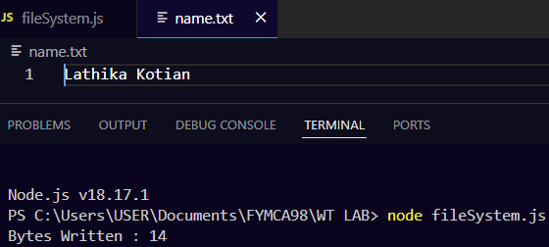

# PRACTICAL -20

**Aim : Write a Node.js code to display Employee Job Registration Form saved in an HTML File in response to the client’s access request to the server**

**CODE :**

**page.html**

**<**html>

<head>

<title>Form</title>

</head>

<body>

<center><H1>EMPLOYEE REGISTRATION FORM</H1> </center>

<p>ADMIN : Lathika Kotian</p>

<form>

<label>Enter your id : </label>

<input type="text"><br><br>

<label for="username">Enter your name:</label>

<input type="text" id="username" name="username"><br><br>

<label for="add">Enter your Address:</label>

<input type="text" id="add" name="add"><br><br>

<label for="phone">Enter your phone number :</label>

<input type="number" id="phone" name="phone"><br><br>

<input type="submit" value="Submit">

</form>

</body>

</html>

**createhttp.js**

var http=require('http'); const fs=require("fs");

const filePath ="page.html"; http.createServer((req,res)=>{

fs.readFile(filePath,(err,data)=>{ if(err){

res.writeHead(404,{'Content-Type': 'text/html'}); res.end("FILE NOT FOUND");

}

res.writeHead(200,{'Content-Type': 'text/html'}); res.end(data);

})

}

).listen(8000,()=>{

console.log('Server is running at [http://localhost:8000');](http://localhost:8000/)

});

**OUTPUT :**



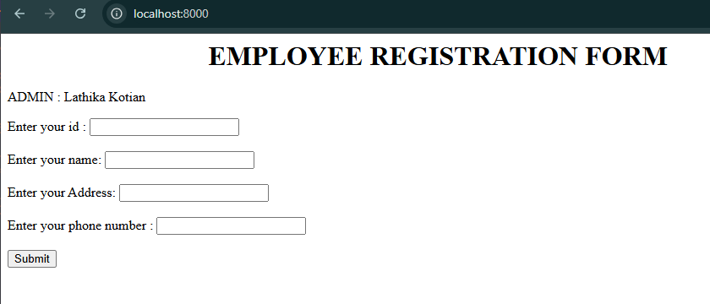

# PRACTICAL – 21

**Aim : Write a program to handle request url between various HTML pages CODE :**

var http=require('http');

var server=http.createServer(function(req,res){ if(req.url=='/'){

res.writeHead(200,{'content-type':'text/html'}); res.write('<html><head><style>');

res.write(`

body {font-family: Arial, sans-serif;background-color: #f4f4f4;} h1 {text-align: center;padding: 20px 0; }

.content{background: white; margin-top: 20px; margin-left:30px;margin-right:30px; padding: 20px; font-size: 16px;

background-color: white;

border-radius: 8px;box-shadow: 0 4px 8px rgba(0, 0, 0, 0.1);

}

ul li{display: inline-block; float: right; height: 40px;} ul li a{

padding: 20px; background:orange; color: white; font-size: 120%; font-weight: bold;

}

.navigation{

border-radius: 8px; box-shadow: 0 4px 8px rgba(0, 0, 0, 0.1); margin-right: 50px;

} `);

res.write('</style></head><body>');

res.write(`<div><h1>First WebPage using http Server</h1></div>

<div class="navigation"><ul>

<li><a href="/admin">Contact Admin</a></li>

<li><a href="/student">Student</a></li>

<li><a href="/home">Home</a></li>

</ul></div></div>`);

res.write(`<div class="content"><h2>Start Page</h2>

<p>This is my first webpage!</p><p>Hi everyone</p></div></body></html>`); res.end();

}

else if(req.url=='/home')

{

res.writeHead(200,{'content-type':'text/html'}); res.write('<html><head><style>');

res.write(`body{padding-left: 43px; padding-right:43px; background-color:lightyellow;} nav {border: 1px solid #000; padding: 10px;margin: 10px;}`);

res.write('</style></head><body>');

res.write('<p><u><h1 style=" color: red;text-align: center;">HOME PAGE</h1></u></p>'); res.write('<center><h1>Lathika Kotian</h1></center>')

res.write(`<div style="margin-left:70px;margin-right:80px">

<h2>This page is a brief insight to who I am.</h2>

<nav

style="background-color:white; text- align:center;

padding-top:10px;padding-bottom:10px;margin-right:420px">

<ul><li><a href="/" style="padding-bottom:10px;font-size: 160%">Start Page</a></li>

<li><a href="/student"style="padding-bottom:10px;font-size: 160%">Student</a></li>

<li><a href="/admin"style="padding-bottom:10px;font-size: 160%">Admin</a></li>

</ul></nav></div>`); res.write('</body></html>'); res.end();

}

else if(req.url=='/student'){ res.writeHead(200,{'content-type':'text/html'}); res.write('<html><head><style>');

res.write(`

body{background-color: #fff2f2; font-family: Arial, sans-serif;

}

form {

width: 50%;margin: 30px auto;background-color: white;

padding: 20px; border-radius: 10px;box-shadow: 0 4px 8px rgba(0, 0, 0, 0.1);

}

label {

font-weight: bold; margin-bottom: 5px; display: block;

}

ul li{display: inline-block; float: right; height: 40px;} ul li a{

padding: 20px; background:orange; color: white; font-size: 120%; font-weight: bold;}

input[type="text"], input[type="email"], input[type="password"], select { width: 100%; padding: 10px; margin: 8px 0 15px;

border-radius: 5px; border: 1px solid ;

}

input[type="radio"] { margin-right: 10px;

}

.hobbies input { margin-right: 10px; margin-left:30px;

}`);

res.write('</style><title>Form</title></head><body bgcolor=White"><h1 align="center">Student Page Form</h1>');

res.write('<div><ul><li><a href="/home">Home</a></li><li><a href="/">Start Page</a></li><li><a href="/admin">Contact Admin</a></li></ul></div>');

res.write('<form action="url" method="post><fieldset><legend>Personal Information</legend>');

res.write('<label><Strong>Student Name </strong></label><br/><input type="text" name="StudentName" placeholder="Enter you name"/><br/>');

res.write('<label><strong>Email</Strong></label></br><input type="email" name "email" placeholder="Enter your Email "/><br/>');

res.write('<label><strong>Password </Strong></label><br/>');

res.write('<input type="password name="password" placeholder="Enter your password "/></br></br><label><Strong>Gender</strong></abel><br/>');

res.write('<input type="Radio" name ="Gender" value="Male"/>Male<input type="Radio" name="Gender" value="Female"/>Female<br/>');

res.write('<div class="hobbies"><label><strong>Hobbies</strong></label><br/>'); res.write('<input type="checkbox" name="Hobbies" values="Playing Sports"/>Playing

Sports<br/>');

res.write('<input type="checkbox" name="Hobbies" value="Listening Music"/>Listening Music<br/>');

res.write('<input type="checkbox" name="Hobbies" value="Travelling"/>Travelling<br/>'); res.write('<input type="checkbox" name="Hobbies" value="Reading Books"/>Reading

Books</div>');

res.write('</br><label><strong>Select Your city</strong></label>'); res.write('<select name="city"><option value="Mumbai">Mumbai</option><option

value="Gujarat">Gujarat</option><option value="Pune">Pune</option><option avlue="Thane">Thane</option></selct><br/>');

res.write('<input style="background-color:green;color: white;padding: 12px 20px;border: none;border-radius: 5px;" type="submit" onclick=alert("Thanks!") name="submit" value="Submit"/></form>');

res.end();

}

else if (req.url=='/admin'){ res.writeHead(200,{'content-type':'text/html'}); res.write('<html><head><style>');

res.write(`

ul li{display: inline-block; float: right; height:40px;}

ul li a{padding: 20px; background:orange; color: white;font-size:120%;font-weight:bold} legend{text-align:center;}

body{background-color:faf8b1;font-family: Arial, sans-serif;border: 5px solid darkred;} form{

width:50%; display: inline- block; float: center;

padding: 20px; text-align:left; margin:40px; background:white;

}

input[type="text"], input[type="password"]{ width: 100%; padding: 12px; margin-top: 5px; border: 2px solid #ccc; border-radius: 5px; font-size: 16px; box-sizing: border-box;

; }

`);

}

button{

border-radius: 5px;background-color:green;color:white;font weight:bold;padding:15px

res.write('</style></head>');

res.write('<div><ul><li><a href="/admin">Contact Admin</a></li><li><a href="/student">Student</a></li><li><a href="/home">Home</a></li></ul></div></div><br><br>');

res.write('<legend><h1><u>Admin Login</u></h1></legend>'); res.write('<center><form action="#" method="POST" autocomplete="off">');

res.write('<h3>Username</h3><input type="text" name="userid" placeholder="Username" required/>');

res.write('<h3>Password</h3><input type="Password"name="pword" placeholder="Password" required/><p></br><br>');

res.write('<button onclick=alert("SUCCESS")>LOGIN NOW</button></form></center>'); res.end();

}

else{

res.end('Invalid request');

}

});

server.listen(9000);

console.log('Node.js web server at port 9000 is running');

**OUTPUT :**

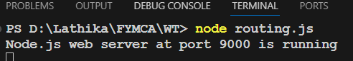

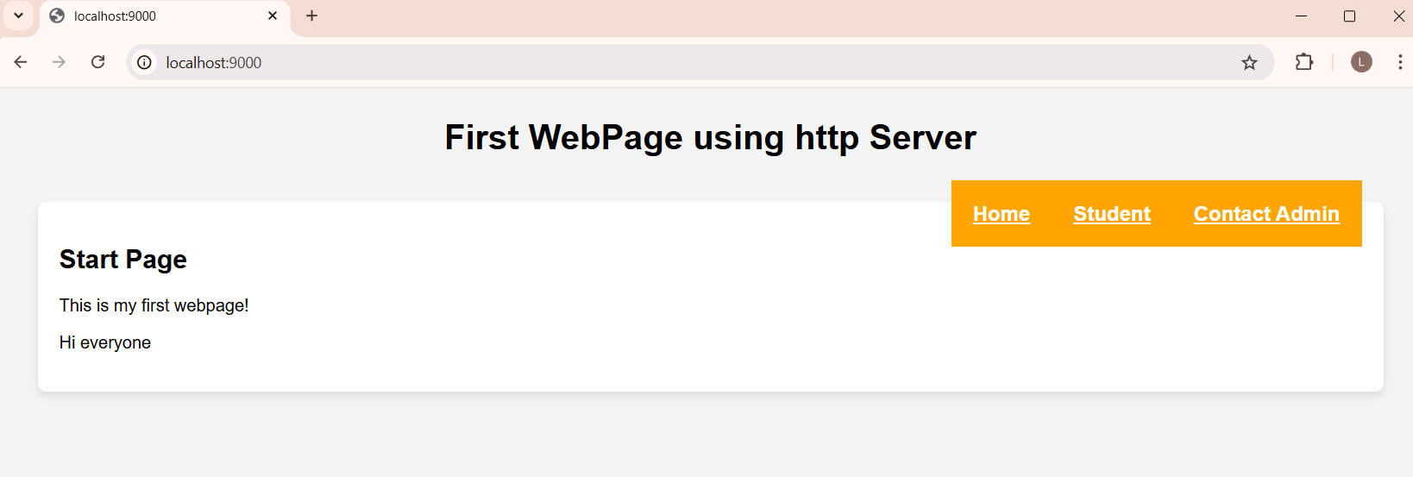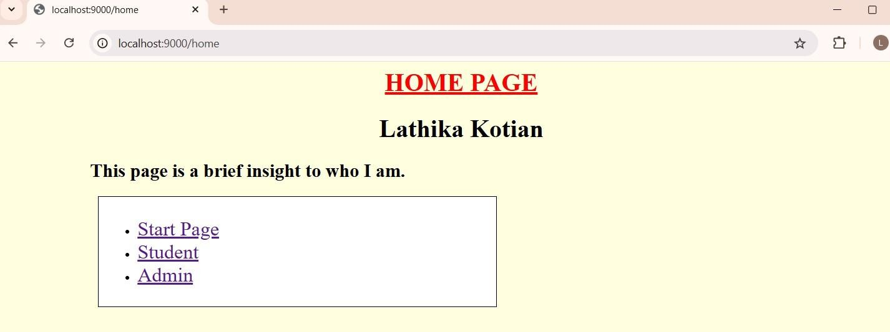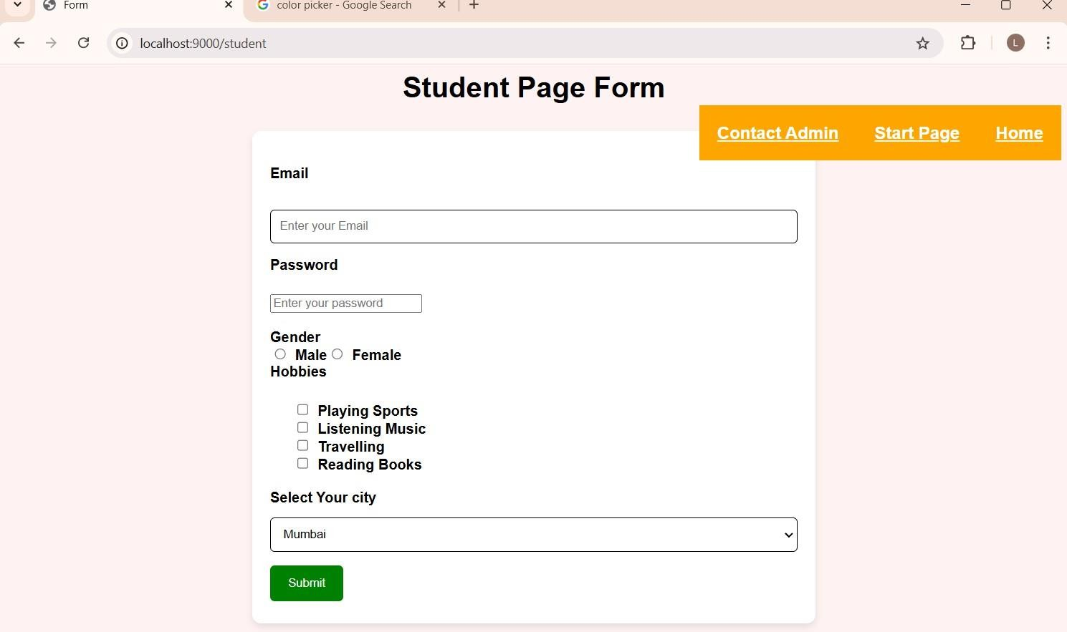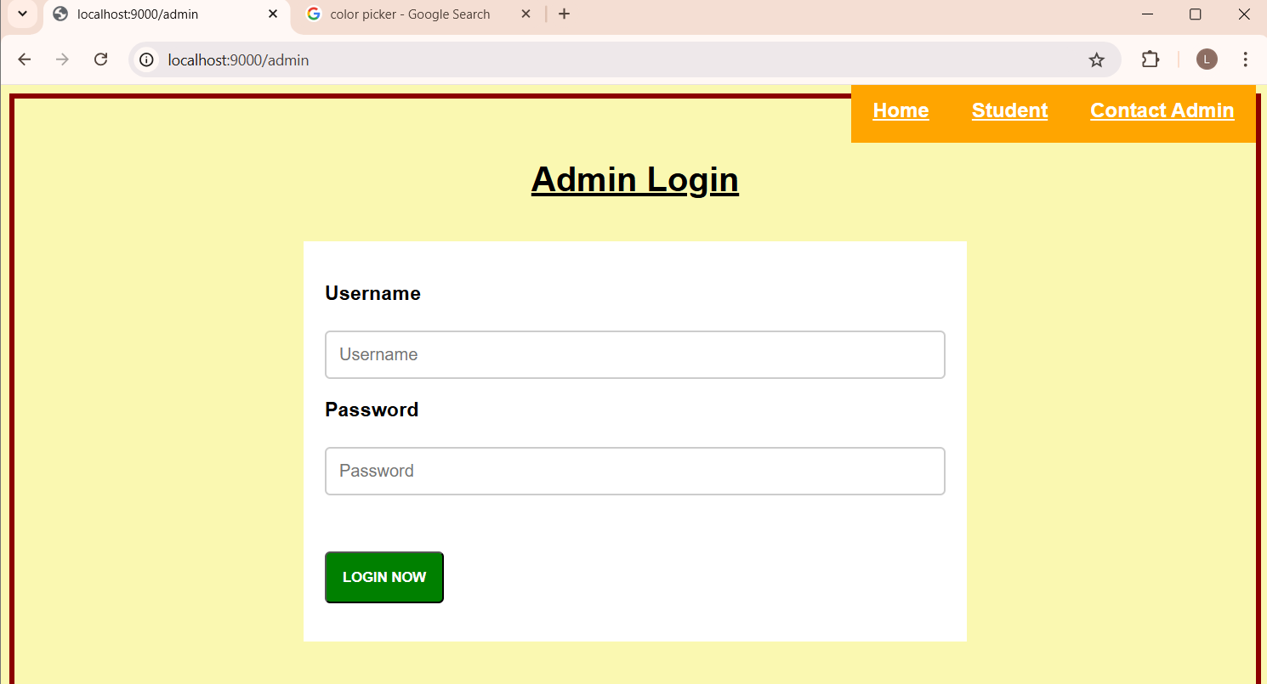

# PRACTICAL - 22

**Aim : Write a program to implement the database in node.js using Xaamp. Open Xampp and start Apache and MySQL**

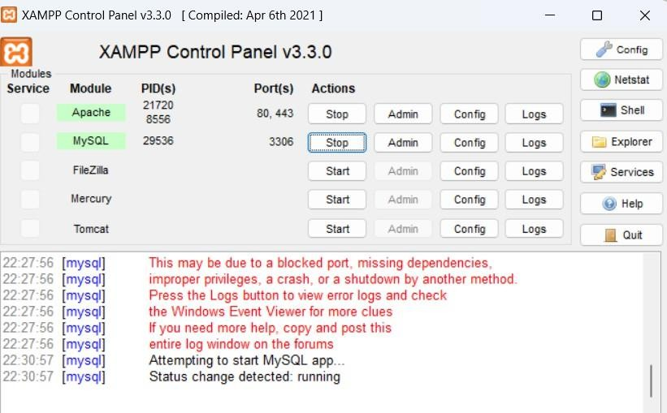

**After starting Apache and MySQL, search ‘localhost/phpMyAdmin/’ in chrome.**

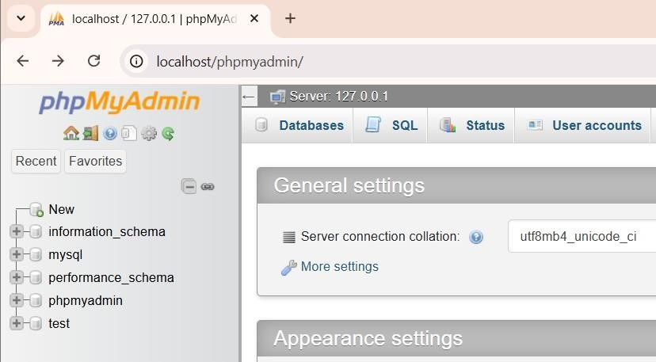

**CODE :**

**Create Database**

var mysql=require('mysql');

var con=mysql.createConnection({ host:'localhost',

port:3306, user:'root',

//password:'root'

});

con.connect(function(err){ if(err){

throw err;

}

else{

console.log("Connected");

con.query("CREATE DATABASE STUDENTS98",function(err,result){ if(err){throw err;}

else{ console.log("Database created");}

});}

})

**OUTPUT :**

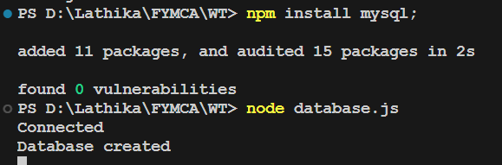

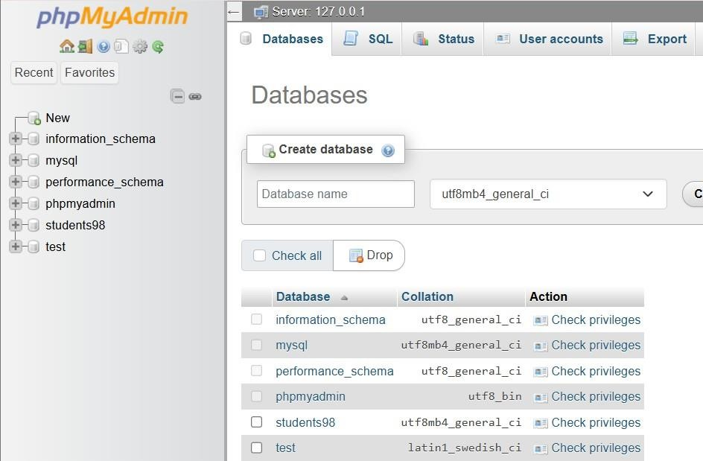

**Create Table in students98 database. CODE :**

con.connect(function(err)

{

if(err){

throw err;

}

else{

console.log("Connected...");

var sql = "CREATE TABLE product(pid INT(10) PRIMARY KEY AUTO_INCREMENT,p_name VARCHAR(255),p_type VARCHAR(20), quantity INT,price INT)";

con.query(sql,function(err,result){ if(err) throw err;

else{

console.log("Product Table created...");}

});

}

});

**OUTPUT :**

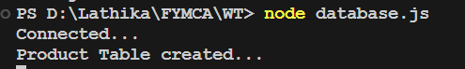

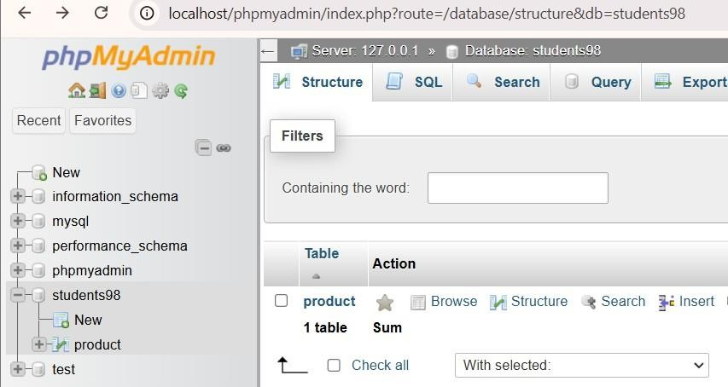

**Insert values CODE :**

con.connect(function(err)

{

if(err) {

throw err;} else{

console.log("Connected to insert...");

var sql2 = "INSERT INTO product(pid ,p_name , p_type,quantity, price)VALUES(1,'Phone','Electronic',120,21000),(2,'Chair','Furniture',80,4000), (3,'Laptop','Electronic',50,60000),(4,'Book','Stationery',320,200),

(5,'HeadPhone','Electronic',20,5000),(6,'DiningTable','Furniture',40,10000),(7,'Mat','Home Decor',200,500), (8,'AirPods','Electronic',320,1500)";

con.query(sql2,function(err,result)

{

if(err) throw err; else{

console.log(" Product values Inserted...");}

});

}

});

**OUTPUT :**

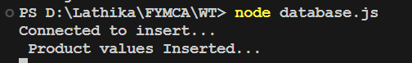

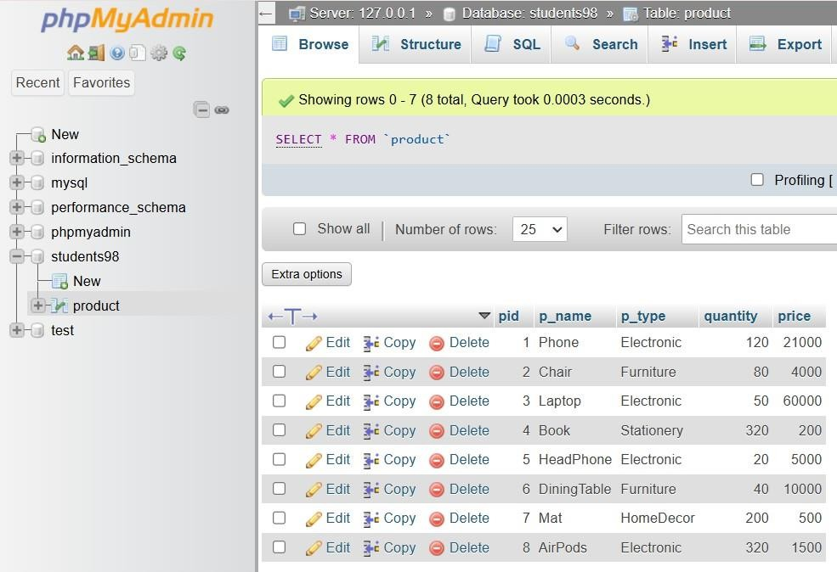

**Add Column CODE :**

con.connect(function(err)

{

if(err) throw err; console.log("Connected...");

var sql = "ALTER TABLE product ADD discount VARCHAR(30)"; con.query(sql,function(err,result){

if(err) throw err;

console.log("Column inserted successfuly...");

});

});

**OUTPUT:**

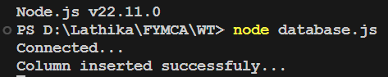

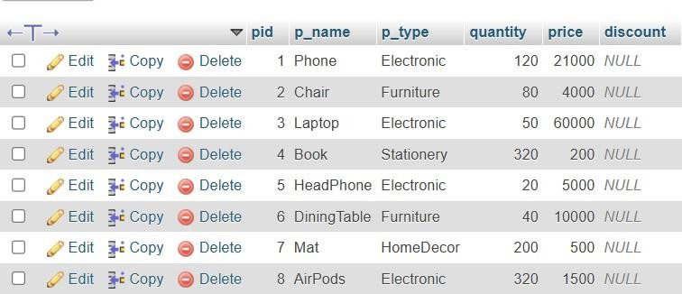

**Update data in Product table CODE :**

con.connect(function(err)

{

if (err) { throw err;}

else{

console.log("Connected successfully to server");

var sql = "SELECT * FROM product WHERE p_type = 'Electronic'"; con.query(sql, function(err, result) {

if (err) { throw err;

}

else{

console.log("Product found: ", result); var newDiscount = '20%';

var updateSql = `UPDATE product SET discount = '${newDiscount}' WHERE p_type = 'Electronic'`;

con.query(updateSql, function(err, result) { if (err) throw err;

console.log("Number of records updated for type Electronic : " + result.affectedRows);

});

var updateSql1 = `UPDATE product SET discount = '10%' WHERE p_type = 'Furniture'`; con.query(updateSql1, function(err, result) {

if (err) throw err;

console.log("Number of records updated for type Furniture : " + result.affectedRows);

});

var updateSql2 = `UPDATE product SET discount = '5%' WHERE p_type = 'Stationery'`; con.query(updateSql2, function(err, result) {

if (err) throw err;

console.log("Number of records updated for type Stationery : " + result.affectedRows);

});

}

})}

});

**OUTPUT :**

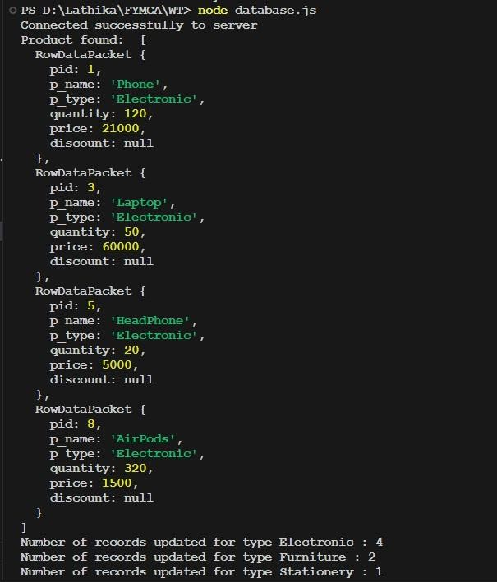

**Delete records CODE :**

con.connect(function(err)

{

if(err) throw err; console.log("Connected...");

console.log("Delete row having pname Mat");

var sql2 =`DELETE from product WHERE p_name = 'Mat'`; con.query(sql2,function(err,result){

if(err) throw err; console.log(result);

});

});

**OUTPUT :**

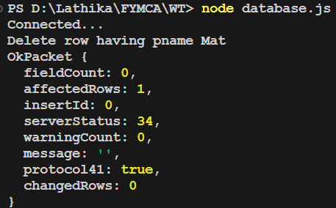

**Display Records CODE :**

con.connect(function(err)

{ if(err) throw err; console.log("Connected...");

var sql2="SELECT * from product"; con.query(sql2,function(err,result){

if(err) throw err; console.log(result);});

});

**OUTPUT :**

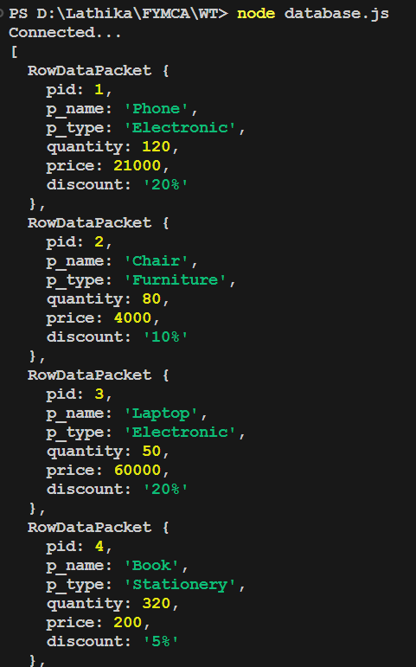

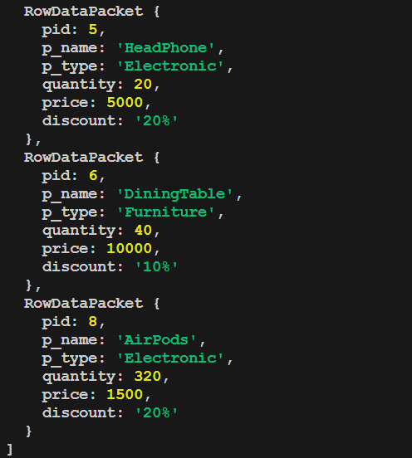

# PRACTICAL - 23

**Aim : Write a program to Display Hello World using ReactJS npx create-react-app <appName>**

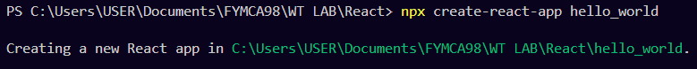

**CODE :**

import logo from './logo.svg'; import './App.css';

function App() { return (

<div className="App">

<header className="App-header">

<img src={logo} className="App-logo" alt="logo" />

<p>

Hello World !!!

</p>

<a

className="App-link" href="https://reactjs.org" target="_blank"

rel="noopener noreferrer"

> Learn React </a>

</header>

</div>

);

}

export default App;

**cd hello_world npm start**

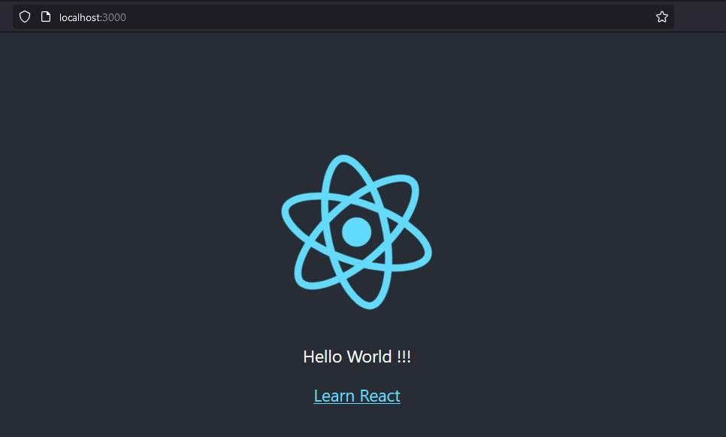

# PRACTICAL -24

**Aim : Create an application in ReactJS to implement component life cycle**

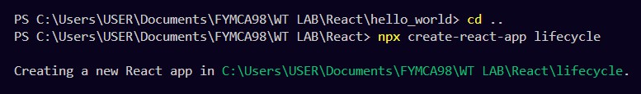

**CODE :**

import './App.css';

import React,{useState,useEffect} from 'react'; const LifecycleComponent=()=>{

const [count,setCount]=useState(0);

const [message,setMessage]=useState("Hello World");

//

useEffect(()=>{

console.log('Component Mounted !'); return ()=>{

console.log("Component will unmount!");

};

},[]);//empty dependency aRRAY MEANS THIS RUNS ONY ON MOUNT

useEffect(()=>{

console.log(`Count updated to : ${count}`);

},[count]);

const handleClick=()=>{

setCount(count+1);//Increment count

};

const handleMessageChange=()=>{

setMessage('Message has been changed !');

};

return(

<div>

<h1>React Component Lifecycle</h1>

<p>Message : {message}</p>

<p>Count : {count}</p>

<button onClick={handleClick}>Increment Count</button>

<button onClick={handleMessageChange}>Change Message</button>

</div>

);

};

const App=()=> { return (

<div className="App">

<h2>React Component Lifecycle Demo</h2>

<LifecycleComponent/>

</div>

);

}

export default App;

**OUTPUT :**

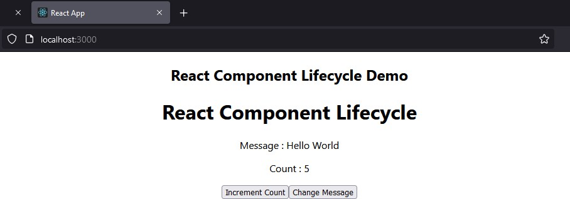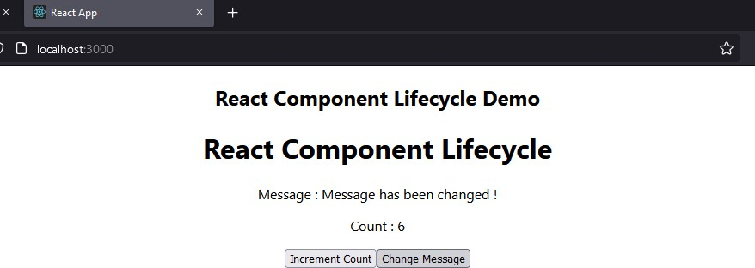

# PRACTICAL -25

**Aim : Create an application to implement class component in ReactJS CODE :**

**MyClassComponent.js**

import React,{Component} from 'react';

class MyClassComponent extends Component{ constructor(props){

super(props); this.state={

message:"This is React Class Component !", counter:0,

};

}

incrementCounter=()=>{ this.setState((prevState)=>({

counter:prevState.counter+1

}));

};

render(){ return(

<div style={{textAlign:'center',margin:'50px',padding:'50px',background:'pink'}}>

<h1>Hello Lathika</h1>

<h1>{this.state.message}</h1>

<p>Counter : {this.state.counter}</p>

<button onClick={this.incrementCounter} style={{padding:'10px 20px',fontSize:'16px'}}>

Increment Counter

</button>

</div>

);

}

}

export default MyClassComponent;

**Replace the content in App.js by the component created above as following**

import logo from './logo.svg'; import './App.css';

import MyClassComponent from './MyClassComponent';

function App() { return (

<div className="App">

<MyClassComponent/>

</div>

);

}

export default App;

**To run :**

**cd class_component npm start**

**OUTPUT :**

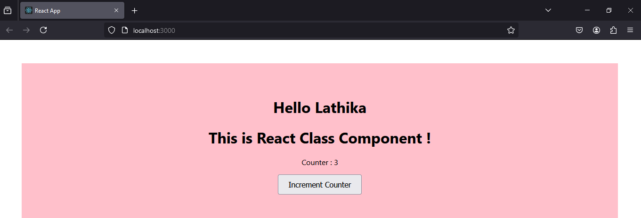

# PRACTICAL -26

**Aim : Create an application to implement functional component in ReactJS**

**CODE :**

**npx create-react-app addition**

import React,{useState} from 'react';

const AddTwoNumbers=()=>{

const [num1,setNum1]=useState(''); const [num2,setNum2]=useState(''); const [sum,setSum]=useState('');

const handleAddition=()=>{

const result=parseFloat(num1)+parseFloat(num2); setSum(result);

}

return(

<div style={{textAlign:'center',margin:'50px',padding:'50px',background:'#9dfada'}}>

<h1>Add Two Numbers</h1>

<div style={{marginBottom:'20px'}}>

<input type="number" placeholder="Enter first number" value={num1} onChange={(e)=>setNum1(e.target.value)}

style={{marginRight:'10px',padding:'5px',fontSize:'18px'}}/>

<input type="number" placeholder="Enter second number" value={num2} onChange={(e)=>setNum2(e.target.value)}

style={{marginRight:'10px',padding:'5px',fontSize:'18px'}}/>

<button onClick={handleAddition} style={{padding:'5px

20px',background:'#f5cc8c',borderRadius:'10px',borderColor:'coral',color:'black',fontWeight:'bold'

,height:'50px',fontSize:'18px'}}> Add

</button>

</div>

{sum!==null && <h2>Result : {sum}</h2>}

</div>

);

}

export default AddTwoNumbers;

**App.js**

import logo from './logo.svg'; import './App.css';

import AddTwoNumbers from './AddTwoNumbers';

function App() { return (

<div className="App">

<AddTwoNumbers/>

</div>

);

}

export default App;

**OUTPUT :**

**Npm start**

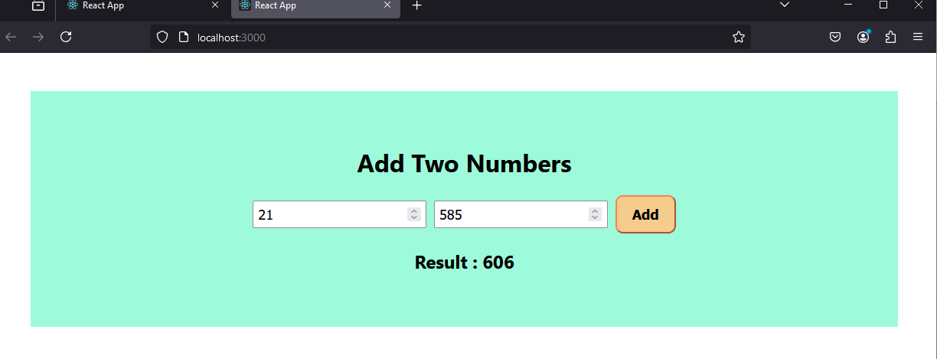

# PRACTICAL – 27

**Aim : Create an application in ReactJS import and export the files (components) . CODE :**

**FileUpload.js**

import React, { useState } from "react";

const FileUpload = () => {

const [fileContent, setFileContent] = useState(""); const handleFileUpload = (e) => {

const file = e.target.files[0]; const reader = new FileReader(); reader.onload = (event) => {

setFileContent(event.target.result);

};

if (file) reader.readAsText(file);

};

return (

<div>

<h3>Upload a File</h3>

<input type="file" onChange={handleFileUpload} />

{fileContent && (

<div>

<h4>File Content:</h4>

<textarea value={fileContent} readOnly rows="10" cols="50" />

</div>

)}

</div>

);

};

export default FileUpload;

**FileDownload.js**

import React from "react" ;

const FileDownload = () => { const handleDownload = () => {

const content = "This is some sample text for the file."; const blob = new Blob([content], { type: "text/plain"}); const url = URL.createObjectURL(blob);

const link = document.createElement("a"); link.href = url;

link.download = "sample.txt"; link.click();

URL.revokeObjectURL(url);

};

return (

<div>

<h3>Download a File</h3>

<button onClick={handleDownload}>Download</button>

</div>

);

};

export default FileDownload;

**===**

**App.js**

import FileDownload from './FileDownload'; import FileUpload from './FileUpload'; import './App.css';

function App() { return (

<div>

<h1>React File Import/Export</h1>

<FileUpload/>

<FileDownload/>

</div>

);

}

export default App;

**OUTPUT :**

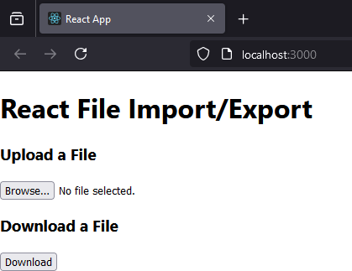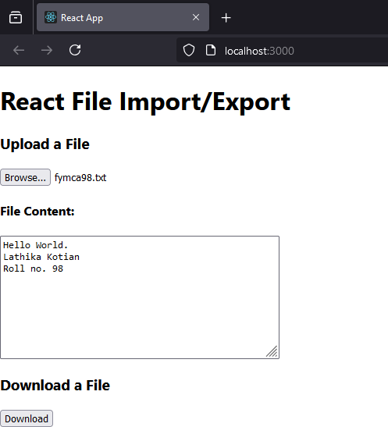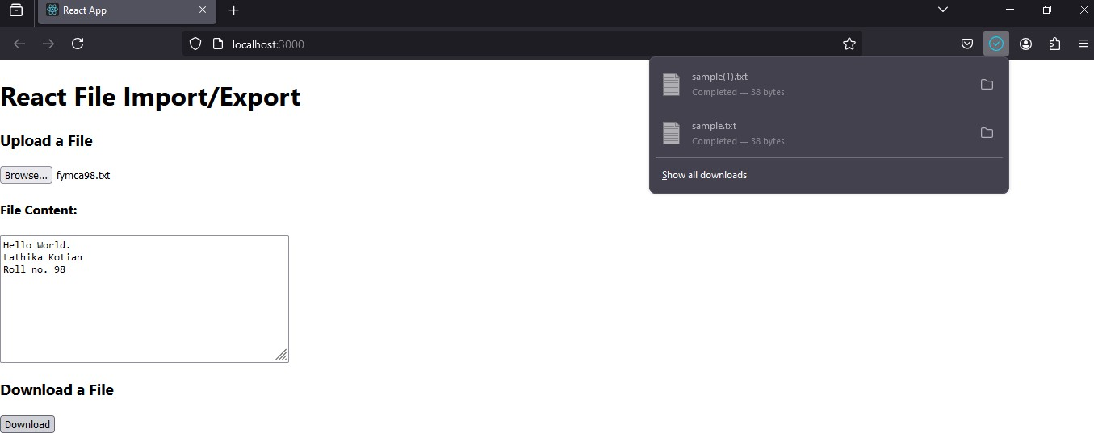

**Aim : Create an application to increment and decrement counter using state. CODE :**

**App.js**

import React, { useState } from 'react'; import './App.css';

function App() {

const [count, setCount] = useState(0); return (

<div>

<h1>Count: {count}</h1>

<button onClick={() => setCount(count + 1)}>Increment</button>

<button onClick={() => setCount(count - 1)}>Decrement</button>

</div>

);

}

export default App;

**OUTPUT :**

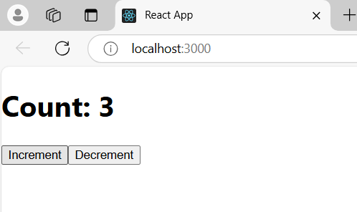

**Aim : Create an application to display your name using prop. CODE :**

import React, { useState } from 'react'; import './App.css';

const Greeting = ({ name }) => {

return <h1>Hello, {name}!</h1>;

};

const App = () => { return (

<div>

<Greeting name="Lathika Kotian" />

{/* <Greeting name="Kotian" /> */}

</div>

);

};

export default App;

**OUTPUT :**

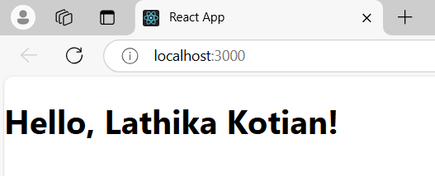

# PRACTICAL -30

**Aim : Create an application to implement To-Do task. CODE :**

**Tasklist.js**

import React from 'react';

const Tasklist=({tasks})=>{ return(

<div style={{marginTop:'20px'}}>

<h2>Your Tasks</h2>

{tasks.length===0?(

<p>No tasks added yet.</p>

):(

<ul>

{tasks.map((task,index)=>(<li key={index}style={{marginBottom:'10px'}}>{task}

</li>

))}

</ul>

)

}

</div>

);

};

export default Tasklist;

**App.js**

import './App.css';

import React, { useState } from 'react'; import Tasklist from'./Tasklist';

const App=() =>{

const[tasks,setTasks]=useState([]); const[taskInput,setTaskInput]=useState('');

const handleAddTask=()=>{ if(taskInput.trim()!==''){

setTasks([...tasks,taskInput]); setTaskInput('');

}

};

return (

<div style={{padding:'20px'}}>

<h1>To Do List</h1>

<div>

<input type='text' value={taskInput} onChange={(e)=>setTaskInput(e.target.value)} placeho lder='Enter a new task' style={{padding:'10px',width:'300px',marginRight:'10px'}}/>

<button onClick={handleAddTask}style={{padding:'10px'}}>Add Task</button>

</div>

<Tasklist tasks={tasks}/>

</div>

);

}

export default App;

**OUTPUT :**

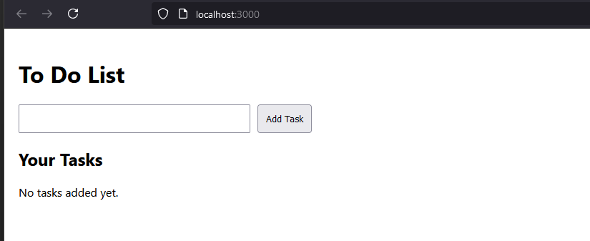

**Aim : Create an application in ReactJS to use DOM events- onChange.. CODE :**

import React, { useState } from "react";

function ToggleMessage() {

const [isChecked, setIsChecked] = useState(false); const handleCheckboxChange = (event) => {

setIsChecked(event.target.checked);

};

return (

<div style={{ margin: "20px", textAlign: "center"

,background:"pink",padding:20,marginLeft:400,marginRight:400, border: "2px solid black",}}>

<h3>Show/Hide Message</h3>

<label>

<input type="checkbox" onChange={handleCheckboxChange} style={{ marginRight: "10px" }}/>

Show Message

</label>

<div style={{ marginTop: "20px" }}>

{isChecked && <p style={{ color: "green" }}>Hello, this is you message! Lathika Here</p>}

</div>

</div> );}

export default ToggleMessage;

**App.js**

import './App.css';

import ToggleMessage from './ToggleMessage'; function App() {

return (

<ToggleMessage/>

);

}

export default App;

**OUTPUT :**

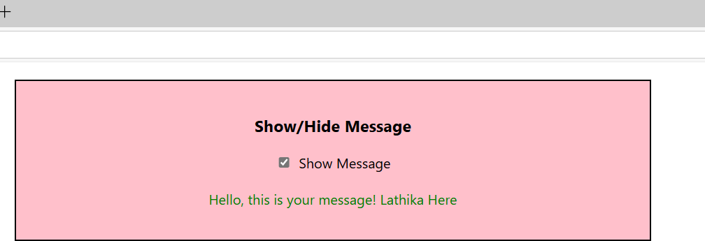

**Aim : Write a program that tracks the changes in an input field and displays the entered text in real- time using onChange DOM event.**

**CODE :**

import React, { useState } from "react";

function InputTracker() {

const [text, setText] = useState(""); const handleChange = (event) => { setText(event.target.value);

};

return (

<div style={{ margin: "20px", textAlign: "center"

,background:"coral",padding:20,marginLeft:400,marginRight:400, border: "2px solid black"}}>

<h3>Input Field Change Tracker</h3>

<input type="text"

placeholder="Type something here..." value={text} onChange={handleChange} // Event handler for onChange

style={{ padding: "8px", border: "1px solid #ccc", borderRadius: "4px", width: "300px",}} />

<p style={{ marginTop: "10px" }}>You typed: {text}</p>

</div>

);

}

export default InputTracker;

**App.js**

import './App.css';

import InputTracker from './InputTracker';

function App() { return (

<InputTracker/>

);

}

export default App;

**OUTPUT :**

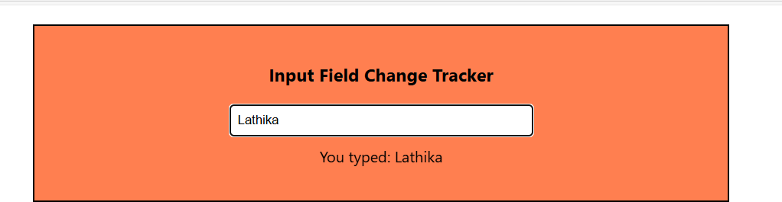

# PRACTICAL -33

**Aim : Create an application in ReactJS to use DOM events- onKeyUp. CODE :**

**KeyDisplay.js**

import React, { useState } from "react";

const KeyDisplay=() =>{

const [keyCode, setKeyCode] = useState(""); const handleKeyUp = (e) => {

setKeyCode(`Key Code: ${e.keyCode}`);

};

return (

<div style={{textAlign:'center',margin:'60px',padding:'20px',background:'coral'}}>

<input style={{height:"30px",fontWeight:'bold'}} type="text"

onKeyUp={handleKeyUp} placeholder="Press a key..."

/>

<p>{keyCode}</p>

</div>

);

}

export default KeyDisplay;

**App.js**

import KeyDisplay from './KeyDisplay'; import './App.css';

function App() { return (

<KeyDisplay/>

);

}

export default App;

**OUTPUT :**

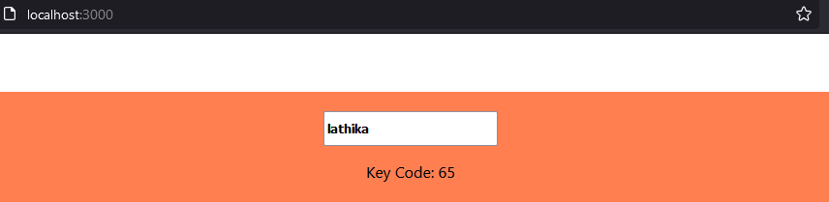

# PRACTICAL – 34

**Aim : Write a Program to Counts words as they are typed using onKeyUp event. CODE :**

import React,{useState} from 'react'; import './App.css';

function App() {

const [wordCount, setWordCount] = useState(0); const handleKeyUp = (e) => {

const words = e.target.value.trim().split(/\s+/);

setWordCount(words[0] === "" ? 0 : words.length);

};

return (

<div style={{textAlign:'center',margin:'60px',padding:'20px'}}>

<textarea

onKeyUp={handleKeyUp}

placeholder="Type your text here..."

/>

<p>Word Count: {wordCount}</p>

</div>

);

}

export default App;

**OUTPUT :**

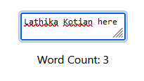

# PRACTICAL -35

**Aim : Write a Program to implements validation logic for an email field using onBlur event. CODE :**

import React,{useState} from 'react'; import './App.css';

function App() {

const [error, setError] = useState(""); const handleBlur = (e) => {

const email = e.target.value; if (!email.includes("@")) {

setError("Please enter a valid email address");

} else {

setError("");

}

};

return (

<div>

<input style={{height:"30px",fontWeight:'bold'}} type="text"

onBlur={handleBlur}

placeholder="Enter your email"

/>

{error && <p style={{ color: "red" }}>{error}</p>}

</div>

);

}

export default App;

**OUTPUT :**

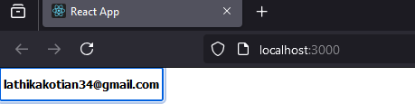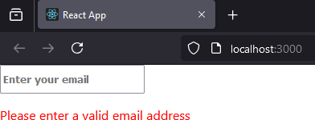

# PRACTICAL NO - 36

**Aim : Create an application in ReactJS form and add client validation**

**CODE :**

**FormValidation.js**

import React, { useState } from "react";

function FormValidation() {

const [formData, setFormData] = useState({ name: "", email: "" }); const [errors, setErrors] = useState({});

const handleChange = (e) => { const { name, value } = e.target;

setFormData({ ...formData, [name]: value });

};

const validate = () => { const newErrors = {};

if (!formData.name) newErrors.name = "Name is required"; if (!formData.email) newErrors.email = "Email is required"; else if (!/\S+@\S+\.\S+/.test(formData.email)) newErrors.email = "Email is invalid";

setErrors(newErrors);

return Object.keys(newErrors).length === 0;

};

const handleSubmit = (e) => { e.preventDefault();

if (validate()) {

alert("Form submitted successfully!");

}

};

return (

<div style={{textAlign:'center',margin:'50px',padding:'50px',background:'pink'}}>

<form onSubmit={handleSubmit}>

<div>

<label>Name:</label>

<input

type="text" name="name" value={formData.name}

onChange={handleChange}

/>

{errors.name && <p style={{ color: "red" }}>{errors.name}</p>}

</div>

<div>

<label>Email:</label>

<input

type="text" name="email" value={formData.email}

onChange={handleChange}

/>

{errors.email && <p style={{ color: "red" }}>{errors.email}</p>}

</div>

<button type="submit">Submit</button>

</form>

</div>

);

}

export default FormValidation;

**App.js**

import './App.css';

import FormValidation from './FormValidation';

function App() { return (

<FormValidation/>

);

}

export default App;

**OUTPUT :**

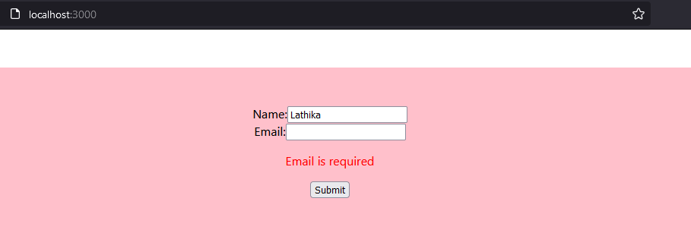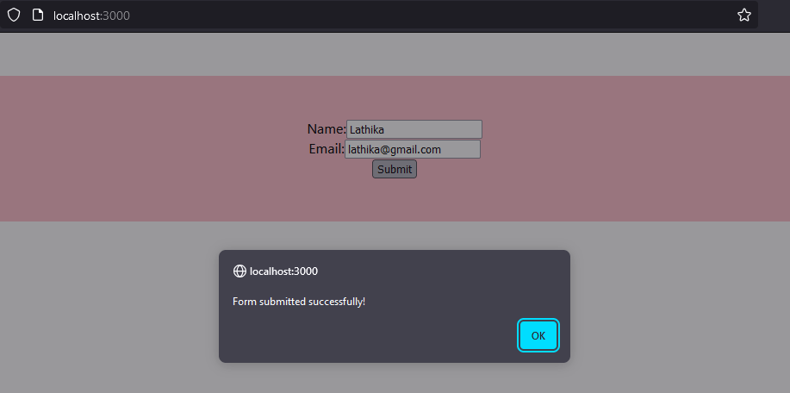

**Practical -37**

**Aim : Write a Program to implements useEffect hook.**

**CODE :**

import './App.css';

import React, { useEffect } from 'react';

import FormValidation from './FormValidation';

function App() {

// return (

// <FormValidation/>

// ); useEffect(() => {

console.log('Component mounted!');

}, []); // Empty dependency array ensures this runs only once on mount

return <div style={{margin:'10px',padding:'5px'}}><strong>Hello, World!</strong></div>;

}

export default App;

**OUTPUT :**

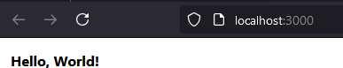

# PRACTICAL – 38

**Aim : Create SPA using React Router. CODE :**

**About.js**

import React from "react"; const About = () => {

return <h1>About Us</h1>;

};

export default About;

**Contact.js**

import React from "react"; const Contact = () => {

return <h1>Contact Us</h1>;

};

export default Contact;

**Home.js**

import React from "react";

const Home = () => {

return <h1>Welcome to the Home Page</h1>;

};

export default Home;

**App.js**

import About from './About.js' import Contact from './Contact.js' import Home from './Home.js'

import { BrowserRouter as Router, Routes, Route, Link } from "react-router-dom"; import './App.css';

function App() { return (

<Router>

<nav>

<ul>

<li>

<Link to="/">Home</Link>

</li>

<li>

<Link to="/about">About</Link>

</li>

<li>

<Link to="/contact">Contact</Link>

</li>

</ul>

</nav>

<Routes>

<Route path="/" element={<Home/>}/>

<Route path="/about" element={<About />} />

<Route path="/contact" element={<Contact />} />

</Routes>

</Router>

);

}

export default App;

**OUTPUT :**

