Corporate Partnership Proposal
Chemotherapy Access Program for Women with treated at Cameroon Oncology Center

Executive Summary
Cancer has become one of the fastest growing public health crises in Sub-Saharan Africa. In Cameroon, approximately 30,000 people are currently living with cancer and about 15,000 die each year due to limited access to treatment. One of the most significant barriers to cancer care is the high cost of chemotherapy drugs, forcing many families to abandon treatment. The Cameroon Cancer Foundation (CCF) proposes a Chemotherapy Access Program that will provide life-saving chemotherapy drugs free of charge to 200 economically disadvantaged women undergoing treatment at the Cameroon Oncology Center.

Submitted by
Victor Samkoh
Executive Director
Cameroon Cancer Foundation (CCF)
&
Professor Paul Mobit
Executive Director
Cameroon Cancer Foundation (CCF)

1. Introduction/Problem: In 2025, Cameroon Oncology Center consulted about 1200 patients with various cancers as shown in Figure 1. 850 of these patients are female. Cervical and breast cancers are the top two cancers diagnosed in Cameroon and affect almost exclusively women since some men can also be diagnosed with breast cancer. The normal treatment protocol for intermediate stage breast cancer include neo-adjuvant chemotherapy for 3-6 months, followed by lumpectomy/mastectomy and then 4-5 weeks of daily radiotherapy. During treatment, these patients need to undergo a lot of tests and scans. So it is not uncommon for breast cancer patients to spend 3-5 million for their care. For intermediate to high staged cervical cancer on the other hand, the treatment may follow a similar sequence or patients may have weekly chemotherapy and daily radiotherapy together for 5 weeks. This is then followed by high dose rate (HDR) brachytherapy for four weeks or Stereotactic body radiotherapy (SBRT) for 2 weeks. Total cost for entire treatment exceeds 3-5 millions whether in public or private hospital.
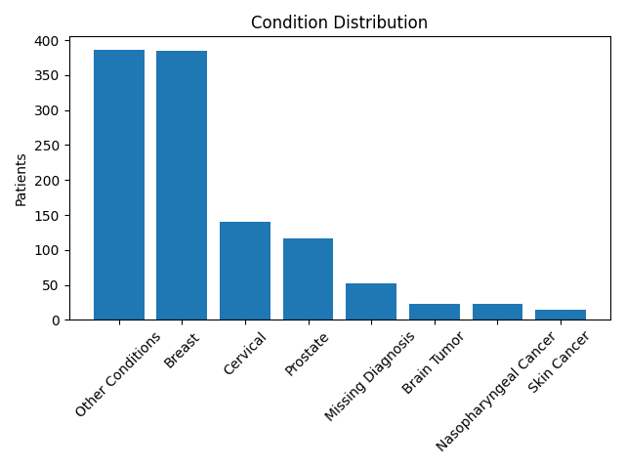
Women all over the world bear the burden of childbirth but in Cameroon as in many parts of Sub-Saharan Africa, they almost exclusively bear the burden of raising their children irrespective of their education or economic status. Data from many African countries including Cameroon has indicated that between 15 and 25% of all women who have cancer are at the same time infected with HIV/AIDS. It can be very devastating when cancer hits women of lower economic status as they may not be able to work and pay for their chemotherapy drugs as needed and the same time take care of their family. The whole family can literally be destroyed if the mother cannot be helped. If they live in a village or even in towns where they may be engaged in “buyam sallam” activities or farming as the case may be, then the high out-of-pocket expenditure associated with modern cancer treatment exposes many Cameroonian households to catastrophic health spending.

2.About Cameroon Cancer Foundation
The Cameroon Cancer Foundation (CCF) is a non-governmental, non-profit organization headquartered in Douala, Cameroon. The foundation works to improve access to cancer screening, diagnosis, and treatment for all Cameroonians regardless of their economic or social status. The mission of CCF is to reduce suffering and mortality caused by cancer through early detection, improved treatment access, education, and research. Consistent with Cameroon Cancer Foundation’s mission of reducing suffering by cancer patients and their family, we will like to focus on provision of chemotherapy drugs free of charge to 200 women suffering from breast, cervix and any cancer in the head and neck region. To be accepted on the program, all these patients will come from economically poor background. Are not civil servants, or engage in formal employment relationship.

3. Our Partner: Cameroon Oncology Center (COC) has been designated by the Ministry of Public Health as the Centre of Excellence in cancerology. COC administers 26 different chemotherapy protocols to their patients based international protocols. This is far more than triple all the other cancer programs in the nation who uses 5-8 protocols. COC also has access to modern targeted and immunotherapy drugs which is generally not available in Cameroon. COC operate the only medical linear accelerator in Cameroon and therefore treat cancer with radiation to international standard. Cameroon Cancer Foundation has also been working with CCF for the past 8 years very closely. COC and CCF have the same founder.

4. Cancer Burden in Cameroon
Cancer is rapidly increasing across Sub-Saharan Africa. In Cameroon, approximately 30,000 people are currently living with cancer and about 15,000 deaths occur annually. Breast and cervical cancers are the most common cancers affecting women. In 2025, the Cameroon Oncology Center consulted about 1,200 cancer patients, of whom approximately 850 were women.

5. Barriers to Cancer Treatment
Cancer treatment in Cameroon faces severe challenges including limited treatment infrastructure, shortage of oncology specialists, and extremely high treatment costs. A typical breast or cervical cancer patient may spend between 3 and 5 million FCFA during treatment. Because most health costs are paid out-of-pocket, many patients cannot complete their treatment.

6. Why Women Are Disproportionately Affected
Women carry a particularly heavy burden from cancer in Cameroon. Breast and cervical cancers are the most common cancers affecting women. In addition, studies suggest that between 15% and 25% of women with cancer in some African countries may also be living with HIV/AIDS. HIV/AIDS itself increases 8 fold probability of getting cancer according to the United States National Cancer Institute. Many women are also primary caregivers and economic pillars of their families, making the impact of cancer especially devastating.

7. Proposed Solution: Chemotherapy Access Program
The Cameroon Cancer Foundation proposes a Chemotherapy Access Program that will provide chemotherapy drugs free of charge to 300 low-income women diagnosed with breast, cervical, or head and neck cancers. Eligible patients will come from economically disadvantaged backgrounds and lack health insurance or formal employment. All 26 protocols currently available at can be used if the recipient patient is a woman.

7. Estimated Cost of Chemotherapy Protocols
Treatment Protocol | Cost per Session (FCFA)
5-Fluorouracil (5-FU) | 18,000
AC60 | 45,000
Cisplatin-based therapy | 72,000
Carboplatin + Paclitaxel | 108,000
Trastuzumab + chemotherapy | 570,000
Immunotherapy | 1,440,000

8. Proposed sponsorship program
The Chemotherapy Access Program will support 200 economically disadvantaged women undergoing cancer treatment. Sponsors can support 5 to 50 women. The support per patient
Budget Category | Estimated Cost (FCFA)
Chemotherapy drug cost | 20,000-100,000 frs CFA
Diagnostic tests and laboratory monitoring | 15,000
Chemotherapy administration fees | 50,000 frs per session
Program administration and coordination | 5,000
Monitoring, evaluation, and reporting | 1,000
Transportation support | 5,000
Total support per cycle would be approximately 100,000 frs per session.
The approximate cost of cervical cancer patients is 600,000 frs. For breast cancer patients and without using immunotherapy, the cost would be approximately 1.2 million per patient.

10. Funding Request
The Cameroon Cancer Foundation respectfully invites corporate partners, philanthropic foundations, and international donors to support this life-saving initiative. An investment of 200 million FCFA will enable the Foundation to provide chemotherapy treatment support to 200 women battling cancer who would otherwise be unable to afford treatment.

11. Monitoring and Transparency
CCF will maintain detailed records for all beneficiaries including patient identification, cancer diagnosis, treatment protocol, chemotherapy sessions received, and the cost of drugs administered. Periodic reports will be shared with funding partners.

12. Sustainability
To sustain this initiative, the Foundation will pursue partnerships with pharmaceutical companies, long-term corporate sponsorships, collaboration with international cancer organizations, and engagement with government stakeholders.

13. Conclusion
Cancer remains a growing public health crisis in Cameroon. Through the Chemotherapy Access Program, the Cameroon Cancer Foundation aims to ensure that 200 women receive the treatment they need to survive and continue supporting their families and communities.

