|  |  |  |
| --- | --- | --- |
| **ITMD 513-**  **LAVANYA SURIKAPURAM**  **A20392981** | ***Open Source Programming: Python*** | BLOG |

1. **Abstract**:

It is a Django **Blog Web application**.

The application has following features,

1. **I(Admin)** can **add posts** to **my blog** as well as allow **permitted users** to **add posts** in my blog. The posts will be displayed on the home page of the Web application as soon as we login.
2. Further, on clicking each post a detailed view of the post will be shown.
3. Each post can be **shared to any email address** from each detailed view of the post by click the **share the post button** which will direct to a form in which the user must provide the email address to whom the post to be shared.
4. Each post has a **comment section**. Either the comment can be added **directly from the admin** page or anyone can **add a comment directly from the blog** by clicking **add comment button** available in the detailed view of each post.
5. The detailed view of the post will show **who Published** the **post** as well as **who all commented** the **post** along with the **timestamp**.
6. The application has **login/logout** features as well.
7. The **SQLITE Database** is used to store the post, comment, timestamp.
8. Pagination feature is used to navigate pages

1. **Resources used** – system imports, modules/packages, kits, etc.

pip install **virtualenv**

pip install **Django**

In **Django**, the following modules were used,

from django.**contrib** import admin

from django.**apps** import AppConfig

from django import **forms**

from django.**db** import models  
from django.**utils** import timezone  
from django.**contrib.auth.models** import User  
from django**.urls** import reverse

from django.**conf.urls** import url

from django.**shortcuts** import render, get_object_or_404  
from django.**core.paginator** import Paginator, EmptyPage, PageNotAnInteger  
from django.**views.generic** import ListView

from django.core.mail import **send_mail**  
from django.db.models import **Count**

Pagination feature is used to navigate pages

**Database 🡪 SQLITE**

3. **credentials user/admin logins**

**Admin:** <http://127.0.0.1:8000/admin>

**UserName**: LAVANYASURIKAPURAM

**Password**: Mommommom09@

**User Login(**<http://127.0.0.1:8000/accounts/login/>**):**

**UserName**: Pragathees**, Password**: Mommommom09

**UserName**: Vignesh**, Password**: Mommommom09

**UserName**: sharadha**, Password**: Mommommom09

**Execution steps:**

* Install Python 3.6.4
* mkdir virtualenvs
* pip install virtualenv
* virtualenv ~/.virtualenvs/djangodev
* pip install -e /path/to/your/local/clone/django/(HAVE TO CLONE IT INITIALLY FROM DJANGO PATH USING GIT) Django 2.1.0 was installed
* django-admin startproject mysite
* Go to mysite directory
* python manage.py startapp blog
* provide gmail password in mysite/settings.py file for email

The application folder structure looks this way,

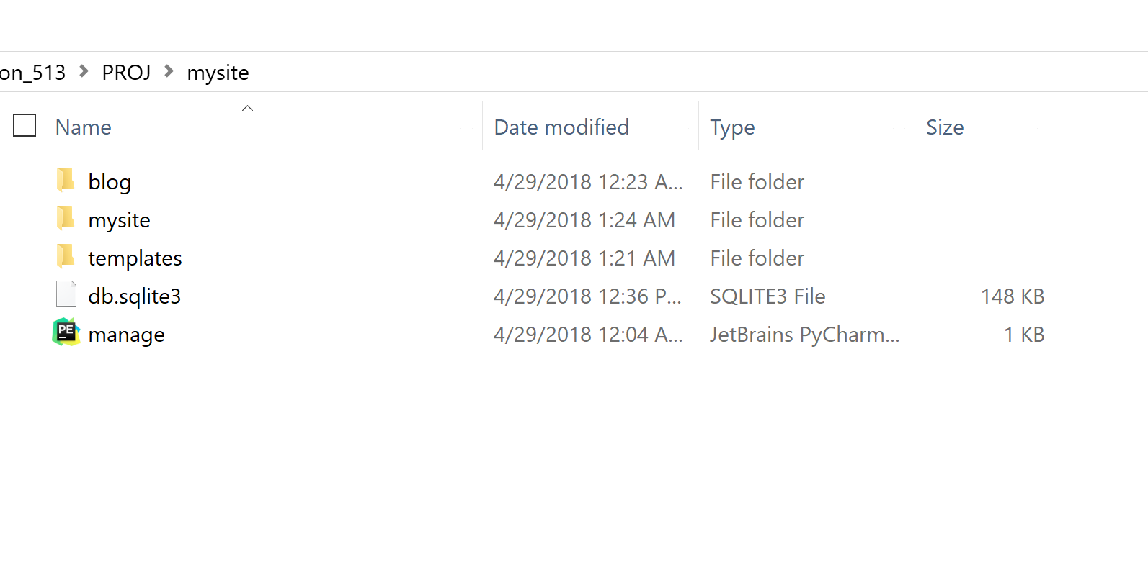

Blog is the app name, mysite is the project name.

Replace all the files with the submitted project files.

Further to run the application, we should run the app with a command

**python manage.py runserver**

from the folder where Mange.py exists.(/mysite/manage.py)

After which the apps login page can be accessed with the following link,

<http://127.0.0.1:8000/accounts/login/>

**Project main folder structure:**

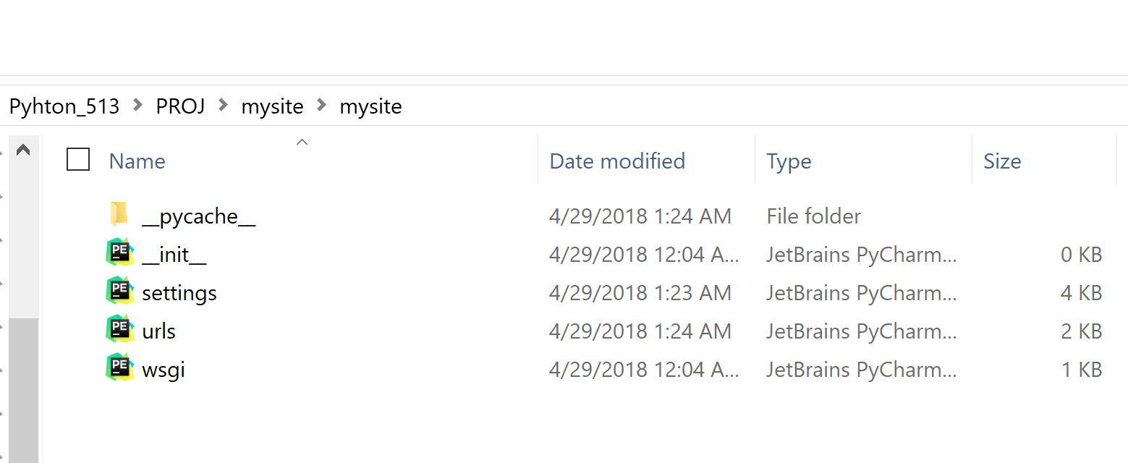

**App folder structure: MVT Template**

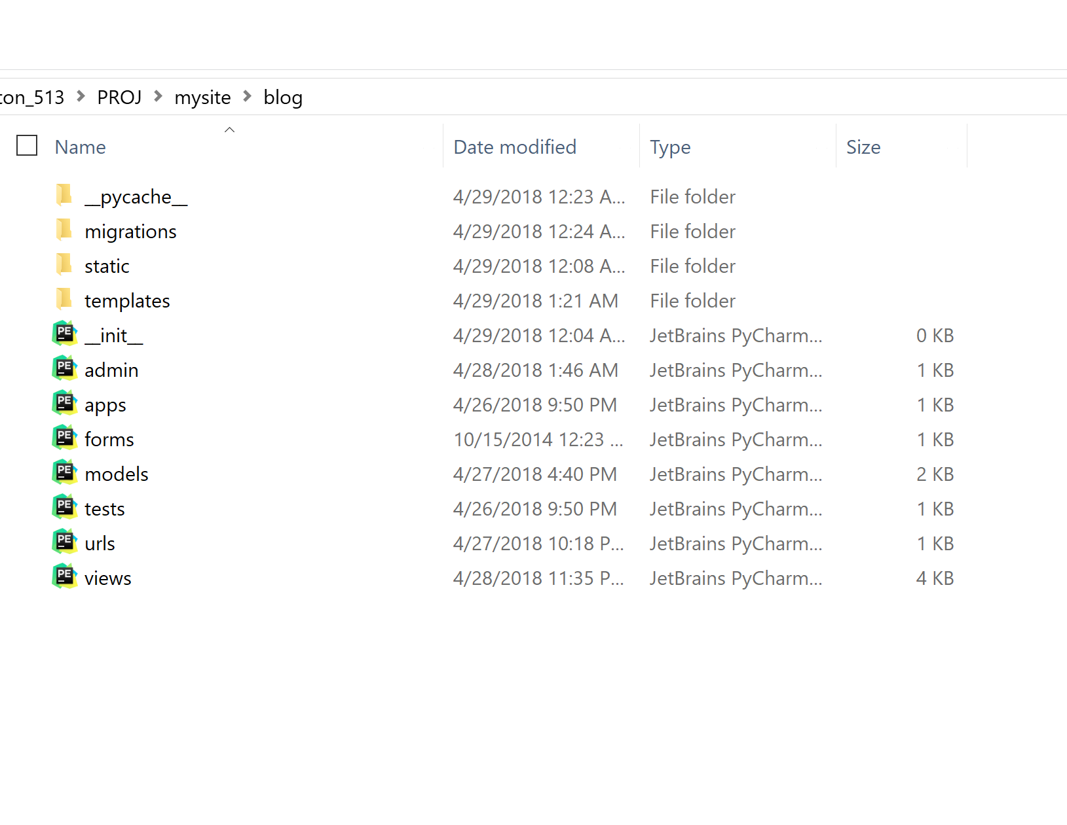

**Code work:**

1. Data source used for reading into your app for processing – **SQLITE**
2. Functionality to work the project idea in some UI.

* **I(Admin)** can **add posts** to **my blog** as well as allow **permitted users** to **add posts** in my blog. The posts will be displayed on the home page of the Web application as soon as we login.
* Further, on clicking each post a detailed view of the post will be shown.
* Each post can be **shared to any email address** from each detailed view of the post by click the **share the post button** which will direct to a form in which the user must provide the email address to whom the post to be shared.
* Each post has a **comment section**. Either the comment can be added **directly from the admin** page or anyone can **add a comment directly from the blog** by clicking **add comment button** available in the detailed view of each post.
* The detailed view of the post will show **who Published** the **post** as well as **who all commented** the **post** along with the **timestamp**.
* The application has **login/logout** features as well.
* The **SQLITE Database** is used to store the post, comment, timestamp.

**\mysite\blog.models.py**

1. **Data presenting**

**from django.core.mail import send_mail** is the best feature in the app which send email regaring the post to any person by specifying his email.

The detailed view of the post will show **who Published** the **post** as well as **who all commented** the **post** along with the **timestamp** is also available in the app.

1. **Application Snapshots:**

**Login Screen:**

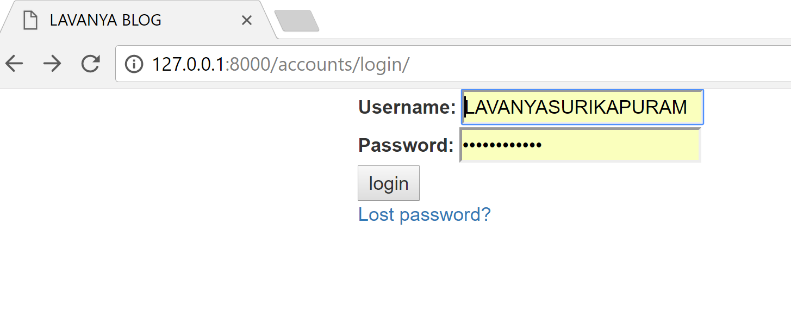

**First Page of the Blog:**

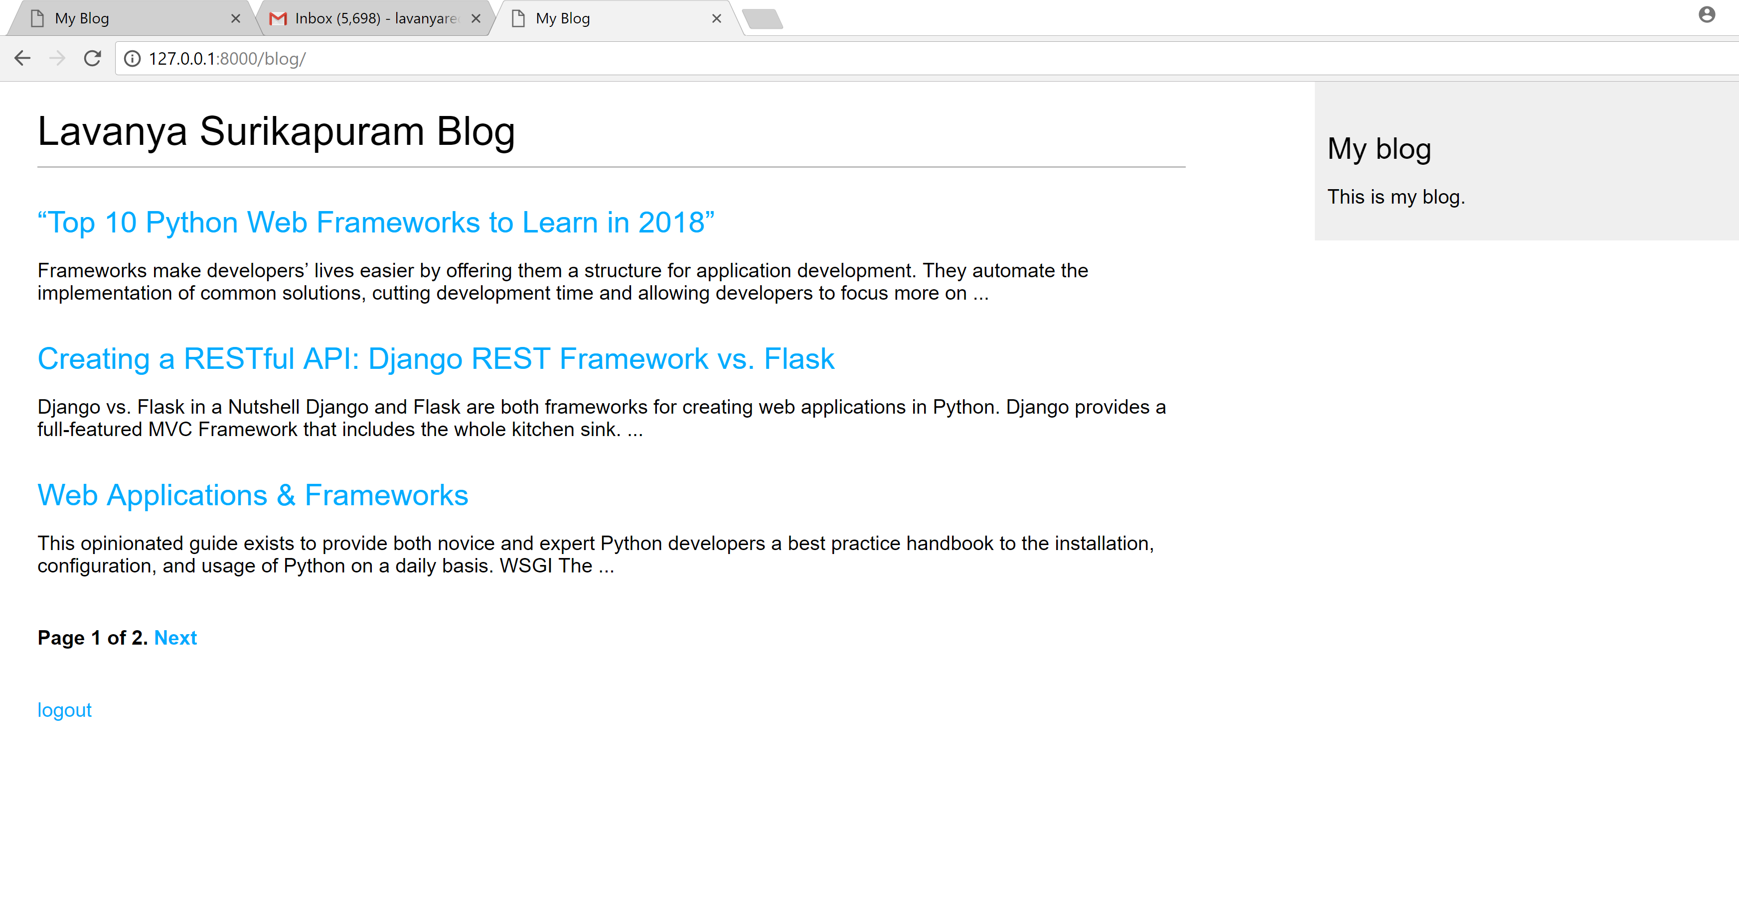

**2nd page of the blog:**

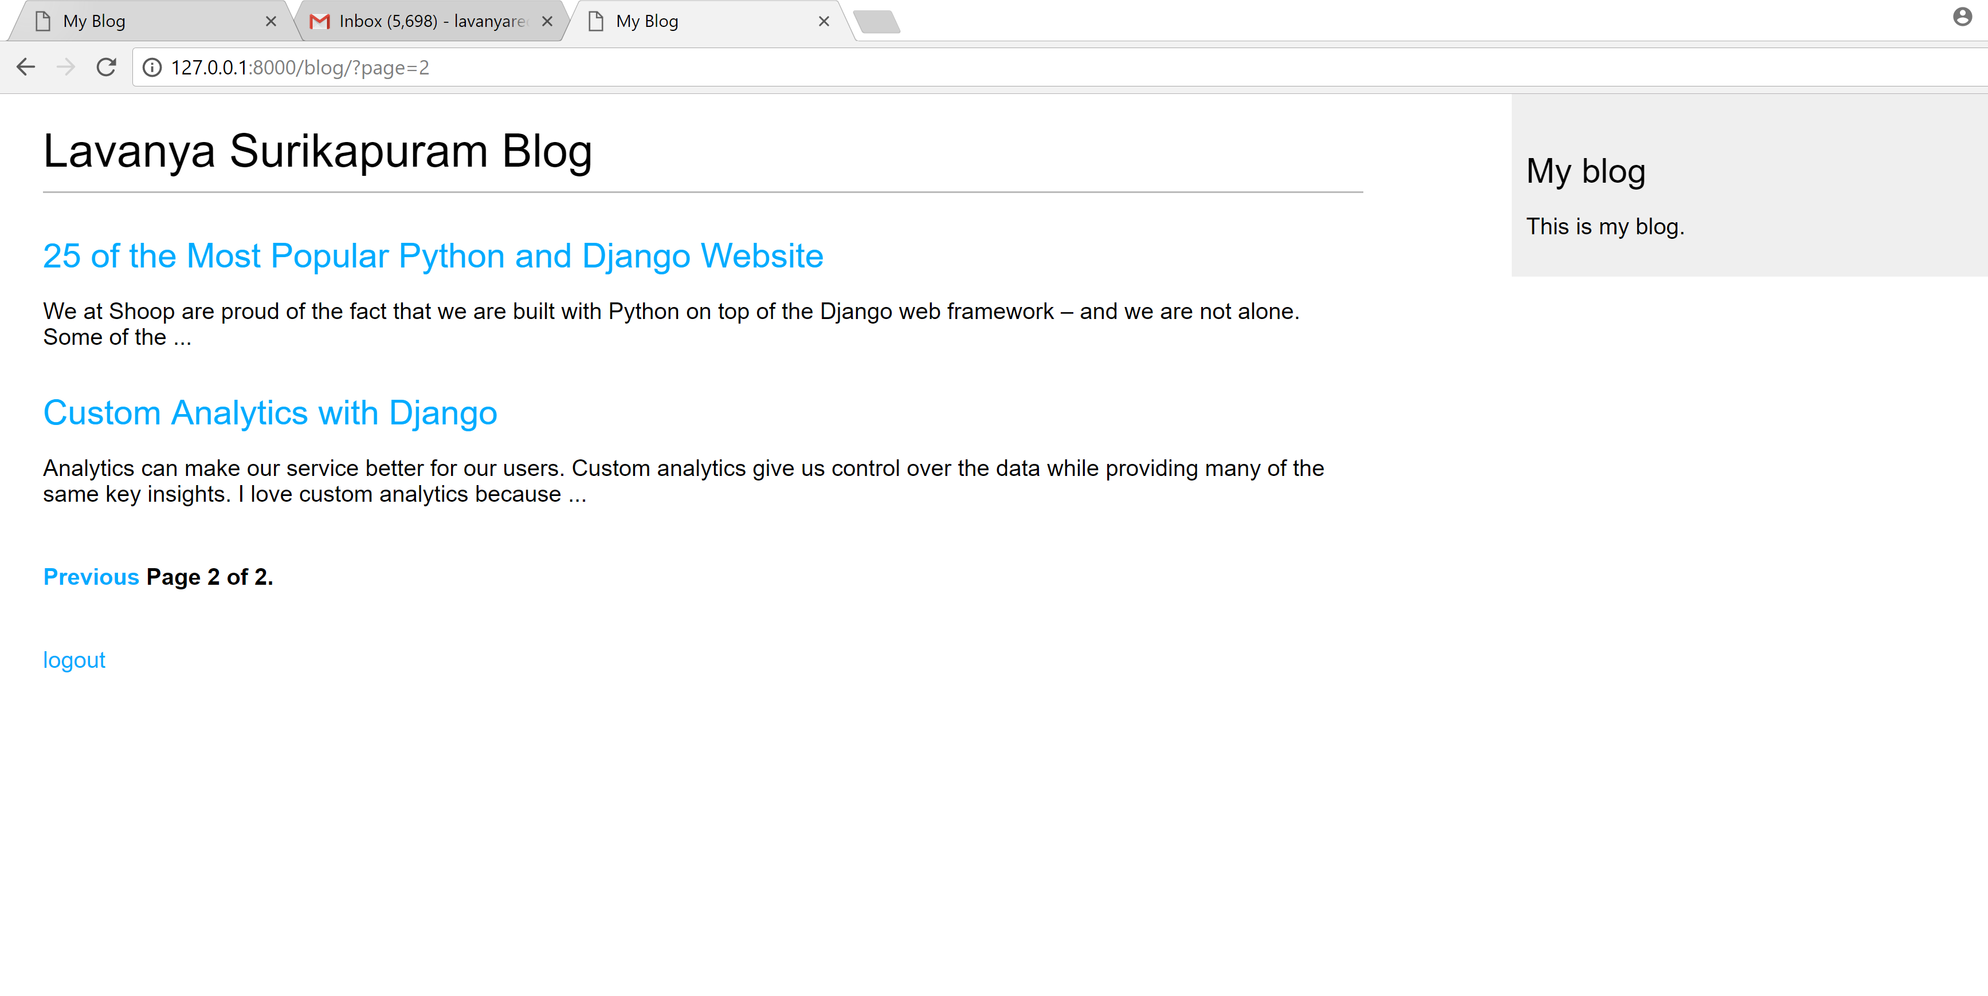

**Detailed view of each post (This is generated by clicking each post heading):**

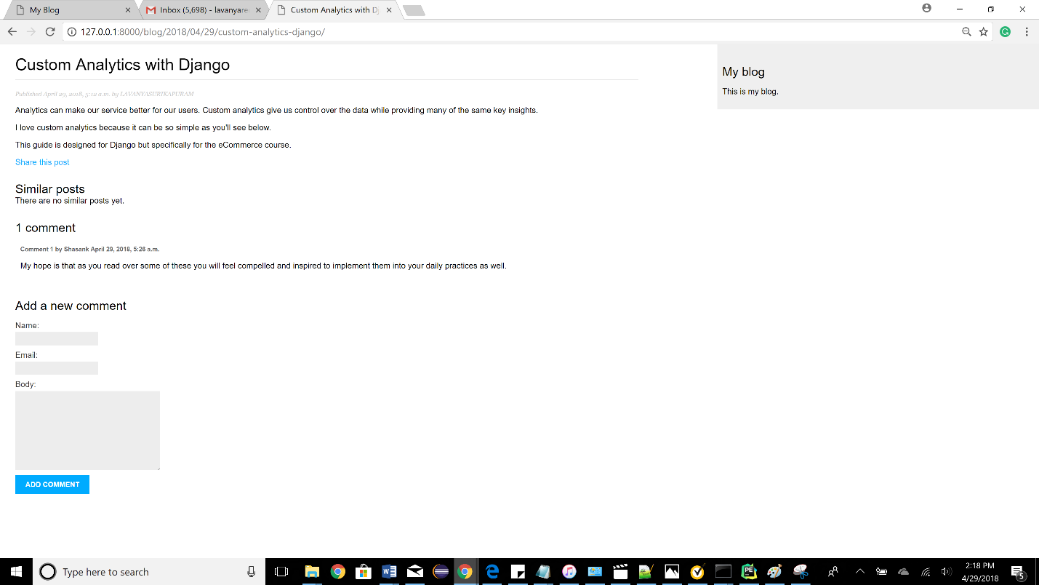

**Clicking the share this post button:**

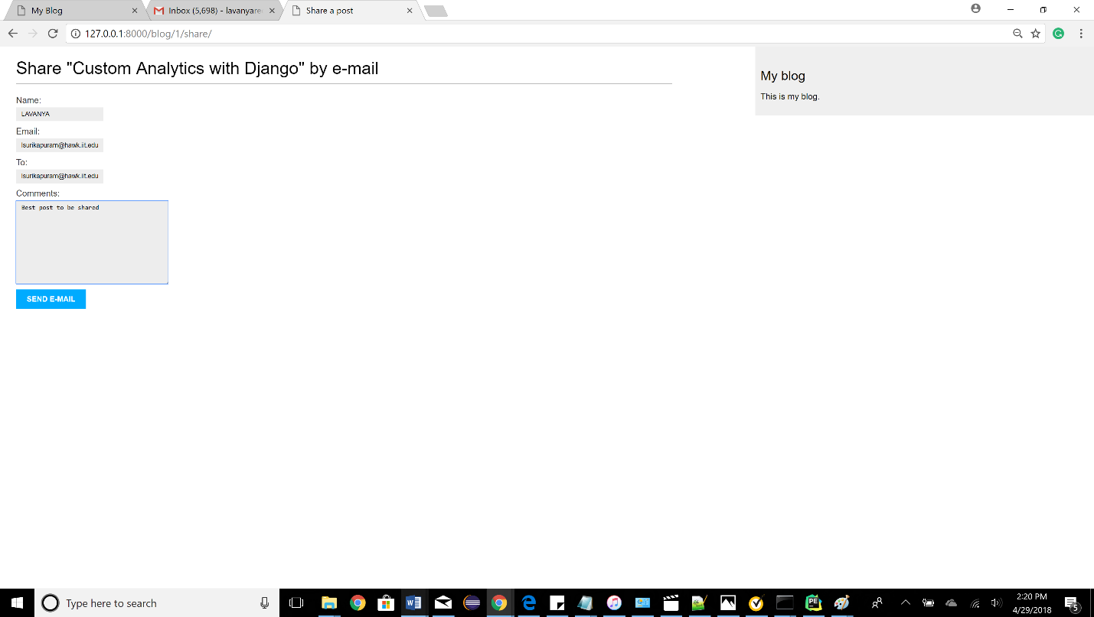

**Email success notification:**

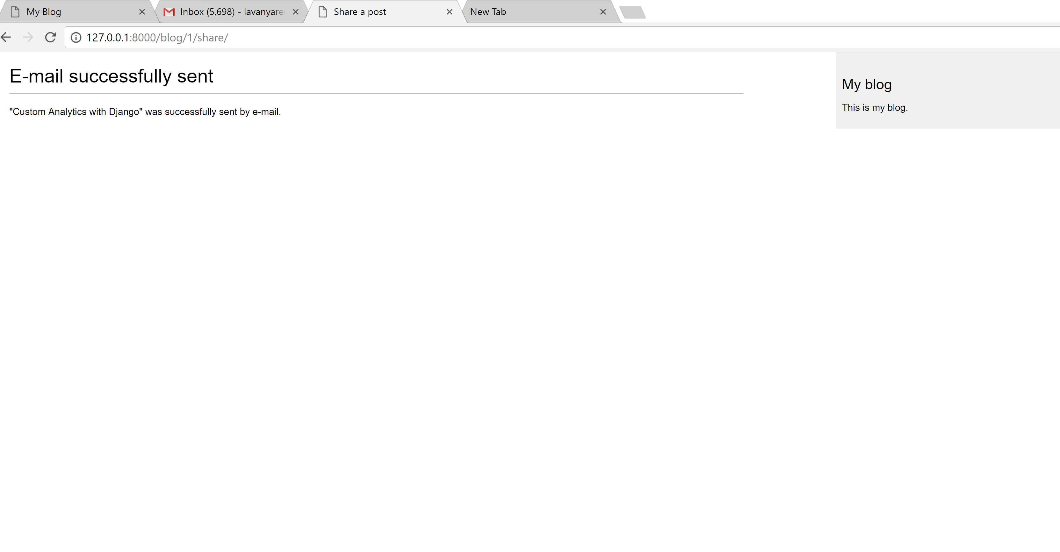

**The email was originally received:**

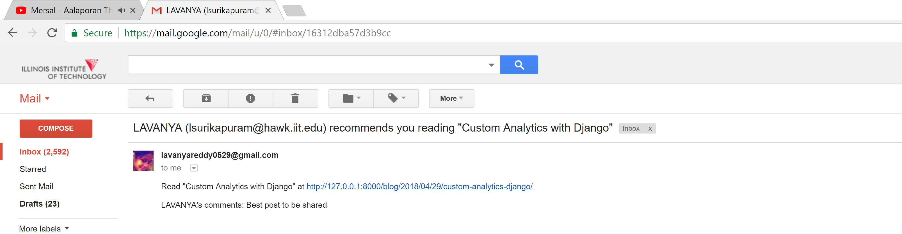

**Adding comments to post:**

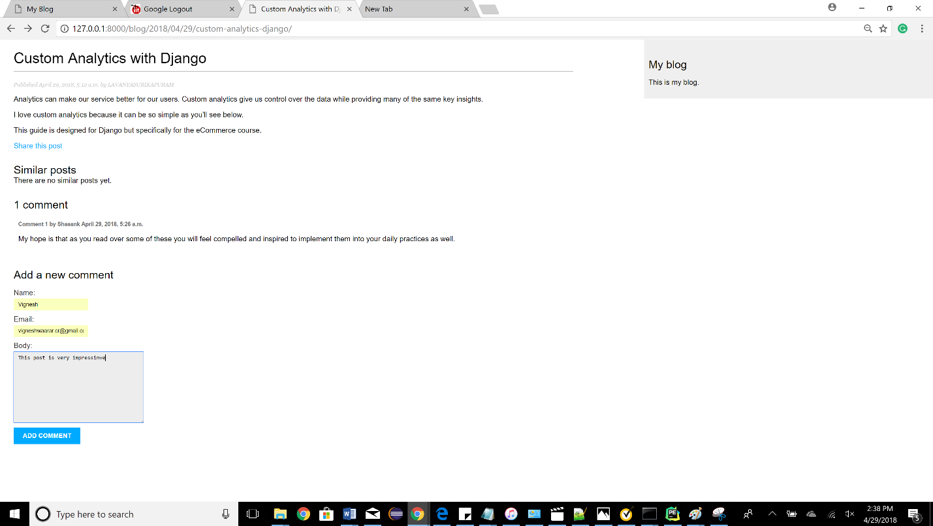

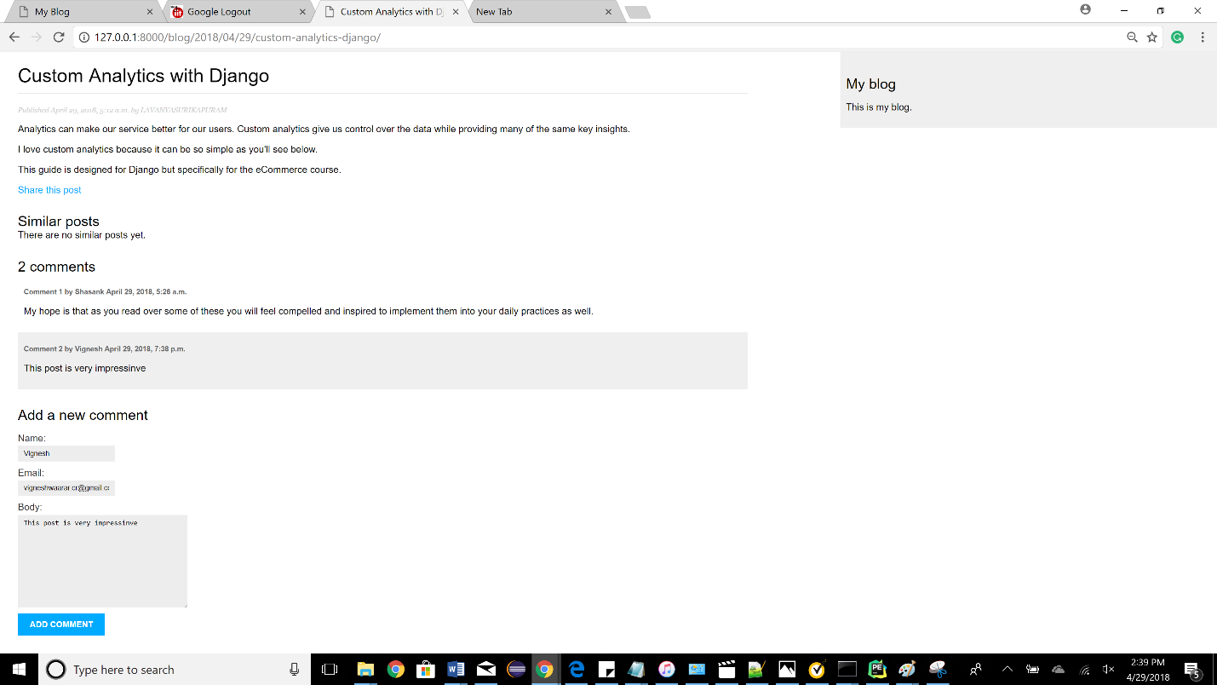

**Admin page:**

**To be accessed with** <http://127.0.0.1:8000/admin>

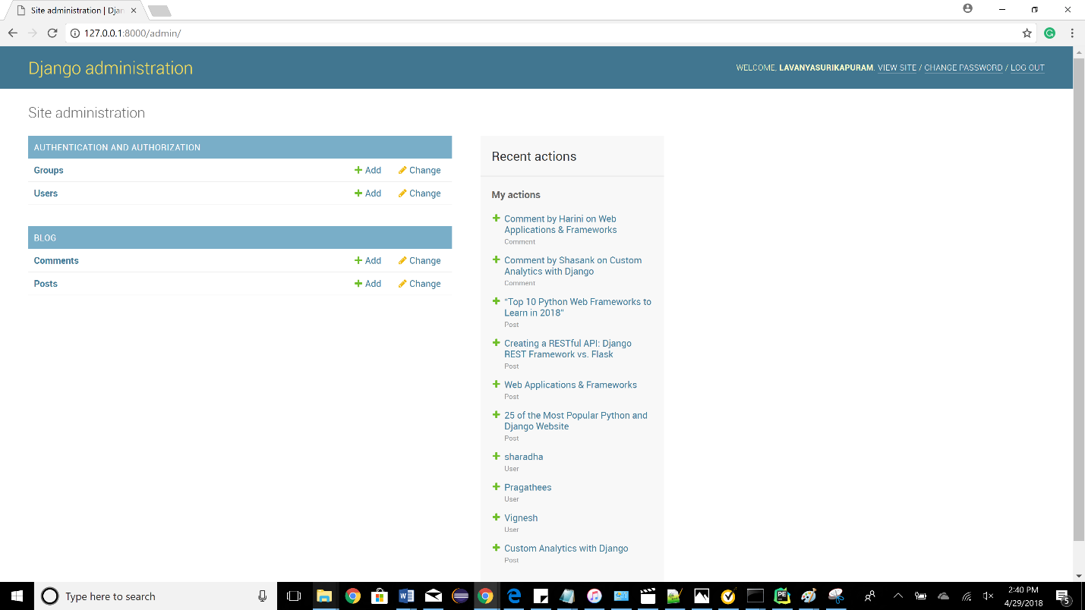

**We can add a new post by clicking on the add button visible on the same line as posts.**

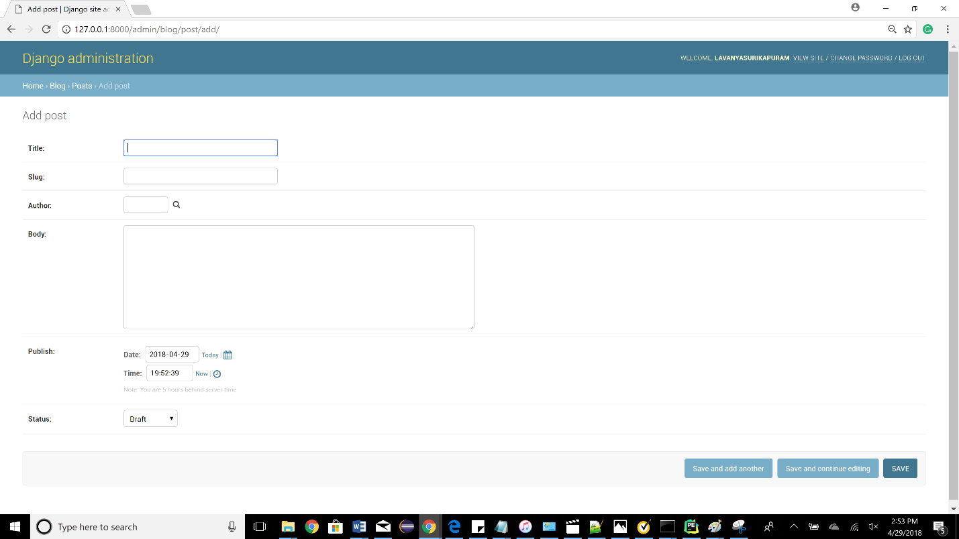

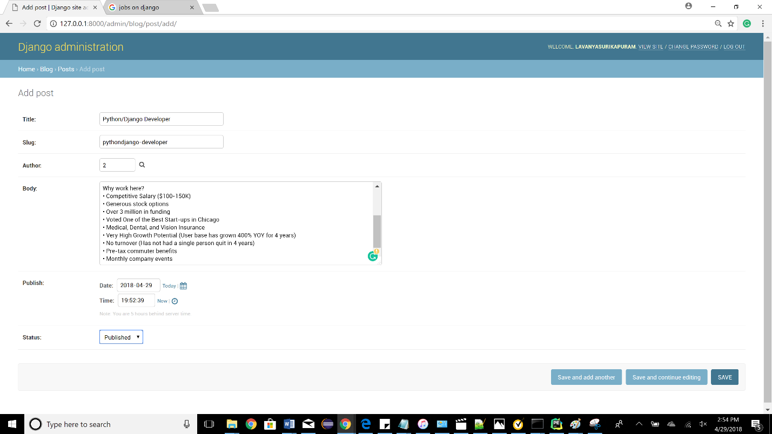

**All the posts will be displayed in**

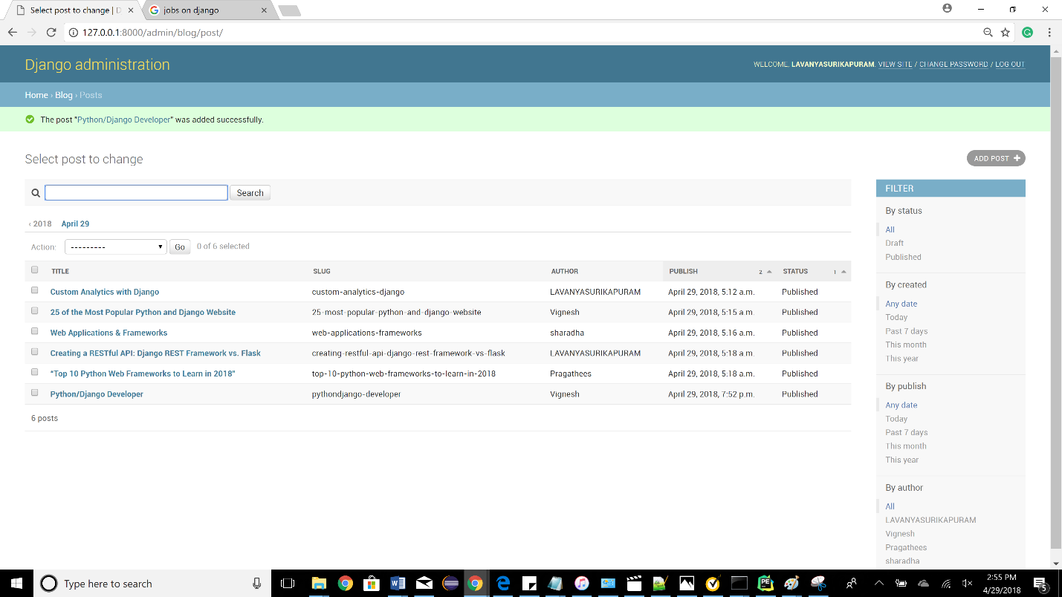

**This added post will get reflected in main blog page:**

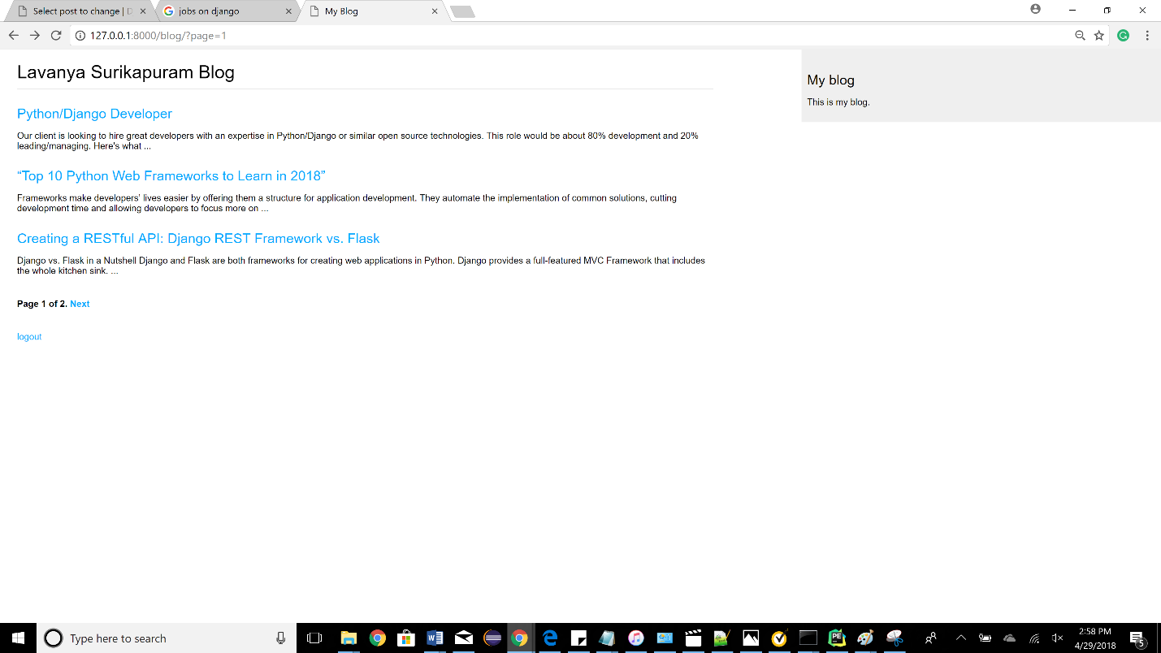

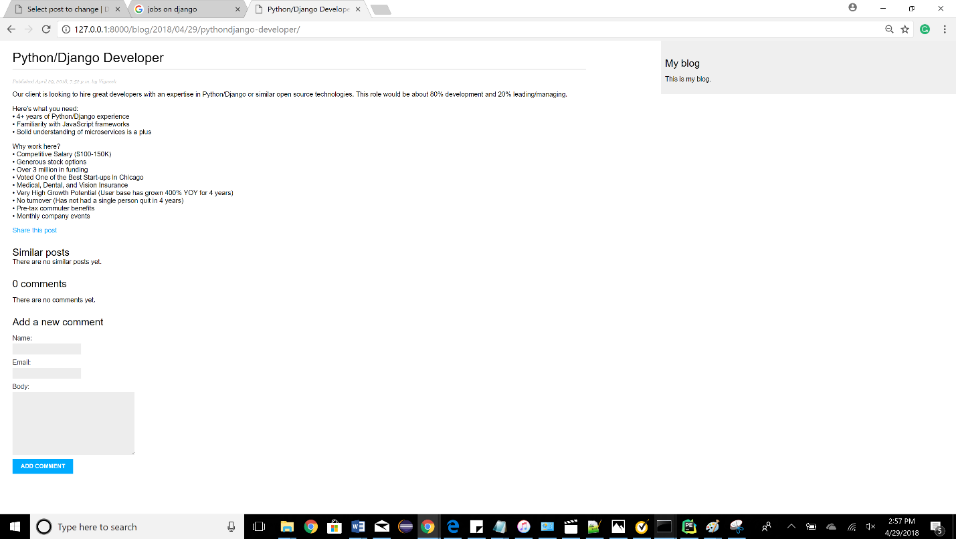

**Date and author name**



**Comments can be added to a specific post from the admin page:**

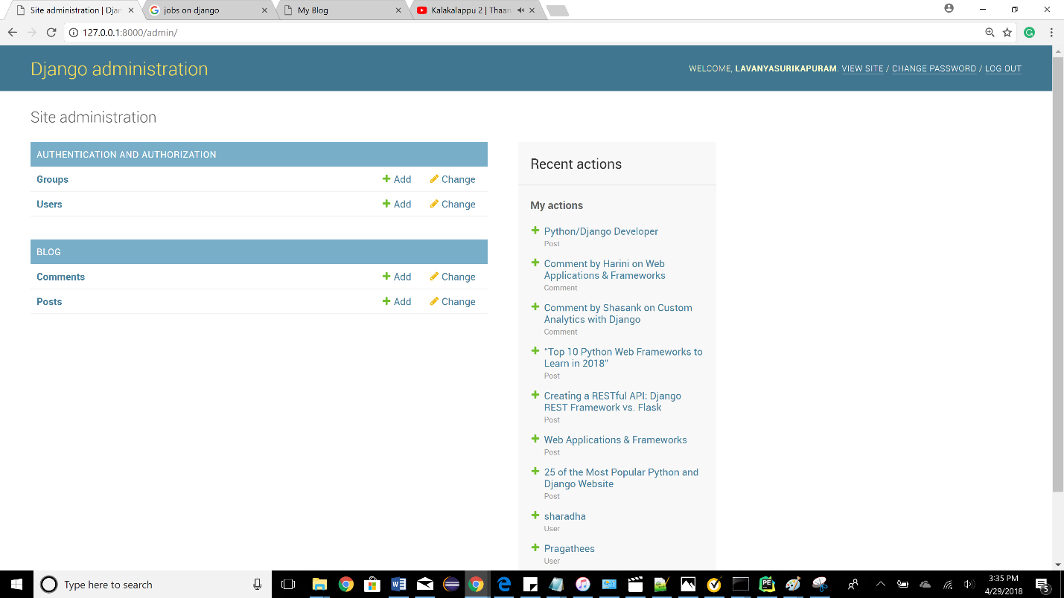

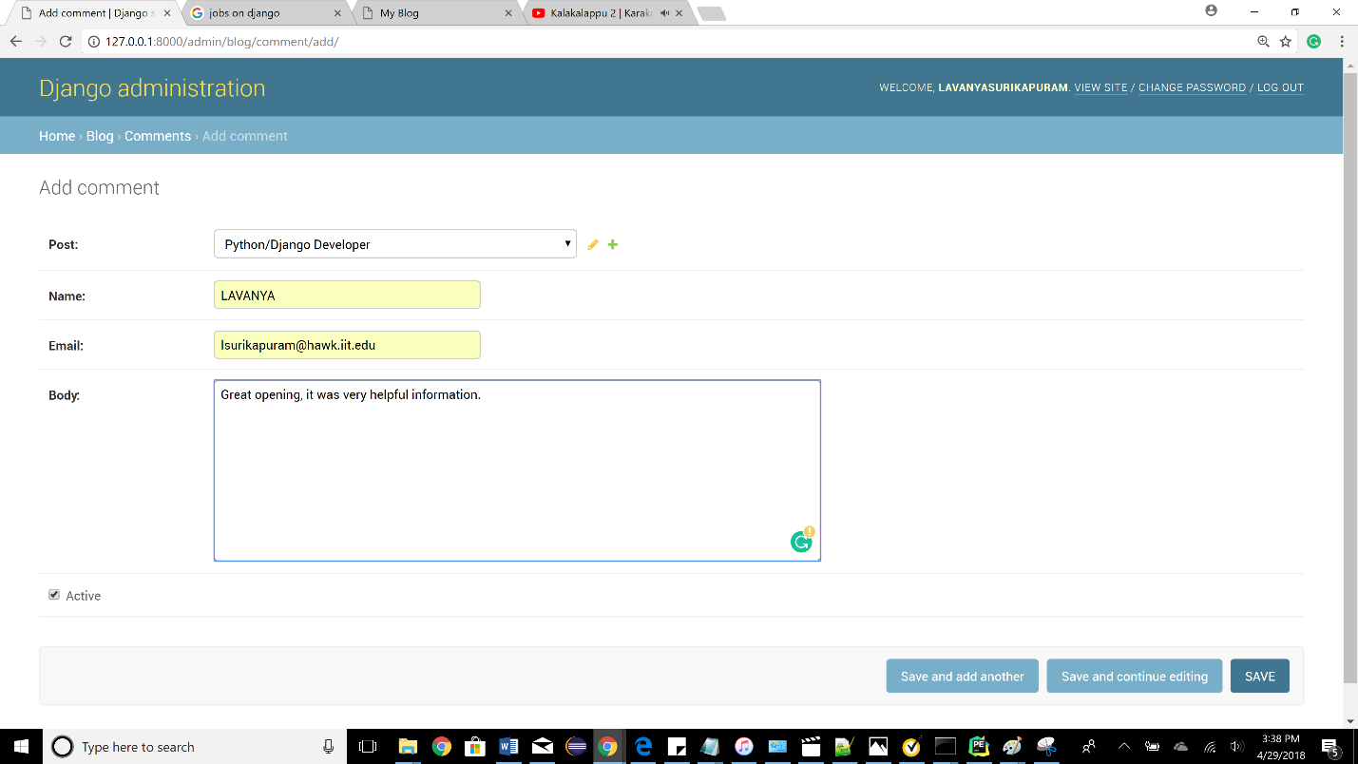

**The added comment will be reflected in the post page of the blog along with the details of who added and when it was added.**

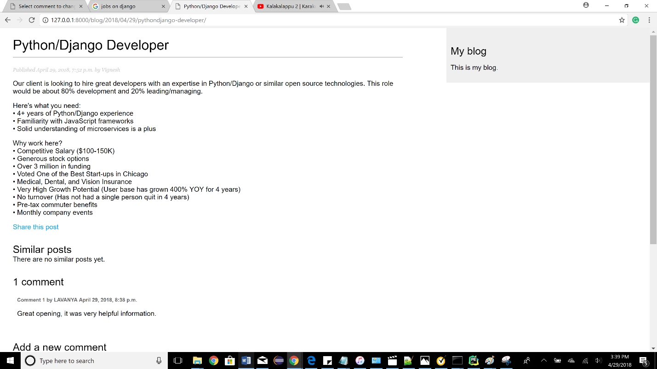

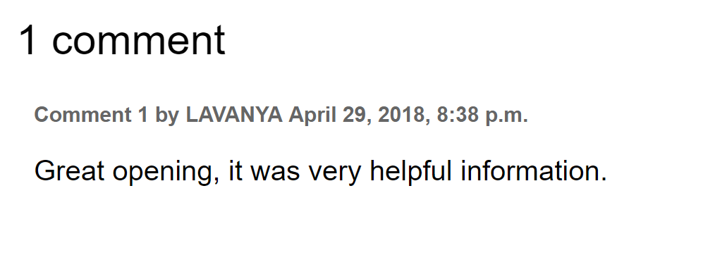

**Logout(There is a logout button at the end of every page):**

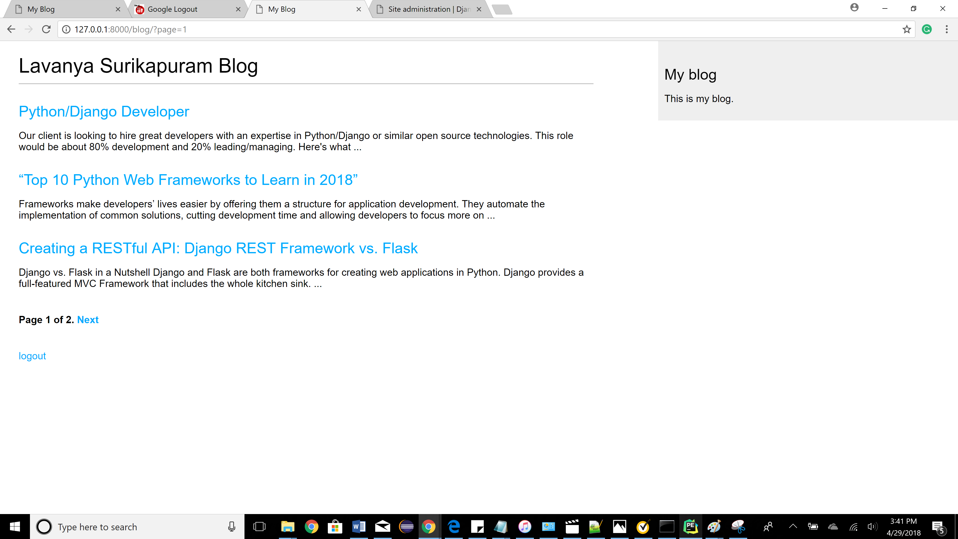

**Logout page:**

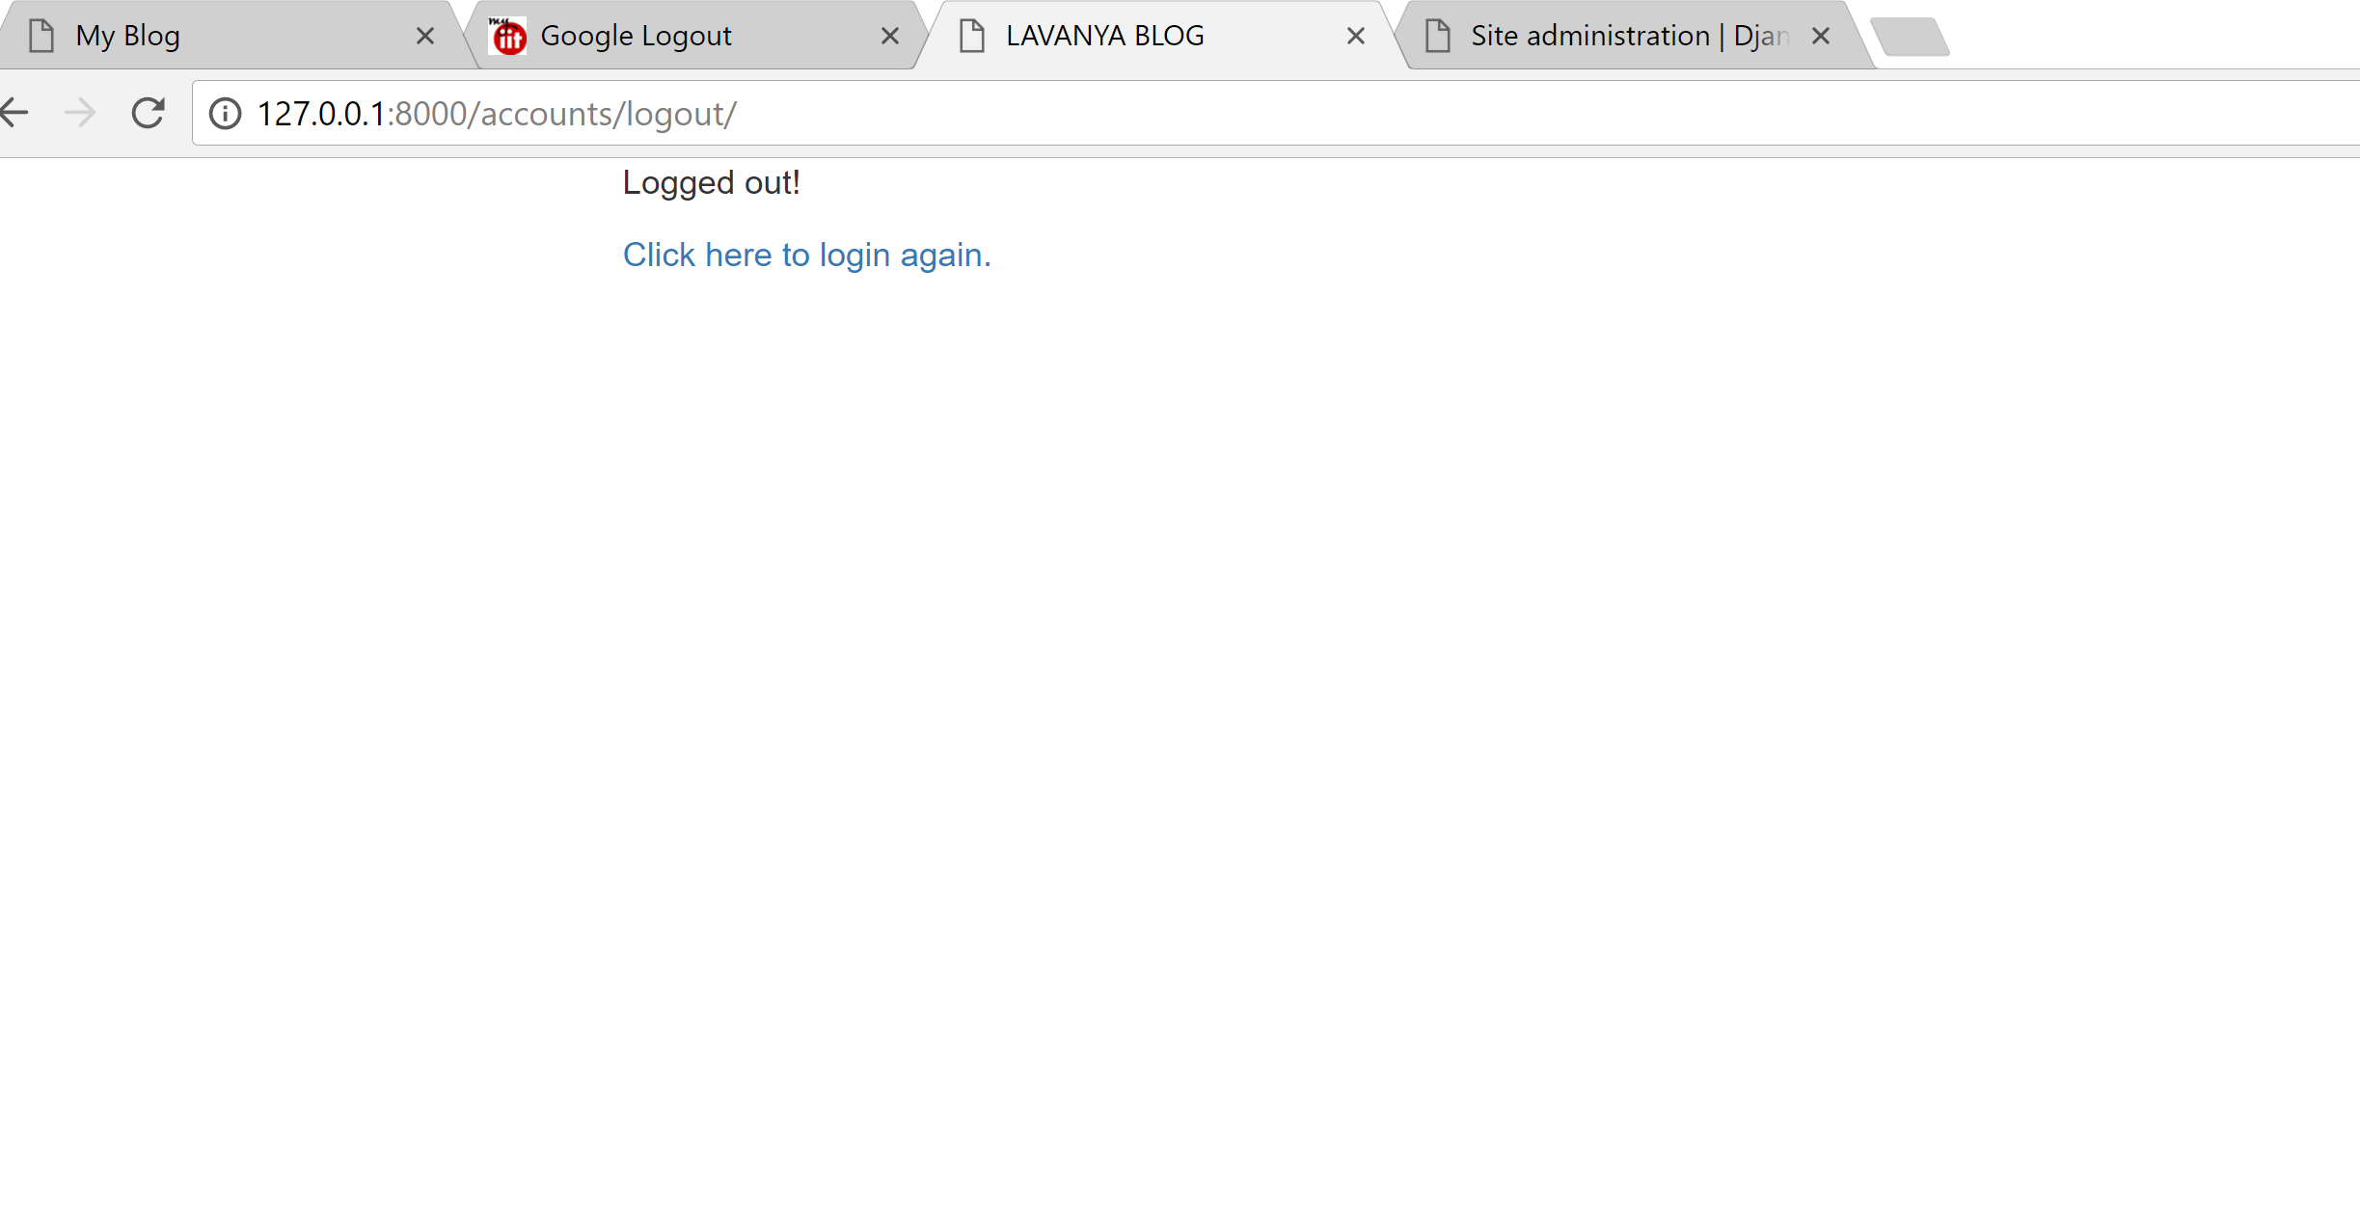

**This app qualified all the grad requirements as well.**