Game Design Document

Fill up the following document

1. Write the title of your project.

Race against Bus

1. What is the goal of the game?

To reach the camp by overcoming the obstacles on the road

1. Write a brief story of your game.

A boy/ girl who has got a chance to visit a camp with his/her classmates, but while in the bus there are some people who hated the boy/girl and wanted to create troubles for the boy/girl so that he/ she gets suspended and loses the chance of going to the camp.

1. Which are the playing characters of this game?

* Playing characters are the ones who respond to the user based on the input from the user.
* Cars, monkeys, dinos, wizards, etc., are the playing characters in the game.

|  |  |  |
| --- | --- | --- |
| Number | Character Name | What can this character do? |
| 1 | Boy | Clear the obstacles |
| 2 |  |  |
| 3 |  |  |
| 4 |  |  |
| 5 |  |  |
| 6 |  |  |
| 7 |  |  |
| 8 |  |  |

1. Which are the Non-Playing Characters of this game?

* Non-Playing characters are the ones that don't have an action or behavior when the user interacts with the game.
* Hurdles, stones, bananas, coins, etc., are non-playing characters in the game.

|  |  |  |
| --- | --- | --- |
| Number | Character Name | What can this character do? |
| 1 | Bus | Move |
| 2 | troublemakers | Will throw garbage so the boy is not able to catch the bus |
| 3 | Obstacles |  |
| 4 |  |  |
| 5 |  |  |
| 6 |  |  |
| 7 |  |  |
| 8 |  |  |

Draw your imagination of this game. What does this game look like?

* Draw the game either on your computer or on paper.
* Add images of the game scenes to show each of the playing and non-playing characters at least once.

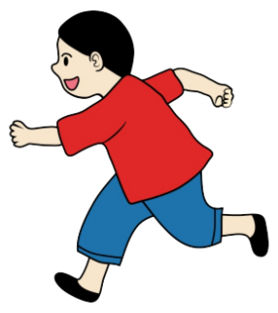 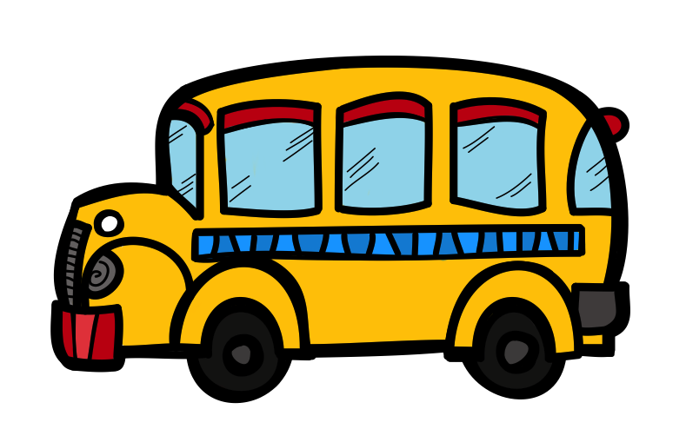

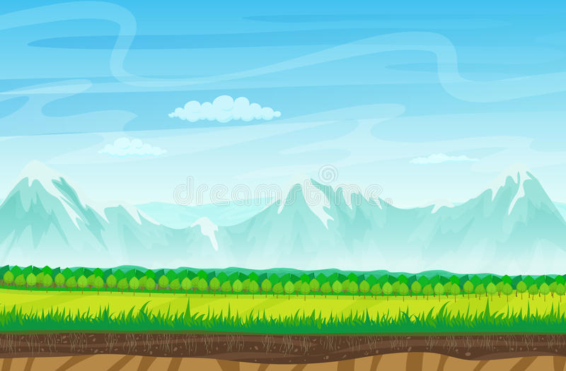

How do you plan to make your game engaging?

By giving players to control the boy through arrow keys and spacebar to jump. And jumping through obstacles and winning the race makes it interesting.