Healthcare Accessibility Analysis in Mampong Municipality, Ghana

Lawrence Kofi Amoako December 2025

Abstract
Access to healthcare is a fundamental component of human well-being and sustainable development. This study utilized Geographic Information Systems (GIS) to assess healthcare accessibility in Mampong Municipality, Ashanti Region, Ghana. Spatial datasets, including health facilities, communities, and administrative boundaries, were analyzed using buffer and distance techniques to classify communities based on accessibility levels. The results revealed significant spatial disparities, with underserved areas identified as priorities for targeted interventions to promote equity.

Introduction
Equitable access to healthcare services remains a persistent challenge in many developing regions. Geographic barriers, such as long distances, inadequate transportation infrastructure, and uneven facility distribution, often hinder timely medical care. GIS provides a powerful framework for evaluating spatial accessibility and supporting evidence-based planning. This study employs GIS techniques to investigate healthcare accessibility in Mampong Municipality, highlighting gaps and recommending improvements.

Study Area
Mampong Municipality, located in Ghana's Ashanti Region, comprises a blend of urban and rural communities. As an administrative and commercial center, it hosts a variety of healthcare facilities, including hospitals, clinics, and Community-based Health Planning and Services (CHPS) compounds. However, accessibility varies widely, with rural areas particularly affected by geographic and infrastructural constraints.

Data Sources
Administrative boundaries were obtained from the GADM database. Health facility and road network data were sourced from OpenStreetMap, while community settlement data were compiled and validated. All datasets were processed in QGIS and projected to a common coordinate reference system (EPSG:32630) for consistency.

Methodology
The analysis employed buffer and distance-to-nearest-facility techniques to evaluate spatial accessibility.
Circular buffers of 1 km and 3 km were created around health facilities using the QGIS Buffer tool, defining:
• ≤1 km: Good Access (easily walkable)

• 1–3 km: Moderate Access • >3 km: Poor Access
Straight-line (Euclidean) distances from community centroids to the nearest facility were then calculated using the "Distance to Nearest Hub (Points)" tool in QGIS Processing Toolbox. Distances were converted to kilometers and reclassified into the same three categories.
A new field was added to the community layer via the Field Calculator to store the accessibility level, facilitating thematic mapping and comparison between Phase 1 (4 Captured facilities only) and Phase 2 (enriched dataset).

Results
The Phase 1 analysis, based on public facilities from OpenStreetMap, indicated substantial spatial disparities. Most communities exhibited poor access, with only urban centers showing good or moderate levels.
In Phase 2, I performed primary data enrichment by manually digitizing an additional 8 facilities, bringing the total to 12 mapped health facilities. These included private clinics (e.g., Quality Health Care), mission hospitals, and rural CHPS compounds (e.g., Krobo).

Map Interpretation
The thematic maps employ a graduated color scheme: green for good access, yellow for moderate, and red for poor. Figure 1 (Phase 1) illustrates widespread poor access, with clusters of moderate and good access limited to central areas. Figure 2 (Phase 2) demonstrates reduced poor-access zones due to additional facilities, though gaps persist in peripheral regions.

Figure 1. Phase 1 Accessibility Map showing poor access in red
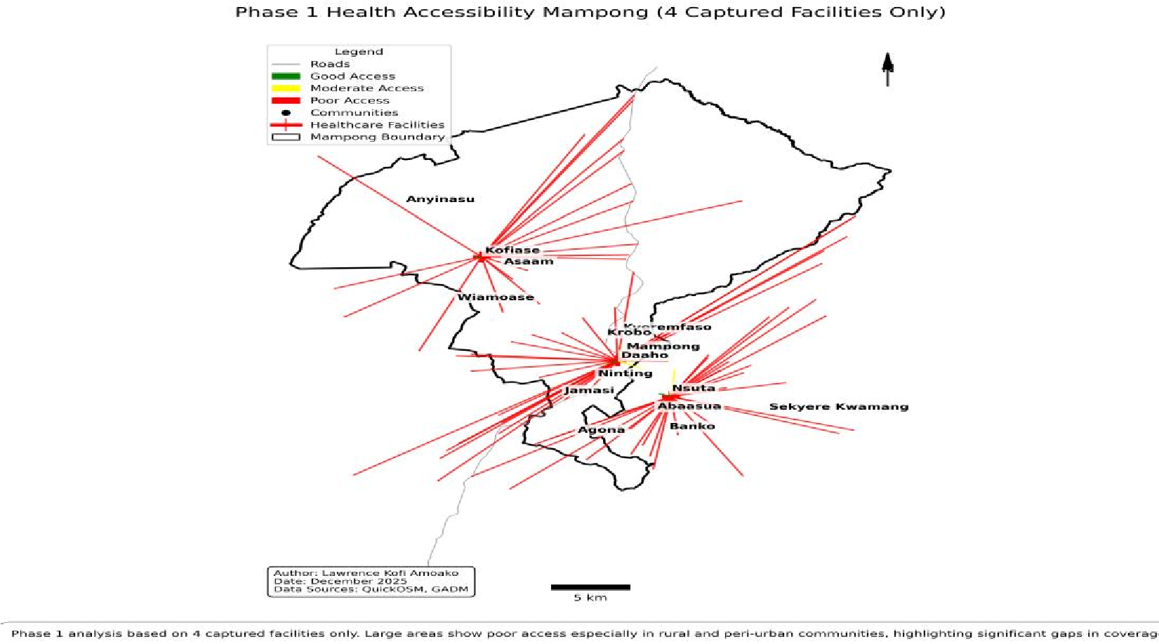

Figure 2. Phase2 Healthcare Accessibility Map
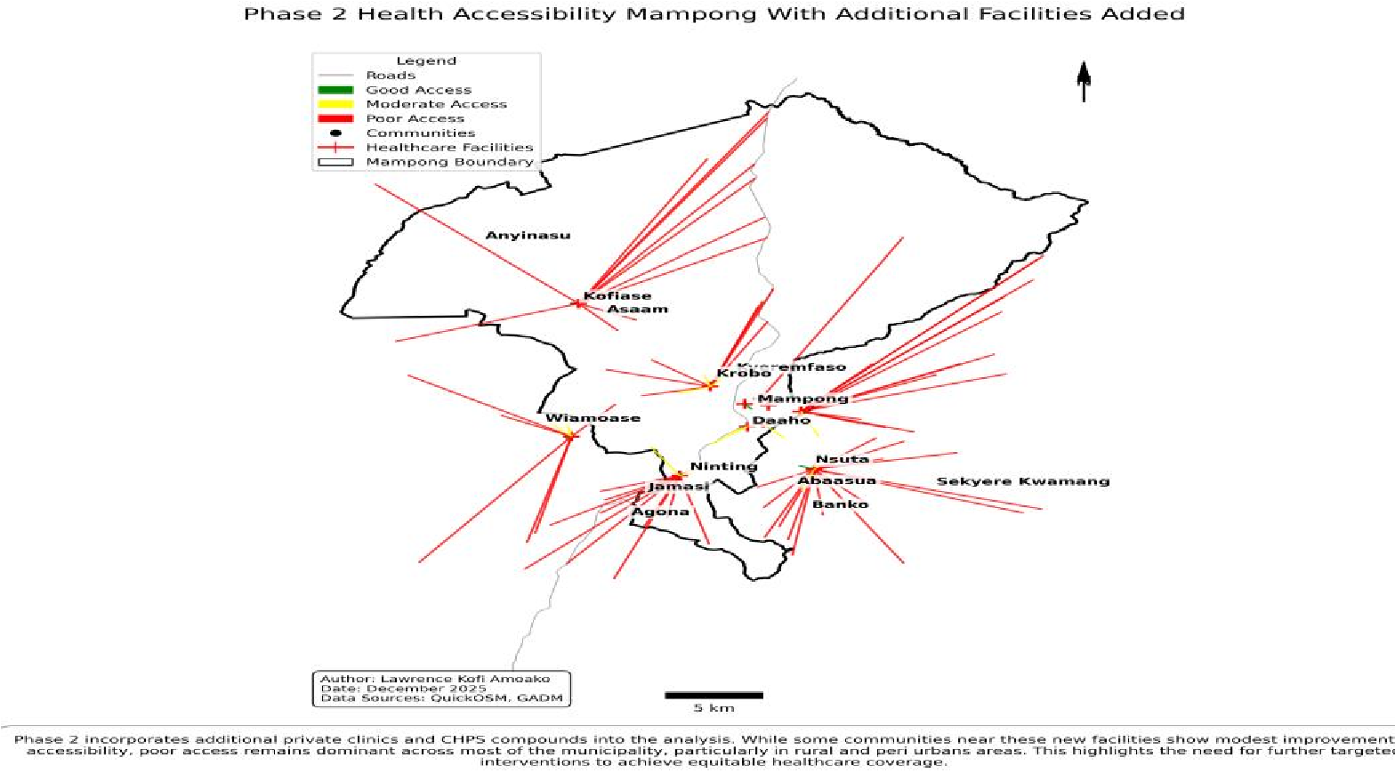

Visual Comparison of Initial and Refined Analyses
Figure 3 presents a side-by-side comparison of Phase 1 and Phase 2, highlighting enhancements from data enrichment. The inclusion of private and CHPS facilities narrows accessibility gaps, but rural disparities endure.

Figure 3. presents a side-by-side comparison of Phase 1 and Phase 2
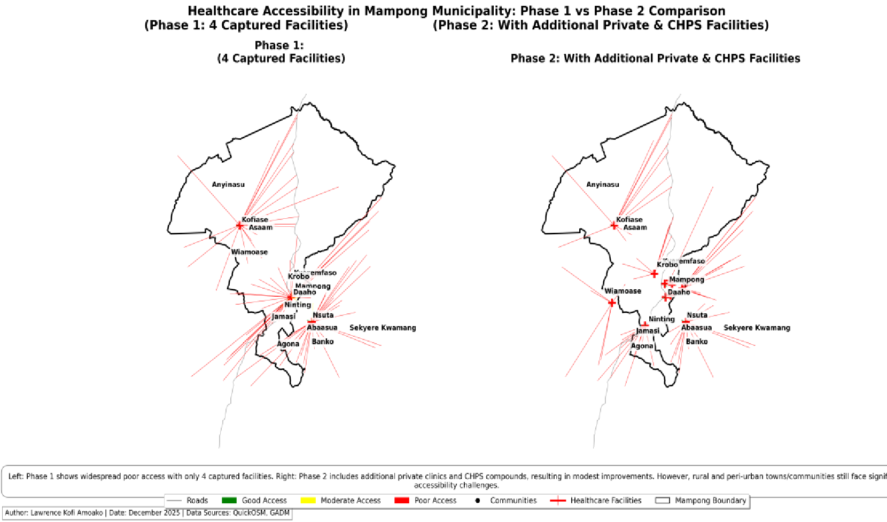

Figure 4. Phase 2 Healthcare Accessibility Analysis Workflow
The workflow for the refined (Phase 2) analysis is depicted below, illustrating the sequential steps from data collection and merging to re-analysis, visualization, and impact comparison with Phase 1.
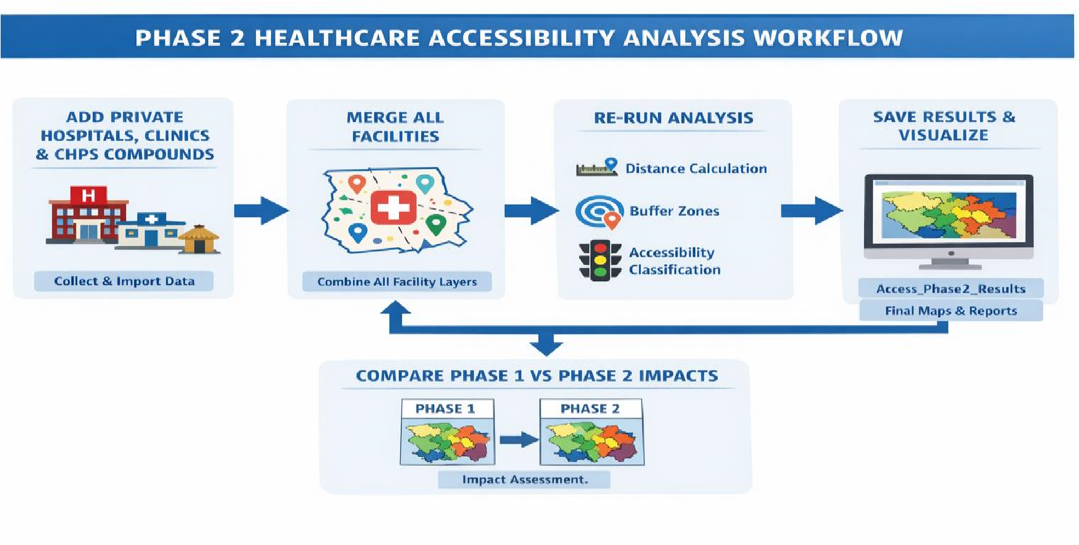

Identification of Underserved Communities
Underserved communities were identified as those exceeding 3 km from the nearest facility, posing risks of delayed care and poorer health outcomes. In Phase 1, a majority fell into this category; Phase 2 reduced the number, but rural communities like Ninting and Kofiase remained underserved.

Policy Implications
The findings emphasize the importance of data-driven healthcare planning. Recommendations include prioritizing new facility construction, enhancing road infrastructure, and deploying mobile clinics in underserved areas to foster equitable access.

Data Refinement and Enhanced Analysis
Initial evaluation revealed omissions of select private hospitals and clinics from the dataset. Recognizing the substantial contribution of private providers to healthcare delivery, this limitation posed risks to analytical accuracy.
The second phase of analysis followed the same methodological framework as the initial assessment, with the key difference being the inclusion of private hospitals, private clinics, and CHPS compounds to enhance data completeness and analytical accuracy.
This subsequent phase yielded a more exhaustive depiction of service distribution. The revised analysis afforded greater precision in community classification, thereby facilitating robust planning and resource allocation.
The initial healthcare facility dataset, obtained via QuickOSM queries in QGIS (using tags such as amenity=hospital, amenity=clinic, and healthcare=*), primarily captured public facilities within Mampong Municipality. However, these queries yielded limited or no results for additional private hospitals, private clinics, and Community-based Health Planning and Services (CHPS) compounds. This reflects known limitations in OpenStreetMap coverage for private and community-level health facilities in rural and peri-urban areas of Ghana.
To overcome this data gap and achieve a more comprehensive representation of healthcare services, Phase 2 involved manual digitization of the missing facilities. Private hospitals, private clinics, and CHPS compounds were identified from secondary sources, including municipal health directories and local knowledge. Facility locations were precisely digitized in QGIS using Google Maps as a basemap layer, which provided detailed road networks, place labels, and health facility icons to guide accurate point placement.
The manually added facilities included:
- Quality Health Care Clinic (Private)
- Calvary Hospital (Private/Mission)
- Philipa Maternity Home (Private)
- Boanim Health Center (Public)
- Mampong Maternity Hospital (Public)
- Ninting Traditional Stroke Center (Traditional)
- Christaa Mission Clinic (Private/Mission)
- Selected CHPS compounds in rural communities (Krobo)
This manual enrichment process significantly improved dataset completeness, enabling a more realistic assessment of healthcare accessibility and highlighting the vital role of private providers in urban areas and CHPS compounds in rural communities.

Conclusion and Recommendations
This study highlights the power of Geographic Information Systems (GIS) in uncovering spatial inequalities in healthcare accessibility within Mampong Municipality. The Phase 1 analysis, based solely on Health facilities captured from OpenStreetMap, revealed widespread poor access, with the majority of communities located more than 3 km from the nearest facility. Rural and peri-urban areas were particularly disadvantaged, illustrating significant gaps in coverage under the 4 Captured Health Facilities only scenario.
The Phase 2 enrichment, through manual digitization of private clinics, mission hospitals, and CHPS compounds, demonstrated modest but meaningful improvements. Some communities shifted from poor to moderate access, particularly those near newly added facilities, underscoring the critical role of private and community-based providers in bridging gaps. However, poor accessibility persisted in many rural areas, indicating that current facility distribution remains insufficient for equitable coverage across the municipality.
These findings emphasize that while private sector contributions enhance urban and semi-urban access, targeted interventions are still needed in peripheral zones to achieve universal healthcare goals aligned with Sustainable Development Goal 3 (Good Health and Well-being).

Recommendations
- Prioritize Facility Expansion in Underserved Areas: The Municipal Assembly and Ghana Health Service should establish new CHPS compounds or upgrade existing health posts in persistently underserved communities such as Ninting, Kofiase, and other rural settlements identified in Phase 2.
- Integrate Private and Mission Facilities into Planning: Formal partnerships with private and mission providers (e.g., Calvary Hospital, Christaa Mission Clinic) should be strengthened to leverage their role in improving accessibility.
- Improve Supporting Infrastructure: Investments in road networks and transportation are essential to reduce effective travel distances, especially in areas where physical distance exceeds 3 km.
- Institutionalize GIS in Health Planning: The Municipal Assembly should adopt GIS tools for ongoing monitoring of healthcare accessibility, facility siting, and resource allocation to support evidence-based decision-making.
- Conduct Regular Data Updates: Given the limitations of OpenStreetMap in capturing private and community-level facilities, periodic ground-truthing and digitization efforts should be undertaken to maintain accurate datasets.
By implementing these recommendations, Mampong Municipality can move toward more equitable healthcare delivery, reducing disparities and improving health outcomes for all residents.

References
Ghana Health Service. (n.d.). Community-based Health Planning and Services (CHPS) Policy. Ministry of Health, Ghana.
Global Database on Administrative Areas (GADM). (2023). GADM version 4.1.
https://gadm.org
OpenStreetMap contributors. (2025). OpenStreetMap data extracts for Ghana. https://www.openstreetmap.org
QGIS Development Team. (2025). QGIS Geographic Information System. Open Source Geospatial Foundation. https://qgis.org
United Nations. (2015). Sustainable Development Goals: Goal 3 – Good Health and Well-being. https://sdgs.un.org/goals/goal3

