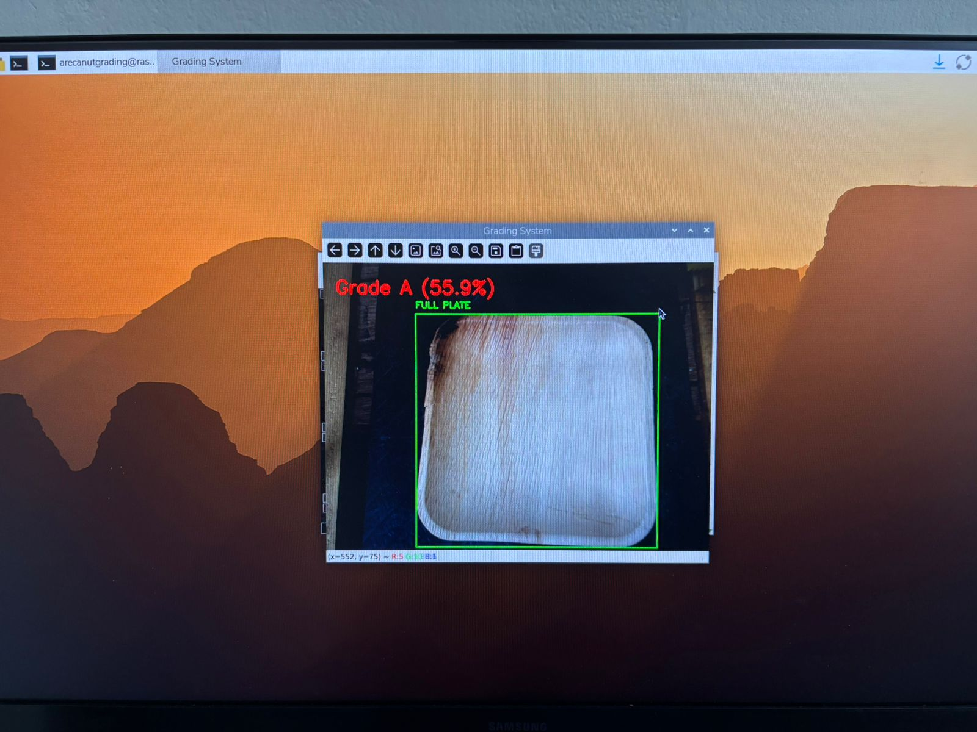
Figure: Classification Result Display of Areca Leaf Plate as Grade A
Title: Classification Result Display of Areca Leaf Plate as Grade A
Description: This figure shows the real-time output of the smart areca leaf plate grading system after image acquisition and processing. The areca leaf plate is classified as Grade A, and the corresponding confidence score is displayed on the system interface.

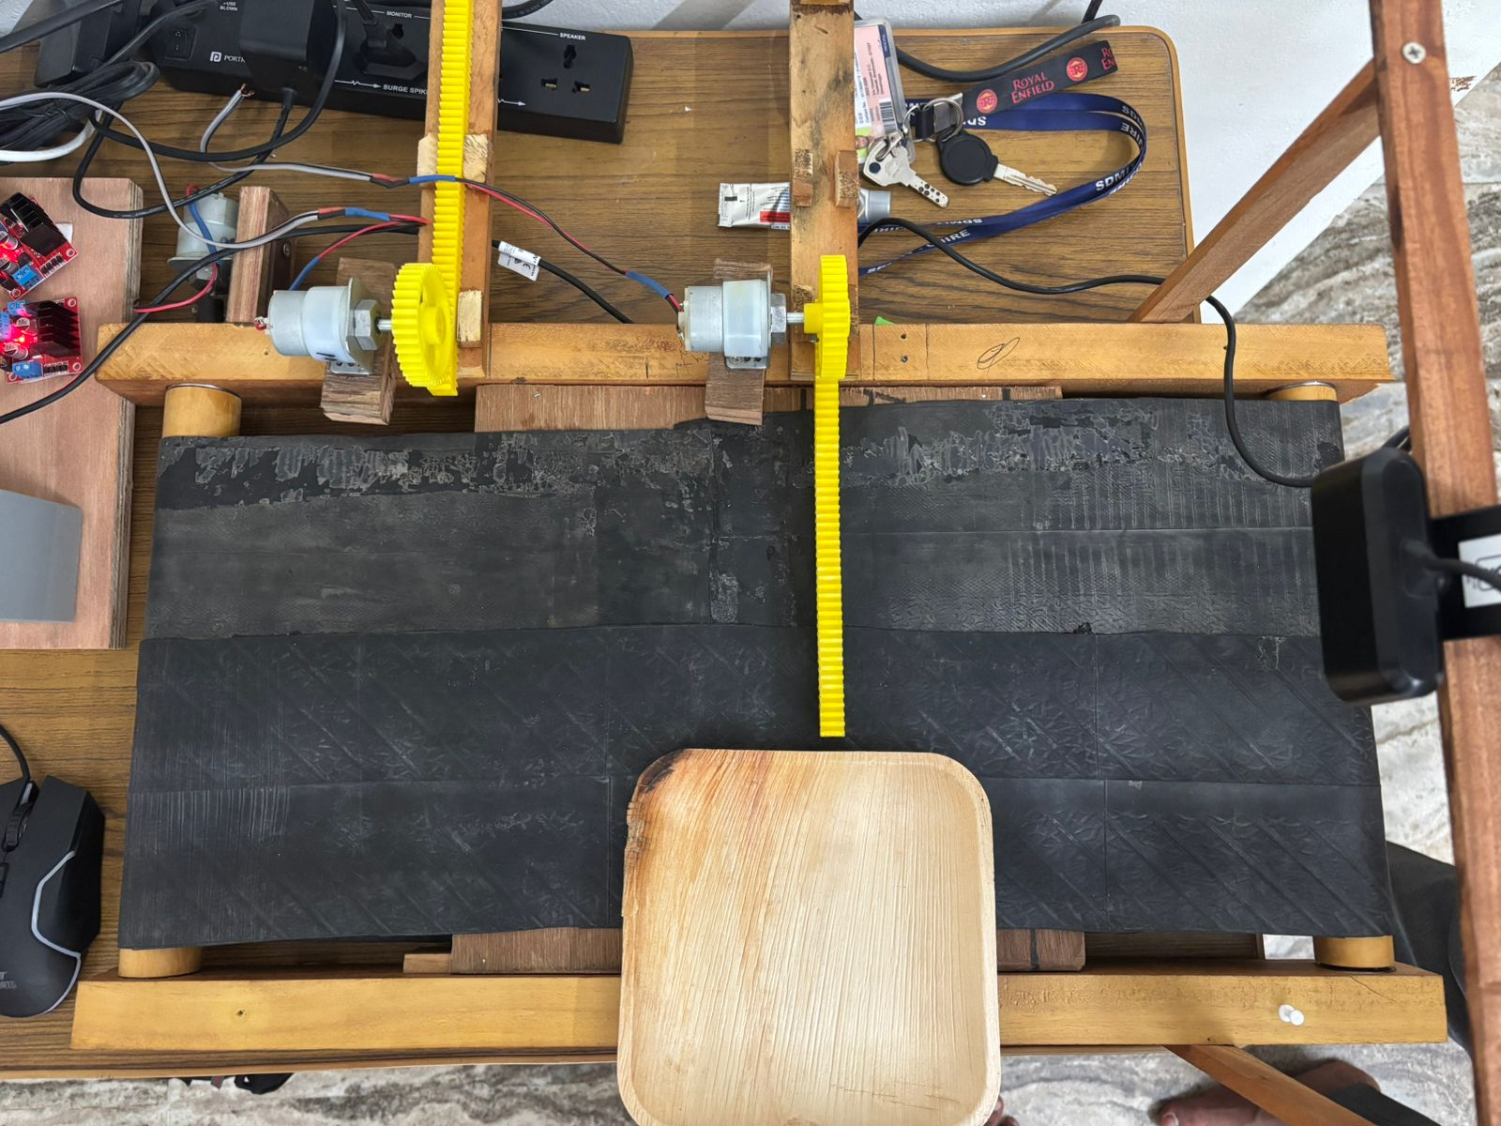
Figure: Conveyor Belt Mechanism with Motor-Driven Sorting of Grade A Areca Leaf Plate
Title: Conveyor Belt Mechanism with Motor-Driven Sorting of Grade A Areca Leaf Plate
Description: This figure illustrates the motor-driven conveyor belt mechanism activated for handling Grade A areca leaf plates. Upon successful classification, the corresponding motor is triggered to guide the plate into the designated collection bin.

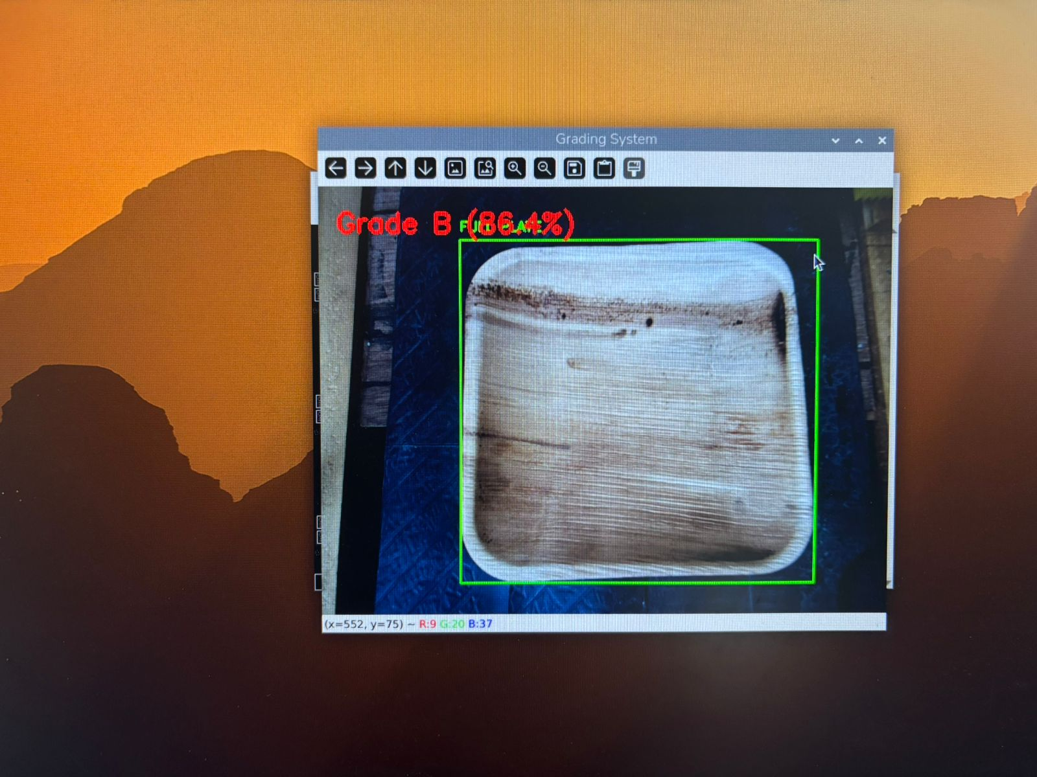
Figure: Classification Result Display of Areca Leaf Plate as Grade B

Title: Classification Result Display of Areca Leaf Plate as Grade B
Description: This figure shows the real-time output of the smart areca leaf plate grading system after image acquisition and processing. The areca leaf plate is classified as Grade B, and the corresponding confidence score is displayed on the system interface.

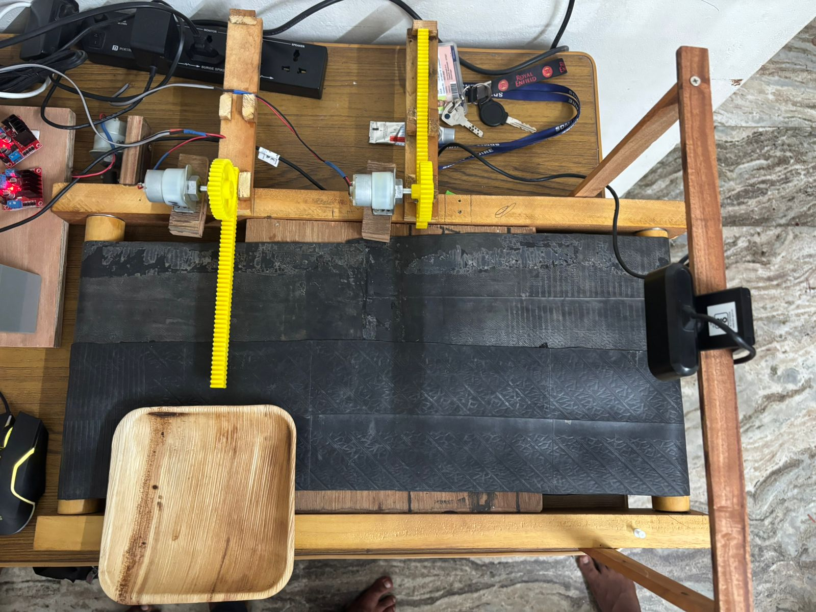
Figure: Conveyor Belt Mechanism with Motor-Driven Sorting of Grade B Areca Leaf Plate

Title: Conveyor Belt Mechanism with Motor-Driven Sorting of Grade B Areca Leaf Plate
Description: This figure illustrates the motor-driven conveyor belt mechanism activated for handling Grade B areca leaf plates. Upon successful classification, the corresponding motor is triggered to guide the plate into the designated collection bin.

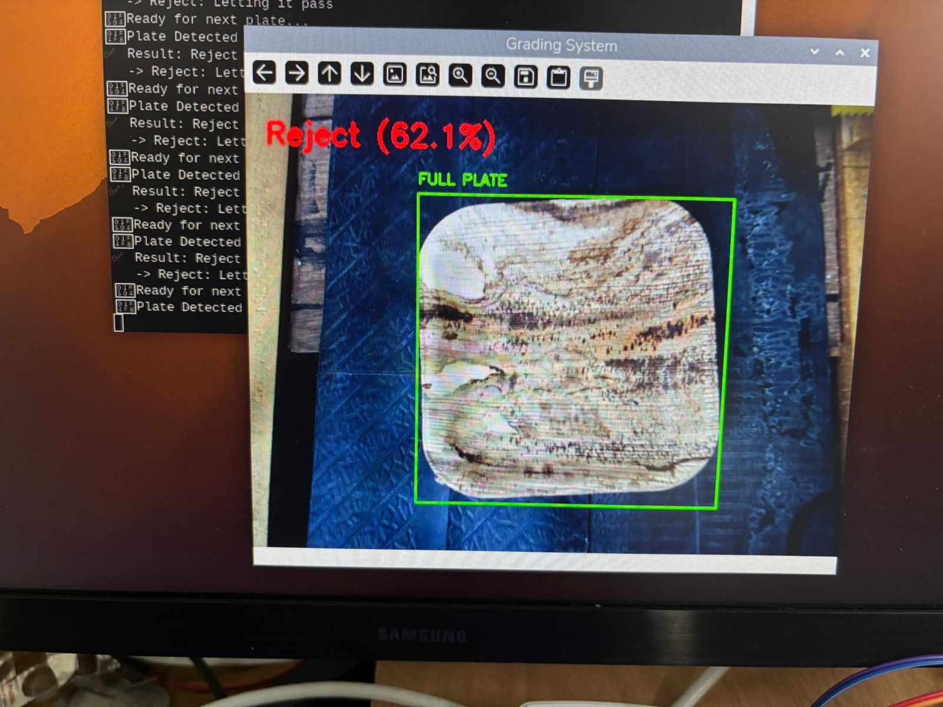
Figure: Classification Result Display of Areca Leaf Plate as Grade Reject
Title: Classification Result Display of Areca Leaf Plate as Grade Reject
Description: This figure shows the real-time output of the smart areca leaf plate grading system after image acquisition and processing. The areca leaf plate is classified as Grade Reject, and the corresponding confidence score is displayed on the system interface.

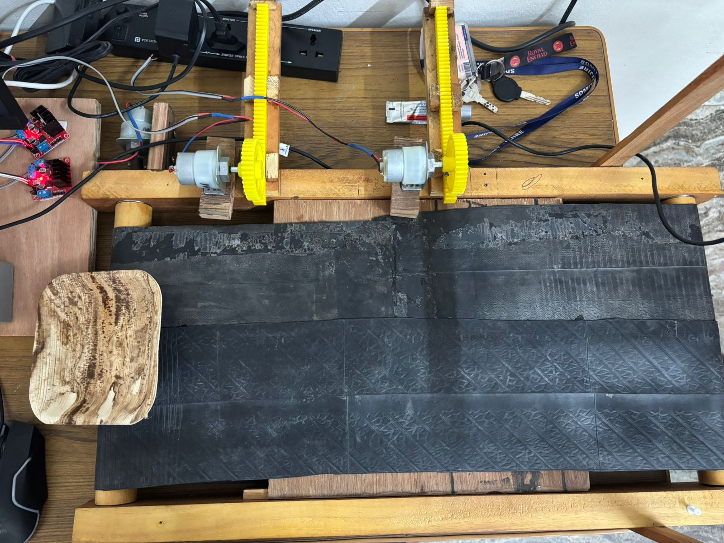
Figure: Conveyor Belt Mechanism for Automatic Rejection of Areca Leaf Plate

Title: Conveyor Belt Mechanism for Automatic Rejection of Areca Leaf Plate
Description: This figure illustrates the conveyor belt mechanism used for handling rejected areca leaf plates in the grading system. When a plate is classified as Reject, no motor-driven diversion is activated, and the plate continues along the default conveyor path and falls into the reject collection bin.

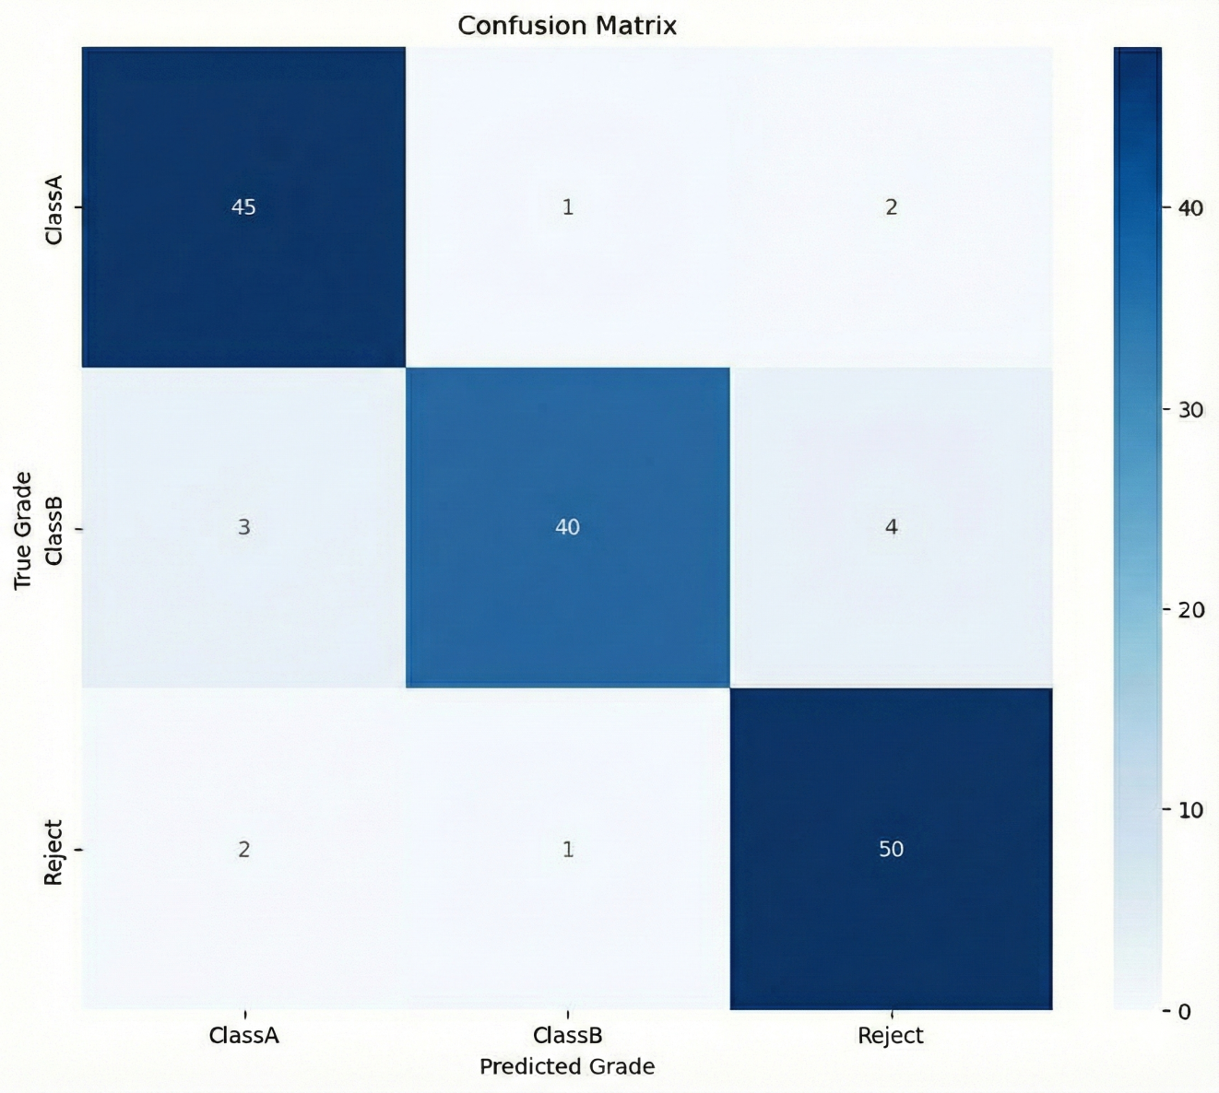
Figure: Confusion Matrix

Title: Confusion Matrix
Description: This figure presents the confusion matrix showing the performance of the proposed areca leaf plate grading model across Class A, Class B, and Reject categories. The diagonal elements indicate correct classifications, while the off-diagonal values represent misclassifications between different grades. The results demonstrate high classification accuracy with most samples correctly identified in their respective classes.

