SYMBIOSIS INSTITUTE OF TECHNOLOGY, PUNE
DevOps | CA-II Task 2
SCREENSHOT EVIDENCE
FA3-CLIP Deepfake Detector: CI/CD, Ansible, Docker, Kubernetes, Prometheus and Grafana
Group Member | PRN
Laxmi Sah | 23070122125
Diksha Jha | 23070122086
Project repository: github.com/LAXMI001-web/btech-project
October 2026

Step 1: GitHub Actions pipeline
Screenshot 1: Successful pipeline run: test, build-and-push and deploy all passed
File name: step1-green-run.png
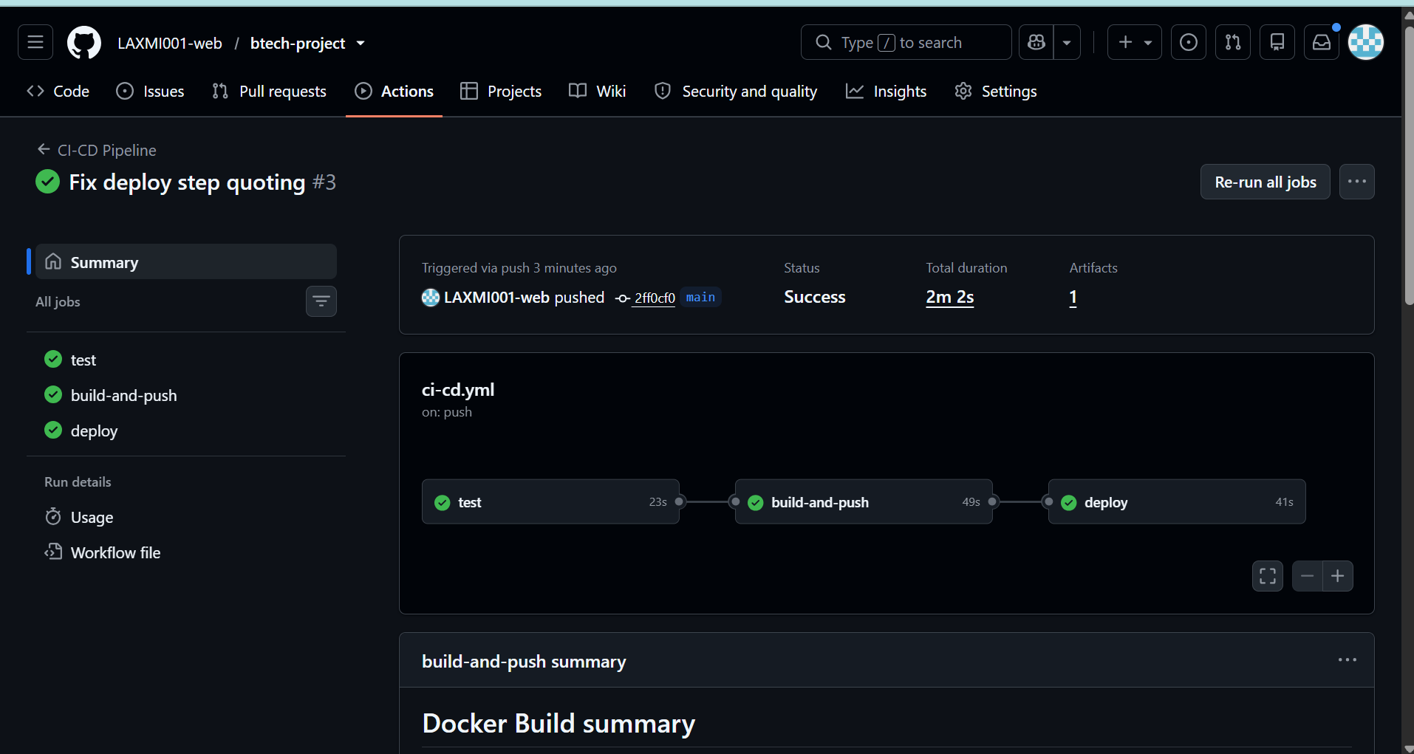
Screenshot 2: Run history: two failed runs fixed, then a green run
File name: step1-actions-list.png
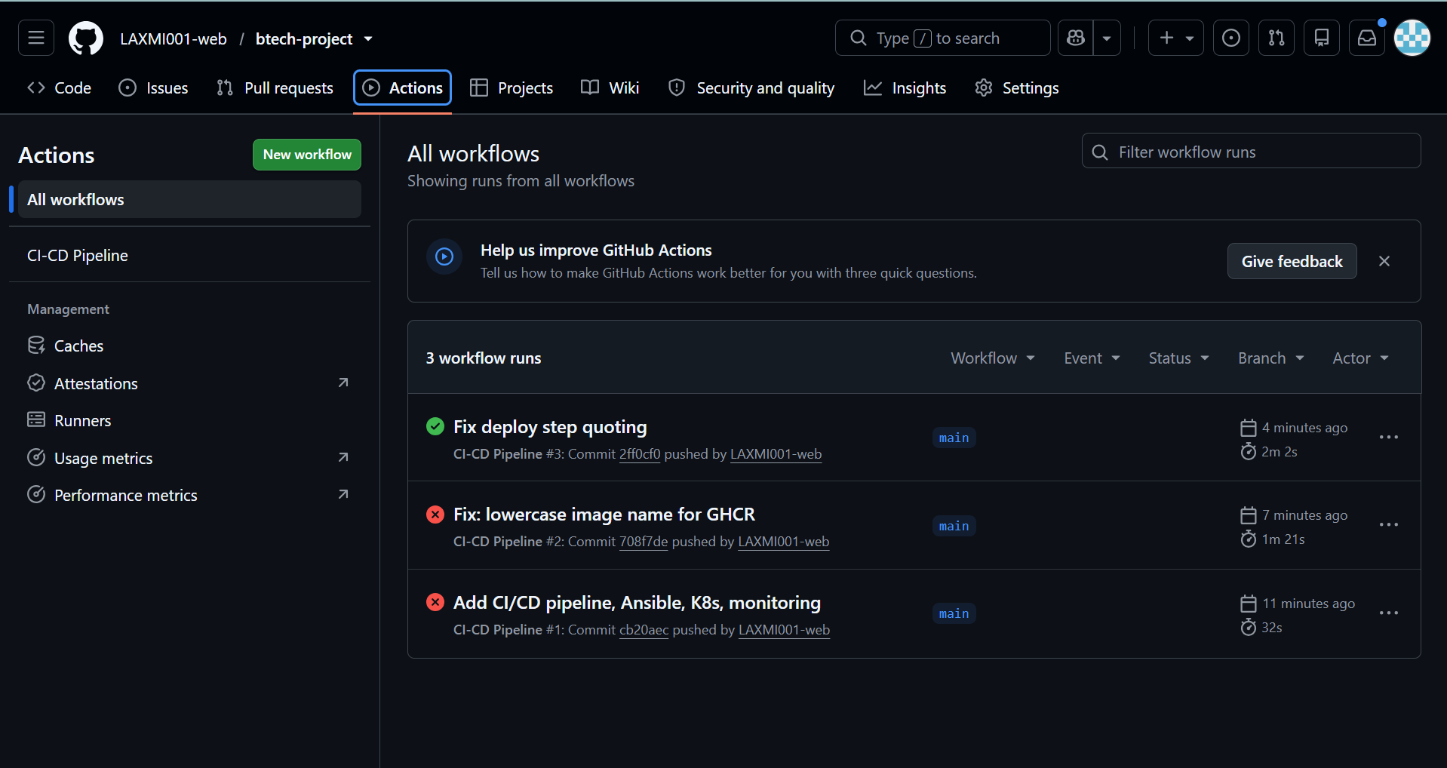
Screenshot 3: Workflow file (ci-cd.yml)
File name: step1-workflow-file.png
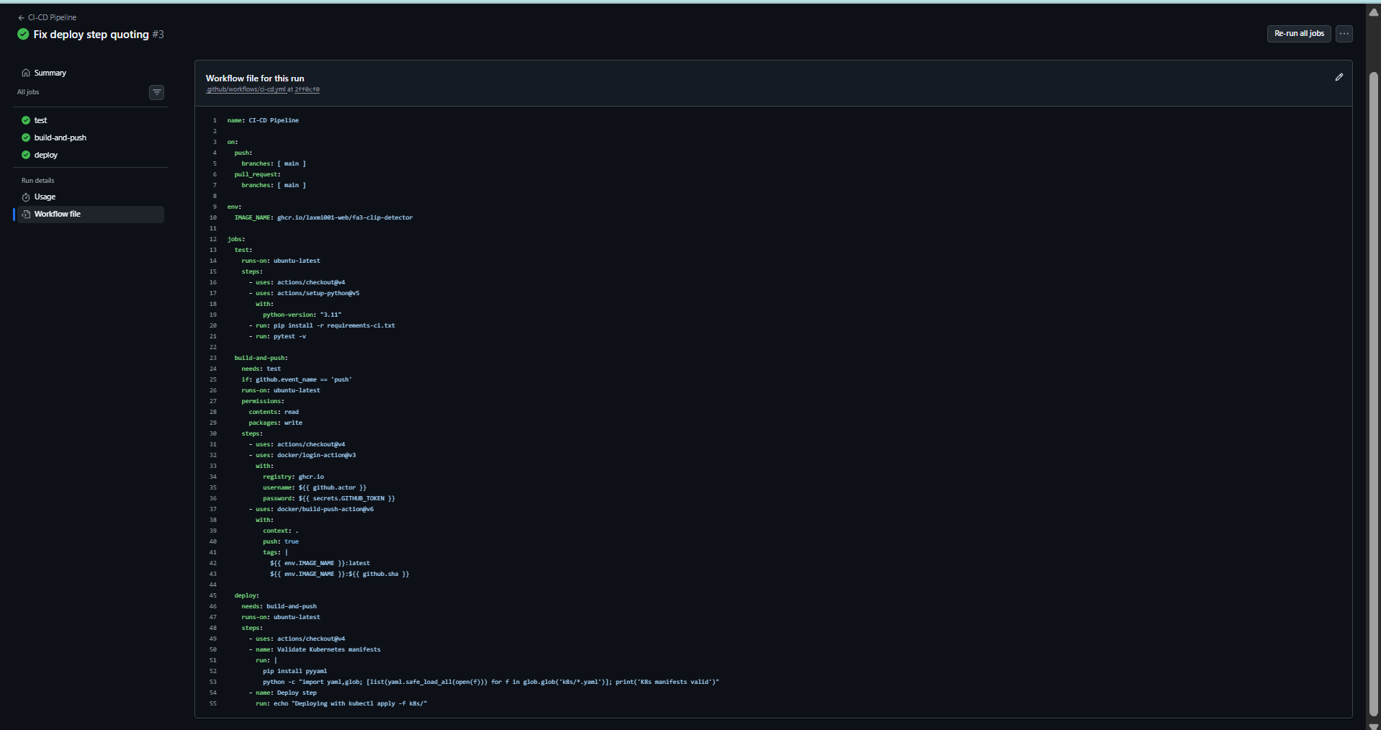
Screenshot 4: Pipeline diagram
File name: step1-pipeline-diagram.png
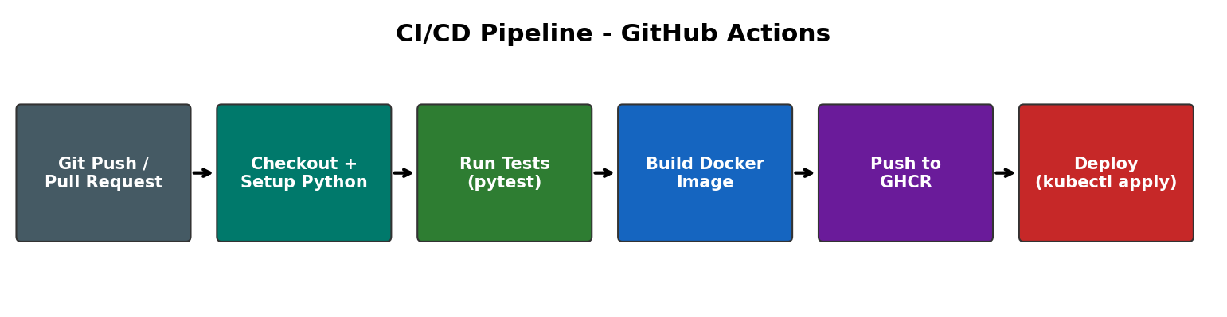

Step 2: Ansible
Screenshot 5: Second playbook run: changed=0, failed=0 (idempotent)
File name: step2-second-run.png
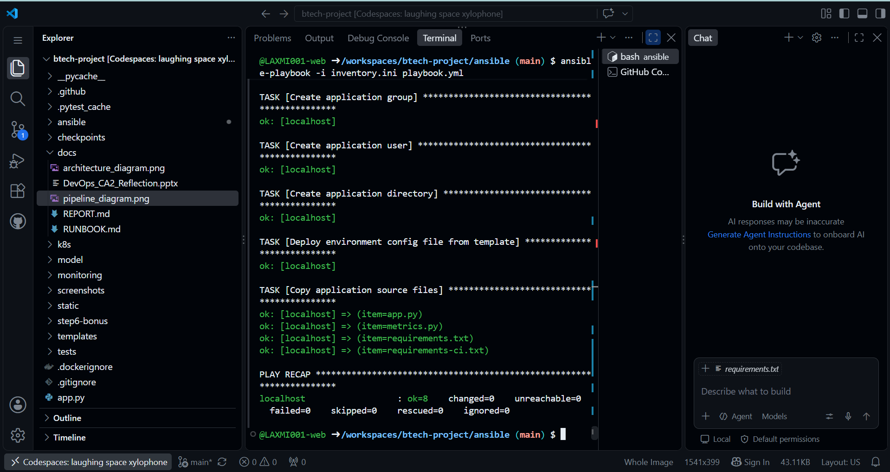
Screenshot 6: Result on the host: user, files and config file
File name: step2-proof.png
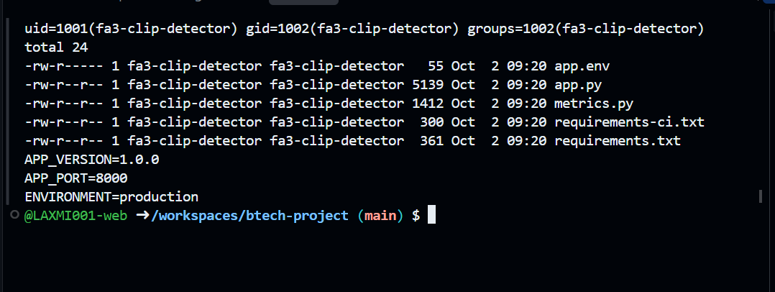

Step 3: Docker and Kubernetes
Screenshot 7: Docker, kubectl and minikube installed
File name: step3-tools.png
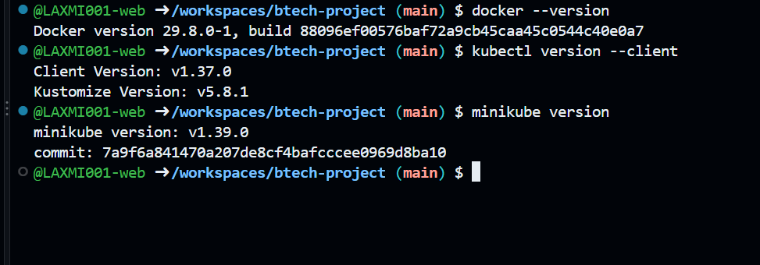
Screenshot 8: Docker images 1.0.0 and 2.0.0 built
File name: step3-images.png
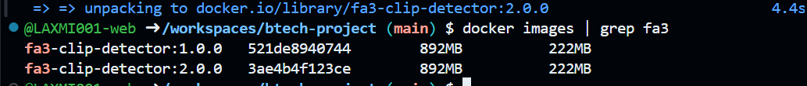
Screenshot 9: minikube cluster started
File name: step3-minikube-start.png
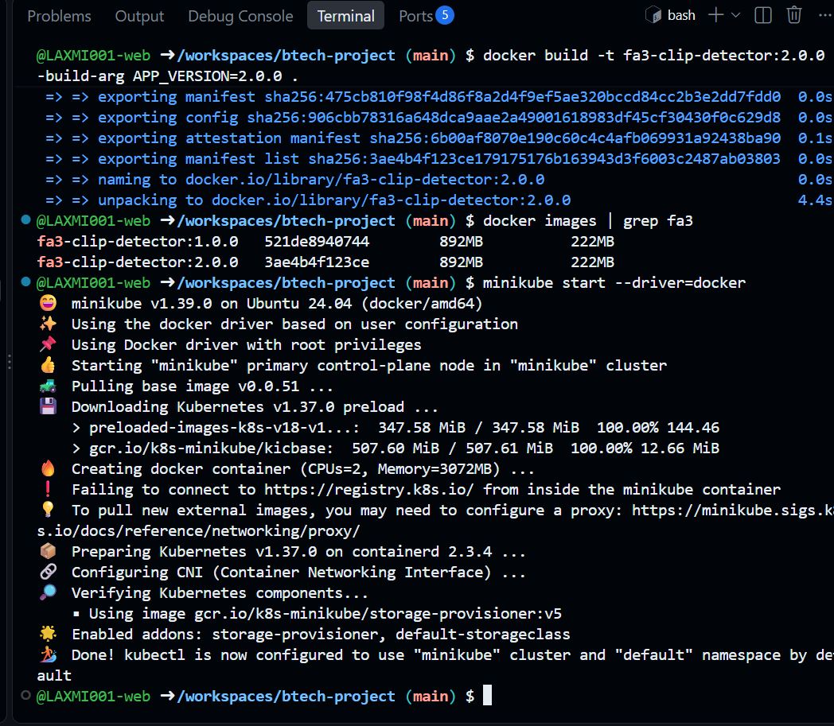
Screenshot 10: Manifests applied; three pods running
File name: step3-pods-running.png
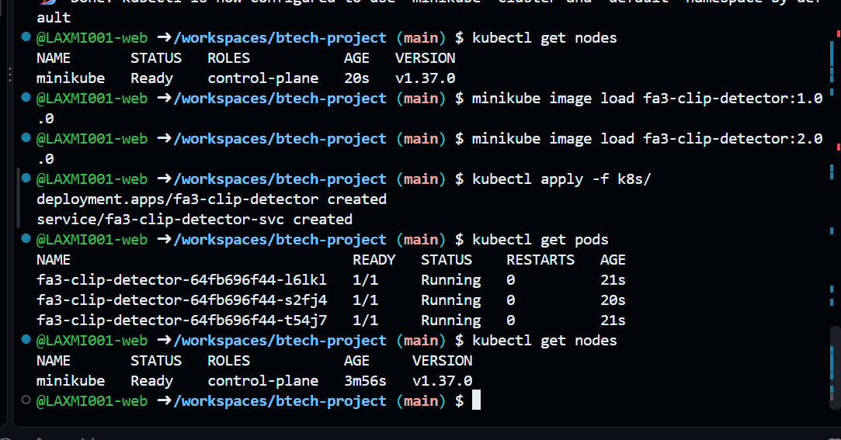
Screenshot 11: Node Ready; deployment 3/3; NodePort service
File name: step3-deployment.png
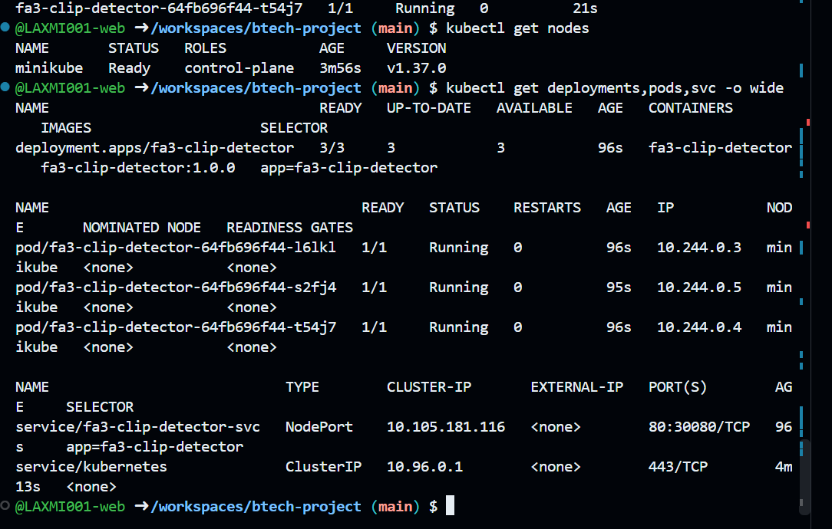
Screenshot 12: Health check through the service
File name: step3-health.png
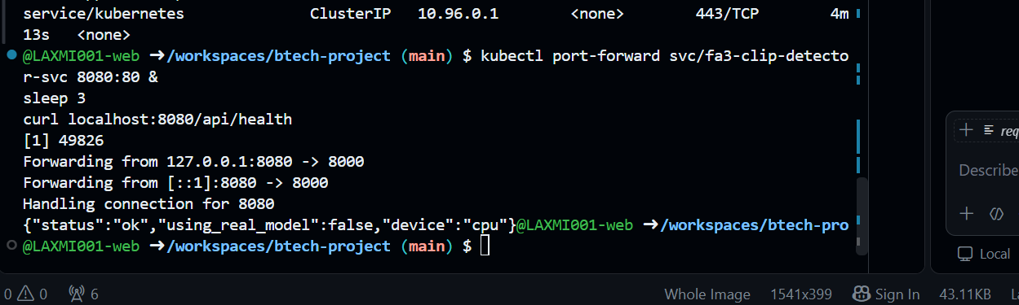
Screenshot 13: Rolling update to 2.0.0 in progress
File name: step3-rolling-update.png
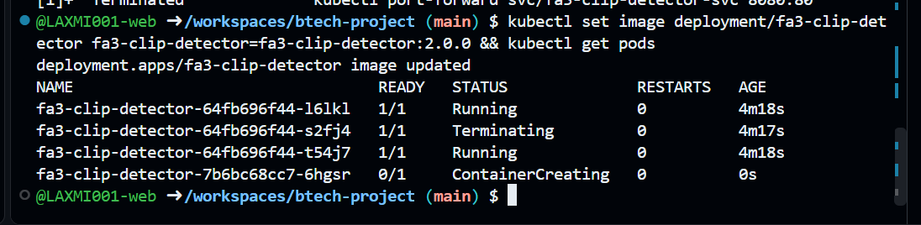
Screenshot 14: Rollout finished successfully
File name: step3-rollout-done.png
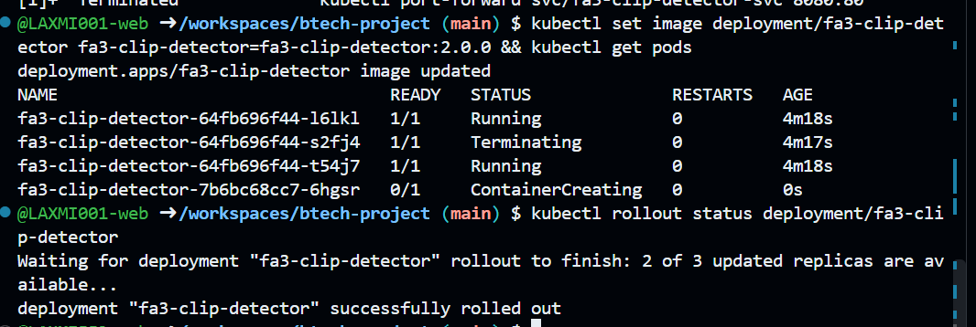
Screenshot 15: New pods running, two revisions, APP_VERSION 2.0.0
File name: step3-version-2.png
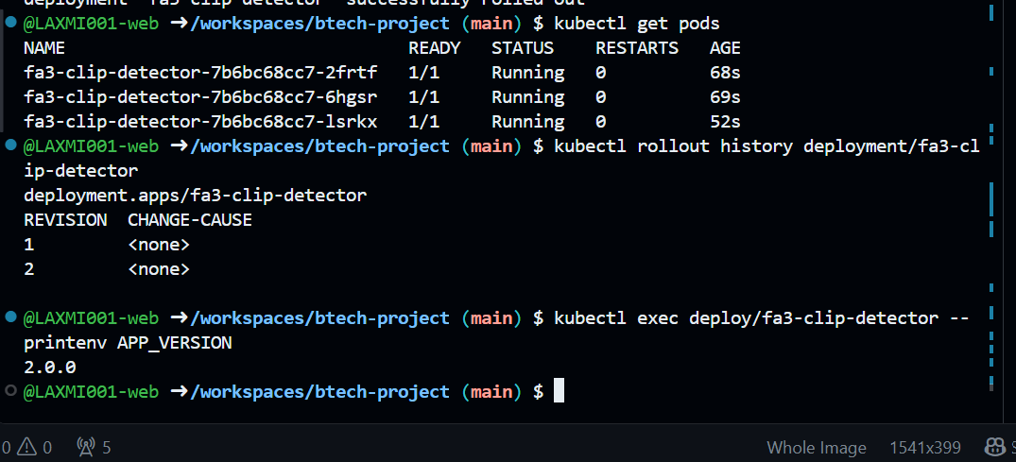
Screenshot 16: Rollback started
File name: step3-rollback-start.png
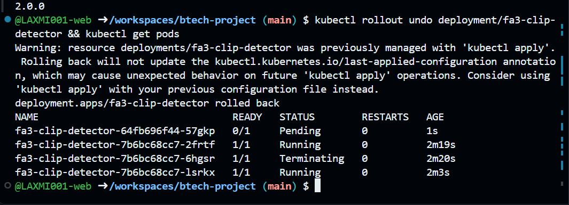
Screenshot 17: Rollback complete: APP_VERSION 1.0.0
File name: step3-rollback-complete.png
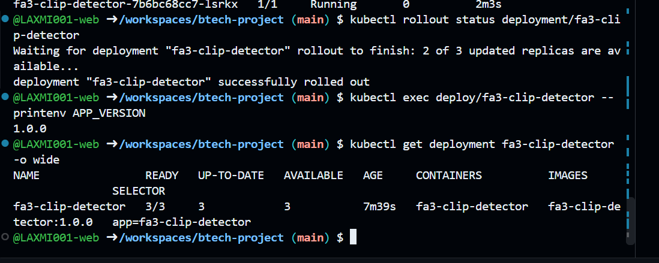

Step 4: Prometheus and Grafana
Screenshot 18: /metrics endpoint showing request counters
File name: step4-metrics.png
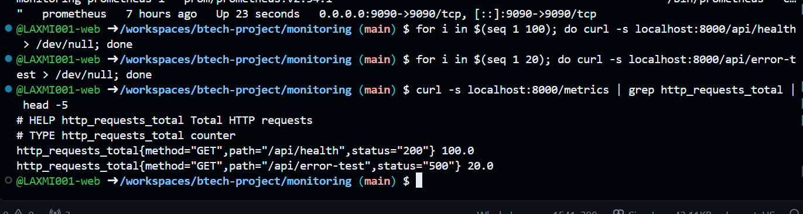
Screenshot 19: Three containers running; Grafana healthy; app 200; Prometheus target up
File name: step4-stack-running.png
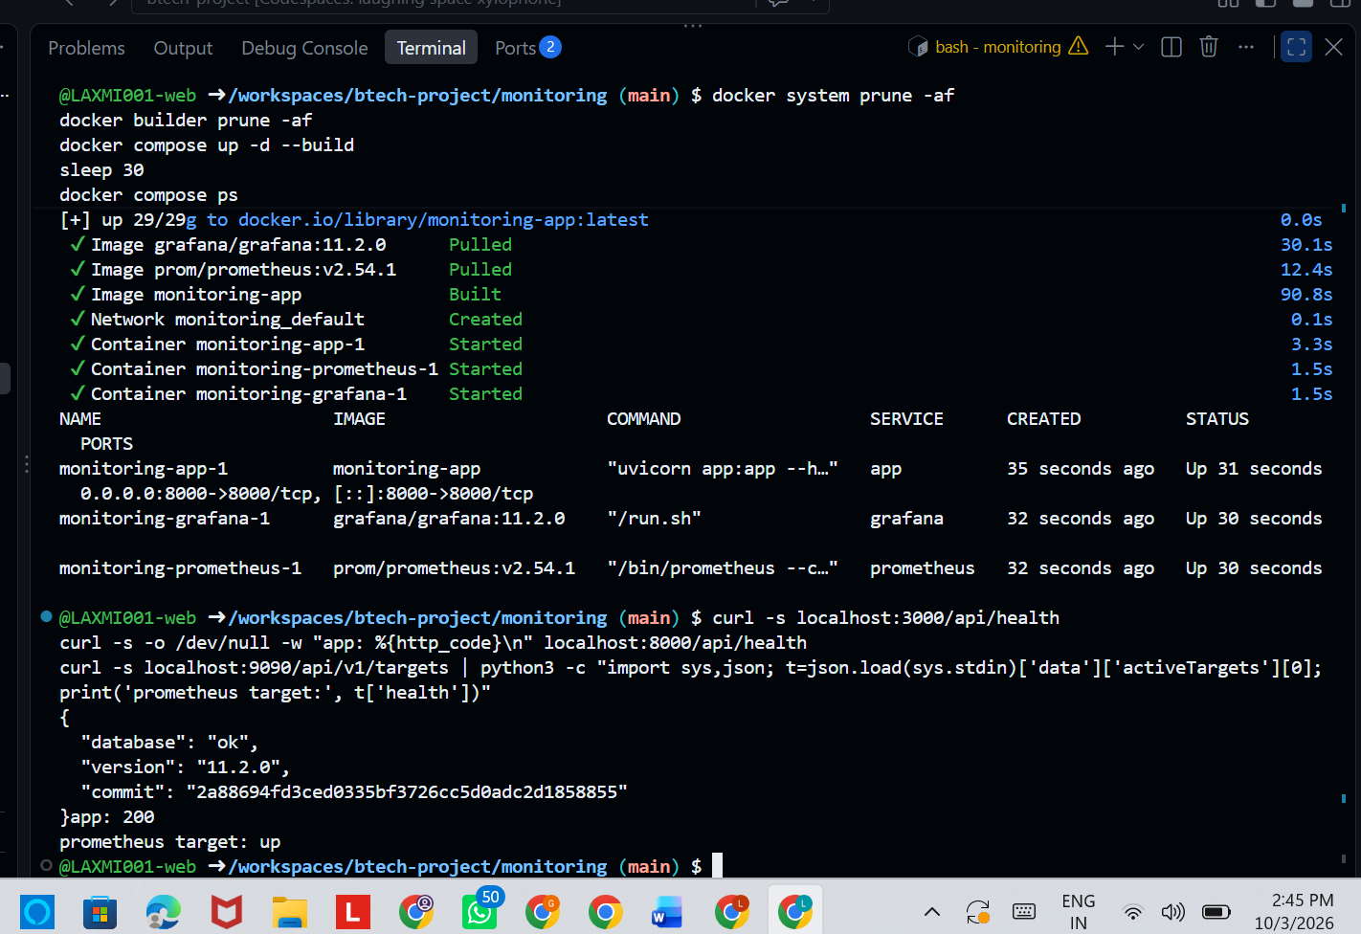
Screenshot 20: Prometheus Targets page: fa3-clip-detector UP
File name: step4-prometheus-up.png
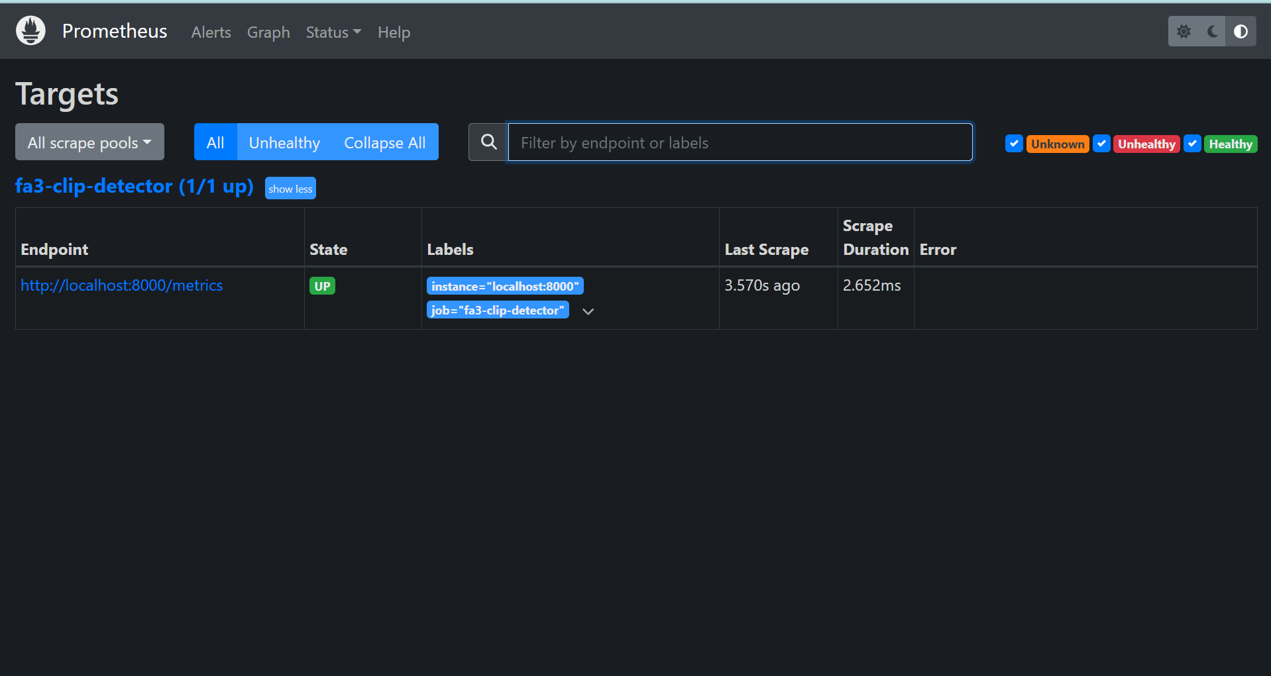
Screenshot 21: Grafana dashboard: uptime, request rate, p95 latency, error rate
File name: step4-grafana-dashboard.png
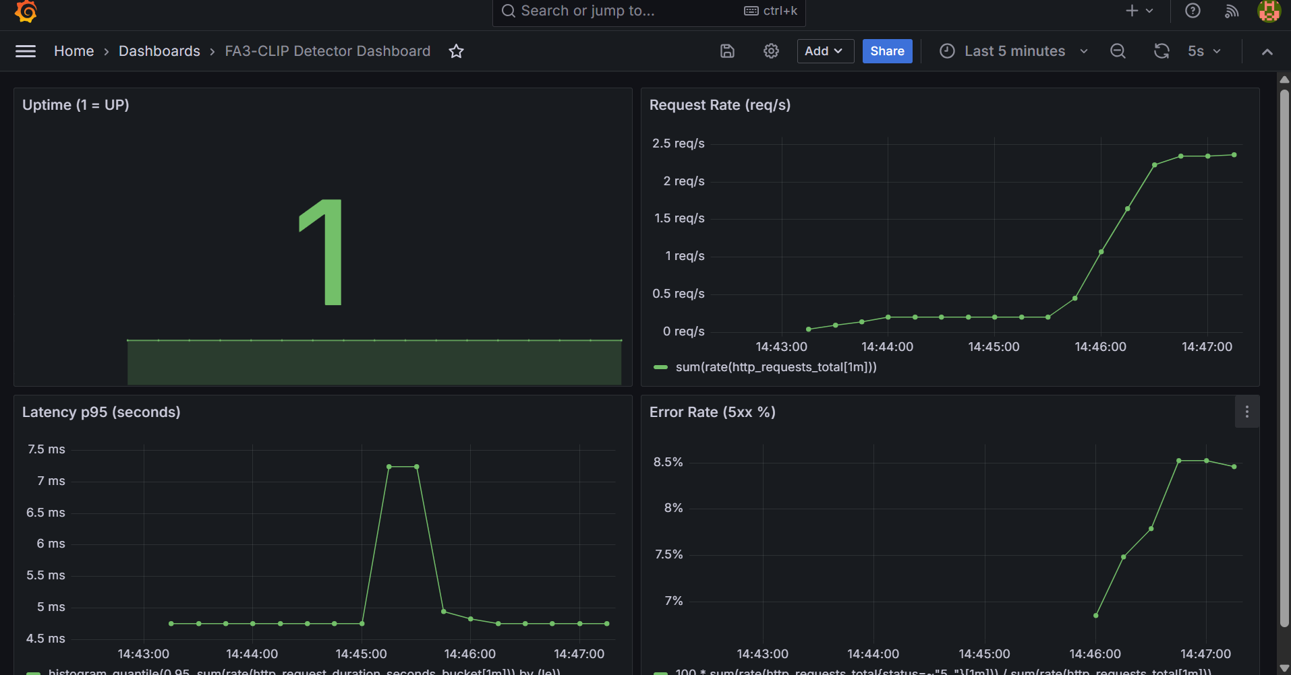

Challenges (evidence)
Screenshot 22: Kubernetes node NotReady before the network-plugin fix
File name: challenge-node-notready.png
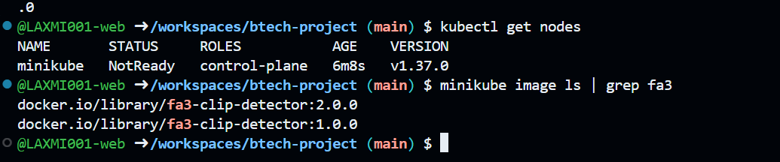
Screenshot 23: Prometheus target down with a timeout before the fix
File name: challenge-prometheus-down.png
