U S Interstate Migration Analysis
  - Project Report
Laxminarayan Sahu
5 October 2026
IBM SkillsBuild Data Analytics with AI Academic Internship Program
Conducted by BharatCares in association with AICTE

Executive summary
This project evaluates whether individual demographics can distinguish adults who reported an interstate move in the previous year. I use 2010–2019 IPUMS CPS ASEC records, a correct interstate-move target, and separate training, validation, and testing periods. The selected histogram gradient-boosting model produces ROC-AUC 0.6994 and average precision 0.04748 on 264,173 test records.
The test interstate-move prevalence is 1.49%. The model improves ranking and positive-class retrieval compared with logistic regression, but precision is only 6.47% at the validation-selected threshold. This is an educational retrospective analysis with substantial false-positive and false-negative rates.

Problem and objectives
Migration data can help describe differences in population mobility across demographic groups and places. The analytical objective is to clean survey microdata, define the outcome accurately, compare a linear classifier with nonlinear models, and report results with enough detail to reproduce and interpret them.
The analysis concerns past-year moves among people in their current state of residence. It does not observe an upcoming migration decision or identify the original state of departure. State summaries therefore describe current residents rather than forecasts of net outflow.

Dataset and preparation
The source is the IPUMS Current Population Survey Annual Social and Economic Supplement. The local raw CSV is 848,671,425 bytes. Filtering retains 1,405,496 adult ASEC records from 2010–2019 with a known domestic migration category, a recognized state code, and a positive ASEC person weight. No synthetic records are generated.
Variable | Role
MIGRATE1 | 5 positive; 1, 3, 4 negative
YEAR and CPSIDP | Temporal splitting and respondent overlap checks
AGE and INCTOT | Age and total personal income
STATEFIP SEX RACE EDUC | Categorical predictors
ASECFLAG and ASECWT | Supplement eligibility and survey weight

MIGRATE1 code 3 indicates a move within a county, code 4 a move between counties within the same state, and code 5 an interstate move. Codes for foreign migration, unknown location, and non-universe responses are excluded. INCTOT is total personal income; values 999999998 and 999999999 become missing values. Negative income is retained.

Feature engineering
The model includes age, squared age, and signed log income. The income transform is sign(income) multiplied by log(1 + absolute income), allowing losses as well as positive income. Missing numerical values are replaced using training medians. Numerical standardization and category encoding are fitted only on training records.
Logistic regression uses one-hot categories. Gradient boosting uses categorical codes with an explicit categorical-feature mask. State names are embedded in the submission notebook, so no external mapping file is needed. State migration outcome aggregates are excluded to prevent target information from appearing among the predictors.

Modeling and evaluation design
Partition | Years | Records | Interstate moves
Train | 2010-2015 | 826,600 | 12,705
Validation | 2016-2017 | 226,022 | 3,637
Test | 2018-2019 | 264,173 | 3,930

CPS can follow the same person across annual observations. The split procedure keeps later partitions and removes 88,701 earlier observations whose person identifier also occurs in a later partition. Identifiers are used for separation rather than as predictors. The supplied extract has no zero person identifiers in the retained partitions.
Three candidates are trained: L2 logistic regression with C = 1, and histogram gradient-boosting classifiers with 15 and 31 maximum leaves. Both boosting candidates use 180 iterations, learning rate 0.06, minimum leaf size 100, and L2 regularization 10. Random state is 42. Survey weights are normalized to a mean of one within training.
The model is selected by unweighted average precision on 2016–2017 validation records. For each candidate, the operating threshold maximizes validation F1. The model family and threshold are frozen before test labels are evaluated; the selected model is not refitted on validation or test records.
Candidate | Validation ROC AUC | Validation average precision
logistic | 0.6899 | 0.04053
boosting_15 | 0.7059 | 0.04680
boosting_31 | 0.7053 | 0.04850

The 31-leaf model has the best validation average precision, 0.04850. Its selected classification threshold is 0.0559536. Primary metrics are unweighted; a separate survey-weighted evaluation and weighted state summaries describe sensitivity to survey weights.

Results and model diagnostics
Metric | Logistic baseline | Selected model
ROC AUC | 0.69604 | 0.69936
Average precision | 0.03919 | 0.04748
Precision | 0.05673 | 0.06469
Recall | 0.13690 | 0.16718
F1 | 0.08021 | 0.09328
Brier score | 0.01451 | 0.01447
Accuracy | 0.95330 | 0.95165

Average precision improves by approximately 21.14% relative to logistic regression. ROC-AUC rises from 0.6960 to 0.6994. These are descriptive differences from this evaluation; confidence intervals or significance tests were not estimated. Weighted ROC-AUC is 0.6921 and weighted prevalence is 1.52%.
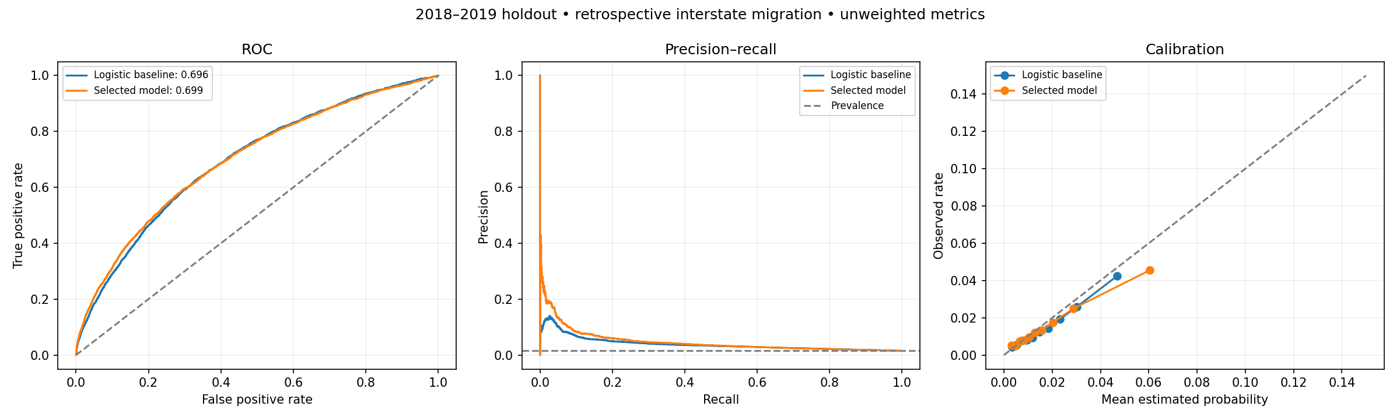
Figure 1 Holdout ROC precision recall and probability reliability diagnostics
Probability reliability is examined using ten quantile bins. The figure shows some overestimation in the highest bin; no separate probability-calibration estimator is fitted. The Brier score is 0.01447 compared with 0.01466 for a constant training-prevalence model.
Predicting no moves yields 98.51% accuracy, higher than the selected model at 95.17%, because positive events are rare. Ranking, average precision, and the false-positive tradeoff are more informative than accuracy alone.

State findings and limitations
Current state | Estimated rate | Observed rate
District of Columbia | 5.26% | 5.23%
Alaska | 3.40% | 2.65%
Oregon | 3.32% | 2.24%
North Dakota | 3.24% | 2.66%
Nevada | 2.89% | 3.26%

The District of Columbia has the highest survey-weighted mean estimated rate, 5.26%, compared with an observed holdout rate of 5.23%. State values average the probabilities for respondents in their current state and cannot be read as migration pressure or expected departures from that state.
Confusion matrix | Predicted stayed | Predicted interstate
Actual stayed | 250744 | 9499
Actual interstate | 3273 | 657

At the chosen threshold, 657 of 3,930 interstate moves are detected, while 9,499 non-interstate observations are flagged. The screening bands are model-relative categories, not confidence intervals, safety labels, or recommended policy cutoffs.
The sample ends in 2019 and does not represent post-pandemic migration patterns. Current demographic characteristics may have changed after a move; temporal separation alone cannot transform the outcome into a future prediction. Survey weights improve population summaries, but replicate weights and design-based uncertainty are not incorporated.
Income is nominal and top-coded under the source disclosure rules; inflation adjustment is future work. Race and sex are included for research comparison. Subgroup performance and fairness would need evaluation before any use affecting people. Employment, housing, destination/origin detail, and causal mechanisms are outside the current feature set.

Conclusion
The notebook provides a reproducible classification benchmark with a correct outcome definition and transparent validation. Gradient boosting improves average precision over the linear baseline, but the low positive-class precision and recall limit its practical screening value. Further work should prioritize richer pre-move features, newer data, fairness checks, and uncertainty estimates.

Reproducibility and submission contents
Install the libraries in requirements.txt in a Python 3.10 or newer environment. The reference run used Python 3.12.7, pandas 3.0.2, and scikit-learn 1.9.0. The dependencies support the complete analytical notebook; the optional React dashboard in the development repository is outside this four-file analytical submission.
Register with IPUMS CPS and request an extract containing YEAR, ASECFLAG, STATEFIP, AGE, SEX, RACE, EDUC, INCTOT, MIGRATE1, ASECWT, and CPSIDP for 2010–2019. Put the CSV at data/cps_00001.csv beside the notebook. The raw extract is not redistributed because IPUMS access and use terms apply.
Run python -m pip install -r requirements.txt, then python -m jupyter notebook LaxminarayanSahu_MigrationRiskAnalysis.ipynb. Restart the kernel and run every cell. All analytical functions and the state mapping are included in the notebook. Generated outputs are written to results, including JSON evaluation reports, CSV summaries, a joblib model, and diagnostic plots.
The submitted notebook also contains stored reference metrics and figures from the full project run. Rerunning the workflow requires the raw extract; it does not generate replacement sample data. Several GB of free memory are recommended for training after the chunked import.
Submission file | Purpose
LaxminarayanSahu_MigrationRiskAnalysis.ipynb | Complete analytical code and reference results
requirements.txt | Required Python packages
LaxminarayanSahu_ProjectReport.docx | Full project documentation
README.md | Overview dataset access and run instructions

References
IPUMS CPS microdata and extract access https://cps.ipums.org/
IPUMS CPS migration status https://cps.ipums.org/cps-action/variables/MIGRATE1
IPUMS CPS total personal income https://cps.ipums.org/cps-action/variables/INCTOT
IPUMS CPS ASEC person weights https://cps.ipums.org/cps-action/variables/ASECWT
U S Census Bureau historical state to state migration tables https://www.census.gov/data/tables/time-series/demo/geographic-mobility/state-to-state-migration.html

