1.What are the two values of the Boolean data type? How do you write them?

ANSWER : The two values of the Boolean data type: True and False , which are written as 1 for True and 0 for False.

2. What are the three different types of Boolean operators?

ANSER: The three different types of Boolean operators are: AND, OR, and NOT.

3. Make a list of each Boolean operator's truth tables (i.e. every possible combination of Boolean values for the operator and what it evaluate ).

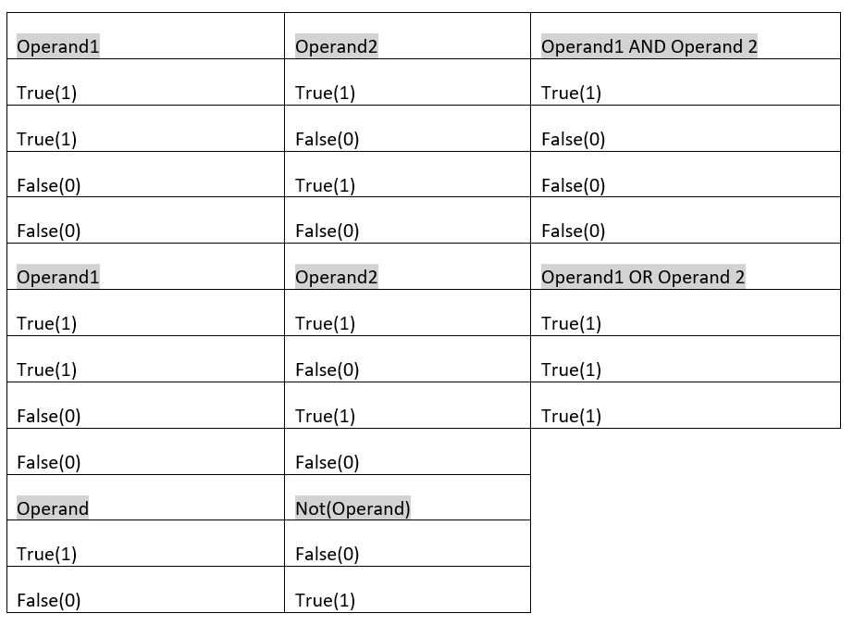

4. What are the values of the following expressions?

(5 > 4) and (3 == 5) ……………………………………..False

not (5 > 4) …………………………………………………..False

(5 > 4) or (3 == 5)…………………………………………True

not ((5 > 4) or (3 == 5))………………………………..True

(True and True) and (True == False)…………...False

(not False) or (not True)…………………………….. None

5. What are the six comparison operators?

<, >, =, <=, >=, !=.

6. How do you tell the difference between the equal to and assignment operators?Describe a condition and when you would use one

ANSWER: ‘=’ is an **Assignment Operator** it is used to assign the value of variable or expression, But, ‘==’ is an **Equal to Operator** and it is a **relation operator** used for comparison (to compare value of both left and right side operands).

Ex.

x=int(input())

y=int(input())

if x==y

print("True");

else

print("False");

7. Identify the three blocks in this code:

spam = 0

if spam == 10:

print('eggs')

if spam > 5:

print('bacon')

else:

print('ham')

print('spam')

print('spam')

ANSWER:

spam = 0

if spam == 10:

print('eggs') # indent increased, block A

if spam > 5: # still block A

print('bacon') # still block A, indent increased, block B inside block A

else: # still block A, indent decreased, block B ended in line above

print('ham') # still block A, indent increased, block C inside block A

print('spam') # still block A, indent decreased, block C ended in line above

print('spam') # indent decreased, block A ended in line above

8. Write code that prints Hello if 1 is stored in spam, prints Howdy if 2 is stored in spam, and prints Greetings! if anything else is stored in spam.

ANSWR: spam = input()

if spam == 1:

print('Hello')

elif spam == 2:

print('Howdy')

else:

print('Greetings!')

9.If your programme is stuck in an endless loop, what keys you’ll press?

ANSWER: CTRL + C

10. How can you tell the difference between break and continue?

ANSWER: Break statement stops the entire process of the loop. Continue statement only stops the current iteration of the loop. Break also terminates the remaining iterations. Continue doesn't terminate the next iterations; it resumes with the successive iterations.

11. In a for loop, what is the difference between range(10), range(0, 10), and range(0, 10, 1)?

ANSWER:

range(10) means 0 to 10 values.

range(0,10) means 0 to 9 values.

range(0,10,1) means 0 to 9 values with increment 1.

12. Write a short program that prints the numbers 1 to 10 using a for loop. Then write an equivalent program that prints the numbers 1 to 10 using a while loop.

ANSWER:

***

for i in range (1,11):

print(i)

***

n = 1

while n <= 10:

print(n, end=' ')

n = n+1

13. If you had a function named bacon() inside a module named spam, how would you call it after importing spam?

ANSWER: We have to use **spam. bacon().**