Recommender Systems - Course Project Report
Cumulative report template - Parts 1, 2, and 3
Team | Group 7
Members | Joel Haakana, Weisheng Xiao and Lassi Cederlöf
For Part 3 track: select one | A / B / C
GitHub repository link | https://github.com/LAZARB0/DATA.ML.360-2026-Group7/blob/main/src/dataset.py

How to use this template
- This is one cumulative report. Extend and revise the same document at each project stage.
- Maximum length: 4 pages at Part 1, 8 pages at Part 2, and 12 pages for the final report, excluding references.
- Keep the section headings below. You may add subsections where useful.
- All explanations and justifications requested in the project specification belong in this report.
- The Results Sheet contains the complete standardized numerical record. In the report, include only the tables and figures needed to support your analysis.
- Delete all italic instructional text before the final submission.

1. Part 1 - Data, Protocol and Baselines

1.1 Data characterization
The experiments were conducted using the MovieLens 1M dataset, which contains 1,000,209 ratings from 6,040 users on 3,952 movies. The user-item interaction matrix therefore contains 23,870,080 possible user-item pairs, resulting in a density of approximately 4.19%
Figure 1 shows the number of ratings per user. The users were sorted by activity level and plotted to visualize the long-tail distribution. A relatively small number of users contribute a large number of ratings, while most users contribute substantially fewer ratings. This behavior is typical for recommender-system datasets and motivates personalized recommendation approaches.
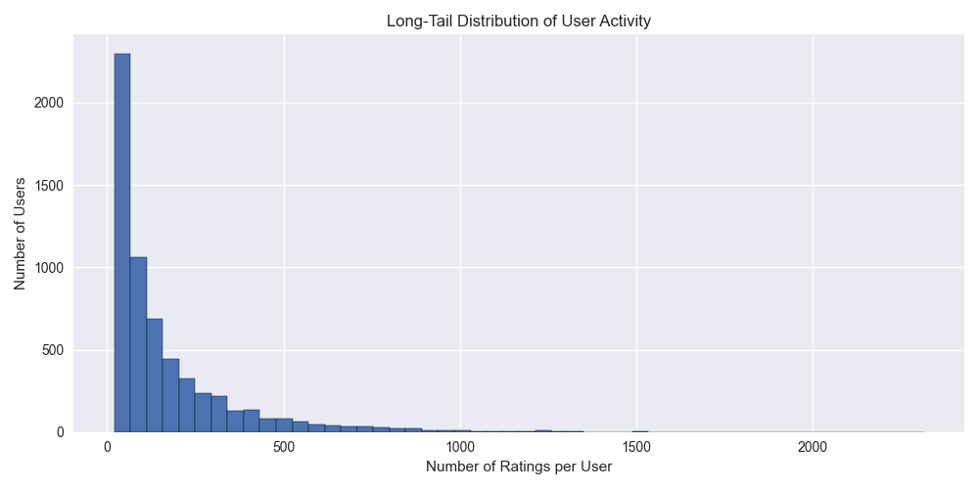
Figure 1, Long-tail distribution of user activity
Figure 2 shows the number of ratings received by each movie. Similar to user activity, movie popularity follows a long-tail distribution. A small number of highly popular movies receive many ratings, whereas most movies are rated by a relatively small number of users.
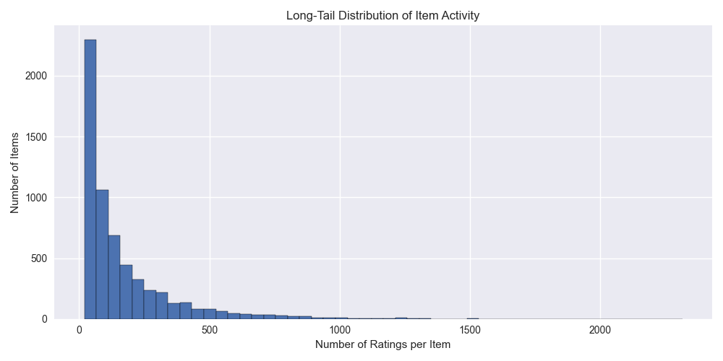
Figure 2, Long-tail distribution of item activity
The rating scale ranges from 1 to 5 stars. The rating distribution is positively skewed as seen in figure 3, with ratings 3, 4, and 5 occurring more frequently than ratings 1 and 2. This suggests that users tend to rate movies they already expect to enjoy.

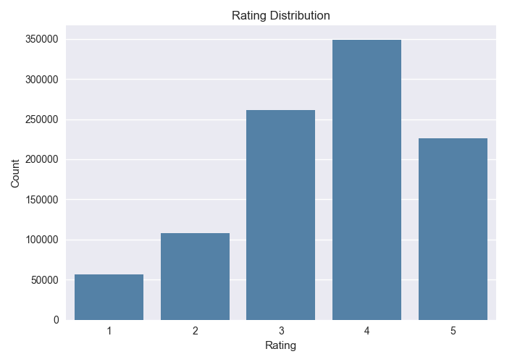
Figure 3, Rating distribution
The timestamps span from 2000-04-25 to 2003-02-28, covering approximately 1039 days. The monthly activity plot indicates how rating activity evolved over time visualized in figure 4.
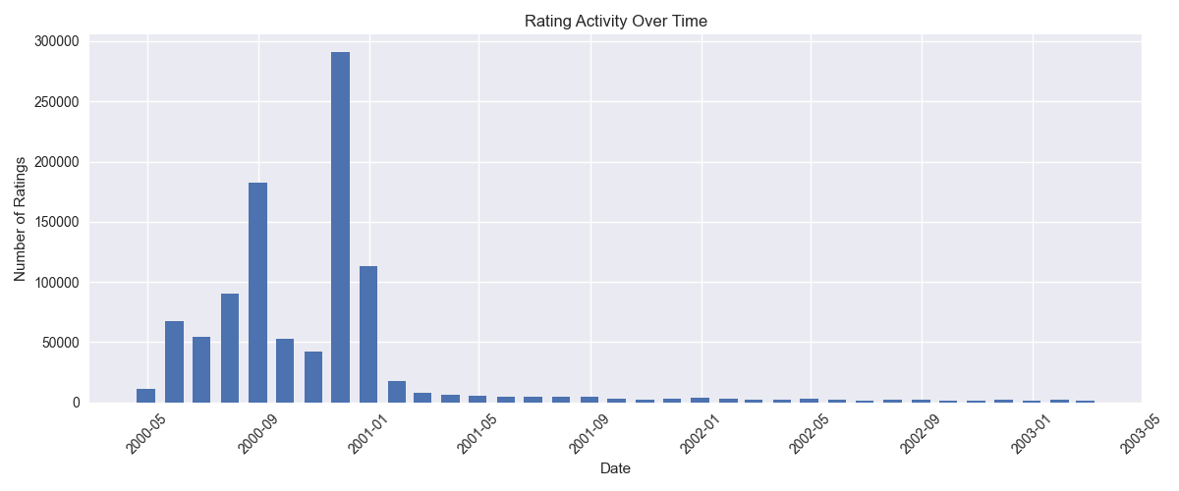
Figure 4, Rating activity over time

1.2 Preprocessing and feedback treatment
MovieLens 1M provides explicit feedback in the form of ratings from 1 to 5. In this work, ratings were kept in their original form and treated as explicit feedback without additional transformation. Both models use positive threshold of 4 meaning that ratings 4 and 5 are considered positive while 1, 2 and 3 are neutral or negative. This allows the systems to focus on movies that users actually liked. KNN model uses filtering to filter out users and items with less than 20 ratings. Users with very few ratings do not provide enough information to reliably identify similar users, and items with very few ratings make similarity calculations less accurate.
The Unix timestamps contained in the dataset were converted into Python datetime objects to enable temporal analysis and chronological splitting. The interactions were then sorted in ascending order by timestamp before creating the train, validation, and test sets.

1.3 Train/validation/test split
A temporal split was used to prevent information leakage from future interactions into model training. All interactions were first sorted chronologically by timestamp. The dataset was then divided using an 80% / 10% / 10% split.
This temporal strategy was chosen because it reflects a realistic recommendation scenario. In practice, recommendation models are trained on historical user behavior and used to predict future interactions. A chronological split therefore provides a more realistic estimate of recommendation performance than a random split, while also avoiding temporal leakage.

1.4 Evaluation protocol

All ratings are used for fitting, with mean-centring to account for users’ different rating scales. Held-out ratings ≥4 define relevant items for evaluation. Most popular follows the same protocol without filtering or mean-centring: popularity is computed from the training set for validation and from train + validation for the final test result.

We rank the full catalogue of 3,883 movies, excluding each user’s previously rated movies, without negative sampling. Precision@10, Recall@10, and NDCG@10 are averaged over users with at least one relevant unseen item; catalogue coverage measures the fraction of movies recommended to anyone.

We compare filtering, removing users with fewer than 20 ratings, removing movies with fewer than 20 ratings, and applying both conditions. These tests assess sensitivity to sparse evidence; thresholds use pre-filter training counts, while test users, the catalogue, and the seen-item exclusion remain fixed.

1.5 Baseline methods and settings1.5 Baseline methods and settings

Item-based KNN model baseline (By Weisheng Xiao)

We compare Cosine and Pearson similarity with K ∈ {10, 20, 50, 100, 200, 400}. Each item retains up to K positive similarity neighbours, requiring at least 2 common raters. Missing neighbour evidence falls back to the user mean or the global mean for unknown users.

Cosine with K =100 achieves the highest validation NDCG@10(0.051218). Selecting K on validation balances neighbourhood size empirically and avoids tuning on the test set. The selected configuration is refit on the training and validation sets.
Most popular model baseline (By Joel Haakana)
Most popular recommends each user the 10 most popular movies they have not already rated. We evaluated three all-time variants: counting all ratings, counting only ratings of 4 or higher, and ranking by average rating among movies with at least the mean number of ratings per movie (218.5).

1.6 Results and analysis

Item-based KNN model baseline (By Weisheng Xiao)
All test results use the same 1,188 eligible users.
Table 1 Item-based KNN results
Filter | Removed ratings | Precision@10 | Recall@10 | NDCG@10 | Coverage
None | 0 | 0.033838 | 0.008841 | 0.037210 | 36.18%
Users ≥20 | 913 | 0.032239 | 0.008428 | 0.037236 | 34.33%
Movies ≥20 | 5,402 | 0.040825 | 0.009794 | 0.044849 | 39.61%
Both ≥20 | 6,311 | 0.034428 | 0.008052 | 0.039778 | 38.58%

Low-frequency movies represent 19.79% of observed training movies but only 0.60% of ratings. Filtering them increases NDCG@10 by 20.53%, whereas additionally filtering users reduces that gain.
Most popular model baseline (by Joel Haakana)
All test results use the same 1,188 eligible users.
Table 2 Most popular results
Variant | Precision@10 | Recall@10 | NDCG@10 | Coverage
All ratings | 0.191751 | 0.052512 | 0.206997 | 3.78%
Only positive (rating > =4) | 0.200926 | 0.057307 | 0.218279 | 3.63%
Average (min count = mean) | 0.108502 | 0.028904 | 0.104727 | 1.98%

Counting only positive ratings was the best Most popular variant, slightly ahead of counting all ratings, because positive ratings match the relevance definition. Ranking by average rating reached only about half that accuracy, as highly rated classics are not what most users rate next.
All variants cover under 4% of the catalogue, since every user receives nearly the same list. Even so, the best variant outperforms item-kNN about five times better on NDCG@10, showing that popularity is a strong signal on this temporal split.

1.7 Contributions
Lassi Cederlöf - In part 1 we had a few discussions that all members attended and where we decided how to split the work. I worked on initializing our github and the environment, doing the dataset analysis (dataset.py), wrote parts 1.1-1.3 regarding the dataset analysis and finalized codebase with run_all.py script and readme instructions.
Weisheng Xiao – In part 1, I am responsible for the KNN model, including model building, parameter selection, and results analysis, and I wrote parts half of 1.4-1.6 (KNN_model.py). In addition, I am also responsible for temporal splits and wrote part 1.3.
Joel Haakana – In part 1, I am responsible for the Most popular model, choosing the variants, model building, and result analysis. I wrote the “Most popular” section in parts 1.5 and 1.6, I also made an addition to part 1.4.

2. Part 2 - Models and Honest Comparison

2.1 Models
Describe the additional models and paradigms. Clearly identify the self-implemented algorithm and explain its implementation.

2.2 Hyperparameter tuning and variability
Describe the validation-only tuning procedure, search spaces/budgets, random seeds, and confidence intervals or statistical testing.

2.3 Overall results
Present and discuss the main comparison. Explain important differences and avoid unsupported claims.

2.4 Disaggregated analysis
Report and interpret results broken down by at least two of the required dimensions: items with few vs. many training interactions, low- vs. high-activity users, popular vs. long-tail items, and early vs. late test period. Define any thresholds used and focus on findings that change or qualify the overall conclusions.

2.5 Sparsity ablation
Report and discuss the 100%, 50%, and 20% training-interaction experiments, including changes in the ranking between models.

3. Part 3 - Beyond Accuracy

3.1 Selected track and motivation
State Track A, B, or C and briefly motivate the selected intervention/extension.

3.2 Method
Describe only your selected track. The Track A/B/C guidance below is provided as instructions; delete the guidance for the two tracks you did not select before submission.

If Track A - Diversity and popularity bias
State the base recommender, selected re-ranking method, genre-vector item representation, trade-off parameter, and exact item-distance measure. Describe how the parameter was swept.

If Track B - Fairness
Define the release-decade provider proxy, report and justify the final decade boundaries and group sizes, state and justify the adopted fairness notion, describe the consumer groups based on MovieLens user attributes, and identify the stage and form of the mitigation.

If Track C - Group recommendations
State the selected synthetic group type and justify the chosen group size (3-5). Describe the three aggregation strategies. Identify which strategy was extended to the sequential scenario and explain how satisfaction is carried forward between recommendation rounds.

3.3 Results and trade-offs
Present the required track-specific results. Track A: report intra-list diversity, catalogue coverage, Gini and calibration error across the parameter sweep, and discuss the accuracy-diversity frontier. Track B: report position-weighted exposure against catalogue share, per-group consumer-side accuracy, and the fairness-performance frontier. Track C: compare group satisfaction, disagreement and minimum member satisfaction across the three aggregation strategies, then analyse how member and group satisfaction develop in the sequential scenario.

3.4 Cost and interpretation
State what is gained, what is lost, and who bears the cost where applicable. Explain what operating choice or strategy you would select and why.

3.5 "One number we cannot explain"
Identify one result you do not fully understand and describe how you would investigate it.

4. Discussion and Conclusions
Summarize the main findings across the project. Discuss limitations, failed approaches where relevant, and what the experiments support.

5. Contribution Statement
For each team member, provide two or three sentences describing their contribution.

6. Use of AI Assistants
State which AI tools were used and for what. If none were used, state that explicitly.

References
List references used in the report. References do not count toward the page limit.

