Teensy Logic Analyzer User's Guide
1/1/2016

OLS user interface

The Teensy communicates with the PC via a SUMP application. The SUMP protocol is a standard for sending logic analyzer data. This document uses the OpenBench Logic Sniffer application for these examples. It is available for download at www.lxtreme.nl/ols. See installation.md for instructions on installing all applications.

Setting up OLS

OLS will remember the settings between runs. But the first time you must set up a few items.

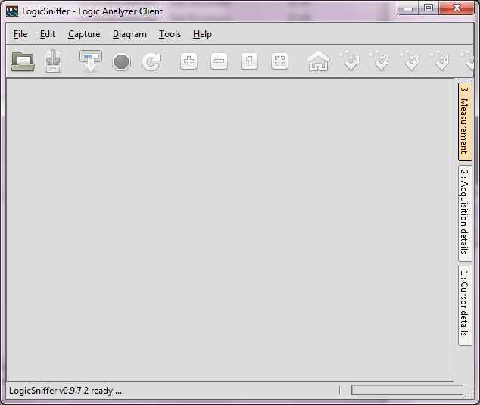
Initial Screen
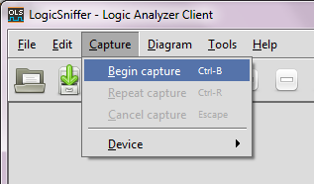
Select Capture → Begin capture:
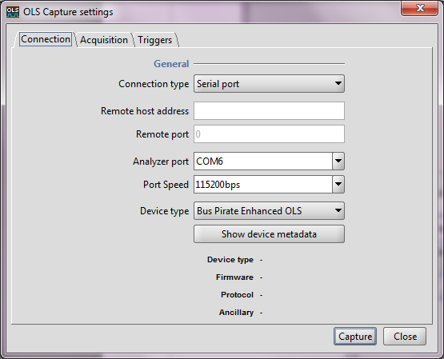

Select Analyzer port if necessary.

Select 'Show device metadata'.

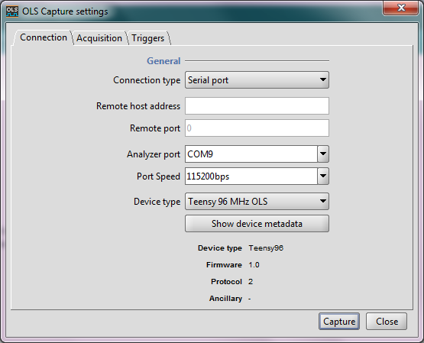
Device type lists various configurations that the Teensy can be built for. Default for Teensy 3.1/3.2 is Teensy96, and default for Teensy LC is Teensy48.

Firmware is the version of the Teensy software.

Protocol is the SUMP protocol and is always 2.

Select the Acquisition tab.

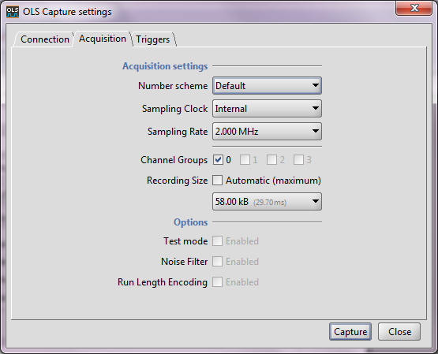

For the basic Teensy 3.1 configuration, the defaults are Sampling Rate of 2 MHz and Recording Size of 58k samples.

Select Capture to start recording.

No inputs:

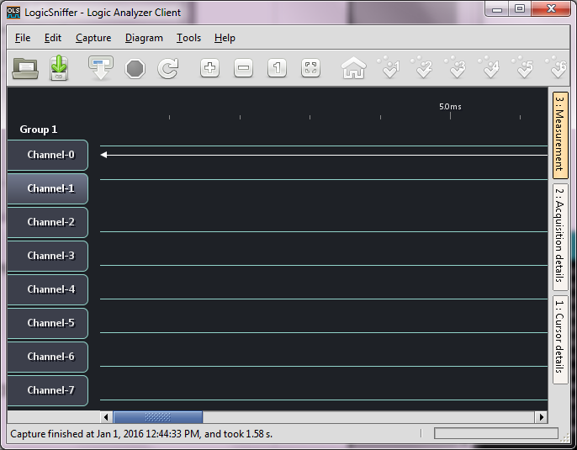

If you compile with #define CREATE_TEST_FREQUENCIES 1, you will see capture data like this:

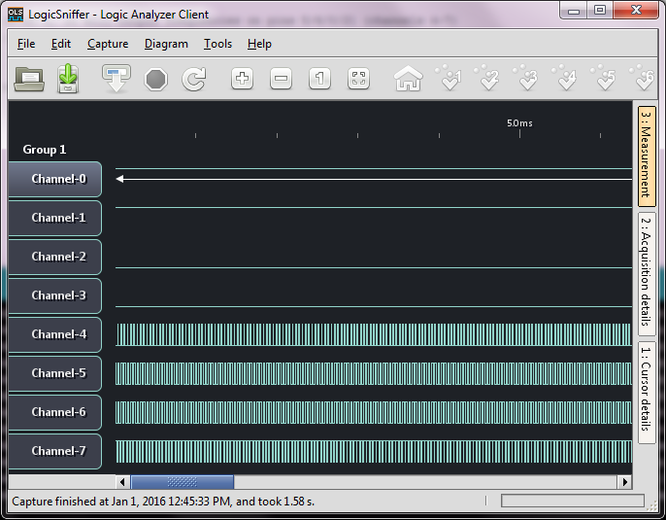
Zoomed in:

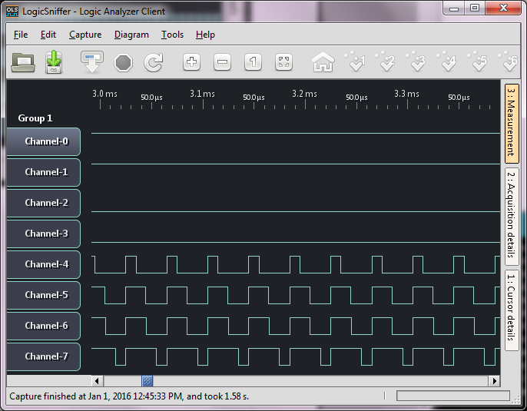
Time measurement – drag right border to the left:

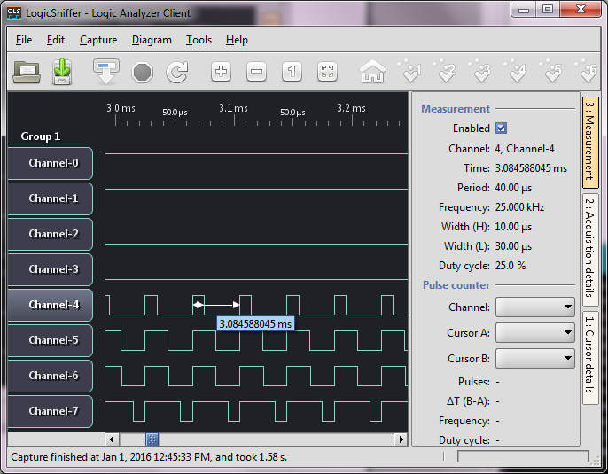

Trigger setup:

This example sets up a trigger on channel 4 being high at 10% into the buffer.

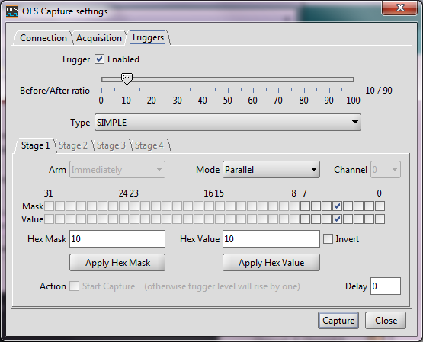
Capture looks like this:

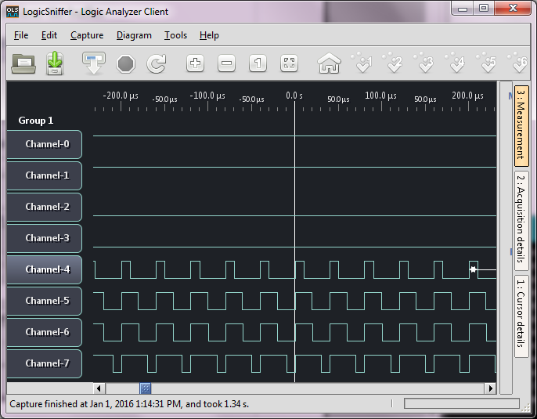
Advanced Configurations (currently only Teensy 3.1/3.2)

Once you are comfortable with the basic configuration, you can try the advanced configuration to get higher speeds and/or more samples. To use it, compile with

#define ADVANCED_CONFIGURATION 1

and select Device type as Teensy 96 MHz OLS Advanced (or select Show device metadata to confirm it is compiled and installed correctly on the Teensy).

There is also a 120 MHz Advanced configuration file. It is the same as below, but 25% faster.

However, all combinations of speed and samples are not valid in Advanced configuration. See table below. When a combination cannot be met, the display will have alternating 1's and 0's in the invalid sections (an entire channel, or a portion of time, or both).

 | 2 MHz and below | 12 MHz | 19.2 MHz
58k samples and below | 8 channels | 8 channels (Note 1) | 8 channels (Notes 1, 3)
116k samples | 4 channels | Note 2 | Note 2
232k samples | 2 channels | Note 2 | Note 2
464k samples | 1 channel | Note 2 | Note 2

Note 1: Timing data is valid up to about 28k samples, then is 10% too fast (upper SRAM?)

Note 2: Limited to 58k samples. No advantage over 58k setting.

Note 3: Trigger Before/After Ratio is not used. Trigger, if selected, is always at the beginning.

