Securing the MediColBox

a study on how accelerometers can detect intrusion

Å sikkre en MediColBox

en studie om hvordan akselerometre kan oppdage innbrudd

Lars Birger Bergmål 321

Bachelor’s thesis in Control System Engineering

Faculty of Engineering ans Science Western Norway University of Applied Science

May 21, 2024



**Abstract**

*EN - english*

This study focuses on the development of a solution to prevent theft and break-ins in medicine collection systems, specifically targeting the MediColBox. The proper disposal of unused and expired medications is crucial for public health, as improper disposal can lead to environmental contamination and potential harm to individuals. The objective of this research is to find methods to detect and deter intrusion attempts in these systems, aiming to minimize the risk of medication loss or theft. A scaled-down prototype utilizing an Inertial Measurement Unit (IMU) is constructed to evaluate different detection and notification methods. The study examines accelerometer data collected during simulated intrusion events, including striking, dropping, sawing, and shaking of the MediColBox. The results demonstrate the effectiveness of the IMU in detecting and capturing accelerative patterns associated with these intrusion scenarios. However, it is noted that the IMU’s sensitivity may lead to false alarms, necessitating the exploration of pattern recognition software and machine learning algorithms to enhance the system’s accuracy. The study also discusses the potential of combining the accelerometer data with gyroscope data to understand the relationship between acceleration and orientation during intrusion events. The findings strongly support the feasibility of utilizing the IMU as a standalone solution for enhancing the security and protection of the MediColBox. Further research directions include integrating other sensor types, such as the gyroscope, and exploring the applicability of this intrusion detection approach to other systems beyond medicine collection boxes. The outcomes of this study contribute to improving the overall security and integrity of portable storage systems and preventing unauthorized access.

*NO - Norsk*

Denne studien fokuserer på utviklingen av en løsning for å hindre tyveri og innbrudd i medisinske innsam- lingssystemer, spesielt rettet mot MediColBox. Riktig håndtering av ubrukte og utløpte medisiner er avgjørende for folkehelsen, da feilaktig håndtering kan føre til miljøforurensning og potensiell skade på enkeltpersoner. Målet med denne forskningen er å finne metoder for å oppdage og avverge innbruddsforsøk i disse systemene, med sikte på å minimere risikoen for tap eller tyveri av medisiner. En nedskalert prototype som bruker en IMU er konstruert for å evaluere ulike metoder for deteksjon og varsling. Studien undersøker akselerometerdata som er samlet inn under simulerte innbruddshendelser, inkludert slag, dropp, såing og risting av MediColBox. Resultatene viser effektiviteten til IMU i å oppdage og fange opp akselerasjonsmønstre knyttet til disse innbruddsscenarioene. Imidlertid bemerkes det at IMUs følsomhet kan føre til falske alarmer, og det er derfor behov for utforsking av mønstergjenkjenning og maskinlæringsalgoritmer for å forbedre nøyaktigheten til systemet. Studien diskuterer også potensialet for å kombinere akselerometerdata med gyroskopdata for å forstå sammenhengen mellom akselerasjon og orientering under innbruddshendelser. Funnene støtter sterkt muligheten for å bruke IMU som en frittstående løsning for å forbedre sikkerheten og beskyttelsen av MediColBox. Videre forskningsretninger inkluderer integrering av andre sensortyper, som gyroskopet, og utforsking av anvendeligheten av denne innbruddsdeteksjonsmetoden på andre systemer utenfor medisinske innsamlingsskap. Resultatene fra denne studien bidrar til å forbedre den generelle sikkerheten og integriteten til bærbare lagringssystemer og forhindre uautorisert tilgang.

**Acknowledgments**

I would like to thank the following people for their help and support:

* **Edmundo Villacorta Soriano:** for sharing his wast amount of knowledge and experience in the different fields spanning this thesis, and for spending his even greater patience to guide me away from folly and towards writing a proper report

Contents

**Acknowledgments** 1

**List of Figures** 3

**List of Tables** 3

**Glossary** 4

1. **Introduction** 4
   1. Background 4
   2. Objectives 5
   3. Limitations 5
   4. Project Stakeholders 5
2. **Background** 6
   1. The MediColBox 6
   2. Definition of the problem 7
3. **Methodology** 10
   1. Phenomenon of Interest 10
   2. Data Collection Methods 10
   3. Prototype Construction 11
   4. Sampling Strategy 15
   5. Data Collection Procedures 15
   6. Ethical Considerations 15
   7. Data Analysis 16
   8. Limitations 17
   9. Tools and Technologies 17
   10. Document Preparation 18
4. **Results** 18
   1. Analysis of the Data 18
      1. A1 Striking the MediColbox 18
5. A2 Dropping the MediColbox 20
6. A3 Sawing on the MediColbox 23
7. A4 Shaking the MediColbox 23
   1. Discussion of Findings 25
      1. B1 data and storage 25
8. **Conclusion** 26

**References** 27

List of Figures

1. render of the MediColBox from before it was built 6
2. a diagram showing the power distribution in the MediColBox 7
3. a diagram showing the data structure in the MediColBox that is related to thi thesis 7
4. Design of the prototype with the cover on 12
5. Design of the prototype without the cover 12
6. Photograph of the sensor card, with the location of the IMU located 12
7. Photograph of the prototype under assembly of the cover 13
8. The “wiring diagram” used 14
9. The Sequence diagram used for the program 14
10. Photograph of the prototype 14
11. Visualisation of which axis points towards what direction in relation to the sensor card 15
12. Accelerometer data during the striking event 19
13. Accelerometer data during the dropping event 20
14. Gyroscope data during the dropping event 21
15. Pose estimate during the dropping event 22
16. Accelerometer data during the sawing event 23
17. Fourier analysis of accelerometer data during the sawing event 24
18. Accelerometer data during the shaking event 24
19. Fourier analysis of accelerometer data during the shaking event 25

List of Tables

1. Types of Intrusion Attempts 8
2. Potential Security Measures for MediColbox 10
3. Potential Data Collection Methods for Intrusion Attempts 11
4. Possible Data Collection Methods for Intrusion Attempts 15
5. Format of the Sensor Data Collected by the Prototype 16

Glossary

Actuator Device or mechanism that convert energy into physical motion or force, often used to control or manipulate a system. Examples of actuators include electric motors, solenoids, hydraulic cylinders, and pneumatic actuators. Actuators are commonly used in a wide range of applications, such as robotics, automation, and control systems.

CCU A component of a system that is responsible for coordinating and managing the activities of other components. In a computer system, the central control unit (CCU) is often the main processor or microcontroller that executes instructions and manages input/output operations. first

DSI Display Serial Interface is a specification used for connecting display panels to electronic devices. It provides a high-speed, serial communication interface for transmitting display data, control signals, and power between devices such as microcontrollers or graphics processing units and display panels.

Exploit An act of utilizing something to gain a benefit or advantage. The term can be used in various contexts, such as in technology, economics, or social interactions.

HMI Human-Machine Interface is a system that allows humans to interact with a machine or computer system, often through a graphical user interface or touch screen. The HMI enables the user to control and monitor the machine or system, and provides feedback to the user about its status and performance first

IMU A device that consists of multiple sensors, such as accelerometers, gyroscopes, and magnetometers, that measures the orientation, velocity, and gravitational forces of an object in motion. IMUs are commonly used in robotics, unmanned vehicles, and virtual reality systems to provide accurate position and motion tracking. They can also be used for stabilization and navigation purposes in aerospace and marine applications.

Intrusion The act of intruding or the state of being intruded. especially: the act of wrongfully entering upon, seizing, or taking possession of the property of another

MediColBox The medicine colletion part of Medretur’s solution for collecting the medicine

RIO A type of input/output (I/O) system that is located away from the central processing unit (CPU) or main controller, and is connected through a network or communication link. Remote input/output (RIO) systems typically consist of one or more I/O modules that are connected to a communication interface or network adapter.

Sensor card A printed circuit board (PCB) or electronic module that contains one or more sensors, such as temperature sensors, humidity sensors, pressure sensors, or motion sensors. Sensor cards are often used in electronic systems for data acquisition, monitoring, or control purposes.

Single-board computer A complete computer system built on a single circuit board, which includes all the basic components of a computer, such as a central processing unit (CPU), memory, input/output (I/O) ports, and storage. SBCs are designed to be compact, low-power, and cost-effective, and are often used for embedded systems, prototyping, and hobbyist projects. They can be used for a wide range of applications, such as robotics, Internet of Things (IoT) devices, and home automation. Examples of popular SBCs include the Raspberry Pi, BeagleBone, and Arduino.

USB Universal Serial Bus is a common interface that allows communication between computers and peripheral devices. It provides a standardized connection and protocol for connecting devices such as keyboards, mice, printers, and storage devices.

* 1. Introduction

**Medretur** wants to develop a medicine collection system that automates the process of disposing of medicines. The task of this project is to research and find methods for this system to detect and deter intrusion attempts. This chapter presents background information on the research project, including its objectives and limitations. Information is also provided on the company that commissioned the study.

1. *Background*

The proper disposal of unused and expired medication is a critical public health issue [1]. Improper disposal of such medicines can lead to contamination of the environment and potential harm to human health [2], [3]. Collection programs for unused medicines have been established to address this issue [4]–[6], but these programs often face challenges in terms of security [7]. This is because these programs deal with sensitive materials that may be valuable to others [8].

1. *Objectives*

The purpose of this task is to find a solution to prevent theft and break-ins in systems for collecting medicines.

The aim of the proposed solution is to allow such systems to operate without the risk of medications being lost or stolen.

The task aims to evaluate different detection and notification methods and create a scaled-down prototype, and then conclude whether or not this solution works.

1. *Limitations*

Parts of a control system that use the same components as the existing control system in the MediColBox will be constructed.

The full-scale control system will have the same CCU, HMI, and sensor card, but also remote input/output (RIO) for the actuators.

The prototype that will be assembled is a Single-board computer Raspberry Pi 4B 8GB [9] as CCU, with a 7-inch touchscreen [10] as HMI and a Raspberry Pi Sense Hat v1.0.0 [11] as a sensor card. The purpose of constructing the prototype is to use the IMU in the sensor card.

1. *Project Stakeholders*

The company **Medretur** is the main target audience. Medretur was a company committed to providing safe and effective waste management solutions to their customers. However, the waste management industry is complex and challenging, and delivering a solution that reliably provides this is not easy. The proposed project seeks to help Medretur navigate this complex landscape by developing a new system that will improve the safety and security of their waste management operations.

It went bankrupt 03. of January 2024, and unfortunately this means most of the citations we could find for this company is no longer avaiable.

By implementing this new system, Medretur hoped to be able to reduce the risk of accidents, errors, and other safety incidents, which will help to protect their employees, customers, and the environment. Overall, the solution proposed by Medretur had the potential to provide significant benefits to Medretur and their customers.

* 1. Background

This chapter presents the definition of the problem, scope of the problem, different solutions related to the problem and why this solution is chosen.

1. *The MediColBox*

the MediColBox is the medicine colletion part of Medretur’s solution for collecting medicine in an effort to prevent medicinal waste and damage.

the MediColBox is a box made by 8 mm thick aluminium plates. It is 600 [*mm*] by 600 [*mm*] wide and 600 [*mm*] high. On the side of it is a removable cart held together with internal locking mechanisms in steel designed to not pose a weak point on the box. the details related to design of the internal locking mechanism is concealed to maintain secure functinality, but it does lock the gap together in such a way that you cannot bend it open without already breaking the aluminium shell, but you might be able to jam it stuck and prevent functinality.

On top of this box is bolted tight a wedge shaped lid, also 600 [*mm*] by 600 [*mm*] wide. The wedge shaped lid is 600 [*mm*] high on the tallest section and 200 [*mm*] high on the lowest section. on top of the lid is a touch screen posing as the HMI and an opening designed to allow you to insert some medications for internal mechanisms to sort.

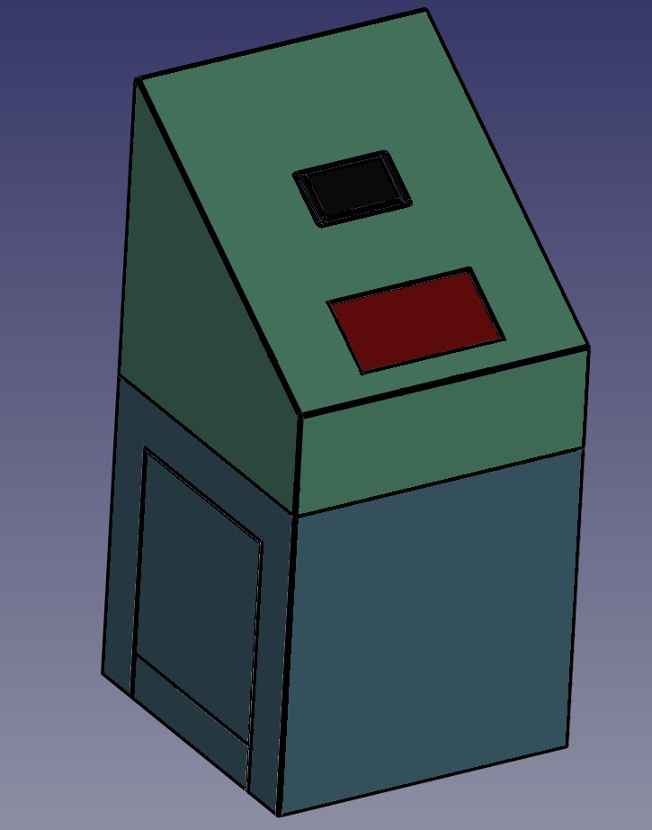

Fig. 1: render of the MediColBox from before it was built

The total weight of the MediColBox is 86 [*kg*] and the aluminium casing has been tested to sustain repeated impacts with an estimated force of 8000 [*N* ] (this has been meassured using an internal accelerometer, meassuring the maximum total acceleration registered during the impact and multiplying that acceleration

with the mass of 86 [*kg*].) In general Aluminium is a somewhat soft metal, so impacts may deform the box, but will most likely not manage to yield access to the inside of the box.

Aluminium, being a soft and malleable material, is somewhat easy to cut, making it weak to the "universal key" constituting of a battery powered angle grinder with specialised cutting discs.

Additionaly, the medicolbox is designed so that it will connect to 230[*V* ] Alternating current, but in case of power loss it can sustain operations, for an undisclosed length of time, while being powered by an internal battery.

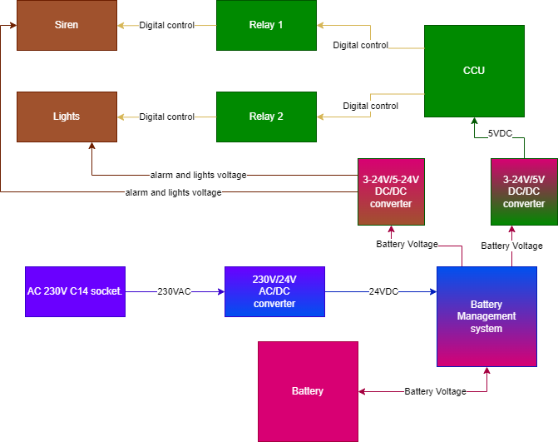

Fig. 2: a diagram showing the power distribution in the MediColBox

It is not shown here, but the MediColbox is not connected to the internet in an effort to prevent hacking attempts that way. this unfortunately also means that we can’t request the positional data of it, if the entire system were to be stolen, so it is important that this is prevented. the study doesn’t look into this problem. This will be designated for future research.

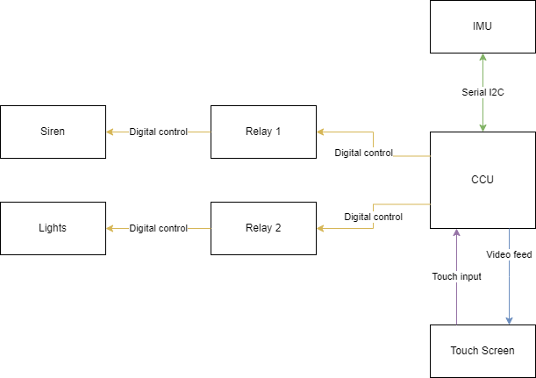

Fig. 3: a diagram showing the data structure in the MediColBox that is related to thi thesis

1. *Definition of the problem*

The problem is intrusion, but is what is intrusion? According to Merriam-Webster, an online English dictionary, intrusion is a noun and is defined in this context as:

“the act of intruding or the state of being intruded” [12] especially:

“the act of wrongfully entering upon, seizing, or taking possession of the property of another” [12]

In the context of the MediColBox, the word "intrusion" refers to attempts on breaking collection system in an effort to gain access to the disposed medicines stored inside. The MediColBox contains medications that are expired or no longer needed, which can pose a danger to individuals if they are not disposed of properly [13].

The improper disposal of medications can lead to environmental contamination, harm to human health, and the potential for misuse.

The black market for medications also presents a criminal incentive to break into the collection system and steal the medications for resale. Additionally, there are individuals who may be addicted to certain medications and would seek to gain access to them for personal use.

Therefore, it is crucial to ensure that the MediColBox is secured and protected from intrusion attempts to prevent the tampering or theft of medications.

This requires the implementation of effective detection and deterrent measures to identify and stop intrusion attempts in real-time.

To intrude into the MediColBox in an attempt to get access to the medicines inside, it will be necessary to get through the outer metal shell. The metal shell, in this context, is a type of mechanical barrier, separating the outside from the inside.

Most types of intrusion attempts can be simplified to the contents of (Table I).

TABLE I: Types of Intrusion Attempts

|  |  |
| --- | --- |
| **Intrusion Attempt** | **Description** |
| Cutting through the shell | This type of intrusion attempt involves using tools such as saws or angle  grinders to physically cut through the outer metal shell of the MediColBox. It is a relatively straightforward method that can be quickly executed if the intruder has the necessary tools and equipment. |
| Forcing apart the shell | Forcing apart the shell refers to attempts to pry open or force the outer metal  shell of the MediColBox using tools such as pry bars or similar implements. This method relies on applying excessive force to separate the components of the shell and gain unauthorized access. |
| Exploiting the shell | Intruders may attempt to unlock the shell using various exploits, such as lock  picking tools, brute force attacks, or electronic hacking techniques. These methods involve manipulating the lock or electronic components of the shell’s locking mechanism to gain access without proper authorization. |

Cutting through or forcing apart the outer metal shell of the MediColBox are relevant intrusion attempts because they can potentially compromise the security of the contents inside, which are the expired or unused medications. Unauthorized access to these medications can pose a serious risk to public health and safety, as they may be misused, abused, or sold illegally.

Cutting through the shell can be done using power tools such as saws or angle grinders, while forcing apart the shell can be done using a pry bar or a similar tool. These methods of intrusion are relatively easy to carry out and can be completed quickly, especially if the intruder has the necessary tools and equipment.

To prevent cutting or forcing open the shell, physical barriers can be implemented. These include tamper- proof screws or bolts, reinforced steel plates, or alarm systems. Tamper-proof screws or bolts are used to secure the outer shell, making it difficult for intruders to unscrew or remove them. Reinforced steel

plates should be placed along the shell to increase its strength and make it more difficult to cut or force apart. Alarm systems are used to alert authorities and deter intruders from attempting to break into the MediColBox.

In addition to physical barriers, other security measures can be employed to prevent intrusion attempts. These include access control systems such as key card readers or biometric scanners, security cameras to monitor the area around the MediColBox, and regular security patrols or checks.

It is important to note that no security measure is completely foolproof, and determined intruders may still be able to find ways to breach the security of the MediColBox. However, by implementing a combination of physical and electronic security measures, the risk of intrusion should be significantly reduced, making contents of the MediColBox better protected.

Exploit-based intrusion attempts on the MediColBox could involve attempts to bypass or manipulate the locking mechanisms in order to gain unauthorized access to the contents inside. These exploit could include using lock picking tools, “brute force attacks”, or electronic hacking techniques.

Lock picking tools are designed to manipulate the internal workings of locks in order to unlock them without using the key. Brute force attacks involve attempting to force the lock by applying excessive force, such as hitting or kicking the lock or using a tool to pry it open. Electronic hacking techniques may involve attempting to manipulate the electronic components of the lock, such as by intercepting signals sent between the lock and its control system or by exploiting vulnerabilities in the lock’s firmware or software.

Exploit-based intrusion attempts are difficult to detect and prevent because they may not leave physical evidence and may not trigger alarms or other security measures. In addition, these types of attacks may be carried out by individuals with specialized knowledge or equipment, making them more difficult to defend against.

The potential consequences of an exploit-based intrusion attempt on the MediColBox could include unauthorized access to the expired or unused medications inside, which could lead to harm to individuals who consume or misuse them. In addition, successful exploitation of the MediColBox’s security measures could compromise the overall security of the system, potentially leading to further unauthorized access or theft of medications.

To prevent exploit-based intrusion attempts, it is important to implement strong physical and electronic security measures, as well as regular monitoring and maintenance of the security systems. This include using tamper-proof locks and security cameras, implementing access control systems with strong authentication mechanisms, and regularly updating the firmware and software of the locking mechanisms to address any known vulnerabilities. It is also important to regularly review and update security policies and procedures to ensure that they are up-to-date and effective in addressing new threats and risks.

the last point in the list implies there is something unpredicted and unplanned, so this project will recommend this for future studies instead of covering it in this study.

the project will therefore focus on detecting and deterring cutting and forcing open the shell.

There are several detection and deterrence methods that should be used to prevent cutting and forcing open the shell of the MediColBox as specified (Table II).

Existing technologies that are adapted for use in the MediColBox include tamper-proof bolts, internal reinforced steel frames, alarm systems, and smart locks. These technologies are integrated into the overall system by connecting them to a central control system or security platform, which monitor and manage the various security measures in real-time.

TABLE II: Potential Security Measures for MediColbox

|  |  |
| --- | --- |
| **Security Measure** | **Description** |
| Physical Barriers | As mentioned earlier, physical barriers such as tamper-proof screws, reinforced  steel plates, or alarm systems are used to prevent unauthorized access to  the MediColBox. These barriers deter intruders from attempting to break into the box and could also alert authorities to any intrusion attempts. |
| Inertial Measurements | Utilizing an IMU in the sensor card to detect any changes in the box’s  orientation or movement, providing additional data for intrusion detection and prevention. |
| Motion Sensors | Motion sensors can if nessecary be placed around the MediColBox to detect  any movement or activity in the surrounding area. If an intruder attempts to cut or force open the shell, the motion sensors will detect their movement and trigger an alarm, alerting authorities to the intrusion attempt. |
| Video Surveillance | Video cameras could if nessecary be installed around the MediColBox to  monitor any activity in the surrounding area. The footage can be monitored in real-time by security personnel, who could alert authorities to any intrusion attempts. |
| Smart Locks | Smart locks are used to secure the MediColBox, using electronic authentica-  tion mechanisms such as biometric scanners, keycard readers, or passwords. These locks should be integrated with other security measures, such as motion sensors or video surveillance, to provide additional layers of security. |
| GPS Tracking | GPS tracking technology can in the future be used to monitor the location  of the MediColBox and track any unauthorized movement or tampering. This could help to deter theft or unauthorized access to the box. |

Overall, by implementing a combination of physical and electronic security measures, the risk of cutting and forcing open the shell of the MediColBox should significantly reduced, making the contents of the box better protected.

* 1. Methodology

In this section, the methodology for observing and analyzing intrusion attempts on the MediColBox will be outlined. A description of the phenomenon of interest, data collection methods, sampling strategy, data collection procedures, ethical considerations, data analysis approach, validity and reliability measures, and limitations of the study will be provided.

1. *Phenomenon of Interest*

The phenomenon of interest in this study is intrusion attempts on the MediColBox. The various aspects of intrusion, and the methods employed by intruders, will be simulated. By understanding these aspects, the project aims to enhance the security and protection of the MediColBox and the medications it contains.

1. *Data Collection Methods*

To collect data on intrusion attempts, the project will primarily utilize the Inertial Measurement Unit (IMU) as the main data collection method for detecting intrusion attempts on the MediColBox. This choice allows for a more focused investigation into the effectiveness of the IMU in identifying unauthorized access.

The IMU, with its capability to capture physical movements, vibrations, and orientation changes of the MediColBox, provides valuable data for intrusion detection and analysis. By relying on the IMU alone, the project aims to determine if it can effectively detect and alert on intrusion attempts without the need for additional systems.

This approach also enables the project to address the feasibility of implementing other data collection methods mentioned earlier, such as motion sensors, video surveillance, access logs, incident reports, and interviews. By evaluating the standalone performance of the IMU, the project will assess its potential to serve as a cost-effective and efficient solution for intrusion detection on the MediColBox.

The investigation will involve testing and analysis of the IMU data collected during simulated intrusion attempts. This evaluation will focus on assessing the accuracy, reliability, and timeliness of the IMU in detecting and alerting on unauthorized movements or tampering.

By dedicating the study to evaluating the IMU’s effectiveness as a standalone solution, the project aims to determine if the implementation of additional data collection methods is necessary for robust intrusion detection. The results will provide insights into the suitability and viability of relying solely on the IMU for enhancing the security and protection of the MediColBox and its contents.

(Table III) presents potential data collection methods for intrusion attempts.

TABLE III: Potential Data Collection Methods for Intrusion Attempts

|  |  |
| --- | --- |
| **Data Collection Method** | **Description** |
| Motion Sensors | Implementing motion sensors that could, if implemented, detect unauthorized  movements near the MediColBox. |
| Inertial Measurements (IMU) | Utilizing an Inertial Measurement Unit (IMU) to detect any changes in the  orientation or movement of the MediColBox, providing data for intrusion detection and analysis. |
| Video Surveillance | Installing surveillance cameras around the MediColBox to capture intrusion  attempts visually. |
| Access Logs | Maintaining detailed logs of access attempts and recording any suspicious  activities. |
| Incident Reports | Gathering information from incident reports filed by security personnel or  individuals who have witnessed intrusion attempts. |
| Interviews | Conducting interviews with security personnel to gain insights into their  experiences and observations regarding intrusion attempts. |

The IMU, with its capability to capture physical movements, vibrations, and orientation changes of the MediColBox, provides valuable data for intrusion detection and analysis. By relying on the IMU alone, the project aims to determine if it is effective at detecting and alerting on intrusion attempts without the need for additional systems.

This approach also enables the project to address the feasibility of implementing the other data collection methods mentioned earlier, such as motion sensors, video surveillance, access logs, incident reports, and interviews. By evaluating the standalone performance of the IMU, the project will assess its potential to serve as a cost-effective and efficient solution for intrusion detection on the MediColBox.

The investigation will involve comprehensive testing and analysis of the IMU data collected during simulated intrusion attempts. This evaluation will focus on assessing the accuracy, reliability, and timeliness of the IMU in detecting and alerting on unauthorized movements or tampering.

By dedicating the study to evaluating the IMU’s effectiveness as a standalone solution, the project aims to determine if the implementation of additional data collection methods is necessary for robust intrusion detection. The results will provide insights into the suitability and viability of relying solely on the IMU for enhancing the security and protection of the MediColBox and its contents.

1. *Prototype Construction*

The prototype control system is constructed using the following components:

* + 1*×* Single-board computer: Raspberry Pi 4B 8 GB [9] as the CCU
  + 1*×* Human-Machine Interface (HMI): 7-inch touchscreen [10]
  + 1*×* Sensor Card: Raspberry Pi Sense Hat v1.0.0 [11] with an integrated IMU
  + 4*×* M3 8 mm long threaded screws
  + 8*×* M3 8 mm long spacers with 8 mm threaded rods on one side
  + 1*×* 22-pin 0.5 mm pitch cable for the DSI connectors

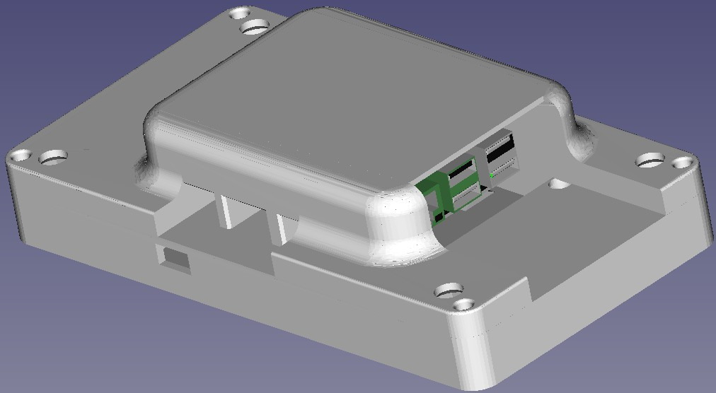

Fig. 4: Design of the prototype with the cover on

* + 1*×* USB type A to USB type micro B cable for power and GND between HMI and Raspberry Pi
  + 1*×* USB type A to USB type C cable for power
  + 1*×* 230 V AC to USB type A power adapter
  + 1*×* Custom-designed cover to protect the electronics during testing
  + 4*×* M3.5 8 mm long screws
  + 4*×* M4 10 mm long screws

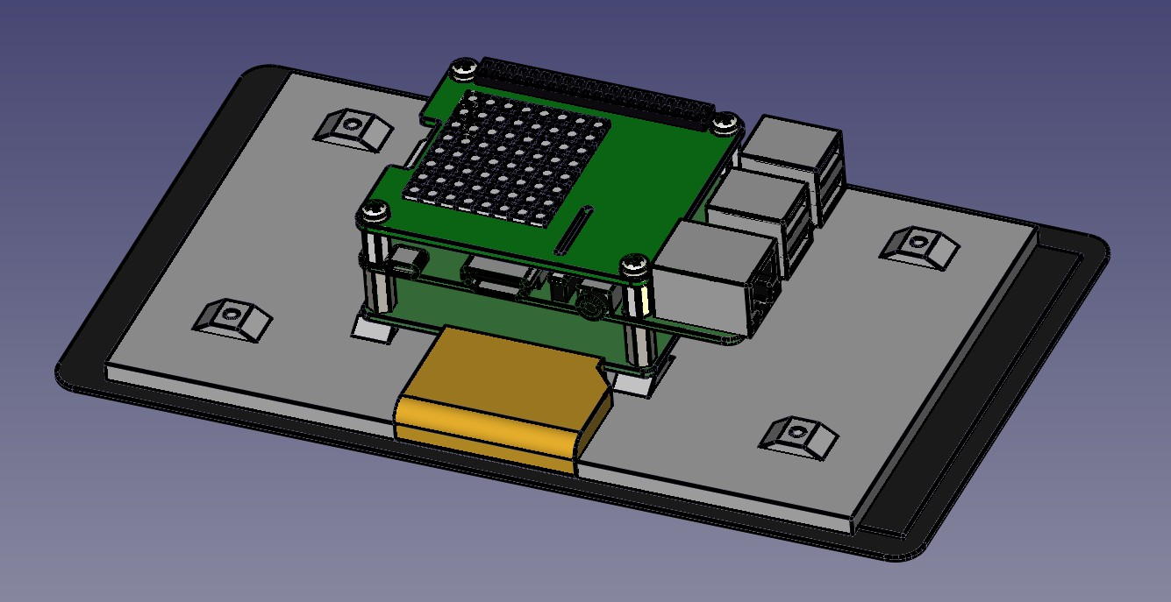

Fig. 5: Design of the prototype without the cover

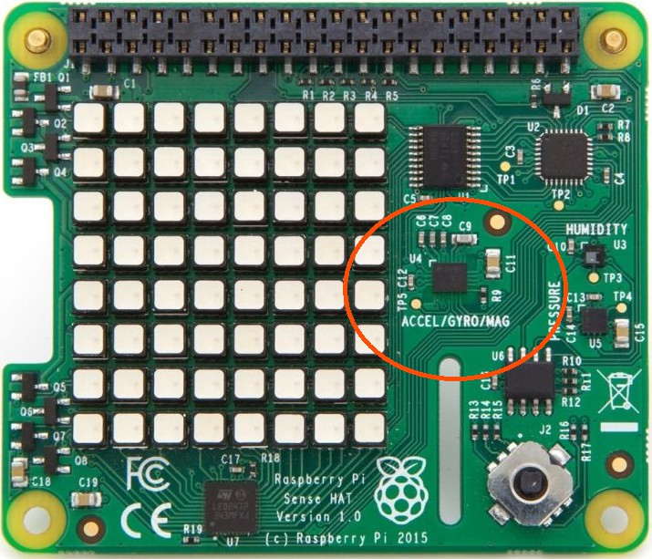Fig. 6: Photograph of the sensor card, with the location of the IMU located The construction process involves the following steps:

1. Assemble the prototype:
   1. Mount the Raspberry Pi 4B on the 7-inch touchscreen by using the threaded spacers.
   2. Mount the Raspberry Pi Sense Hat on the Raspberry Pi 4B by attaching it to the 2*×*20 pin.
2. Connect the components according to the wiring diagram (Figure 8):
   1. Connect the DSI output from the Raspberry Pi to the DSI input on the 7-inch touchscreen using a suitable ribbon cable.

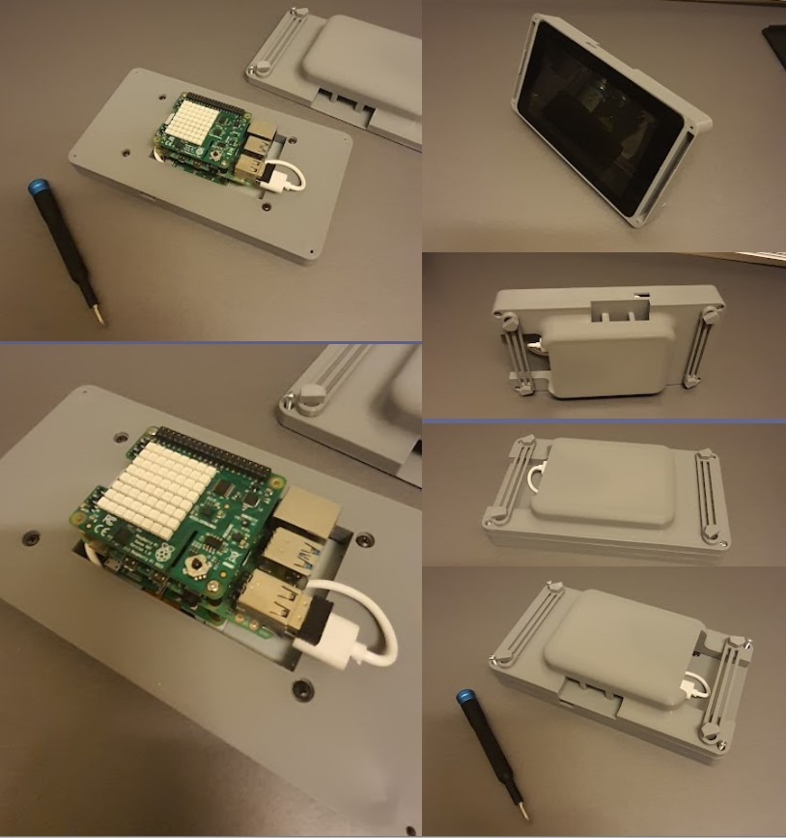

Fig. 7: Photograph of the prototype under assembly of the cover

* 1. Connect the display’s USB type micro B power connector input to one of the USB type A connectors on the Raspberry Pi (it does not matter which one).

1. Enclose the electronics with the custom-designed cover.
   1. Attach the screen to the first part of the casing using the M3.5 screws.
   2. Attach the second part of the casing to the first part of the casing using the M4 screws.
2. Configure the software environment for the Raspberry Pi 4B and install the necessary libraries and drivers.
   1. Open Raspberry Pi Imager. Install it if you don’t already have.
   2. Insert the micro SD card into you computer. You can use adapter if needed.
   3. On Raspberry Pi Imager, select the storage device to install the operating system. Select the micro SD card.
   4. On Raspberry Pi Imager, select operating system to install. Select Raspberry Pi OS.
   5. Click “write” and wait til complete.
   6. Remove the micro SD card and insert it into the Raspberry Pi.
   7. start the Raspberry Pi, open terminal and type the code:

sudo raspi-config

* 1. Select “Interfacing Options”
  2. Select the “I2C” option
  3. Select “<Yes>”
  4. Select “<Ok>”
  5. Select “<Yes>”

1. Establish communication between the CCU, HMI, and the sensor card by setting up appropriate interfaces and protocols.
   1. implement software that follows this sequence (Figure 9)

USB A - C Cable 2x20 GPIO header

Raspberry Pi 4B 8 GB

230V AC - USB C

Raspberry Pi Sense HAT

USB

A-microB Cable

DSI

22 pin

0.5 mm Pitch Cable

Fig. 8: The “wiring diagram” used

7" touch screen

Start

Main_Loop()

Setup()

Connect to IMU over I2C

Setup() Start

Setup() Start

Start button

what button was pressed

?

Save button

Stop button

start intervall to read all data from IMU every

50 millisecond

stop intervall to read all data from IMU every

50 millisecond

save .csv file

specify name for .csv file

Main_Loop()

Fig. 9: The Sequence diagram used for the program

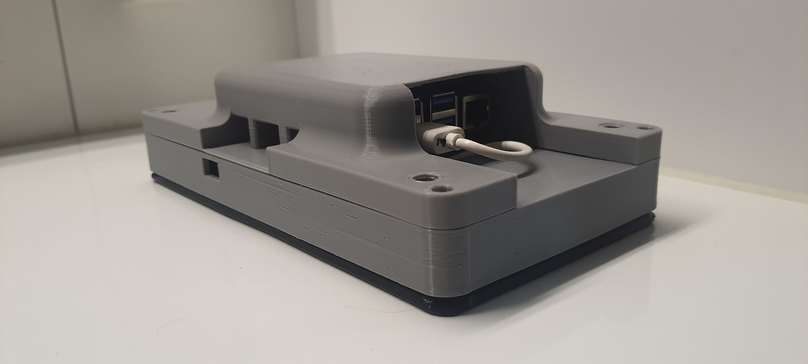

Fig. 10: Photograph of the prototype

1. *Sampling Strategy*

For our study, we define a sampling strategy hoping to simulate the different scenarios associated with intrusion attempts on the MediColBox. Our samples will include the prototype being exposed to scenarios that should emulate how the IMU would "see" the instances of related intrusion attempts,

1. *Data Collection Procedures*

To collect data on intrusion attempts, we could use different methods for gathering data. These methods involve implementing the following data collection methods (Table IV):

TABLE IV: Possible Data Collection Methods for Intrusion Attempts

|  |  |
| --- | --- |
| **Data Collection Method** | **Description** |
| Installing Surveillance Cameras and Motion Sensors | Installing surveillance cameras and motion sensors at strategic locations  around the MediColBox. |
| Implementing Protocols for Incident Documentation | Implementing protocols for documenting and reporting intrusion incidents,  including recording timestamps, descriptions of the events, and any available contextual information. |
| Reviewing Video Footage, Access Logs, and Incident Reports | Regularly reviewing video footage, access logs, incident reports, and conduct-  ing interviews to gather relevant data. |
| Ensuring Equipment Functionality and Maintenance | Ensuring the proper functioning and maintenance of surveillance equipment  and data storage systems. |

All of these procedures could help us capture the necessary data for analysis and provide a comprehensive understanding of intrusion attempts on the MediColBox. However, this study will solely study how the IMU stands on its own, which is why the prorotype is made to read the simulated scenarios.

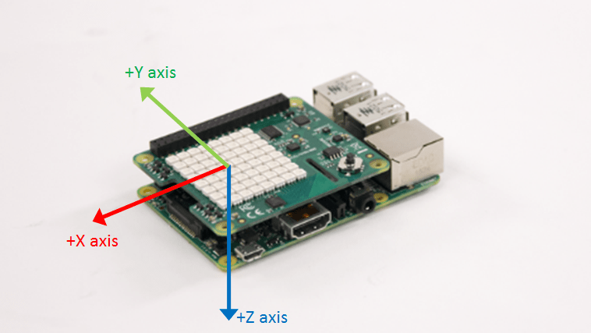

Fig. 11: Visualisation of which axis points towards what direction in relation to the sensor card

The prototype is designed to gather a wide range of sensor data, which is stored in CSV format for subsequent analysis. The CSV file contains the following headers representing different measurements:

The dataset provided by the Prototype is all of the data the sensor card will provide. Analysis of the data and understanding of the dynamics of intrusion attempts, should enable the development of more robust security measures for the MediColBox.

The fusionPose and the tiltHeader are estimated values and will not be used during this study. However, the fusionPose and the tiltHeader are mentioned so that for others reading through the svg files know what they are.

1. *Ethical Considerations*

We recognize and address ethical considerations related to our study. This includes:

* + Adhering to relevant data protection regulations and guidelines.
  + Anonymizing data during the analysis phase to protect the identities of individuals involved.

TABLE V: Format of the Sensor Data Collected by the Prototype

|  |  |  |
| --- | --- | --- |
| **Header** | **Description** | **Unit** |
| timestamp | The date and time when the data was recorded | ISO 8601 |
| accelX | Accelerometer reading along the X-axis | fraction of g (local gravitational acceleration) |
| accelY | Accelerometer reading along the Y-axis | fraction of g (local gravitational acceleration) |
| accelZ | Accelerometer reading along the Z-axis | fraction of g (local gravitational acceleration) |
| gyroX | Gyroscope reading around the X-axis | radians/s |
| gyroY | Gyroscope reading around the Y-axis | radians/s |
| gyroZ | Gyroscope reading around the Z-axis | radians/s |
| compassX | Magnetometer reading along the X-axis | *µT* (microteslas) |
| compassY | Magnetometer reading along the Y-axis | *µT* (microteslas) |
| compassZ | Magnetometer reading along the Z-axis | *µT* (microteslas) |
| fusionPoseX | Euler angle from sensor fusion along the X-axis | radians |
| fusionPoseY | Euler angle from sensor fusion along the Y-axis | radians |
| fusionPoseZ | Euler angle from sensor fusion along the Z-axis | radians |
| tiltHeading | Heading angle based on the tilt compensation | radians |
| pressure | Atmospheric pressure | hPa (hectopascals) |
| temperature | Ambient temperature | °C (Celsius) |
| humidity | Relative humidity | % |

By considering these ethical considerations, we aim to conduct our study with integrity and respect for individuals’ privacy.

1. *Data Analysis*

The collected data from the IMU is analyzed using a systematic approach. Since there is no video footage or access logs available, our analysis focuses solely on the data captured by the IMU. The analysis process includes the following steps:

* + Data preprocessing: The collected IMU data is preprocessed to ensure its quality and suitability for analysis. This may involve removing any noise or outliers, normalizing the data, and performing any necessary transformations to prepare it for further analysis.
  + Exploratory data analysis: We conduct exploratory data analysis to gain a better understanding of the IMU data. This involves visualizing the data, examining summary statistics, and identifying any patterns or trends that may be present. Exploratory analysis helps in identifying initial insights and forming hypotheses for further investigation.
  + intrusion detection algorithm: We develop or utilize an intrusion detection algorithm that process the IMU data and identify potential intrusion attempts. This algorithm is trained and validated using a suitable methodology to ensure its effectiveness in detecting unauthorized access based on the IMU readings.
  + Statistical analysis: If applicable, statistical analysis techniques will be employed to analyze the IMU data further. This may include identifying correlations between different variables or conducting hypothesis testing to validate any observed patterns or relationships.
  + Data visualization: Data visualization techniques, such as plots, charts, or graphs, will be employed to present the analyzed IMU data effectively. Visualizations should help in understanding the patterns, trends, and anomalies in the data, making it easier to interpret and communicate the findings.

By conducting an analysis of the anonymized IMU data, we aim to gain insights into the effectiveness of the IMU in detecting intrusion attempts on the MediColBox. This analysis will contribute to the assessment of the IMU as a standalone solution for enhancing the security and protection of the MediColBox and its contents.

1. *Limitations*

It is essential to acknowledge the limitations inherent in studying intrusion attempts on the MediColBox. These limitations may include:

* + **Availability of intrusion data:** The limited availability of documented intrusion attempts may impact the sample size and the generalizability of the findings.
  + **Challenges in capturing all intrusion attempts:** Some intrusion attempts may go undetected or unreported, leading to potential underrepresentation in the collected data.
  + **Generalizability of findings:** The context of the MediColBox and the specific locations where it is deployed may influence the generalizability of the findings to other similar systems.
  + **Resources avaiable:** the team working on this study is constituting of one singular bachelors student, very much both guided and helped along by one internal mentor. This poses a limit for both the amount of collective knowledge avialable and the work-hours the team has capacity for. Additionally, due a lack of external funding for the project, many a task, both planned and hoped for, had to be cut.

We address many of these limitations by selecting as much data as the funding allowed for gathering, and by providing contextual information to aid in the interpretation and application of our findings.

By incorporating these elaborations into the methodology section, we should effectively be able to observe and analyze intrusion attempts on the MediColBox, hopefully gaining insights into the methods, motivations, and potential vulnerabilities associated with these attempts.

1. *Tools and Technologies*

During the course of this study, the following tools and technologies were utilized:

* + **LaTeX:** LaTeX, a typesetting system widely used in academia and scientific research, was used for document preparation. It provided powerful tools for creating professional-looking documents, including support for mathematical equations, figures, tables, and bibliographic references.
  + **Visual Studio Code (VSCode):** VSCode, a versatile text editor, served as the primary tool for writing code, editing documents, and managing project files. It provided a user-friendly interface, syntax highlighting, code completion, and integration with version control systems like Git.
  + **FreeCAD:** FreeCAD, an open-source computer-aided design (CAD) software, was utilized for designing and creating 3D models of the prototype. It enabled precise modeling and visualization of the physical components, ensuring accurate representation and construction.
  + **GitHub:** GitHub, an open-source web-based platform for version control and collaboration, was used to track changes, collaborate with team members, and maintain the integrity and availability of project files. It provided a centralized repository for source code and project documentation.
  + **Programming Languages:** The primary programming languages used in this study were Python and JavaScript. Python, an open-source language, was employed for data analysis, algorithm development, and system control, while JavaScript, also open-source, was utilized for web development and implementing the human-machine interface (HMI) functionality.
  + **Electron:** Electron, an open-source framework for building cross-platform desktop applications, was utilized for developing the HMI. It enabled the integration of open-source web technologies (HTML, CSS, and JavaScript) into a standalone application, providing a responsive and user-friendly interface.

These tools and technologies played a crucial role in streamlining the research process, facilitating data analysis, and developing a functional prototype that aligns with the research objectives. By prioritizing open-source solutions, the study fostered collaboration, transparency, and accessibility, promoting the advancement of knowledge and encouraging community contributions.

1. *Document Preparation*

The document was prepared using LaTeX, an open-source typesetting system widely used in academia and scientific research. LaTeX provided powerful tools for creating professional-looking documents, including support for mathematical equations, figures, tables, and bibliographic references.

To facilitate the writing process, Visual Studio Code (VSCode), an open-source text editor, was utilized as the primary tool. VSCode offered a range of features and extensions that enhanced productivity and provided a seamless writing experience. It enabled efficient collaboration, syntax highlighting, code completion, and integration with version control, ensuring the integrity and consistency of the document.

By leveraging open-source tools like LaTeX and VSCode, the study embraced the principles of openness, collaboration, and knowledge sharing, fostering innovation and contributing to the open-source community.

* 1. Results

The results’ section presents the findings from the analysis of the data collected during the simulated intrusion attempts on the MediColbox. The data provides insights into the physical movements and vibrations experienced by the MediColbox during these intrusion scenarios.

1. *Analysis of the Data*

The data captured the inertial patterns resulting from different simulated intrusion attempts, including striking, dropping, sawing, and shaking the MediColbox. The data analysis focused on the accelerometer readings as base point to evaluate the sensitivity and effectiveness of the IMU in detecting unauthorized access. Some of the events will, if relevant, use the gyroscopic data.

* 1. *Striking the MediColbox:* This event is an attemp to simulate an intrusion event in the form of somebody trying to break open the MediColBox by hitting the box with something like a hammer that might expose the box to a large force.

Figure 12 presents the accelerometer data recorded when the MediColbox was struck with a fist.

at the start of the graph we can see the reading of the body of the prorotype at rest. it shows an acceleration wit hthe magnitude of approximately 10 [*m/s*2] divided among the *z* and *y* direction of the sensor. this is the object experiencing the "normal force" which acts upon the object to keep it standing still against the acceleration of gravity. if we are to read 0 [*m/s*2] the IMU will need to be in "free fall". "free fall" is any motion of a body where gravity is the only force acting upon it [14]. thus, now that we know that the read acceleration is from the normal force, which means it is pointing opposite to the direction of gravity, we can compare the direction of the read acceleratoin with the directions from Figure 11 and conclude the orientation of the protoype will be with the face of the HMI facing downwards.

When we continue looking at the graph, moving our gaze along the axis of time, the accelerometer readings show a sharp increase in acceleration, describing the impact during the event of somebody striking the prototype, followed by a swift, and then gradual decrease in acceleration as the impact of the strike dissipate. We can see that the acceleration is the same direction as the normal force. The strike is done from above, striking directly down at the prototype. The aceleration read is most likely again the normal force, accelerating the prortype back to standing still, resisting the force from the fist. We should also see the acceleration from the fist hitting the prototype, but it seems the sampling frequency isn’t hight enough to pick up all the details in the event. The peak acceleration value reached during the strike was measured at *X* = 5 [*m/s*2], *Y* = *−*31[*m/s*2], *Z* = *−*55 [*m/s*2] and occurred at *t* = 0*.*8 [*s*]. The analysis of the data indicates that the IMU successfully detected and recorded the impact caused by the striking event.

strike

10

X axis

Y axis

Z axis

5

0

−5

−10

−15

−20

Acceleration [m/s^2]

−25

−30

−35

−40

−45

−50

−55

−60

0 1 2 3

Time [s]

Fig. 12: Accelerometer data during the striking event

Looking at the data we can also see the peak acceleration and how it stands out from the rest of the data visualized. However, how do we set criteria so that we can automatically differentiate an attempt of intrusion from just a random event? A way we, during the data gathering, could reason for, would be to find the force needed to break the box and estimate it from the weight of the box how much acceleration would be close to breaking the box open. In this case the data gathering "Protoype" is 0*.*645 [*kg*]. With the measured acceleration in *X*, *Y* and *Z* direction results in a combined acceleration

p

of *|→−a |* = 52 + (*−*32)2 + (*−*55)2 [*m/s*2] *≈* 63*.*332 [*m/s*2]. If a box is designed to handle an impact

large enough to momentary expose it to 63*.*332 [*m/s*2] multiplied by a given safety factor, then it would be viable to account for sensor error margins and say that any acceleration above 60 [*m/s*2] should immediately trigger an alarm.

If we look back to the begining of this paper, on to how it is mentioned that the MediColBox is tested for impacts up to 8000 [*N* ], using Newtons second (*F* = *ma*) law we estimate that a force of 8000 [*N* ] would be meassured as an acceleration with the magnitude of 93 [*m/s*2] since it weights 86 [*kg*]. calculating it backwards an acceleration of 60 [*m/s*2] would result in 5160 [*N* ]. That is a massive force, and not something you would just randomly expose an object to without massive effort. To put it in persoective, if you pushed down on a bathroom-weight with the force of 5000 [*N* ] it would show approximately 500 [*kg*] on the display. The Prototype is a lot lighter (it only weights 0*.*645 [*kg*]) so in reality the impact force is a lot closer to 40 [*N* ] which is a lot less than the 5000 [*N* ] that would be needed to accelerate it similarly. Logically this means that the heavier the box, the lower the criteria will be for meassured acceleration to trigger an alarm, and the more difficult it will be for this method to differentiate an intrusion attempt with random noise.

Another method that could be to assume that if somebody wanted to break the box, they would either break the box in one strike, or try to hit the box repeatedly with strikes that individually might not break the box but that combined might manage to break the bx due to material fatigue. If we divide the strike force that would immediately trigger an alarm (in this case 60 [*m/s*2]), by the estimated resistance to fatigue in a scale from 0 to 1 and raise it to the number of strikes you assume you would need to break the box using the assumed amount of needed repeated strikes. An example of this could be to do the calculation:

*aRepeated ∗ ρfatiguenstrikes →* 60[*m/s*2] *∗* 0*.*95 *≈* 35*.*43[*m/s*2]

In this example then 5 repeated strikes of approximately 35*.*43[*m/s*2] will also trigger an alarm.

An algorithm we deviced would be to run two loops, one loop every time we read a value from the IMU. If the acceleration has a magnitude equal to, or greater than the strike kriteria *Kstrike*, then raise the alarm. additionally, if the acceleration has a magnitude equal to, or greater than the weaker strike kriteria *Krepeated*, increase the value of *nrepeated*. If the value of counted strikes *nrepeated* becomes equal to, or greater than the criteria of repeated strikes *nstrikes*, which we mentioned in one of the equations earlier, then trigger the alarm.

the second loop will occur periodically with a time interval equalt to *T* , which can be described as:

*T* = *TtotalCountingT ime*

*nstrikes*

Where *TtotalCountingT ime* is the total time span you expect the number of strikes *nstrikes* to happen within.

In the case of striking we have found that *Kstrike* = 60 [*m/s*2] combined with *ρfatigue* = 0*.*9, *nstrikes* = 5 and *TtotalCountingT ime* = 10 [*s*] will be optimal values to detect impacts on the prototype. As the MediColBox is substantially heavier, we will need too lower *Kstrike*.

* 1. *Dropping the MediColbox:* The accelerometer data, collected when the MediColbox was slowly and carefully pushed off of a table, is presented in Figure 13.

here we observe the protope starts at rest with the face of the HMI facing directly upwards. you then see a small time where an acceleration read is 0 [*m/s*2]. This is the time the protoype experiences free fall. After the time of free fall we se a peak similar to the impact during the striking with the dirrefence of the read acceleration in *z* direction goes from being positiveto being negative. This change suggests that the prototype changes orientation from where the face of the HMI faces upwards to be facing downwards.

The maximum acceleration value recorded during the drop was *X* = *−*7*.*7[*m/s*2], *Y* = 35[*m/s*2], *Z* =

*−*50*.*7[*m/s*2], which occurred at *t* = 5*.*1[*s*]. The analysis confirms that the IMU effectively captured the acceleration changes associated with the dropping event.

40

35

30

25

20

15

10

5

0

Acceleration [m/ ^2]

−5

−10

−15

−20

−25

−30

−35

−40

−45

−50

−55

drop

Z axi

X axi Y axi

0 1 2 3 4 5 6 7 8 9

Time [ ]

Fig. 13: Accelerometer data during the dropping event

Analyzing the data similarly to how we did at the striking event we find that in this case we have a total peak acceleration of *|→−a | ≈* 62[*m/s*2] this would already trigger the previously set trigger criteria of

60[*m/s*2]. looking at the gyroscope data from Figure 14 we can see that there is also a lot of rotational movement starting as early as *t* = 4 this suggests that the Prototype is rolling of the edge of where it was dropped from. this reading of roation confirms that the object was rotating when the acceleration

suggested the prortype changed orientation.

Gyroscope

6

gyroX gyroY gyroZ

4

radians per second [rad/s]

2

0

−2

0 2 4 6 8

seconds [s]

Fig. 14: Gyroscope data during the dropping event

If we numerically integrate the Gyroscope’s angular velocity over time to make position we get an estimate of pose visualized in Figure 15.

we can approximate this by multiplying the time difference ∆*t* at any point *i* of reading, with the meassured

angular velocity *dθ* from the gyroscope at that same point *i*, and accumulate it over time, making the

*dt*

current accumulated changes in angle of time at the point *i* to be the current angle *θ* at that point *i*.

Z *dθdt ≈* X *dθi* ∆*t* = *θ*

*dt dt i* *i i*=0

In the pose data we notice that the estimated pose changes by approximately 3*.*1[*rad*] (about 180 degrees) in between time *t* = 4 and *t* = 4*.*7 this strongly suggest that the Protoype has roled half a round around the *X*-axis. This is supported in how the acceleration (Figure 13) shows the *Z*-axis changes from being positive to being negative. The pose changing in such drastic ways will be representative of how a box can be tipped over or turned around during an intrusion attempts when an intruder tries to figure out where to attack. Integrating position and velocity from acceleration and pose is also possible and combining the accumulated change in pose and the accumulated change in change of position might be valuable when

Pose

3.0

poseX poseY poseZ

2.5

2.0

pose [radians]

1.5

1.0

0.5

0.0

−0.5

0 2 4 6 8

seconds [s]

Fig. 15: Pose estimate during the dropping event

the box wants to detect if somebody picks up the box and/or moves it to somewhere it shouldn’t be. Using this we could theoretically set an area of where box is restricted to be within or outside.

A problem with this is that differentiating between intrusion attempts and just any random regular use is near impossible, and combined with how accumulating values also result in accumulated error. This makes any estimate less accurate over time, and reliability-maximizing algorithms, will be necessary if we are to do anything over longer time with this data with accumulating error.

However, even though the gyroscope data alone cannot help without increasing reliability, we can by using newtons first law (a body at rest experiences a sum of zero forces in any direction) make use of the orientation of the read normal force at every time when the magnitude is close to the local gravitational constant.

X *F* = *m* X *a* = 0

X *F* = *Fnormal* + *Fgravity* = 0

Using this logic we can say that if *a* = 0 then *Fnormal* + *Fgravity* = 0 meaning that *|Fnormal|* = *|Fgravity|*

and the two vectors points opposite to each others.

this way we can estimate the orientation of the prortype using the accelerometer. and an algorithm saying that any time we detects the protoype being tipped on the side, or up side down, should be a time where we should sound the alarm.

giving us an aditional trigger to the alarm triggering algorithm.

If the angle of the prototype in pith and/or roll, changes to become equal to, or greater than 90 degrees plus minus an error value, then trigger the alarm.

* 1. *Sawing on the MediColbox:* This event is tested by mounting the prototype to a wooden plank, and manually sawing in that plank using a hacksaw.

Figure 16 illustrates the accelerometer data recorded while sawing on the MediColbox using a metal cutting saw. The data exhibited periodic variations in acceleration corresponding to the back-and-forth sawing motion. The analysis of the data indicated a consistent pattern of acceleration changes during the sawing event. This suggests that the IMU was able to capture the vibrations and oscillations caused by the sawing action.

the data seems like noise, so we might need to look at the Fourier analysis of the data.

1

0

−1

−2

−3

−4

Accelera ion [m/s^2]

−5

−6

−7

−8

−9

−10

−11

−12

sawing

|  |  |  |  |  |  |  |  |  |  |  |  |  |  |  |  |  |  |  |  |  |
| --- | --- | --- | --- | --- | --- | --- | --- | --- | --- | --- | --- | --- | --- | --- | --- | --- | --- | --- | --- | --- |
| X axis  Y axis  Z axis |  |  |  |  |  |  |  |  |  |  |  |  |  |  |  |  |  |  |  |  |
|  |  |  |  |  |  |  |  |  |  |  |  |  |  |  |  |  |  |  |  |  |
|  |  |  |  |  |  |  |  |  |  |  |  |  |  |  |  |  |  |  |  |  |
|  |  |  |  |  |  |  |  |  |  |  |  |  |  |  |  |  |  |  |  |  |
|  |  |  |  |  |  |  |  |  |  |  |  |  |  |  |  |  |  |  |  |  |
|  |  |  |  |  |  |  |  |  |  |  |  |  |  |  |  |  |  |  |  |  |
|  |  |  |  |  |  |  |  |  |  |  |  |  |  |  |  |  |  |  |  |  |
|  |  |  |  |  |  |  |  |  |  |  |  |  |  |  |  |  |  |  |  |  |
|  |  |  |  |  |  |  |  |  |  |  |  |  |  |  |  |  |  |  |  |  |
|  |  |  |  |  |  |  |  |  |  |  |  |  |  |  |  |  |  |  |  |  |
|  |  |  |  |  |  |  |  |  |  |  |  |  |  |  |  |  |  |  |  |  |
|  |  |  |  |  |  |  |  |  |  |  |  |  |  |  |  |  |  |  |  |  |
|  |  |  |  |  |  |  |  |  |  |  |  |  |  |  |  |  |  |  |  |  |

0 1 2 3 4 5 6 7 8 9 10 11 12 13 14 15 16 17 18 19

Time [s]

Fig. 16: Accelerometer data during the sawing event

The Fourier analysis of the accelerometer data during the sawing event is shown in Figure 17. The Fourier analysis allows us to examine the frequency components present in the accelerometer readings and provides insights into the characteristics of the sawing action. By analyzing the frequency distribution and identifying prominent peaks or patterns in the frequency domain, we can gain a deeper understanding of the dynamic response of the MediColbox to the sawing forces.

We see a large peak at 4000 [*m/s*2] at about 0*.*1 [*Hz*] or about every 10 [*s*]. this appears to be the times when the hacksaw jammed in the wood, which happened about every 8 to 12 seconds when sawing. Even though it would be nice to assume athat an intrusion attampt done by a hacksaw would preiodically jam, we dont want to use this as a trigger. it seems too unreliable a phenomenon to trigger the alarm.

* 1. *Shaking the MediColbox:* The accelerometer data is obtained by mounting the protoype to a sifter. this shaking motion is suppoesd to simulate and intrusion attempt done by trying to cut the MediColbox with an angle grinder. the data is shown in Figure 18. The data exhibited irregular and rapid fluctuations in acceleration due to the shaking motion. The analysis of the data demonstrated that the IMU was sensitive

fourier analysis of sawing

4000



Y Axis

Z Axis

X Axis

3500

3000

2500

2000

Acceleration [m/s^2]

1500

1000

500

0

0 2 4 6 8 10

Frequency [Hz]

Fig. 17: Fourier analysis of accelerometer data during the sawing event

enough to detect and record these rapid changes in acceleration, indicating its potential for detecting unauthorized access attempts involving similar movements.

shaking

40

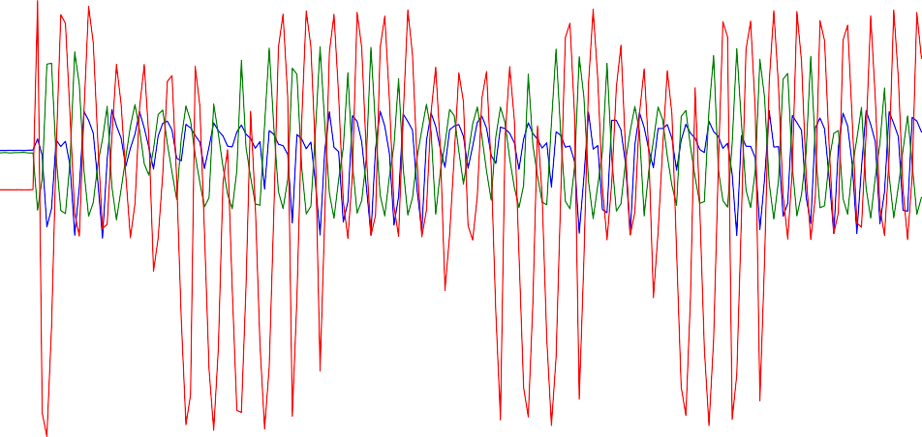

X axis Y axis

Z axis

35

30

25

20

15

10

5

0

−5

Accele ation [m/s^2]

−10

−15

−20

−25

−30

−35

−40

−45

−50

−55

−60

−65

−70

0 1 2 3 4 5 6 7 8 9 10 11 12 13 14 15 16 17 18 19

Time [s]

Fig. 18: Accelerometer data during the shaking event

Analysing the accelerometer data using Fourier analysis is shown in Figure 19. The Fourier analysis shows 3 peaks at frequencies near to 0*.*1 [*Hz*], near to 1*.*8 [*Hz*] and near 8*.*3 [*Hz*] these are the mayor frequency components of the sifter automatically shaking over time.

this looks like it could suffice to make another alarm triggering criteria, but to simplify the criteria, we can go back to looking at Figure 18 and look at the amplitude. referencing back to the striking event, we can state the found triggering criteria of *Kstrike* = 60 [*m/s*2] combined with *ρfatigue* = 0*.*9, *nstrikes* = 5 and *TtotalCountingT ime* = 10 [*s*]

Putting it again in the function:

fourier analysis of shaking

4000



X Axis

Y Axis

Z Axis

3500

3000

2500

2000

Acceleration [m/s^2]

1500

1000

500

0

0 2 4 6 8 10

Frequency [Hz]

Fig. 19: Fourier analysis of accelerometer data during the shaking event

*aRepeated ∗ ρfatiguenstrikes →* 60[*m/s*2] *∗* 0*.*95 *≈* 35*.*43[*m/s*2]

We result in 35*.*43 [*m/s*2] trigginering the counter, and the alarm triggering after the count of 5. Also, this should scale similarly with *Kstrike* as the mass of the object in question changes from the prototype to the MediColbox, as it was suggested during the striking event.

1. *Discussion of Findings*

The analysis of the accelerometer data during the simulated intrusion attempts provides valuable insights into the IMU’s ability to detect and capture unauthorized access events. The results demonstrate that the accelerometer readings accurately captured the accelerative patterns associated with striking, dropping, sawing, and shaking the MediColbox.

The findings suggest that the IMU is a reliable and effective sensor for detecting striking, droppign and even angle grinding, which are indicative of intrusion attempts triggering an alarm. The accelerometer data recorded during the simulated scenarios showcased the IMU’s sensitivity to changes in acceleration, enabling it to capture both high-impact events and subtle vibrations. it was not successfull at detecting sawing, so this may need a different approach or further study to detect and use for triggering an alarm.

However, it is important to note that the analysis focused solely on the accelerometer data, and other data collected by the IMU, such as magnetometer readings, were not considered in this study. Further research could explore the integration of multiple sensor data to enhance the accuracy and robustness of intrusion detection.

Overall, the results indicate the potential of the IMU as a standalone solution for intrusion detection on the MediColbox. The findings support the feasibility of utilizing the IMU to enhance the security and protection of the MediColbox by effectively detecting and alerting on many of the different unauthorized access attempts event though it. However,as it currentle stands, it should be used in combination with other meassures of preventing intrusion.

*1) data and storage:* The data gathered will need to be stored, but is there any good methods for soring the samples?

On average, the current data format uses 6*.*6 [*KB/s*] of data stored. If relating this to time recorded data this is equivalent to 396 [*KB*] each minute, 23*.*76 [*GB*] each hour, and 570*.*24 [*GB*] each day.

so we cannot store too much time back without needing massive storage systems or applying clever methods for data storage.

One clever method is to only store a few seconds around the interesting events, like when it triggers an alarm. this will be applied to the medicolbox algorithm for gathering data for further studying.

Another clever data method is to only store the change from the values from one point to another. this might doubl the computational power needed at each time, but it will allow for numbers using less bits, saving the data needed to be stored without loosign information. this method will also be applied to the medicolbox algorithm for gathering data for further studying.

* 1. Conclusion

The analysis of the accelerometer data during the simulated intrusion attempts on the MediColbox revealed several key findings. Firstly, the IMU demonstrated remarkable sensitivity to changes in acceleration, successfully capturing both high-impact events and strong vibrations. The accelerometer readings accurately detected the accelerative patterns simulating striking, dropping, and angle-grinding, but not sawing the MediColbox, indicating the effectiveness of the IMU in detecting and capturing different intrusion scenarios.

Additionally, the analysis highlighted a potential of combining the accelerometer data with other sensor types, such as gyroscope data, to gain a comprehensive understanding of both acceleration and orientation during intrusion events. This integration could enhance the overall security and integrity of the MediColbox system by providing a more holistic approach to intrusion detection.

The feasibility of utilizing the IMU as a standalone solution for enhancing the security and protection of the MediColbox is not supported by the study’s findings, but it is supported if combined with other means. It is important to address the challenges associated with false alarms and explore the potential of integrating multiple sensor types to further improve the intrusion detection capabilities.

The implications of this study’s findings extend beyond the MediColbox system. The successful application of the IMU in detecting intrusion attempts suggests its potential use in other portable storage systems or similar applications that require intrusion prevention. Future research should investigate the adaptability of this intrusion detection approach to different contexts and explore its broader implications.

In conclusion, the analysis of the accelerometer data during the simulated intrusion attempts provides valuable insights into the effectiveness of the IMU in detecting unauthorized access. The study lays the foundation for further research in the field of intrusion detection, including the development of more advanced algorithms and the exploration of potential applications beyond the MediColbox system. By improving the security and integrity of portable storage systems, these findings contribute to the protection of sensitive information and resources.

References

1. D. C. Throckmorton, “Fda stresses critical importance of safe disposal of medications,” *U.S. Food and Drug Administration*, Apr 2021. [Online]. Available: [https://www.fda.gov/news-events/fda-voices/fda-stresses-critical-importance-safe-disposal-medications-](http://www.fda.gov/news-events/fda-voices/fda-stresses-critical-importance-safe-disposal-medications-) ahead-national-prescription-drug-take
2. A. B. Boxall, “The environmental side effects of medication,” *EMBO reports*, Dec 2004. [Online]. Available: [https://www.ncbi.nlm.nih.gov/pmc/articles/PMC1299201/](http://www.ncbi.nlm.nih.gov/pmc/articles/PMC1299201/)
3. OECD, *Management of Pharmaceutical Household Waste*, 2022. [Online]. Available: https://www.oecd- ilibrary.org/content/publication/3854026c-en
4. *Apotek 1*, Jan 2023. [Online]. Available: [https://www.apotek1.no/bruk-av-legemidler/retur-og-destruksjon-av-legemidler](http://www.apotek1.no/bruk-av-legemidler/retur-og-destruksjon-av-legemidler)
5. O. o. t. Commissioner, “Whereand how to dispose of unused medicines,” *U.S. Food and Drug Administration*, Apr 2021. [Online].

Available: [https://www.fda.gov/consumers/consumer-updates/where-and-how-dispose-unused-medicines](http://www.fda.gov/consumers/consumer-updates/where-and-how-dispose-unused-medicines)

1. *Helsenorge*, Sep 2019. [Online]. Available: [https://www.helsenorge.no/medisiner/medisiner-holdbarhet-og-oppbevaring/](http://www.helsenorge.no/medisiner/medisiner-holdbarhet-og-oppbevaring/)
2. A. Lutro, “Medisintyveri kan ende i tragedie,” *Nettavisen*, Nov 2005. [Online]. Available: [https://www.nettavisen.no/artikkel/medisintyveri-kan-ende-i-tragedie/s/12-95-495291](http://www.nettavisen.no/artikkel/medisintyveri-kan-ende-i-tragedie/s/12-95-495291)
3. U. Nations, “Drug trafficking,” *United Nations : Office on Drugs and Crime*, May 2023. [Online]. Available: [https://www.unodc.org/unodc/en/drug-trafficking/index.html](http://www.unodc.org/unodc/en/drug-trafficking/index.html)
4. R. Pi, “Buy a raspberry pi 4 model b,” *Raspberry Pi*. [Online]. Available: [https://www.raspberrypi.com/products/raspberry-pi-4-model-](http://www.raspberrypi.com/products/raspberry-pi-4-model-) b/?variant=raspberry-pi-4-model-b-8gb
5. ——, “Buy a raspberry pi touch display,” *Raspberry Pi*. [Online]. Available: [https://www.raspberrypi.com/products/raspberry-pi-touch-](http://www.raspberrypi.com/products/raspberry-pi-touch-) display/
6. ——, “Buy a sense hat,” *Raspberry Pi*. [Online]. Available: [https://www.raspberrypi.com/products/sense-hat/](http://www.raspberrypi.com/products/sense-hat/)
7. “Intrusion definition and meaning,” *Merriam-Webster*. [Online]. Available: [https://www.merriam-webster.com/dictionary/intrusion](http://www.merriam-webster.com/dictionary/intrusion)
8. M. C. Lovegrove, N. J. Weidle, and D. S. Budnitz, “Trends in Emergency Department Visits for Unsupervised Pediatric Medication Exposures, 2004–2013,” *Pediatrics*, vol. 136, no. 4, pp. e821–e829, 10 2015. [Online]. Available: https://doi.org/10.1542/peds.2015-2092
9. t. w. o. Encyclopædia Britannica, “Freefall,” Jan 2024. [Online]. Available: [https://www.britannica.com/science/freefall-physics](http://www.britannica.com/science/freefall-physics)