2dx – Image processing for 2D crystals

Manual

By Bryant Gipson, Stahlberg lab, UC Davis,
http://2dx.org

Beginning an Image Processing Project

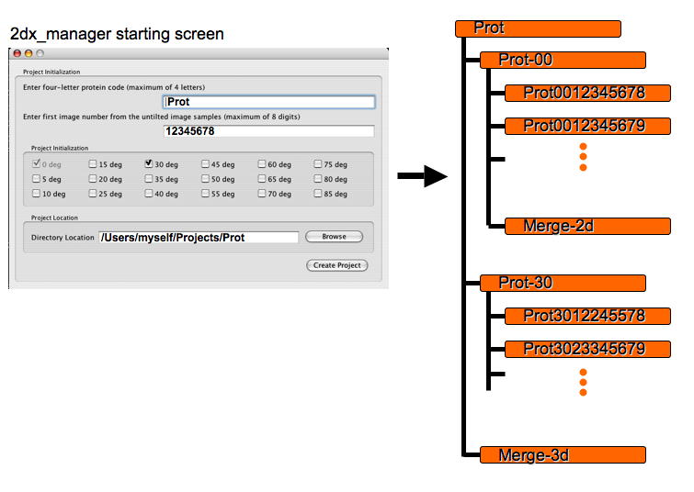

A protein project begins with the creation of a folder hierarchy for your images.

Begin by creating a folder named for the protein of interest. This folder will be used to hold all images/configuration files related to this particular protein project.

Optionally create a series of folders labeled by a 3-4 character code followed by a dash then a 2 digit tilt angle code (rounded to the nearest 5 degree). These folders will contain all images from tilt angles around the given angle, the division of which will be useful for image processing and later merging.

Into each of these folders a series of subfolders should be created with the 3-4 character protein code followed by a 2 digit tilt angle (to nearest 1 degree), ending with an unique 8 digit code. These folders represent the images themselves and in the course of image processing will contain all relevant data relating to this image.

These folders should each contain only one image, which should be a MRC file format image. The ending of the image file name has to be “.mrc”. All MRC format image files will have the ending “.mrc”, including the Fourier transform files. These usually have the ending “.fft.mrc”. Post Script files have the ending “.ps”.

Explanation of the 2dx GUI

The upper left pane in the 2dx interface contains all scripts, which will be useful in one round of a sequentially executed workflow. Each script represents an individual processing routine and groups of such scripts may be executed sequentially via multiple selection.

Assuming that the 2dx/config/2dx.cfg is properly configured (for binary distributions this should nearly always be the case) double clicking on any of the scripts will open it for editing in the editor selected in the configuration file.
The Specific Scripts (located just below the Standard Scripts) are accessed and run in a manner similar to those above. Specific Scripts, however, are designed to fulfill auxiliary roles, supporting the Standard Scripts and do not execute sequentially. In the scripts included with the 2dx release are a number of specific function scripts designed to make processing easier, or to fulfill specific alternate roles. For example it may not always be desirable to generate a symmetrized final map in the final stage of processing. This is then left as a Generate SymMap script, which can be optionally executed as a last step.

The center window, Processing Data, presents all processing parameters relevant to the particular script being executed. Variables found here may take the form of text boxes, drop down menus, push buttons or any other kind of standard input type. All of these are dynamically generated from an external configuration file, which is locally stored in the image directory.

Certain variables may be locked to prevent both accidental changes by users and, more importantly, intentional changes from running scripts. For example users may wish to protect a manually refined lattice but still wish to see the results of Get Lattice & Tilt which generates a number of other results related to the reciprocal lattice. Clicking the Lock icon next to the lattice parameters will prevent change to this variable, though all non-locked variables will still change accordingly.

Every parameter appearing in the Processing Data window has an associated context sensitive help feature accessible via right-click. This help will display the variable’s unique identifier (in this case magnification) as well as a short description of the parameter. The last line in this help window is a link to online help for this variable at http://2dx.org, where one can find detailed descriptions for every parameter as well as documentation. If 2dx/config/2dx.cfg contains a line specifying a web-browser, clicking this link will automatically direct it to the appropriate page
Any script may be executed by clicking on the Play button in the upper left corner of the GUI. As the script is executing, the progress bar will advance according to directives found in the script. In almost all cases the bar represents a rough time-based estimate of progress (as opposed to step based). Occasionally scripts may take advantage of the control and reset the progress at various stages, for instance those that run through multiple iterations of a particular image processing phase. During the execution of any script a user may halt the execution by pressing the Stop button (though the process by which the currently running sub-program is halted is os-dependent and may take awhile).

The top of the Processing Data window contains two buttons. The first (aqua) is default and presents the user with the most common parameters of interest to the current script. The second (red) displays all parameters available to the script. Parameters found only under the “Advanced” heading are frequently changed once and then left alone, or generally produce “acceptable” results when defaults are applied.

As scripts are run their output is displayed to the Logfile Browser, located in the bottom center of the GUI. This is a reduced version of the full Log Browser, which can be accessed via double clicking the top bar of this window, or by right click in the text area. The output can be filtered according to one of 3 verbosity modes. Low, which shows only the most important output of the script, medium, which shows slightly more detailed information and highest which displays all available output. (Clicking these buttons will not alter the verbosity of data that has already been displayed and will only affect future updates to this window. To view the full log file use the Log Browser.)
Once a script has finished executing, the parameters, which it has altered, are displayed in the upper right of the GUI in the Results window. If a script completes and a variable is locked, the parameter it tries to change will appear in red in this window. All parameters appearing in black represent those that (assuming they were present in the database) were successfully altered. This window is also often used for display purposes, as in the case of Evaluate Lattice where a calculated real unit cell is displayed in the Results window, but the actual values are not updated into the global database.
Similar to the Results window (and located just below) is the Images window. Here image names that are related to the current processing task are displayed upon script completion. Clicking once on any of the image files listed in this view will display information about it in the preview window. Double clicking an image will launch the fullscreen Navigator for mrc-format images or the postscript viewer (defined in 2dx/config/2dx.cfg) in the case of postscript images.

The Image Preview/Header window, located in the bottom left corner of the GUI, displays information about the currently selected image. The header view displays the entire header of the MRC file, (without labels) while the image preview displays a 200 x 200 preview of the image.

The preview is generated once, then added to the end of the same image file as a second Mode 0 MRC file section, complete with header. Pressing the I in the bottom left corner of the GUI allows switching between header and preview mode.
The Show/Hide buttons hide the Preview/Header from view. When in either Header mode or hidden from view no previews will be generated for any of the selected images –preview generation occurs once, the first time Preview mode is initiated for the image.

The Status window, found in the bottom right corner of the GUI displays a number of values relevant to the overall processing of the image. In particular, the two rows in the center of this window list the number of spots, found in the final post-unbending power spectrum, of given IQ values. In the example the first unbending step found 25 spots of IQ 1, 6 of IQ 2, 5 of IQ 3, and so on.
The bottom 4 columns display the tilt geometry as calculated by 4 different methods: Defocus gradient, Lattice distortions (emtilt), Spot Splitting evaluation (ttrefine), and from 3D Merging of the data (origtilt).

The theoretical magnification, as calculated from the current lattice, real unit cell, etc, is listed in the upper right or this window. Ideally this value will be nearly identical to the manually specified magnification and servers as an indication of fitness of values. The quality value, shown in the upper left, represents an empirical measure of overall image “fitness” based on a number of factors, including IQ values.

Processing an individual image

With parameters set appropriately you are ready to begin image processing.
The scripts on the left represent individual processing steps which need to be performed to fully process an image.

Calculate FFT begins image processing by calculating the initial Fourier transform of a tapered version of your original image. Additionally it alters any parameters, which are obviously incorrect in the
database. In particular the image side length will be automatically corrected to the correct length and the non-masked image name will be changed to match up to an appropriate value if the specified file can’t be found.

To begin processing select any number of scripts via the shift key to select contiguous blocks, or the control (command on Mac) key to additionally select individual scripts.
While Get Defocus & Tilt, Get Lattice & Tilt and Get Spotlist are optional in order to generate a final map, the rest of the standard scripts are not. The former merely automate the process of automatically determining parameters relevant to unbending and CTF correction as well as determining the underlying reciprocal lattice.

Whether or not these scripts are run, users always have the option to manually refine any of these parameters including the determined CTF. Automatically determined lattices then often provide a good starting point for manual lattice determination.

Any script may be run and rerun any number of times, with the results files simply overwriting previous ones.

The Full-Screen Image Navigator

The image navigator is designed primarily to provide information about the current image. However, in addition to displaying the image, the current reciprocal lattice and other parameters, the navigator provides the option to manually refine parameters as well. In particular the defocus of the image (and thereby the CTF), the primary and secondary reciprocal lattices and the spot list used to generate initial unbending references can be edited or refined.

Refining a lattice
The lattice refinement tool can be accessed via the navigator menubar or via the keyboard shortcut: Shift-R.
To begin refining select a spot in the Fourier transform on one of the lattice nodes. At the bottom of the window the current point will be displayed as well as its Miller index, generated by the current lattice Information. Initial Miller index guesses might be incorrect, but after definition of the first two or three correct lattice points, they should be accurate enough to be able to skip manual entry.

When a point/Miller pair has been successfully assigned it can be added either by clicking Add Point or by using the keyboard shortcut Enter. Ideally, once a generic lattice has been defined lattice refinement should become a process of point selection followed by the Enter key.

To delete a point from the list of current pairs, select the row describing the point then click Delete Point. If no row is selected when Delete Point is selected, the first point will be deleted. At any time the entire list can be cleared of points by pressing Clear All.

As points are added to the list, an increasingly refined reciprocal lattice candidate is displayed at the top of the lattice refinement window. This refinement is based on a least squares fit of the lattice points/indices provided. When the lattice is sufficiently refined it may then be saved, as the primary or secondary lattice, by clicking either Accept Lattice 1 or Accept Lattice 2.

Viewing the current lattice as refinements are made (or viewing how changes are affecting the current lattice) can often be useful. At any time either lattice may be viewed either by selection from the Navigator menu or via the keyboard shortcuts l and s respectively.

Refining the CTF

The automated defocus search used in 2dx is based entirely on ctffind2 (Grigorieff) and will find the CTF in a majority of cases. However when vibration or other distorting factors destroy parts of the CTF, or in cases where the fit is imprecise, it may be desirable to fit this manually.

To do so, select either the option from the Navigator menu or press the keyboard shortcut c. The parameters which are displayed in the defocus window allow intuitive refinement of the defocus in the x and y directions as well as refining the angle of astigmatism. This refinement of the overall defocus is achieved by altering linear combinations of Defocus X and Defocus Y in the following way:

Defocus =

Astigmatism =

This allows the defocus to control the overall size (larger values result in zero-crossings closer to the origin) and the Astigmatism to control the relative proportion of Defocus in the two directions. The astigmatic angle remains the same in both cases.

Fitting the CTF does not change the original values of Defocus X and Y, but instead presents a candidate CTF based on the current values. The stored CTF may be reloaded at any time by clicking Reload. Similarly when the parameters produce an acceptable candidate CTF click Accept to replaced the stored data with the current values.

Spot Selection

Spot refinement is needed to generate an initial reference map for cross correlation in the unbending steps. Automatic spot detection is based on the local signal to noise ratio of the peak to the surrounding background. The step arguably requires the highest level of user-interaction due to the subjective nature of the points being considered.

The spot list may be viewed at any time via the Navigator menu or by pressing the keyboard shortcut p. When the primary lattice is also displayed, the ring-display of the spots changes to X-display across their associated lattice nodes. The dimensions of the rings or crosses can be adjusted in the parameter pane (accessible via letter d).

To manually refine the spot list select the menu Lattice Refinement and the sub-option Enter Lattice Refinement Mode. This will display both the lattice and the current spot selection, either of which may still be toggled using the Navigator menu or keyboard shortcuts. To add spots select the appropriate node, to remove them select the appropriate spot. Spots selected when the lattice is hidden are still constrained to lattice nodes, but selection in this manner can make identifying spots easier as high-contrast ellipses are no longer present.

