Cost Calculator

User Guide

Contents

Overview 2

Logging In 3

Forgotten password? 3

Features and Access 4

Uploading Data Files 5

Managing Your Data Files 5

Import a New Data File 6

Processing the Data 7

Viewing Reports 8

Introduction 8

Filters & Reports 8

Report Navigation 9

Reports 10

Total Spend by Client 10

Total Spend by Service 11

Client Spend Breakdown 12

Filters 13

Basic Filters 13

Advanced Filters 14

Client Lookup 15

Changing Settings 16

Logging Out 17

# Overview

The Cost Calculator is a web-based intelligence tool designed to support local authorities in analysing the use of the services they provide. It uses the cost of service provision as the primary measure of service use.

The tool is capable of:

* processing data sets that contain financial information about the users of services;
* matching individuals across the different data sets to produce a "client index", which is used to calculate all costs associated with those clients;
* producing three types of reports about service use, which can be filtered in different ways to aid analysis.

This User Guide provides essential instructions on how to use the different features of Cost Calculator.

The source code and full technical documentation, including installation instructions, for the tool is available online. Go to: <https://github.com/LBHounslow/cost-calc>

# Logging In

The Cost Calculator works as a web service which you access using your web browser.

To log in to the Cost Calculator you will need the web address or URL for your installation of the tool, as well as an email address and password. These need to be provided to you by the person with responsibility for managing Cost Calculator user access and permissions.

To log in to the Cost Calculator:

* Open your web browser and enter the web address for your installation.
* This should take you to the following web page where you enter your email address and password and select the **Login** button.

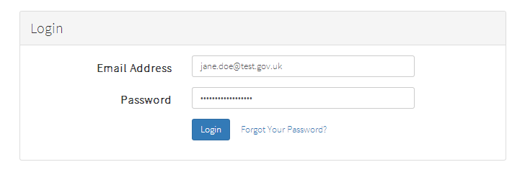

## Forgotten password?

If you can’t remember your password, or need to reset it, you can click on the **Forgot Your Password?** link.

This will send you an email with a link in it that will take you to a page where you can choose a new password.

# Features and Access

The Cost Calculator tool provides the user with three main functions:

* The ability to upload cost data
* The ability to query the uploaded data to produce reports
* And a client look up function that allows the user to see details about an individual that can help to identify them

The tool also has a number of settings that a user can use to configure different aspects of the tools operation, and some logs that monitor activity as the tool is being used.

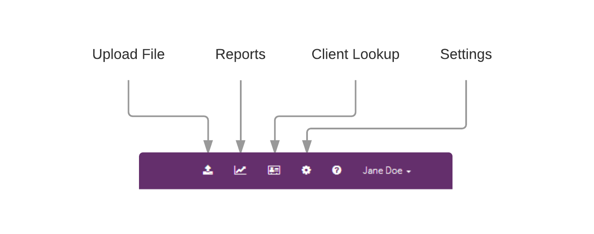These different features can be accessed from the menu bar in the top right corner of the Cost Calculator screen.

However, it is likely that you will not be able to access all of these options. Different users of Cost Calculator will have different user permissions that restrict which features they can use.

For example, if you have been given permissions to use the tool to upload data and carry out analysis your menu bar may look like this:



**Important:** We recommend that users who have permission to use the **Client Lookup** feature do not have access to other features. This is to help with managing issues of information governance and data privacy. These users’ menu bar will therefore look like this:



# Uploading Data Files

The tool allows the user to upload and import standard Microsoft Excel files containing data. Each data file needs to be associated with one of the file types already set up in the tool. Each of these file types is associated with one of the included data schemas and its accompanying import script.

In order for the import process to work the structure of each data file needs to conform to the relevant data schemas. These schemas define what columns need to be included in the file and the format of the data in each column.

Before attempting to upload a data file you should make sure that it has been formatted to match the structure specified in the schema.

The tool initially contains the following four file types:

* Temporary Accommodation
* Adult Social Care
* Housing Benefit Switch
* Troubled Families

Additional file types can be added by those with access to the **Settings** feature.

To manage data files in Cost Calculator navigate to the **Upload File** feature.

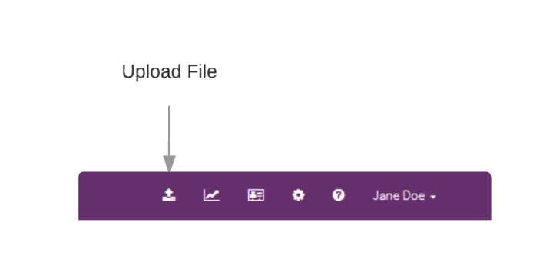

## Managing Your Data Files

The Upload File screen shows a log of all the data files that have previously been upload to your installation of Cost Calculator.

From this screen you can:

* See the details of each previously uploaded data file
* Delete a previously uploaded data file and remove all its data from the tool
* Upload a new data file

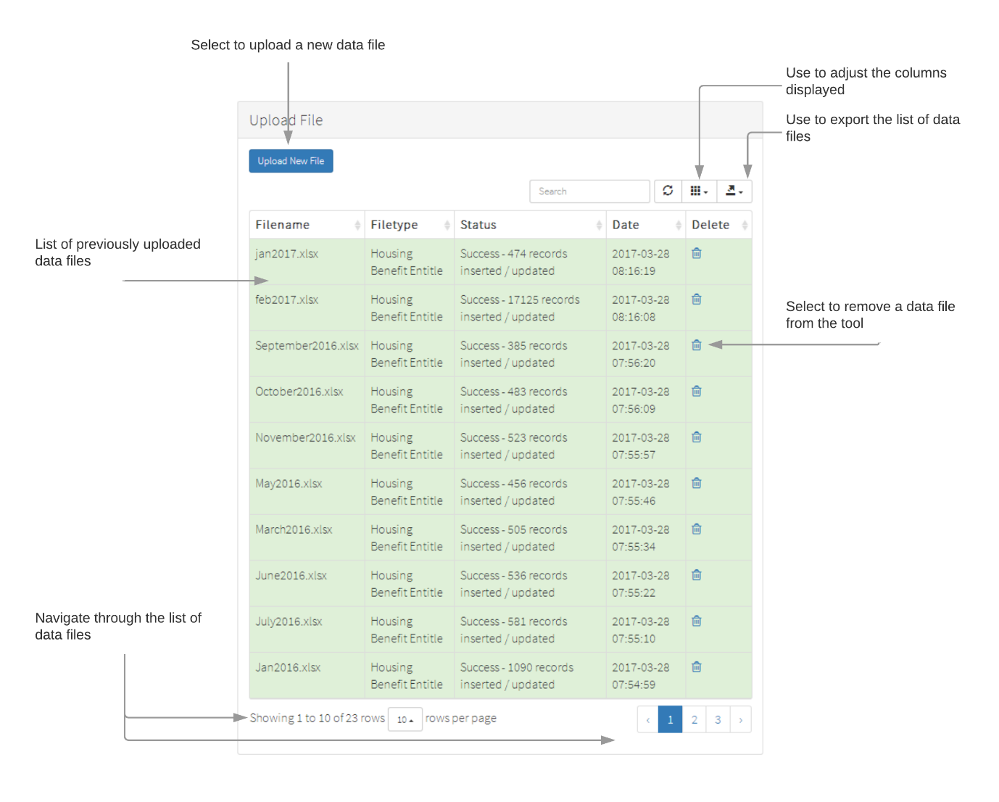

## Import a New Data File

To import a new data file into Cost Calculator:

* Make sure that the structure of the file matches that specified by the relevant schema
* Navigate to the Upload File screen and select the **Upload New File** button
* 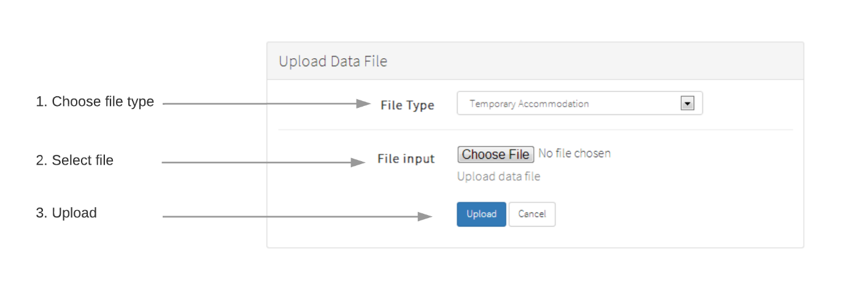This should open the **Upload Data File** screen:
* Select the **File Type** that matches the data file you want to import
* Select the **Choose File** which should open a dialog that will allow you to select the data file from the hard drive on your computer
* Select the **Upload** button to begin the import process

The import process won’t happen straight away. Depending on the size of the file it may take several minutes to process. When the import has finished this will be indicated on the list of uploaded files.

If there was a problem with the import this will also indicated on the list. You can then make adjustments to your file to fix the problem and then repeat the upload process.

## Processing the Data

Once the data has been imported further processing takes place to match each record against an index of individual clients.

This 'client index' is queried to see if the details of the client specified in each record of the imported data matches the details of a client already recorded. This matching process currently uses the following personal identifiers:

* Last Name
* Postcode
* Date of Birth

If there is a match against an existing record in the client index then the cost data is attached to it. If there isn’t a match then new record in the client index is created and the cost data attached to it.

Attaching the cost to an individual is done by assigning a unique ID number that represents the individual to the cost record. These ID numbers are used throughout the tool to represent individual clients. This means that Cost Calculator does not need to display identifiable personal information about clients in the tool, thus helping to preserve their privacy. Using this process, as more data is added, the tool is able to build up a database of cost information that is all indexed against specific individuals.

# Viewing Reports

## Introduction

After data files have been imported into Cost Calculator it will contain a database of cost information that is all indexed against specific individuals. This enables the tool to run queries against the data which will result in various cost calculations that can be presented to the user as reports.

### Filters & Reports

Using the cost calculations the tool presents the following three types of report to the user:

* Total Spend by Client
* Total Spend by Service
* Breakdown of Spend by Client

The above reports can have the following filters applied to them:

* The date range covered by the report
* The type of services included in the report

To enable a more sophisticated level of analysis of the cost data there are also some additional advanced ways that the data in the reports can be filtered.

### Report Navigation

## Reports

### Total Spend by Client

The **Total Spend by Client** report lists the individuals recorded in Cost Calculator’s database in the order of the total amount of cost they have generated through service use.

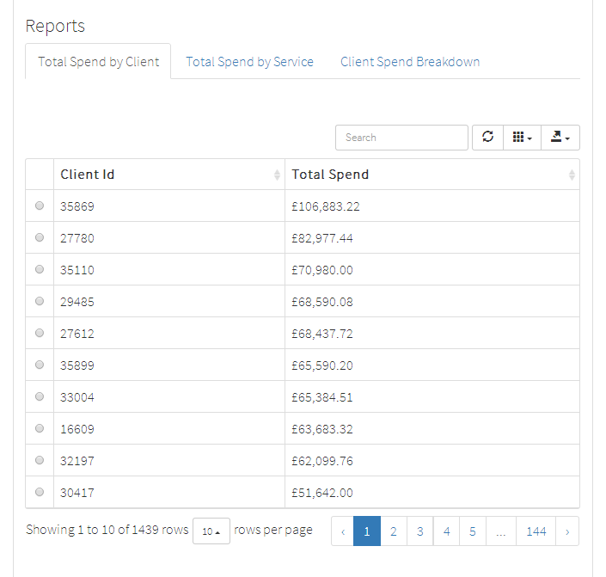

### Total Spend by Service

The **Total Spend by Service** report shows the total amount of cost incurred by the different types of service.

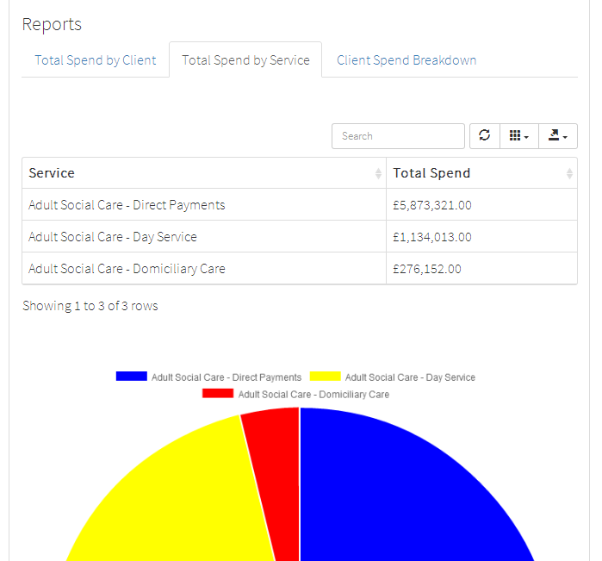

### Client Spend Breakdown

The **Client Spend Breakdown** report shows the details of the cost of service use incurred by a specific individual.

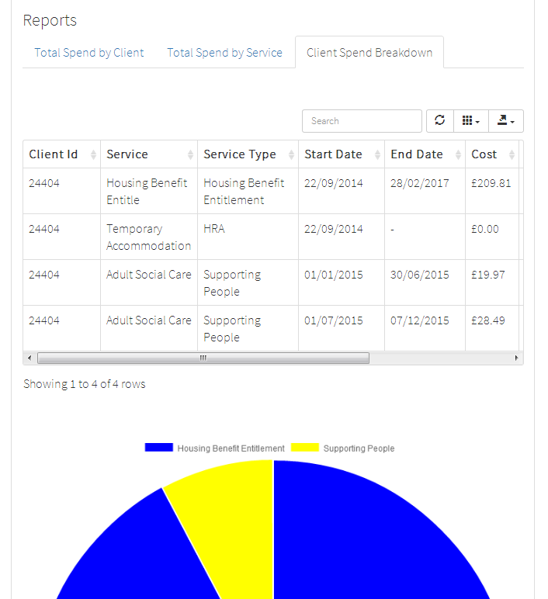

## Filters

### Basic Filters

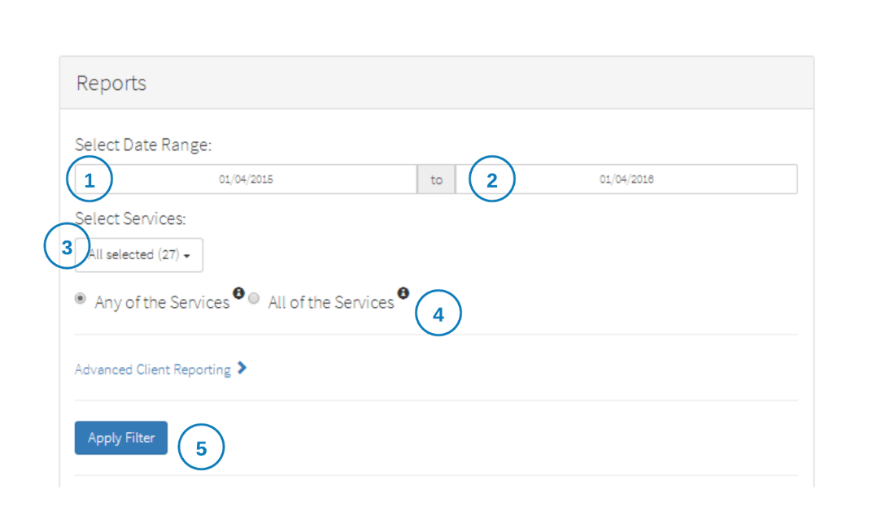The content of each of the three reports will be determined by the chosen filter options.

To set the basic filter options do the following:

1. Choose the beginning of the date range you want to look at
2. Choose the end of the date range you want to look at
3. Choose the services you want included in the reports
4. Choose whether you want those clients who have used *any* of the chosen services or *all* of the chosen services included in the reports
5. Apply the filter to update the data included in the reports

#### Selecting All or Any

At step 4 you can choose to include in the report clients who have used any of the services selected in the filter or only those clients who have used all of the selected services.

For example, if you have chosen two services – Service A and Service B – if you select “Any of the Services” the report will include:

* Clients who have used Service A
* Clients who have used service B
* Clients who have used both Service A and Service B

However, if you select “All of the Services” the report will include only:

* Clients who have used both Service A and Service B

### Advanced Filters

In addition, an advanced filter can be used to change the pool of clients that the reports are looking at.

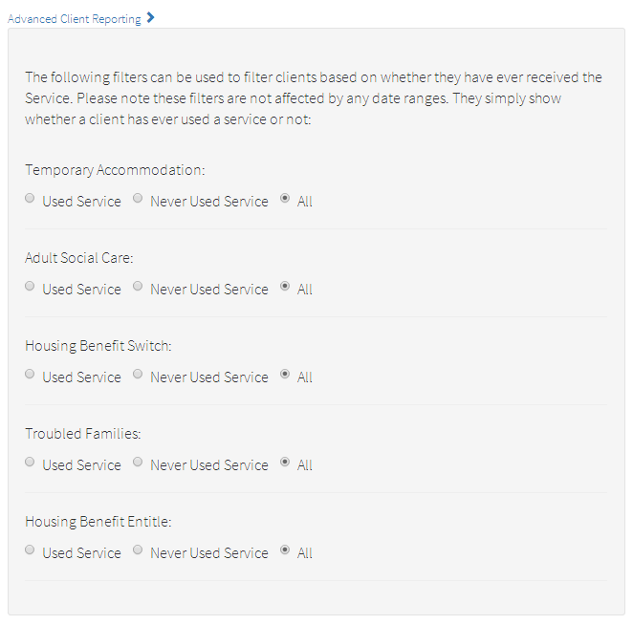

These filters can be used to include or exclude clients based on whether they have *ever* received the specified service or group of services.

The services or groups of services that the advanced filter allows you to choose from are determined by the file type that the services originated from. So another way of understanding the advanced filter is to think of it as a way of including or excluding clients who are included in the data from a particular file type.

The Cost Calculator tool allows you to have file types that include client details - but do not include cost information. The advanced filter is how these file types are made use of in the tool. In these cases the "services" from these file types are acting as a form of status assigned to the clients.

# Client Lookup

In order to protect the privacy of the clients whose information is used by the tool we use a unique ID number to represent these individuals. This means we do not need to display personal information that could be used to identify an individual within the tool.

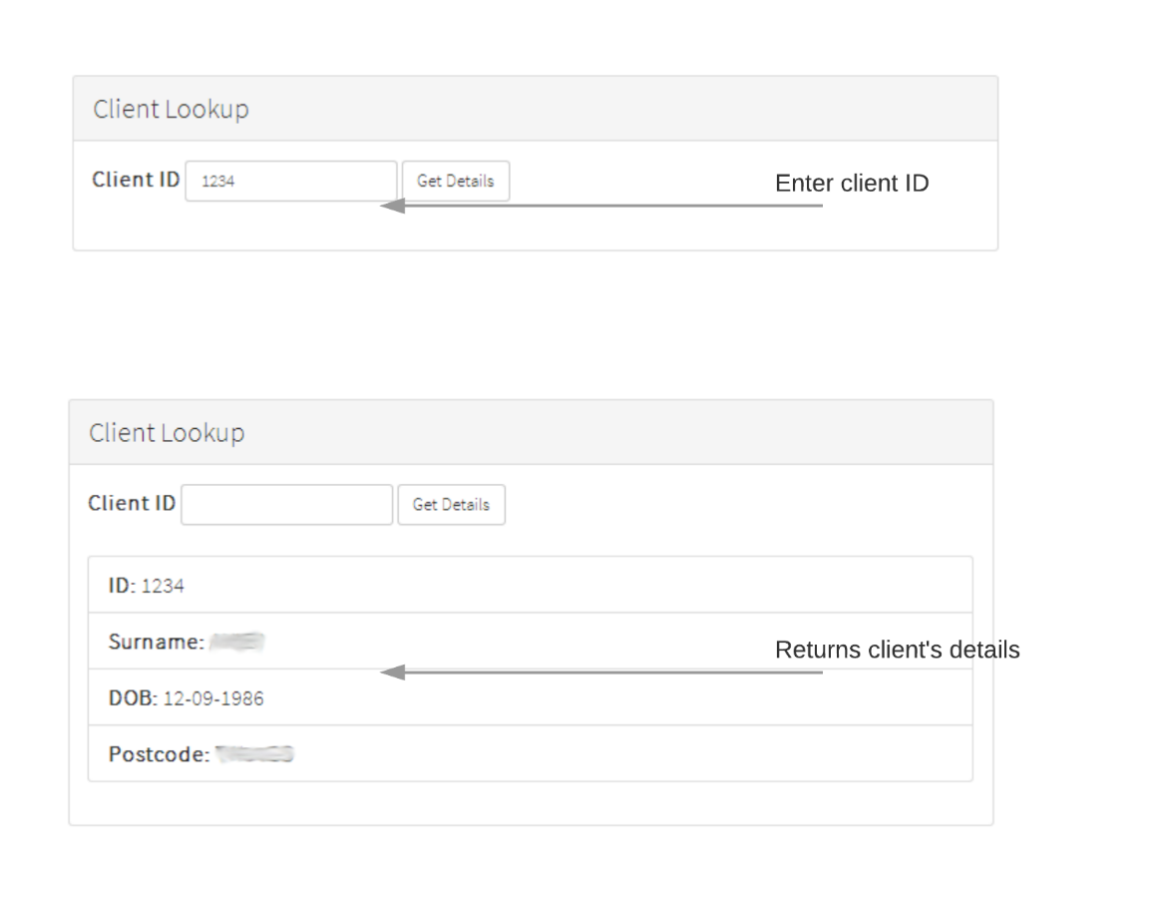However, there may be circumstances that require an individual to be identified. The client lookup feature is used to convert a unique client ID into personal information (last name, date of birth, and postcode).

# Changing Settings

The **Settings** feature of Cost Calculator allows administrators of the tool to configure different aspects of its operation, and provides some logs that monitor activity as the tool is being used.

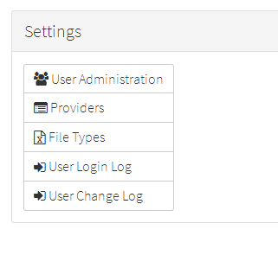

The **User Administration** page allows for additional user accounts to be added and passwords to be updated. This is also where the permissions controlling access to the different elements of the tool for each user account are set. User accounts can also be temporarily suspended.

The **Providers** page allows for the configuration of different providers. The tool was built with the assumption that data would be provided by different departments within a local authority and by a range of partner organisations. From this page the data files that these different data providers can upload into Cost Calculator can be restricted to only those they have responsibility for.

The **File Types** page allows new file types to be added to the tool. These means that the range of different data sets included in the tool can be increased.

The **User Login Log** records both successful and unsuccessful attempts and accessing the tool.

The **User Change Log** records changes to user accounts.

# Logging Out

You can log out of Cost Calculator by selecting you name in the menu bar in the top right corner of the screen and then selecting **Logout**.

