LD_Merged

Datasets Used
A disdrometer is a specialized scientific instrument used to measure the size, speed, and distribution of falling precipitation particles like rain, snow, and hail. Disdrometers were deployed as part of the WFIP-3 campaign at the Nantucket land site (NANT), the air-sea interaction tower (ASIT), and the instrumented barge (BARG) from 06/2024 to 10/2025. At sites BARG and ASIT, two disdrometers were installed perpendicular to each other North-South, East-West. Using wind information from nearby instrumentation, we created a merged disdrometer dataset corrected by wind direction. At NANT where only a single disdrometer was installed, we incorporated wind information and filtered for only North-South rain events. Wind direction at 100m was used to filter the data for consistency because surface winds were not always available. Using the methods of Tokay et al 2013, we filtered the spectral data for erroneous droplets and recalculated rain intensity, visibility, and reflectivity.
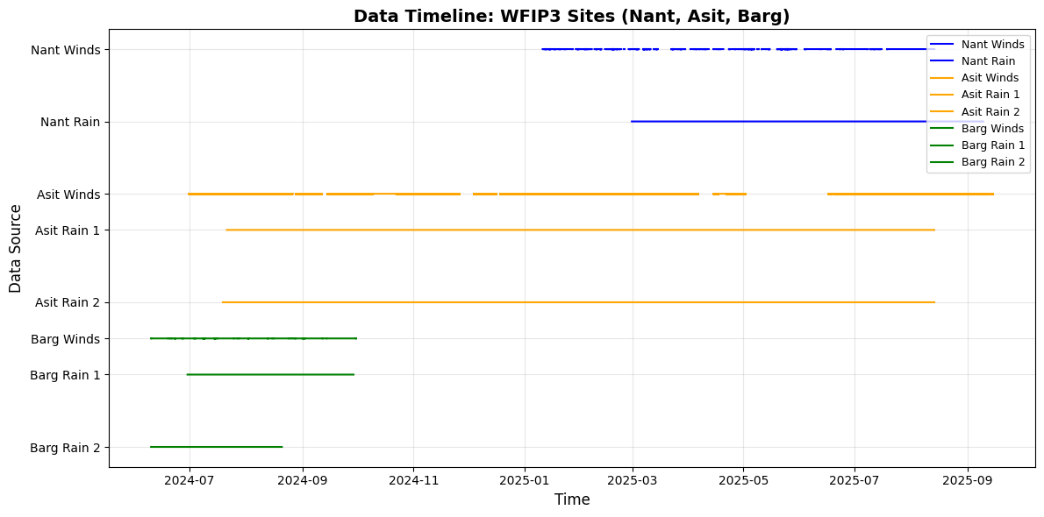
Figure 1: Timeline of Available Data. BARG: 39 overlapping days, ASIT: 224 overlapping days, NANT: 108 overlapping days.

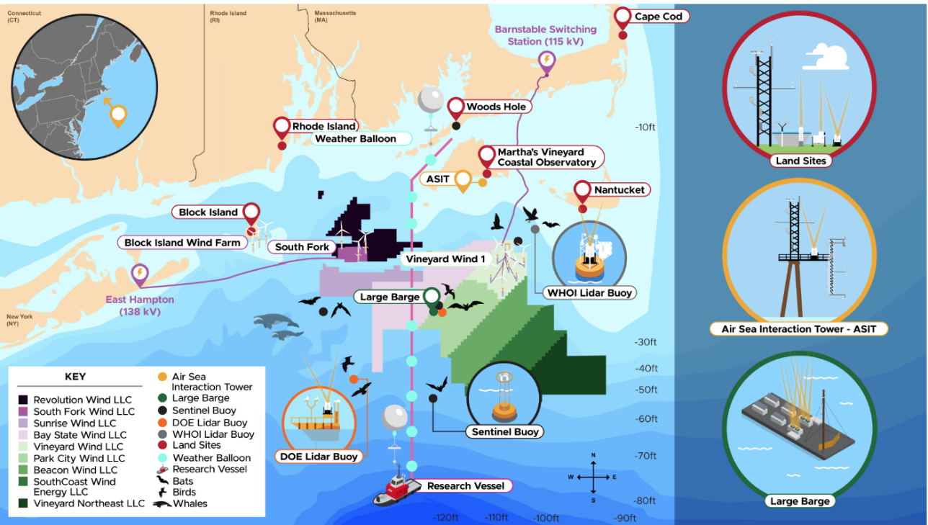
Figure 2: Map of the WFIP-3 Sample Area

Disdrometer
Data recorded every 15 seconds
- asit.ld.z01.b1
- asit.ld.z02.b1
- barg.ld.z01.b1
- barg.ld.z02.b1
- nant.ld.z01.b1
Code | Data Description | Format | Range | Unit
1 | Rain Intensity | Float | 0.0 to 9999.999 | milli-meter per hour
2 | Rain amount accumulated | Float | 0.00 to 300.00 | milli-meter
3 | Weather Code acc to SYNOP; Table 4680 | Integer | 00 to 99
4 | Weather Code acc to SYNOP; Table 4677 | Integer | 00 to 99
5 | Weather Code acc to SYNOP; Table 4678 | Char
6 | Weather code according to NWS | Char
7 | Radar reflectivity | Float | -9.999 to 99.999 | dBz
8 | MOR visibility in precipitation | Integer | 0 to 20000 | meters
9 | Sample interval | Integer | 0 to 3600 | seconds
10 | Singal amplitude of the laser strip | Integer | 0 to 99999 | 1
11 | Number of particles detected and validated | Integer | 0 to 99999 | 1
12 | Temperature in the sensor housing | Integer | -99 to 100 | deg C
13 | Sensor serial number | Integer
14 | Firmware IOP version number | Char
15 | Firmware DSP version number | Char
16 | Sensor head heating current | Float | 0.00 to 4.00 | Amps
17 | Power supply voltage | Float | 0.00 to 30.00 | Volts
18 | Sensor status | Integer | 0 to 3
19 | Date/time measuring start |  | DD.MM.YYYY_hh:mm:ss
20 | Sensor time |  | hh:mm:ss
21 | Sensor date |  | DD.MM.YYYY
22 | Station name | Char | XXXXXXXXXX
23 | Station number | Char /Integer | XXXX
24 | Rain amount absolute | Float | 0.000 to 999.999 | milli-meter
25 | Error code | Integer
26 | Temperature PCB | Integer | -99 to 100 | deg C
27 | Temperature in the right sensor head | Integer | -99 to 100 | deg C
28 | Temperature in the left sensor head | Integer | -99 to 100 | deg C
30 | Rain intensity (16 bit) max. 30.000 mm/h | Float | 0.000 to 30.000 | milli-meter per hour
31 | Rain intensity (16 bit) max. 1200.0 mm/h | Float | 0.0 to 1200.0 | milli-meter per hour
32 | Rain amount accmulated (16 bit) | Float | 0.00 to 300.00 | milli-meter
33 | Radar reflectivity (16 bit) | Float | -9.99 to 99.99 | milli-meter
34 | Kinetic energy | Float | -9.99 to 99.99 | dBz
35 | Snow depth intensity (volume equivalent) | Float | 0.000 to 999.999 | J/(m2h)
40 | Ignore
41 | Ignore
50 | Ignore
51 | Ignore
60 | Number of all particles detected | Float
61 | List of all particles detected (including size and particle speed) | Float | 0.2 to 25.0; 0.2 to 20.00 | mm; mm/s
90 | Field N (d) | Vector Float | -9.999 to 99.999 | log10 (1/m3 mm)
91 | Field v (d) | Vector Float | 0.000 to 99.999 | m/s
93 | Raw data | Vector Float | 0 to 999 | Data vector (65 estimates)

Winds
Wind Products used: 100m at every site to maintain consistency. Not all sites had surface wind, but comparison at ASIT shows overall wind direction is comparable.
- nant.lidar.10min.z01.c1
- asit.lidar.z01.a0
- barg.lidar.z02.a0
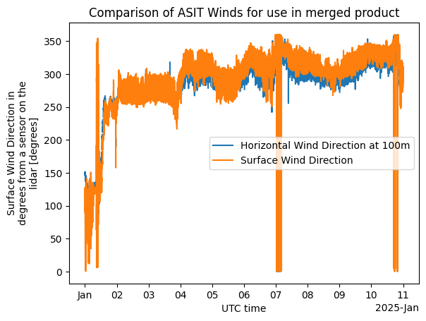
Figure 3: Comparison of Wind products at ASIT

Merge Method
- Find days where data exists for both wind and precipitation datasets
- Map data to the N-S disdrometer’s time coordinate
- Visually inspect datasets for erroneous data
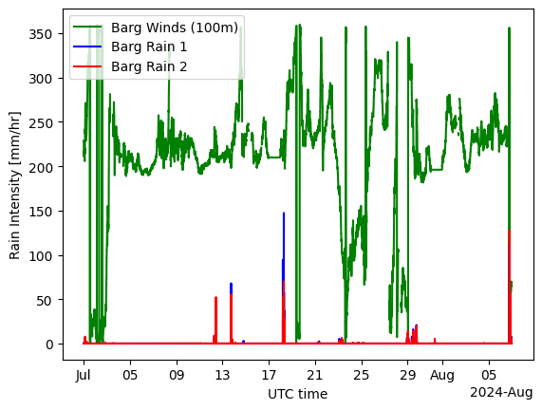
Figure 4: Timeseries of data

- Select wind direction nearest to the 100m neight
- Create new xarray dataset merged on masks on N-S and E-W quadrants. Add back original data to preserve
WD = datasets['Barg Winds']['wind_direction'].sel(height=100, method = 'nearest').compute()

ds1 = datasets["Barg Rain 1"]# Dataset
ds2 = datasets["Barg Rain 2"]# Dataset

# Boolean masks (True where condition met)
mask_ns = ((WD > 315) | (WD < 45) | ((WD > 135) & (WD < 225)))
mask_ew = (((WD > 45) & (WD < 135)) | ((WD > 225) & (WD < 315)))

new_ds = xr.where(mask_ns, ds1, xr.where(mask_ew, ds2, np.nan))
new_ds["rain_intensity_ns"] = ds1["rain_intensity"]
new_ds["rain_intensity_ew"] = ds2["rain_intensity"]
new_ds["wind_direction"] = WD
new_ds["wind_speed"] = datasets["Barg Winds"]["wind_speed"].sel(height=100, method='nearest').compute()
new_ds["vertical_wind_speed"] = datasets["Barg Winds"]["vertical_wind_speed"].sel(height=100, method='nearest').compute()

- Check data anew
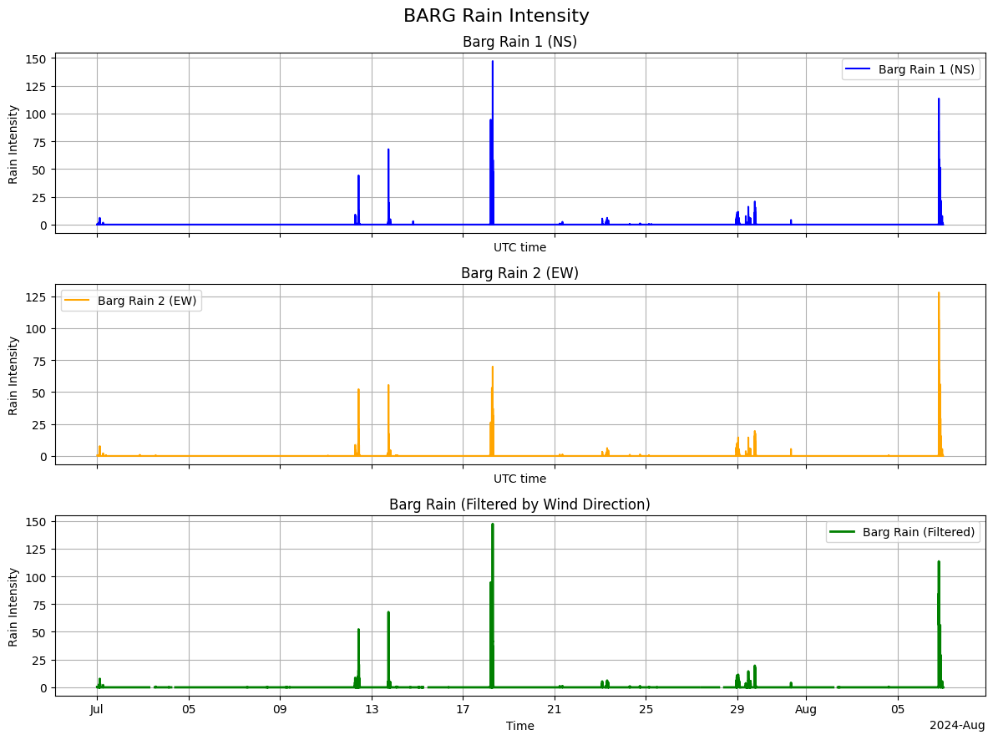
Fig 5. Check Results of wind direction merge
- Save daily files

QC Applied
The principles in Tokay et al 2013 were used to filter to our dataset. The raw output of the disdrometer is the number of drops in 32 size and 32 fall velocity categories. The size and fall velocity ranges are from 0.2 to 25 mm and from 0.2 to 20 m/s, respectively. Data from the first two size categories, which correspond to sizes less than 0.2 mm, is filtered because of the low signal-to-noise ratio.
Times when it is raining is defined as when R ≥ 0.1 mm/h. To create the droplet size distributions, we aggregate the data into one-minute averages, where the values in a given minute are summed, averaged, or first taken depending on the variable. We fit the distribution to a gamma model DSD
 | $$N\left(D\right)=N_{max}\frac{1}{Λ}ⅇ^{-ΛD}$$ | (1)

where $Λ$ is the shape parameter, and D is the drop diameter. The range of shape parameters may be considered to fall between 0.4 and 2. If the fitted shape is outside this range the value is filtered. We filter drops from our dataset that exceeded ±50% of their theoretical terminal fall speed (Beard 1976). We don’t apply a correction factor for the fall speeds of snowflakes (Battaglia et al 2010) or droplets between sizes 1 and 5mm (M. Loffler-Mang and U. Blahak). We calculated terminal fall speed v_{t} using the empirical formula derived by Atlas et al 1973.
 | $$v\left(t\right)= 9.65-10.3e^{-0.6D}$$ | (2)

In summary, our filter methods are universally correct for hydrometeors. From the filtered spectral data we recalculate the 1d variables. For the majority of hydrometeors recorded during WFIP, which are smaller and non-frozen, this is sufficient. For frozen hydrometeors and larger hydrometeors, data users may want to return to the spectral data to apply fall speed corrections. Because fall speed correction methods aren’t as universal and apply only to a small fraction of the data, we chose not to apply these corrections. Users can use weather codes provided in the dataset to filter by hydrometeor type.

Steps Applied in Practice
- Filter to periods when raining
- Filter out two smallest bins
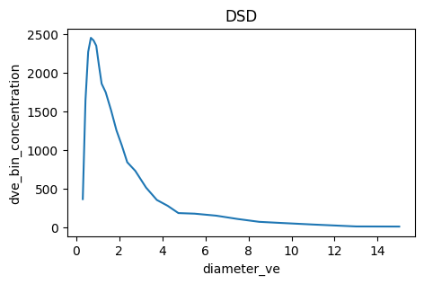
Fig 6. Droplet size distribution

- Reduce to one minute
Take care, some variables need to be averaged (like rain intensity), others summed (like number of particles), others you can take the first value (like weather codes).
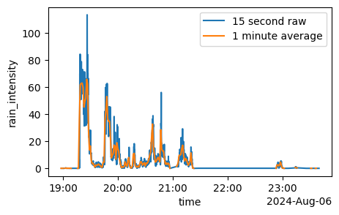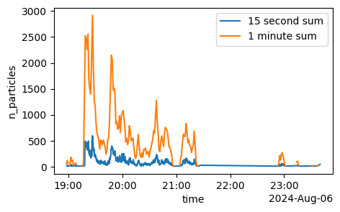
Fig 7&8. Demonstration of 1 minute frequency

- Filter erroneous fall speeds against $±$50% terminal velocity
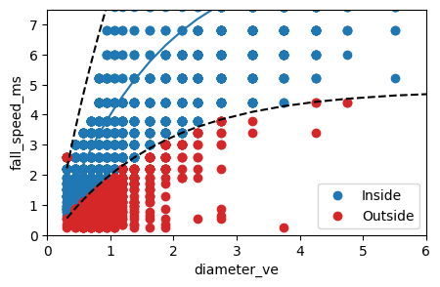
Fig 9. Demonstration of terminal velocity bounds on spectral data
- Check size distribution with gamma function
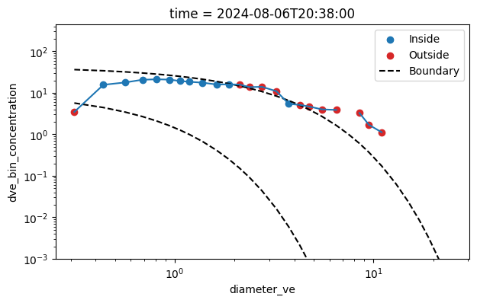
Fig 10. Demonstration of using gamma function to remove unreal droplets

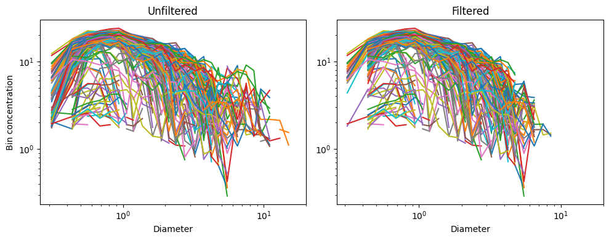
Fig 11. Side by side comparison of all DSD.

We also apply this filter to the spectral data.
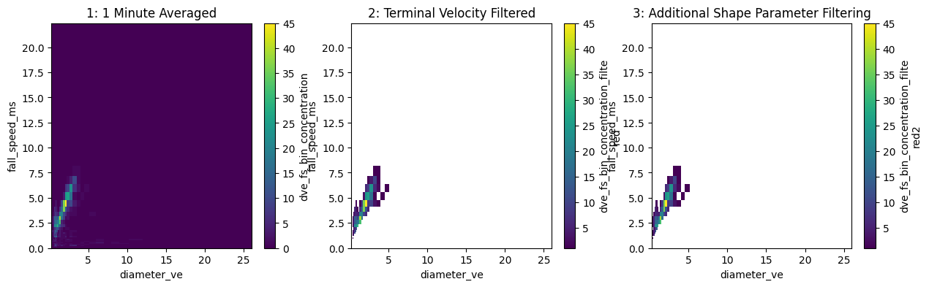
Fig 12. Levels of filtering applied.
- Compute new rain rate
$$R= \frac{1}{A∙∆t}\sum_{i}{\sum_{j}{n_{i,j}∙V_{i}∙v_{j}}}$$
The OTT PD laser beam is 180 mm long, 30 mm wide, and 1 mm thick. The nominal cross-sectional area is 54 cm². $∆t$ is now 60 seconds from the original 15 seconds.
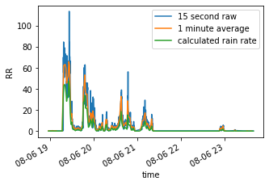
Fig 13. Different rain rates

- Compute new visibility (Meteorological Optical Range, MOR)
Calculated using Koschmieder’s equation and the atmospheric extinction coefficient simplified assuming mie scattering theory
 | $$MOR=20,000- \ln\left(ϵ\right)*\frac{π}{2}\sum_{i}{D_{i}^{2}N_{i}}$$ | (4)
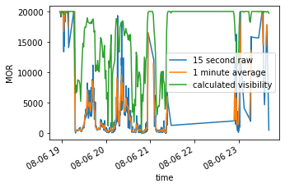
Fig 14. Different visibilities

- Compute new radar reflectivity
 | $$dbZ=10* \log_{10}(\sum_{i}{\frac{D_{i}^{6}}{V_{i}}N_{i}})$$ | (4)

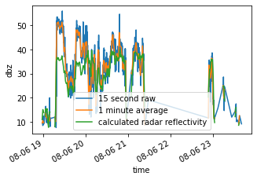
Fig 15. Different reflectivity

- Save Dataset

The entire dataset is filtered by wind direction, whether data from disdrometer z01 or z02 is used.
The two variables we filter based on Tokay et al 2013 methods are:
- D bin concentration
- D & FS bin concentration
The three variables we recalculate are:
- Rain intensity
- Visibility
- Radar Reflectivity

Filter & Recalculate Variables Code
Masks
condition = ds["rain_intensity"].fillna(0) > 0.1
mask = (ds_filtered["diameter_ve"] >= 0.2)

1 Minute
sum_vars = ['n_particles',
'dve_bin_concentration',
'fs_bin_concentration',
'dve_fs_bin_concentration'
]
mean_vars = [ 'rain_intensity',
]

result = xr.merge([
ds_filtered[sum_vars]
.resample(time="1min")
.sum(min_count=1),

ds_filtered[mean_vars]
.resample(time="1min")
.mean(),
])

Filter Terminal Velocity
da = result["dve_fs_bin_concentration"]

# Broadcast data and coordinates to identical dimensions
data, diameter, fall_speed = xr.broadcast(
da,
da["diameter_ve"],
da["fall_speed_ms"],
)

# Terminal-velocity curve and its boundaries
vt = 9.65 - 10.3 * np.exp(-0.6 * diameter)

line_low = np.minimum(vt * 0.5, vt * 2.0)
line_high = np.maximum(vt * 0.5, vt * 2.0)

# True only for nonzero points inside the boundaries
inside = (
data.notnull()
& (data != 0)
& (fall_speed >= line_low)
& (fall_speed <= line_high)
)

# Outside points become NaN
filtered = data.where(inside)

result["dve_fs_bin_concentration_filtered"] = filtered

Filter shape parameter
da = result['dve_bin_concentration']
db = result['dve_fs_bin_concentration_filtered']

SD = []
SDD = []

for i in range(len(da.time.values)):
t = da.time.values[i]
single_distribution = da.sel(time=t)
single_2d_distribution = db.sel(time=t)

# 1D x and y arrays
x = single_distribution["diameter_ve"]
y = single_distribution

x_values = x.values
y_values = y.values

# Boundary equations
a = 2
b = 0.4

y_max = y.max(skipna=True).values

lower_line = (y_max / a) * np.exp(-a * x_values)
upper_line = (y_max / b) * np.exp(-b * x_values)

line_low = np.minimum(lower_line, upper_line)
line_high = np.maximum(lower_line, upper_line)

# Valid, nonzero data
valid = (
np.isfinite(x_values)
& np.isfinite(y_values)
& (y_values != 0)
)

inside = valid & (y_values >= line_low) & (y_values <= line_high)
inside_x = xr.DataArray(inside,dims='diameter_ve',coords={'diameter_ve': da['diameter_ve']})

SD.append(single_distribution.where(inside))
SDD.append(single_2d_distribution.where(inside_x))

result['dve_bin_concentration_filtered'] = xr.concat(SD, dim="time")
result['dve_fs_bin_concentration_filtered2'] = xr.concat(SDD, dim="time")

Calculate rain rate from filtered data
da = result['dve_fs_bin_concentration_filtered2']

# Keep only non-NaN concentration values
valid_da = da.where(da.notnull(), 0)

# Volume for each diameter
Vj = (np.pi/6) * ((da['diameter_ve'] / 2)*0.001) ** 3
# Calculate R; xarray broadcasts Vj and fall speed across the 2D grid
R = valid_da * Vj * da['fall_speed_ms']

# Sum over diameter and fall-speed for each time
RR = R.sum(
dim=['diameter_ve', 'fall_speed_ms'],
skipna=True
)* ((1000*3600) / (60*0.0054))

Calculate Visibility from filtered data
da = result['dve_bin_concentration_filtered']

# Keep only non-NaN concentration values
valid_da = da.where(da.notnull(), 0)

# Calculate extinction coefficient
sigma = (np.pi/2) * ((da['diameter_ve'])) ** 2 * valid_da

# Sum over diameter and MOR for each time
MOR = 20000-(sigma.sum(
dim=['diameter_ve'],
skipna=True
))*10

result['visibility_corrected'] = MOR.rename('MOR')

Calculate Reflectivity from filtered data
da = result['dve_bin_concentration_filtered']

# Keep only non-NaN concentration values
valid_da = da.where(da.notnull(), 0)

# Calculate linear radar reflectivity factor (Z)
Z = (((1/6)*np.pi*(da['diameter_ve']) ** 3)**-1)*((da['diameter_ve']) ** 6) * valid_da

# Sum over diameter and calculate dbz for each time
zsum = Z.sum(dim="diameter_ve", skipna=True)
dbz = 10 * np.log10(zsum.where(zsum > 0))

Processed Files
Results Examples:
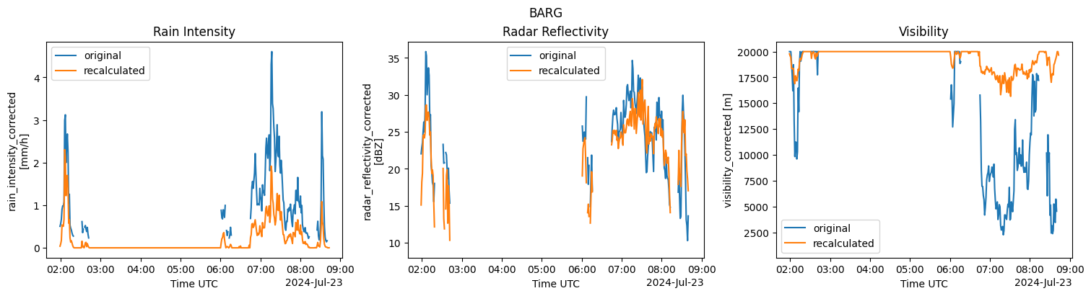
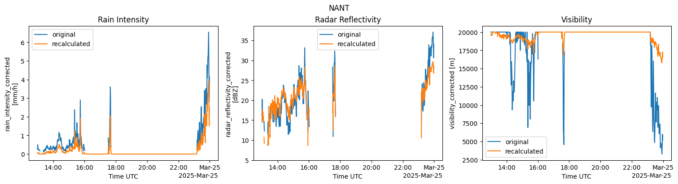

BARG
(.venv) [gold396@deception02 gold396]$ python tokay_correction.py /rcfs/projects/oracle/gold396/BARG /rcfs/projects/oracle/gold396/BARG_filtered
Processed barg_merged_20240701.nc
Failed to process barg_merged_20240702.nc: No rainy timestamps in /rcfs/projects/oracle/gold396/BARG/barg_merged_20240702.nc
Processed barg_merged_20240703.nc
Failed to process barg_merged_20240704.nc: No rainy timestamps in /rcfs/projects/oracle/gold396/BARG/barg_merged_20240704.nc
Failed to process barg_merged_20240705.nc: No rainy timestamps in /rcfs/projects/oracle/gold396/BARG/barg_merged_20240705.nc
Failed to process barg_merged_20240706.nc: No rainy timestamps in /rcfs/projects/oracle/gold396/BARG/barg_merged_20240706.nc
Failed to process barg_merged_20240707.nc: No rainy timestamps in /rcfs/projects/oracle/gold396/BARG/barg_merged_20240707.nc
Failed to process barg_merged_20240708.nc: No rainy timestamps in /rcfs/projects/oracle/gold396/BARG/barg_merged_20240708.nc
Failed to process barg_merged_20240709.nc: No rainy timestamps in /rcfs/projects/oracle/gold396/BARG/barg_merged_20240709.nc
Failed to process barg_merged_20240710.nc: No rainy timestamps in /rcfs/projects/oracle/gold396/BARG/barg_merged_20240710.nc
Failed to process barg_merged_20240711.nc: No rainy timestamps in /rcfs/projects/oracle/gold396/BARG/barg_merged_20240711.nc
Processed barg_merged_20240712.nc
Processed barg_merged_20240713.nc
Processed barg_merged_20240714.nc
Failed to process barg_merged_20240715.nc: No rainy timestamps in /rcfs/projects/oracle/gold396/BARG/barg_merged_20240715.nc
Failed to process barg_merged_20240716.nc: No rainy timestamps in /rcfs/projects/oracle/gold396/BARG/barg_merged_20240716.nc
Failed to process barg_merged_20240717.nc: No rainy timestamps in /rcfs/projects/oracle/gold396/BARG/barg_merged_20240717.nc
Processed barg_merged_20240718.nc
Failed to process barg_merged_20240719.nc: No rainy timestamps in /rcfs/projects/oracle/gold396/BARG/barg_merged_20240719.nc
Failed to process barg_merged_20240720.nc: No rainy timestamps in /rcfs/projects/oracle/gold396/BARG/barg_merged_20240720.nc
Processed barg_merged_20240721.nc
Failed to process barg_merged_20240722.nc: No rainy timestamps in /rcfs/projects/oracle/gold396/BARG/barg_merged_20240722.nc
Processed barg_merged_20240723.nc
Processed barg_merged_20240724.nc
Processed barg_merged_20240725.nc
Failed to process barg_merged_20240726.nc: No rainy timestamps in /rcfs/projects/oracle/gold396/BARG/barg_merged_20240726.nc
Failed to process barg_merged_20240727.nc: No rainy timestamps in /rcfs/projects/oracle/gold396/BARG/barg_merged_20240727.nc
Processed barg_merged_20240728.nc
Processed barg_merged_20240729.nc
Failed to process barg_merged_20240730.nc: No rainy timestamps in /rcfs/projects/oracle/gold396/BARG/barg_merged_20240730.nc
Processed barg_merged_20240731.nc
Failed to process barg_merged_20240801.nc: No rainy timestamps in /rcfs/projects/oracle/gold396/BARG/barg_merged_20240801.nc
Failed to process barg_merged_20240802.nc: No rainy timestamps in /rcfs/projects/oracle/gold396/BARG/barg_merged_20240802.nc
Failed to process barg_merged_20240803.nc: No rainy timestamps in /rcfs/projects/oracle/gold396/BARG/barg_merged_20240803.nc
Processed barg_merged_20240804.nc
Failed to process barg_merged_20240805.nc: No rainy timestamps in /rcfs/projects/oracle/gold396/BARG/barg_merged_20240805.nc
Processed barg_merged_20240806.nc
processing complete

NANT
(.venv) [gold396@deception02 gold396]$ python tokay_correction.py /rcfs/projects/oracle/gold396/NANT /rcfs/projects/oracle/gold396/NANT_f
iltered
Failed to process nant_merged_20250228.nc: No rainy timestamps in /rcfs/projects/oracle/gold396/NANT/nant_merged_20250228.nc
Failed to process nant_merged_20250302.nc: No rainy timestamps in /rcfs/projects/oracle/gold396/NANT/nant_merged_20250302.nc
Processed nant_merged_20250303.nc
Processed nant_merged_20250306.nc
Processed nant_merged_20250307.nc
Failed to process nant_merged_20250308.nc: No rainy timestamps in /rcfs/projects/oracle/gold396/NANT/nant_merged_20250308.nc
Failed to process nant_merged_20250310.nc: No rainy timestamps in /rcfs/projects/oracle/gold396/NANT/nant_merged_20250310.nc
Failed to process nant_merged_20250311.nc: No rainy timestamps in /rcfs/projects/oracle/gold396/NANT/nant_merged_20250311.nc
Failed to process nant_merged_20250312.nc: No rainy timestamps in /rcfs/projects/oracle/gold396/NANT/nant_merged_20250312.nc
Failed to process nant_merged_20250313.nc: No rainy timestamps in /rcfs/projects/oracle/gold396/NANT/nant_merged_20250313.nc
Failed to process nant_merged_20250315.nc: No rainy timestamps in /rcfs/projects/oracle/gold396/NANT/nant_merged_20250315.nc
Failed to process nant_merged_20250316.nc: No rainy timestamps in /rcfs/projects/oracle/gold396/NANT/nant_merged_20250316.nc
Processed nant_merged_20250317.nc
Processed nant_merged_20250318.nc
Failed to process nant_merged_20250319.nc: No rainy timestamps in /rcfs/projects/oracle/gold396/NANT/nant_merged_20250319.nc
Processed nant_merged_20250321.nc
Failed to process nant_merged_20250322.nc: No rainy timestamps in /rcfs/projects/oracle/gold396/NANT/nant_merged_20250322.nc
Processed nant_merged_20250324.nc
Processed nant_merged_20250325.nc
Processed nant_merged_20250326.nc
Processed nant_merged_20250329.nc
Processed nant_merged_20250330.nc
Failed to process nant_merged_20250331.nc: No rainy timestamps in /rcfs/projects/oracle/gold396/NANT/nant_merged_20250331.nc
Processed nant_merged_20250401.nc
Failed to process nant_merged_20250402.nc: No rainy timestamps in /rcfs/projects/oracle/gold396/NANT/nant_merged_20250402.nc
Processed nant_merged_20250403.nc
Failed to process nant_merged_20250404.nc: No rainy timestamps in /rcfs/projects/oracle/gold396/NANT/nant_merged_20250404.nc
Processed nant_merged_20250405.nc
Processed nant_merged_20250406.nc
Processed nant_merged_20250407.nc
Processed nant_merged_20250408.nc
Failed to process nant_merged_20250409.nc: No rainy timestamps in /rcfs/projects/oracle/gold396/NANT/nant_merged_20250409.nc
Failed to process nant_merged_20250410.nc: No rainy timestamps in /rcfs/projects/oracle/gold396/NANT/nant_merged_20250410.nc
Processed nant_merged_20250411.nc
Processed nant_merged_20250412.nc
Processed nant_merged_20250414.nc
Processed nant_merged_20250415.nc
Failed to process nant_merged_20250416.nc: No rainy timestamps in /rcfs/projects/oracle/gold396/NANT/nant_merged_20250416.nc
Failed to process nant_merged_20250417.nc: No rainy timestamps in /rcfs/projects/oracle/gold396/NANT/nant_merged_20250417.nc
Failed to process nant_merged_20250418.nc: No rainy timestamps in /rcfs/projects/oracle/gold396/NANT/nant_merged_20250418.nc
Processed nant_merged_20250419.nc
Failed to process nant_merged_20250420.nc: No rainy timestamps in /rcfs/projects/oracle/gold396/NANT/nant_merged_20250420.nc
Failed to process nant_merged_20250423.nc: No rainy timestamps in /rcfs/projects/oracle/gold396/NANT/nant_merged_20250423.nc
Failed to process nant_merged_20250424.nc: No rainy timestamps in /rcfs/projects/oracle/gold396/NANT/nant_merged_20250424.nc
Processed nant_merged_20250426.nc
Processed nant_merged_20250427.nc
Processed nant_merged_20250428.nc
Failed to process nant_merged_20250429.nc: No rainy timestamps in /rcfs/projects/oracle/gold396/NANT/nant_merged_20250429.nc
Failed to process nant_merged_20250430.nc: No rainy timestamps in /rcfs/projects/oracle/gold396/NANT/nant_merged_20250430.nc
Failed to process nant_merged_20250501.nc: No rainy timestamps in /rcfs/projects/oracle/gold396/NANT/nant_merged_20250501.nc
Processed nant_merged_20250502.nc
Failed to process nant_merged_20250503.nc: No rainy timestamps in /rcfs/projects/oracle/gold396/NANT/nant_merged_20250503.nc
Failed to process nant_merged_20250504.nc: No rainy timestamps in /rcfs/projects/oracle/gold396/NANT/nant_merged_20250504.nc
Processed nant_merged_20250505.nc
Processed nant_merged_20250506.nc
Processed nant_merged_20250507.nc
Processed nant_merged_20250508.nc
Processed nant_merged_20250509.nc
Processed nant_merged_20250510.nc
Failed to process nant_merged_20250511.nc: No rainy timestamps in /rcfs/projects/oracle/gold396/NANT/nant_merged_20250511.nc
Failed to process nant_merged_20250513.nc: No rainy timestamps in /rcfs/projects/oracle/gold396/NANT/nant_merged_20250513.nc
Failed to process nant_merged_20250514.nc: No rainy timestamps in /rcfs/projects/oracle/gold396/NANT/nant_merged_20250514.nc
Processed nant_merged_20250515.nc
Processed nant_merged_20250516.nc
Failed to process nant_merged_20250517.nc: No rainy timestamps in /rcfs/projects/oracle/gold396/NANT/nant_merged_20250517.nc
Failed to process nant_merged_20250518.nc: No rainy timestamps in /rcfs/projects/oracle/gold396/NANT/nant_merged_20250518.nc
Failed to process nant_merged_20250519.nc: No rainy timestamps in /rcfs/projects/oracle/gold396/NANT/nant_merged_20250519.nc
Failed to process nant_merged_20250520.nc: No rainy timestamps in /rcfs/projects/oracle/gold396/NANT/nant_merged_20250520.nc
Processed nant_merged_20250521.nc
Processed nant_merged_20250522.nc
Processed nant_merged_20250523.nc
Processed nant_merged_20250524.nc
Failed to process nant_merged_20250525.nc: No rainy timestamps in /rcfs/projects/oracle/gold396/NANT/nant_merged_20250525.nc
Processed nant_merged_20250526.nc
Failed to process nant_merged_20250527.nc: No rainy timestamps in /rcfs/projects/oracle/gold396/NANT/nant_merged_20250527.nc
Failed to process nant_merged_20250528.nc: No rainy timestamps in /rcfs/projects/oracle/gold396/NANT/nant_merged_20250528.nc
Processed nant_merged_20250529.nc
Failed to process nant_merged_20250530.nc: No rainy timestamps in /rcfs/projects/oracle/gold396/NANT/nant_merged_20250530.nc
Processed nant_merged_20250531.nc
Failed to process nant_merged_20250601.nc: No rainy timestamps in /rcfs/projects/oracle/gold396/NANT/nant_merged_20250601.nc
Failed to process nant_merged_20250602.nc: No rainy timestamps in /rcfs/projects/oracle/gold396/NANT/nant_merged_20250602.nc
Processed nant_merged_20250603.nc
Processed nant_merged_20250604.nc
Processed nant_merged_20250625.nc
Processed nant_merged_20250707.nc
Processed nant_merged_20250708.nc
Failed to process nant_merged_20250709.nc: No rainy timestamps in /rcfs/projects/oracle/gold396/NANT/nant_merged_20250709.nc
Processed nant_merged_20250710.nc
Processed nant_merged_20250711.nc
Failed to process nant_merged_20250712.nc: No rainy timestamps in /rcfs/projects/oracle/gold396/NANT/nant_merged_20250712.nc
Failed to process nant_merged_20250713.nc: No rainy timestamps in /rcfs/projects/oracle/gold396/NANT/nant_merged_20250713.nc
Failed to process nant_merged_20250714.nc: No rainy timestamps in /rcfs/projects/oracle/gold396/NANT/nant_merged_20250714.nc
Failed to process nant_merged_20250715.nc: No rainy timestamps in /rcfs/projects/oracle/gold396/NANT/nant_merged_20250715.nc
Failed to process nant_merged_20250716.nc: No rainy timestamps in /rcfs/projects/oracle/gold396/NANT/nant_merged_20250716.nc
Failed to process nant_merged_20250717.nc: No rainy timestamps in /rcfs/projects/oracle/gold396/NANT/nant_merged_20250717.nc
Processed nant_merged_20250718.nc
Failed to process nant_merged_20250719.nc: No rainy timestamps in /rcfs/projects/oracle/gold396/NANT/nant_merged_20250719.nc
Failed to process nant_merged_20250813.nc: No rainy timestamps in /rcfs/projects/oracle/gold396/NANT/nant_merged_20250813.nc
processing complete

ASIT
(.venv) [gold396@deception04 gold396]$ python tokay_correction.py /rcfs/projects/oracle/gold396/ASIT_submit2 /rcfs/projects/oracle/gold396/ASIT_filtered
Failed to process asit_merged_20250501.nc: No rainy timestamps in /rcfs/projects/oracle/gold396/ASIT_submit2/asit_merged_20250501.nc
Processed asit_merged_20250502.nc
Failed to process asit_merged_20250623.nc: No rainy timestamps in /rcfs/projects/oracle/gold396/ASIT_submit2/asit_merged_20250623.nc
Processed asit_merged_20250624.nc
Failed to process asit_merged_20250625.nc: No rainy timestamps in /rcfs/projects/oracle/gold396/ASIT_submit2/asit_merged_20250625.nc
Processed asit_merged_20250401.nc
Failed to process asit_merged_20250402.nc: No rainy timestamps in /rcfs/projects/oracle/gold396/ASIT_submit2/asit_merged_20250402.nc
Processed asit_merged_20250403.nc
Failed to process asit_merged_20250404.nc: No rainy timestamps in /rcfs/projects/oracle/gold396/ASIT_submit2/asit_merged_20250404.nc
Processed asit_merged_20250405.nc
Processed asit_merged_20250406.nc
Failed to process asit_merged_20250422.nc: No rainy timestamps in /rcfs/projects/oracle/gold396/ASIT_submit2/asit_merged_20250422.nc
Failed to process asit_merged_20250423.nc: No rainy timestamps in /rcfs/projects/oracle/gold396/ASIT_submit2/asit_merged_20250423.nc
Failed to process asit_merged_20250424.nc: No rainy timestamps in /rcfs/projects/oracle/gold396/ASIT_submit2/asit_merged_20250424.nc
Failed to process asit_merged_20240722.nc: No rainy timestamps in /rcfs/projects/oracle/gold396/ASIT_submit2/asit_merged_20240722.nc
Processed asit_merged_20240723.nc
Failed to process asit_merged_20240724.nc: No rainy timestamps in /rcfs/projects/oracle/gold396/ASIT_submit2/asit_merged_20240724.nc
Failed to process asit_merged_20240725.nc: No rainy timestamps in /rcfs/projects/oracle/gold396/ASIT_submit2/asit_merged_20240725.nc
Failed to process asit_merged_20240726.nc: No rainy timestamps in /rcfs/projects/oracle/gold396/ASIT_submit2/asit_merged_20240726.nc
Processed asit_merged_20240727.nc
Failed to process asit_merged_20241204.nc: No rainy timestamps in /rcfs/projects/oracle/gold396/ASIT_submit2/asit_merged_20241204.nc
Processed asit_merged_20241205.nc
Processed asit_merged_20240728.nc
Failed to process asit_merged_20241206.nc: No rainy timestamps in /rcfs/projects/oracle/gold396/ASIT_submit2/asit_merged_20241206.nc
Processed asit_merged_20240729.nc
Failed to process asit_merged_20241207.nc: No rainy timestamps in /rcfs/projects/oracle/gold396/ASIT_submit2/asit_merged_20241207.nc
Processed asit_merged_20240730.nc
Processed asit_merged_20241208.nc
Processed asit_merged_20240731.nc
Processed asit_merged_20241209.nc
Processed asit_merged_20241210.nc
Processed asit_merged_20241211.nc
Processed asit_merged_20241226.nc
Failed to process asit_merged_20241227.nc: No rainy timestamps in /rcfs/projects/oracle/gold396/ASIT_submit2/asit_merged_20241227.nc
Processed asit_merged_20250801.nc
Processed asit_merged_20241228.nc
Processed asit_merged_20250802.nc
Processed asit_merged_20241229.nc
Processed asit_merged_20241230.nc
Processed asit_merged_20250803.nc
Processed asit_merged_20250804.nc
Failed to process asit_merged_20240917.nc: No rainy timestamps in /rcfs/projects/oracle/gold396/ASIT_submit2/asit_merged_20240917.nc
Processed asit_merged_20250805.nc
Failed to process asit_merged_20240918.nc: No rainy timestamps in /rcfs/projects/oracle/gold396/ASIT_submit2/asit_merged_20240918.nc
Failed to process asit_merged_20250806.nc: No rainy timestamps in /rcfs/projects/oracle/gold396/ASIT_submit2/asit_merged_20250806.nc
Processed asit_merged_20240919.nc
Failed to process asit_merged_20250807.nc: No rainy timestamps in /rcfs/projects/oracle/gold396/ASIT_submit2/asit_merged_20250807.nc
Processed asit_merged_20240920.nc
Processed asit_merged_20250808.nc
Processed asit_merged_20240921.nc
Failed to process asit_merged_20250809.nc: No rainy timestamps in /rcfs/projects/oracle/gold396/ASIT_submit2/asit_merged_20250809.nc
Processed asit_merged_20240922.nc
Processed asit_merged_20250810.nc
Processed asit_merged_20240923.nc
Processed asit_merged_20250811.nc
Processed asit_merged_20250812.nc
Failed to process asit_merged_20240924.nc: No rainy timestamps in /rcfs/projects/oracle/gold396/ASIT_submit2/asit_merged_20240924.nc
Processed asit_merged_20250813.nc
Processed asit_merged_20240925.nc
Processed asit_merged_20240926.nc
Processed asit_merged_20240927.nc
Processed asit_merged_20240928.nc
Processed asit_merged_20240929.nc
Failed to process asit_merged_20240930.nc: No rainy timestamps in /rcfs/projects/oracle/gold396/ASIT_submit2/asit_merged_20240930.nc
Processed asit_merged_20241001.nc
Processed asit_merged_20241002.nc
Failed to process asit_merged_20241003.nc: No rainy timestamps in /rcfs/projects/oracle/gold396/ASIT_submit2/asit_merged_20241003.nc
Processed asit_merged_20241004.nc
Processed asit_merged_20241005.nc
Processed asit_merged_20241006.nc
Failed to process asit_merged_20241101.nc: No rainy timestamps in /rcfs/projects/oracle/gold396/ASIT_submit2/asit_merged_20241101.nc
Processed asit_merged_20241007.nc
Failed to process asit_merged_20241102.nc: No rainy timestamps in /rcfs/projects/oracle/gold396/ASIT_submit2/asit_merged_20241102.nc
Processed asit_merged_20241008.nc
Failed to process asit_merged_20241009.nc: No rainy timestamps in /rcfs/projects/oracle/gold396/ASIT_submit2/asit_merged_20241009.nc
Failed to process asit_merged_20241022.nc: No rainy timestamps in /rcfs/projects/oracle/gold396/ASIT_submit2/asit_merged_20241022.nc
Failed to process asit_merged_20241103.nc: No rainy timestamps in /rcfs/projects/oracle/gold396/ASIT_submit2/asit_merged_20241103.nc
Failed to process asit_merged_20241023.nc: No rainy timestamps in /rcfs/projects/oracle/gold396/ASIT_submit2/asit_merged_20241023.nc
Failed to process asit_merged_20241104.nc: No rainy timestamps in /rcfs/projects/oracle/gold396/ASIT_submit2/asit_merged_20241104.nc
Processed asit_merged_20241105.nc
Failed to process asit_merged_20241024.nc: No rainy timestamps in /rcfs/projects/oracle/gold396/ASIT_submit2/asit_merged_20241024.nc
Failed to process asit_merged_20241106.nc: No rainy timestamps in /rcfs/projects/oracle/gold396/ASIT_submit2/asit_merged_20241106.nc
Processed asit_merged_20241025.nc
Failed to process asit_merged_20241107.nc: No rainy timestamps in /rcfs/projects/oracle/gold396/ASIT_submit2/asit_merged_20241107.nc
Failed to process asit_merged_20241026.nc: No rainy timestamps in /rcfs/projects/oracle/gold396/ASIT_submit2/asit_merged_20241026.nc
Failed to process asit_merged_20241108.nc: No rainy timestamps in /rcfs/projects/oracle/gold396/ASIT_submit2/asit_merged_20241108.nc
Failed to process asit_merged_20241027.nc: No rainy timestamps in /rcfs/projects/oracle/gold396/ASIT_submit2/asit_merged_20241027.nc
Processed asit_merged_20241109.nc
Processed asit_merged_20241028.nc
Failed to process asit_merged_20241110.nc: No rainy timestamps in /rcfs/projects/oracle/gold396/ASIT_submit2/asit_merged_20241110.nc
Processed asit_merged_20241029.nc
Processed asit_merged_20241111.nc
Processed asit_merged_20241030.nc
Failed to process asit_merged_20241112.nc: No rainy timestamps in /rcfs/projects/oracle/gold396/ASIT_submit2/asit_merged_20241112.nc
Failed to process asit_merged_20241031.nc: No rainy timestamps in /rcfs/projects/oracle/gold396/ASIT_submit2/asit_merged_20241031.nc
Processed asit_merged_20250101.nc
Failed to process asit_merged_20241113.nc: No rainy timestamps in /rcfs/projects/oracle/gold396/ASIT_submit2/asit_merged_20241113.nc
Failed to process asit_merged_20241120.nc: No rainy timestamps in /rcfs/projects/oracle/gold396/ASIT_submit2/asit_merged_20241120.nc
Processed asit_merged_20250102.nc
Processed asit_merged_20241121.nc
Failed to process asit_merged_20250103.nc: No rainy timestamps in /rcfs/projects/oracle/gold396/ASIT_submit2/asit_merged_20250103.nc
Processed asit_merged_20241122.nc
Failed to process asit_merged_20250104.nc: No rainy timestamps in /rcfs/projects/oracle/gold396/ASIT_submit2/asit_merged_20250104.nc
Processed asit_merged_20241123.nc
Failed to process asit_merged_20250105.nc: No rainy timestamps in /rcfs/projects/oracle/gold396/ASIT_submit2/asit_merged_20250105.nc
Failed to process asit_merged_20241124.nc: No rainy timestamps in /rcfs/projects/oracle/gold396/ASIT_submit2/asit_merged_20241124.nc
Processed asit_merged_20250106.nc
Failed to process asit_merged_20241125.nc: No rainy timestamps in /rcfs/projects/oracle/gold396/ASIT_submit2/asit_merged_20241125.nc
Failed to process asit_merged_20250107.nc: No rainy timestamps in /rcfs/projects/oracle/gold396/ASIT_submit2/asit_merged_20250107.nc
Failed to process asit_merged_20241126.nc: No rainy timestamps in /rcfs/projects/oracle/gold396/ASIT_submit2/asit_merged_20241126.nc
Failed to process asit_merged_20250108.nc: No rainy timestamps in /rcfs/projects/oracle/gold396/ASIT_submit2/asit_merged_20250108.nc
Processed asit_merged_20250109.nc
Failed to process asit_merged_20250110.nc: No rainy timestamps in /rcfs/projects/oracle/gold396/ASIT_submit2/asit_merged_20250110.nc
Failed to process asit_merged_20250120.nc: No rainy timestamps in /rcfs/projects/oracle/gold396/ASIT_submit2/asit_merged_20250120.nc
Failed to process asit_merged_20250121.nc: No rainy timestamps in /rcfs/projects/oracle/gold396/ASIT_submit2/asit_merged_20250121.nc
Processed asit_merged_20250122.nc
Failed to process asit_merged_20250123.nc: No rainy timestamps in /rcfs/projects/oracle/gold396/ASIT_submit2/asit_merged_20250123.nc
Failed to process asit_merged_20250124.nc: No rainy timestamps in /rcfs/projects/oracle/gold396/ASIT_submit2/asit_merged_20250124.nc
Failed to process asit_merged_20250125.nc: No rainy timestamps in /rcfs/projects/oracle/gold396/ASIT_submit2/asit_merged_20250125.nc
Failed to process asit_merged_20250126.nc: No rainy timestamps in /rcfs/projects/oracle/gold396/ASIT_submit2/asit_merged_20250126.nc
Failed to process asit_merged_20250127.nc: No rainy timestamps in /rcfs/projects/oracle/gold396/ASIT_submit2/asit_merged_20250127.nc
Processed asit_merged_20250128.nc
Processed asit_merged_20250129.nc
Processed asit_merged_20250130.nc
Processed asit_merged_20250131.nc
Failed to process asit_merged_20250301.nc: No rainy timestamps in /rcfs/projects/oracle/gold396/ASIT_submit2/asit_merged_20250301.nc
Failed to process asit_merged_20250302.nc: No rainy timestamps in /rcfs/projects/oracle/gold396/ASIT_submit2/asit_merged_20250302.nc
Failed to process asit_merged_20250303.nc: No rainy timestamps in /rcfs/projects/oracle/gold396/ASIT_submit2/asit_merged_20250303.nc
Failed to process asit_merged_20250304.nc: No rainy timestamps in /rcfs/projects/oracle/gold396/ASIT_submit2/asit_merged_20250304.nc
Processed asit_merged_20250305.nc
Processed asit_merged_20250306.nc
Processed asit_merged_20250307.nc
Failed to process asit_merged_20250308.nc: No rainy timestamps in /rcfs/projects/oracle/gold396/ASIT_submit2/asit_merged_20250308.nc
Processed asit_merged_20250201.nc
Failed to process asit_merged_20250309.nc: No rainy timestamps in /rcfs/projects/oracle/gold396/ASIT_submit2/asit_merged_20250309.nc
Failed to process asit_merged_20250202.nc: No rainy timestamps in /rcfs/projects/oracle/gold396/ASIT_submit2/asit_merged_20250202.nc
Failed to process asit_merged_20250310.nc: No rainy timestamps in /rcfs/projects/oracle/gold396/ASIT_submit2/asit_merged_20250310.nc
Processed asit_merged_20250203.nc
Failed to process asit_merged_20250311.nc: No rainy timestamps in /rcfs/projects/oracle/gold396/ASIT_submit2/asit_merged_20250311.nc
Processed asit_merged_20240801.nc
Failed to process asit_merged_20250312.nc: No rainy timestamps in /rcfs/projects/oracle/gold396/ASIT_submit2/asit_merged_20250312.nc
Failed to process asit_merged_20250204.nc: No rainy timestamps in /rcfs/projects/oracle/gold396/ASIT_submit2/asit_merged_20250204.nc
Processed asit_merged_20240802.nc
Processed asit_merged_20250318.nc
Failed to process asit_merged_20250205.nc: No rainy timestamps in /rcfs/projects/oracle/gold396/ASIT_submit2/asit_merged_20250205.nc
Processed asit_merged_20240803.nc
Failed to process asit_merged_20250319.nc: No rainy timestamps in /rcfs/projects/oracle/gold396/ASIT_submit2/asit_merged_20250319.nc
Processed asit_merged_20250206.nc
Failed to process asit_merged_20250320.nc: No rainy timestamps in /rcfs/projects/oracle/gold396/ASIT_submit2/asit_merged_20250320.nc
Failed to process asit_merged_20240804.nc: No rainy timestamps in /rcfs/projects/oracle/gold396/ASIT_submit2/asit_merged_20240804.nc
Failed to process asit_merged_20250207.nc: No rainy timestamps in /rcfs/projects/oracle/gold396/ASIT_submit2/asit_merged_20250207.nc
Processed asit_merged_20250321.nc
Failed to process asit_merged_20240805.nc: No rainy timestamps in /rcfs/projects/oracle/gold396/ASIT_submit2/asit_merged_20240805.nc
Failed to process asit_merged_20250208.nc: No rainy timestamps in /rcfs/projects/oracle/gold396/ASIT_submit2/asit_merged_20250208.nc
Failed to process asit_merged_20250322.nc: No rainy timestamps in /rcfs/projects/oracle/gold396/ASIT_submit2/asit_merged_20250322.nc
Processed asit_merged_20240806.nc
Processed asit_merged_20250209.nc
Processed asit_merged_20250323.nc
Processed asit_merged_20240807.nc
Failed to process asit_merged_20250210.nc: No rainy timestamps in /rcfs/projects/oracle/gold396/ASIT_submit2/asit_merged_20250210.nc
Processed asit_merged_20250324.nc
Processed asit_merged_20240808.nc
Failed to process asit_merged_20250211.nc: No rainy timestamps in /rcfs/projects/oracle/gold396/ASIT_submit2/asit_merged_20250211.nc
Processed asit_merged_20250325.nc
Failed to process asit_merged_20240809.nc: No rainy timestamps in /rcfs/projects/oracle/gold396/ASIT_submit2/asit_merged_20240809.nc
Processed asit_merged_20250212.nc
Failed to process asit_merged_20250214.nc: No rainy timestamps in /rcfs/projects/oracle/gold396/ASIT_submit2/asit_merged_20250214.nc
Processed asit_merged_20250326.nc
Processed asit_merged_20240810.nc
Processed asit_merged_20250215.nc
Failed to process asit_merged_20250327.nc: No rainy timestamps in /rcfs/projects/oracle/gold396/ASIT_submit2/asit_merged_20250327.nc
Processed asit_merged_20240811.nc
Processed asit_merged_20250216.nc
Failed to process asit_merged_20250328.nc: No rainy timestamps in /rcfs/projects/oracle/gold396/ASIT_submit2/asit_merged_20250328.nc
Processed asit_merged_20240812.nc
Processed asit_merged_20250217.nc
Processed asit_merged_20250329.nc
Processed asit_merged_20240813.nc
Failed to process asit_merged_20240814.nc: No rainy timestamps in /rcfs/projects/oracle/gold396/ASIT_submit2/asit_merged_20240814.nc
Processed asit_merged_20250330.nc
Processed asit_merged_20250218.nc
Failed to process asit_merged_20250331.nc: No rainy timestamps in /rcfs/projects/oracle/gold396/ASIT_submit2/asit_merged_20250331.nc
Processed asit_merged_20240815.nc
Processed asit_merged_20250219.nc
Processed asit_merged_20240816.nc
Failed to process asit_merged_20250220.nc: No rainy timestamps in /rcfs/projects/oracle/gold396/ASIT_submit2/asit_merged_20250220.nc
Failed to process asit_merged_20240817.nc: No rainy timestamps in /rcfs/projects/oracle/gold396/ASIT_submit2/asit_merged_20240817.nc
Failed to process asit_merged_20250221.nc: No rainy timestamps in /rcfs/projects/oracle/gold396/ASIT_submit2/asit_merged_20250221.nc
Processed asit_merged_20240818.nc
Failed to process asit_merged_20250222.nc: No rainy timestamps in /rcfs/projects/oracle/gold396/ASIT_submit2/asit_merged_20250222.nc
Processed asit_merged_20240819.nc
Failed to process asit_merged_20250223.nc: No rainy timestamps in /rcfs/projects/oracle/gold396/ASIT_submit2/asit_merged_20250223.nc
Processed asit_merged_20240820.nc
Failed to process asit_merged_20250224.nc: No rainy timestamps in /rcfs/projects/oracle/gold396/ASIT_submit2/asit_merged_20250224.nc
Failed to process asit_merged_20240821.nc: No rainy timestamps in /rcfs/projects/oracle/gold396/ASIT_submit2/asit_merged_20240821.nc
Failed to process asit_merged_20250225.nc: No rainy timestamps in /rcfs/projects/oracle/gold396/ASIT_submit2/asit_merged_20250225.nc
Failed to process asit_merged_20240822.nc: No rainy timestamps in /rcfs/projects/oracle/gold396/ASIT_submit2/asit_merged_20240822.nc
Failed to process asit_merged_20250226.nc: No rainy timestamps in /rcfs/projects/oracle/gold396/ASIT_submit2/asit_merged_20250226.nc
Failed to process asit_merged_20240823.nc: No rainy timestamps in /rcfs/projects/oracle/gold396/ASIT_submit2/asit_merged_20240823.nc
Processed asit_merged_20250227.nc
Processed asit_merged_20240824.nc
Processed asit_merged_20250228.nc
Failed to process asit_merged_20240825.nc: No rainy timestamps in /rcfs/projects/oracle/gold396/ASIT_submit2/asit_merged_20240825.nc
Processed asit_merged_20240826.nc
Processed asit_merged_20250702.nc
Processed asit_merged_20250703.nc
Processed asit_merged_20250704.nc
Processed asit_merged_20250705.nc
Failed to process asit_merged_20250706.nc: No rainy timestamps in /rcfs/projects/oracle/gold396/ASIT_submit2/asit_merged_20250706.nc
Processed asit_merged_20250707.nc
Processed asit_merged_20250708.nc
Processed asit_merged_20250709.nc
Processed asit_merged_20250710.nc
Failed to process asit_merged_20250711.nc: No rainy timestamps in /rcfs/projects/oracle/gold396/ASIT_submit2/asit_merged_20250711.nc
Processed asit_merged_20250712.nc
Processed asit_merged_20250713.nc
Processed asit_merged_20250714.nc
Processed asit_merged_20250715.nc
Failed to process asit_merged_20250716.nc: No rainy timestamps in /rcfs/projects/oracle/gold396/ASIT_submit2/asit_merged_20250716.nc
Processed asit_merged_20250717.nc
Processed asit_merged_20250718.nc
Processed asit_merged_20250719.nc
Processed asit_merged_20250720.nc
Processed asit_merged_20250721.nc
Failed to process asit_merged_20250722.nc: No rainy timestamps in /rcfs/projects/oracle/gold396/ASIT_submit2/asit_merged_20250722.nc
Processed asit_merged_20250723.nc
Processed asit_merged_20250724.nc
Processed asit_merged_20250725.nc
Processed asit_merged_20250726.nc
Processed asit_merged_20250727.nc
Processed asit_merged_20250728.nc
Processed asit_merged_20250729.nc
Failed to process asit_merged_20250730.nc: No rainy timestamps in /rcfs/projects/oracle/gold396/ASIT_submit2/asit_merged_20250730.nc
Failed to process asit_merged_20250731.nc: No rainy timestamps in /rcfs/projects/oracle/gold396/ASIT_submit2/asit_merged_20250731.nc
processing complete
(.venv) [gold396@deception04 gold396]$

