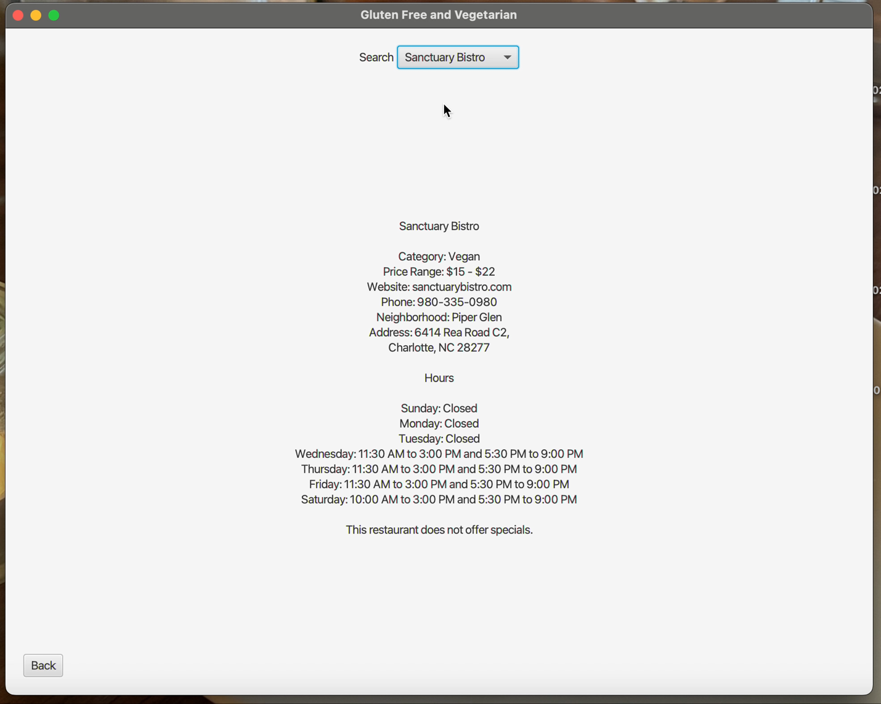

**Below is the video of the program running**