
Q1

____________________________

Q2

____________________________

Q3

____________________________

Math Practice
Q4
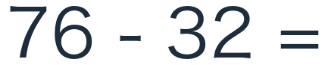
____________________________

Q5
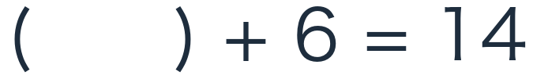
____________________________

Q6
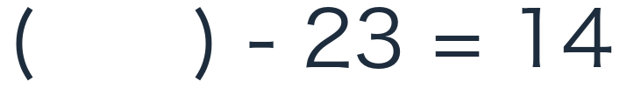
____________________________

Math Practice
Q7
____________________________

Q8

____________________________

Q9
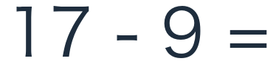
____________________________

Math Practice
Q10
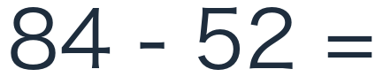
____________________________

Q11
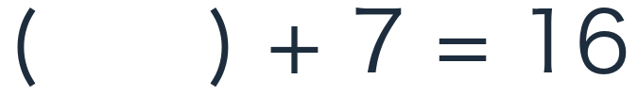
____________________________

Q12
____________________________

