Blog

First steps and considerations

1. reference material

I could just start sculpting around but since the target audience is in the field of academics, it makes more sense to attempt to recreate a real roman aqueduct, instead of just randomly create arches. Form the reference model we can tell that the aqueduct is supposed to bridge over a valley and optionally a river or ancient river bed. “Optionally” because despite the image we typically have of an aqueduct in our mid, not all of them cross rivers and wide. So it needs to be well preserved, well documented and rather large.

The easiest way to get a list of candidates is the “List of aqueducts in the Roman Empire” on Wikipedia.

Based on those requirements and the seemingly large scale and expected size of the 3D print, two specific aqueduct bridges come to mind:

First the Pont du Gard in France, which is probably the most iconic roman aqueduct. It’s also known to be the tallest and among the best preserved. It was built in the 1st century AD and has very wide and near circular arches, of various positions and dimensions, meaning it requires a lot of handwork in modelling.

<https://upload.wikimedia.org/wikipedia/commons/0/02/Pontdugard.jpg>

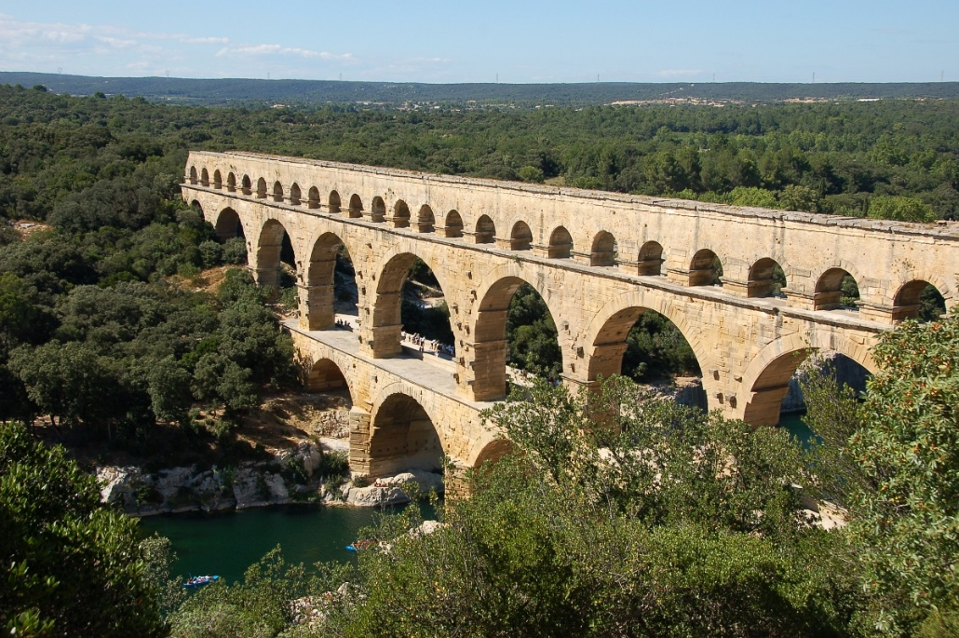

My second option is found in Spain and called the Aqüeducte de les Ferreres, or Pont del Diable (Catalan). It was built in the same century and the architectural design is overall very uniform. That should make modelling easier.

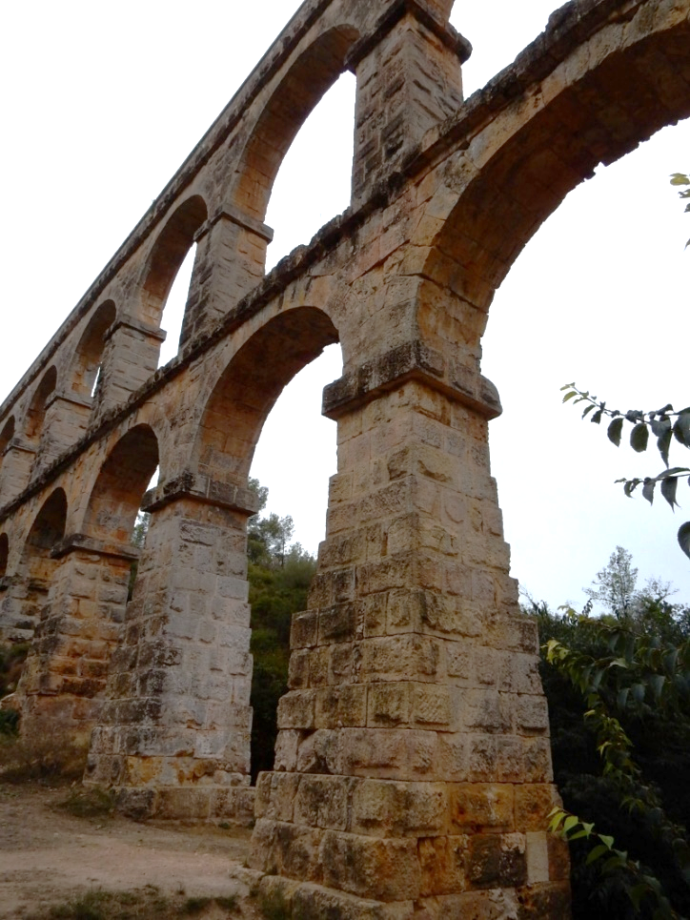

2. Distortion and scaling of the reference material

There aren’t many elevation or section plans published for this aqueduct bridge and after my initial research, it seems there currently exists no really accurate stone-true plan. Instead, the archaeological literature did what happens all too often. It copies, scales and reprints old plans (doing all that in the pre-digital era), resulting in some amount of distortion. Also, old plans are typically hand drawn and based on hand measures, so anything outside of an actual “Steinplan” can be considered a somewhat scaled sketch. In the referred publication it seems like the old French plan has some compression in the height axis (Z normally). It also fails to represent the steps in the pillar. This can be seen much better in the authors 2D drawing, which respects the roman units and appears to be scaled more correctly. But this is only an assumption. The unit P represents the Roman Foot??

Therefore, the old plan is only good for estimating the scale of the roman-unit-scaled plan, since this one does not come with a scale bar. In the end, I scaled this plan based on pillar width and height of the lower gallery.

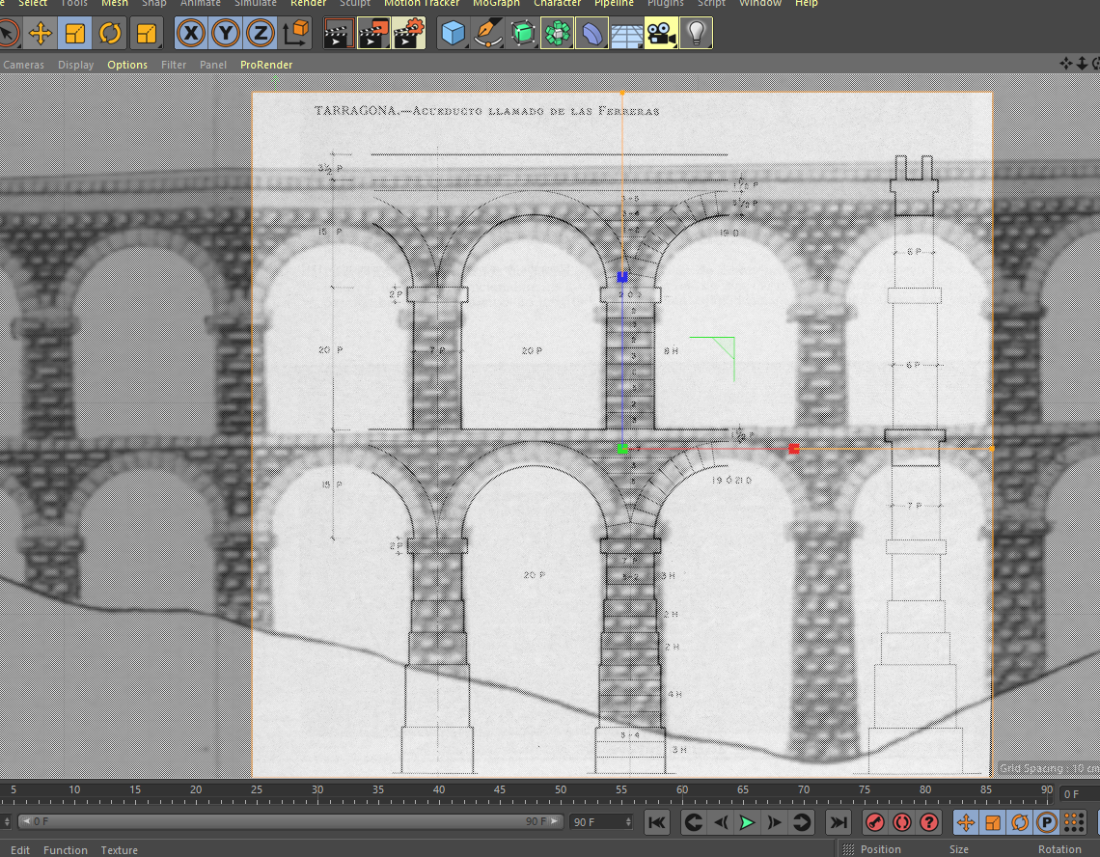

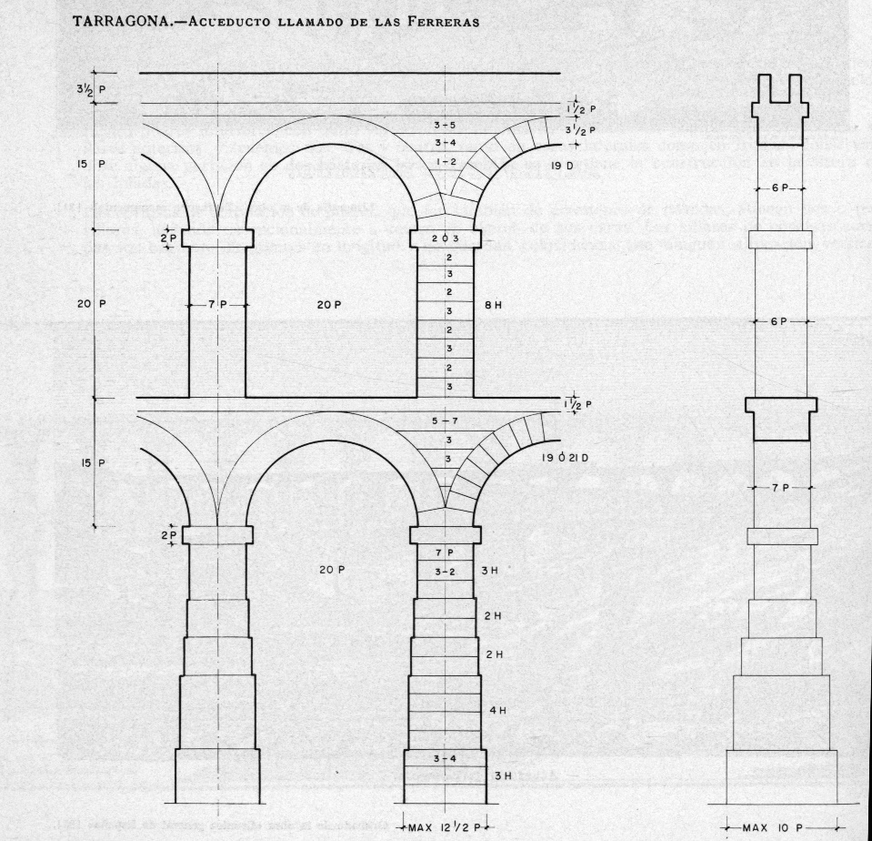

3. The modelling approach and considerations on 3D Printing.

A choice that poses itself once the reference images are done, is whether to use box or spline modelling. IMO, the spline can create more complex shapes when modelling based on 2D images but just increases the handy work when dealing with simple geometries.

Thanks to the overall uniformity, symmetry and lack of serious architectural decorations (which is typical on a utility building outside of urban spaces), box modelling seems to be the better approach, at least for the pillars. The surfaces of cubes can be easily extruded to match the existing plans, while providing more uniformity and simplicity than spline modelling could. With a few boxes the bottom pillar is quickly done. The layers seen in the background image represent the actual (standardized) block height.

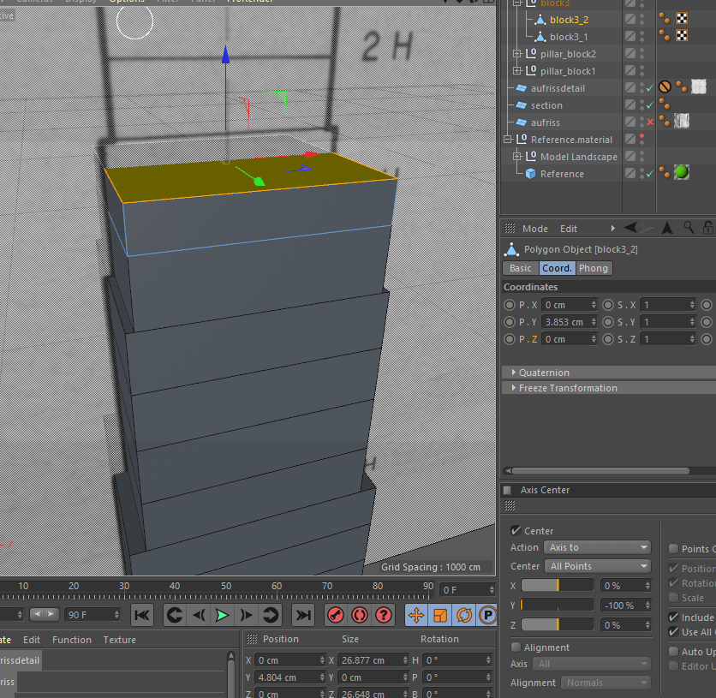

Noteworthy is the use of snapping to assure that the individual blocks are actually touching each other, or else the 3D print may run into issues. For my experience I’d expect errors like layer shifts or bad layer adhesion, resulting in a failed print. This is very frustrating as such small oversights are hard to fix afterwards. Furthermore, the use of box modelling and the relative simplicity helps with avoiding mesh holes (in my experience), which confuse slicer programs and will create unusable gcode.

One more question that arises from the use of such a standardized schematic plan is the possible lack of ‘realism’, or rather it misses certain details like architectonical decorations (ornaments, beveling, irregularities, etc.) that make it feel believable and alive. The resulting boxes may even look too simplistic.

Since the archaeological documentation does not reliably record any of that, e. g. in form of a LIDAR, or SFM generated point cloud, we could only hope to ‘fictionalize’ (aka fake) the missing details. One fix to this could be the recreation of the bossage visible on photos. If I have time later on and consider it necessary, I will look into that. Bossage however, does not appear on every block and it’s generally debatable when it is a style element and when it is simply a sign of unfinished work. The arches (Photo) appear with their bossage removed. MY point is that I’d need to make extra consideration and explanation why and where I recreate a bossage, when it isn’t even well documented.

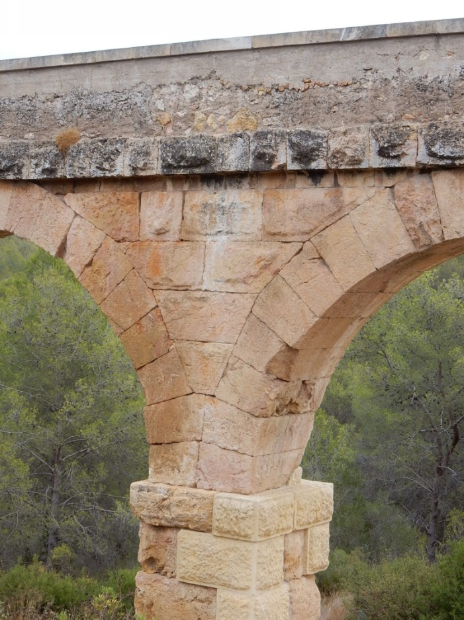

From the perspective of 3D printing, it depends on the print scale and the purpose of the model. If I create bossage and the model will be printed at a small scale, they may not even appear because they disappear between layer heights and my even introduce other issues like stringing, at least in my experience with cheap FDM printers. Also, if the purpose is to show students what bossage looks like, I believe a separate model based on, for example, an SFM point cloud, of a section of a single pillar, printed on a larger scale, would make far more sense. In that scenario the purpose would be teaching of architectural details. I would assume the model only serves to visualize the main components of an aqueduct bridge.

<http://www.romanaqueducts.info/aquasite/tarragona/foto10.html>

Day 2

Bossage

<https://www.google.com/maps/place/Aqu%C3%A4dukt+Teufelsbr%C3%BCcke/@41.1458977,1.24392,-45a,35.3y/data=!3m8!1e2!3m6!1sAF1QipORh3WKWBSCvegfKQMa0Qg-3i6yrHk84H4qVwm1!2e10!3e12!6shttps:%2F%2Flh5.googleusercontent.com%2Fp%2FAF1QipORh3WKWBSCvegfKQMa0Qg-3i6yrHk84H4qVwm1%3Dw203-h360-k-no!7i1080!8i1920!4m7!3m6!1s0x12a3fd04564b2a67:0xa907a384d29d6e81!8m2!3d41.1458977!4d1.24392!10e5!16s%2Fm%2F04ldf1n?entry=ttu>

werwerwerwer

<http://www.romanaqueducts.info/aquasite/tarragona/index.html>

https://en.wikipedia.org/wiki/List_of_aqueducts_in_the_Roman_Empire