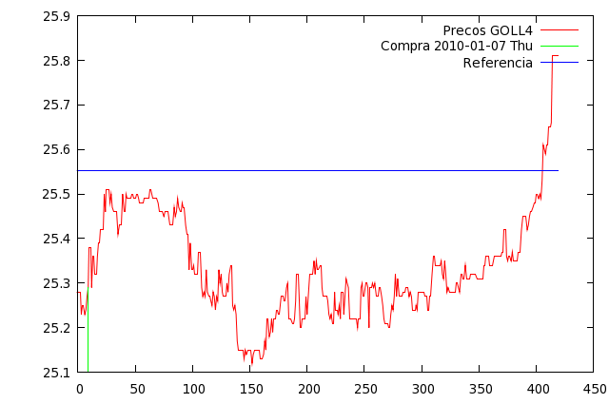
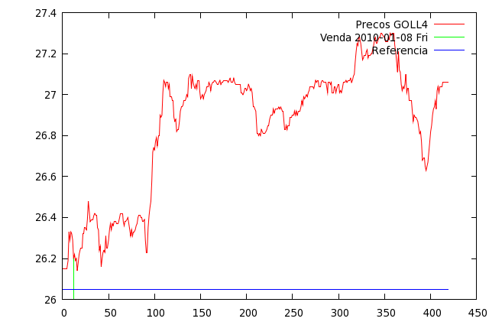
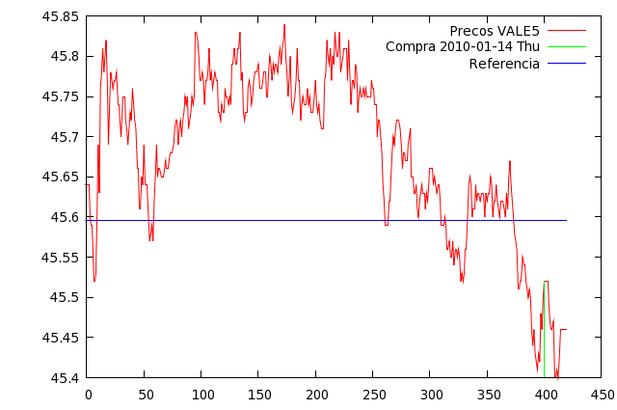
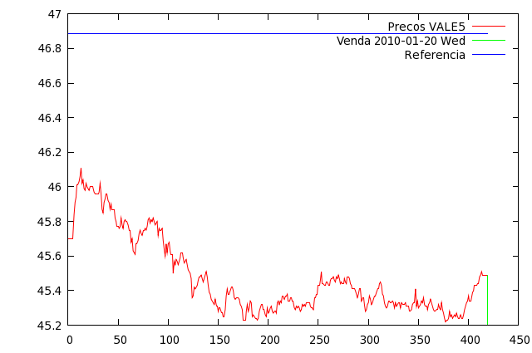
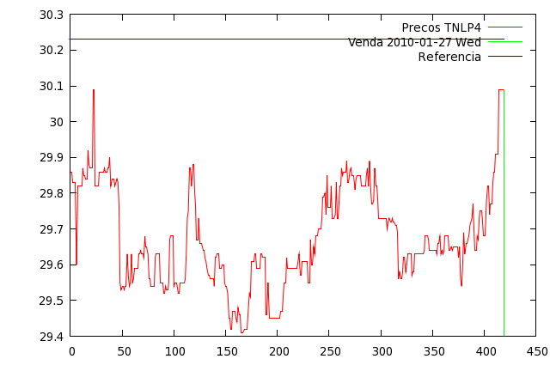
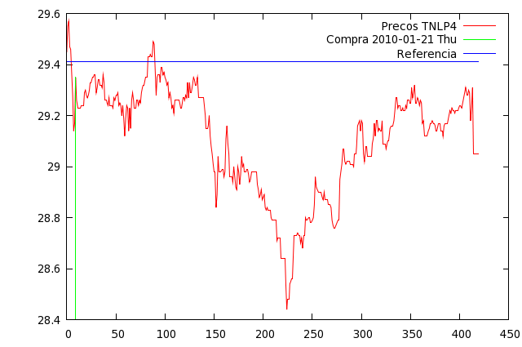

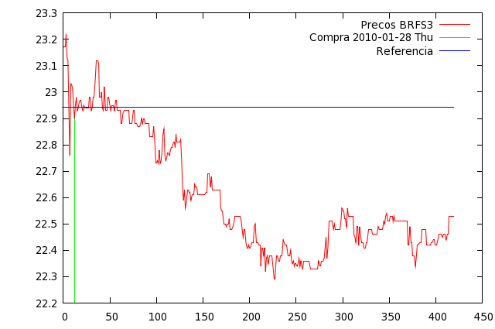
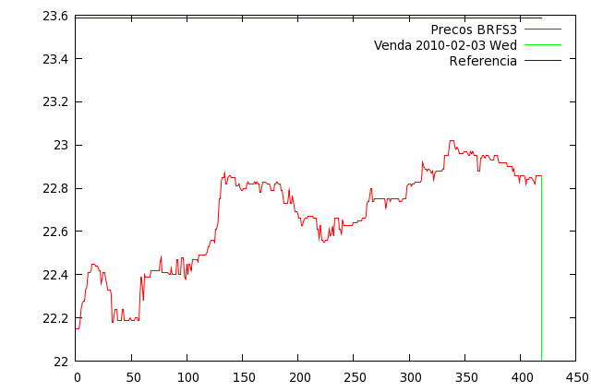
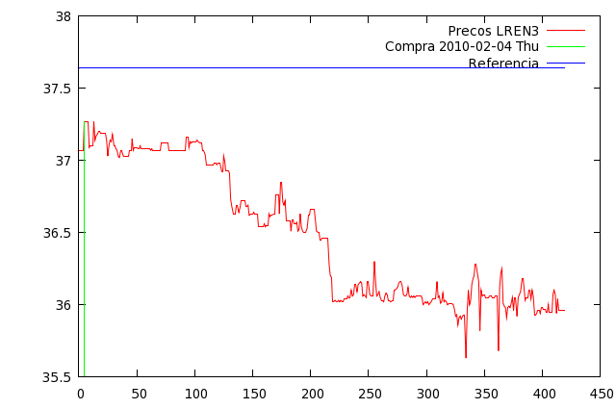
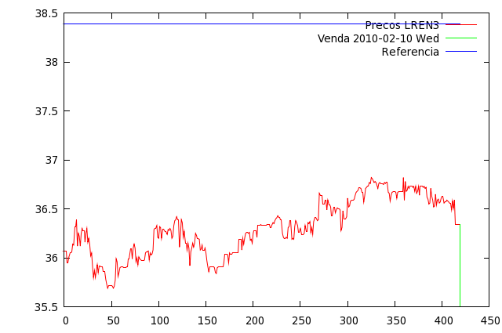
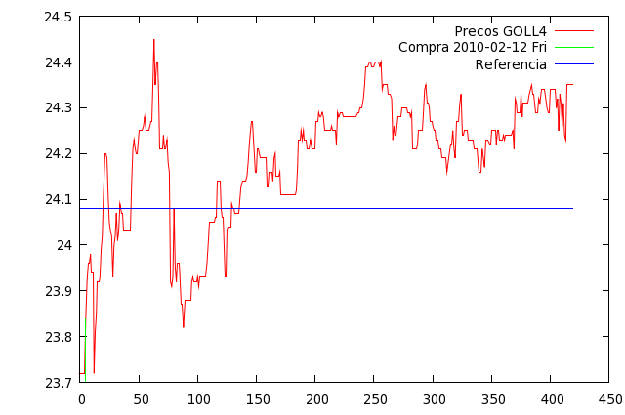
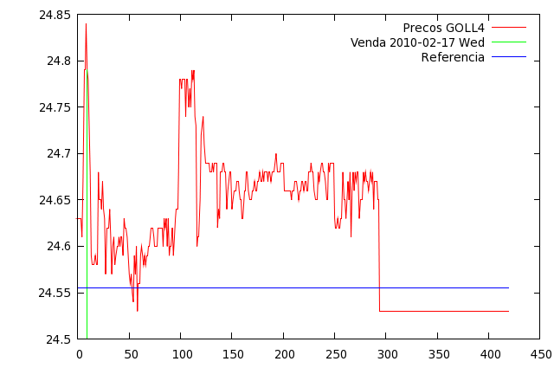

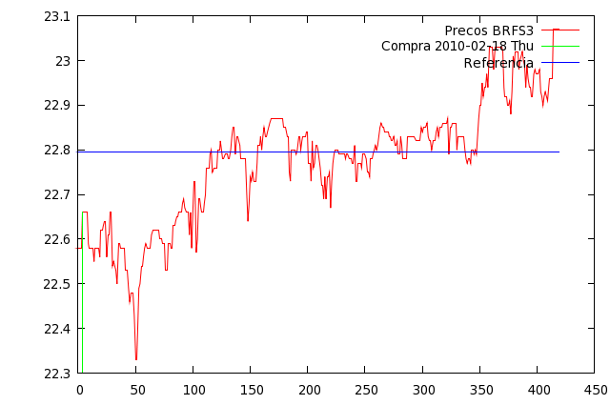
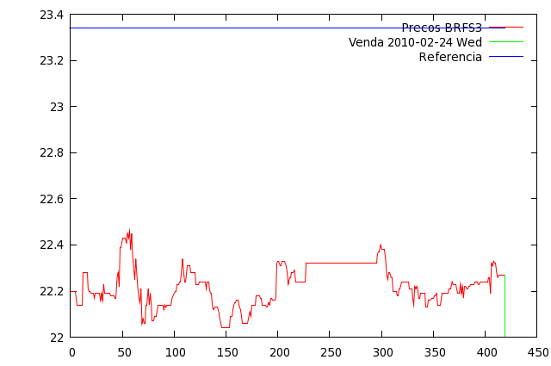
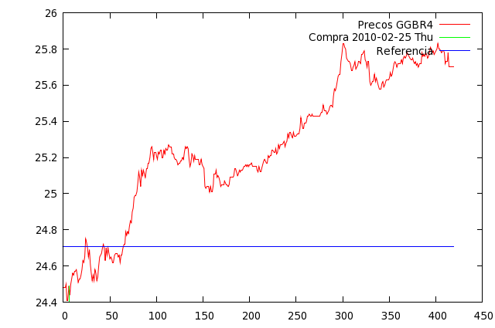
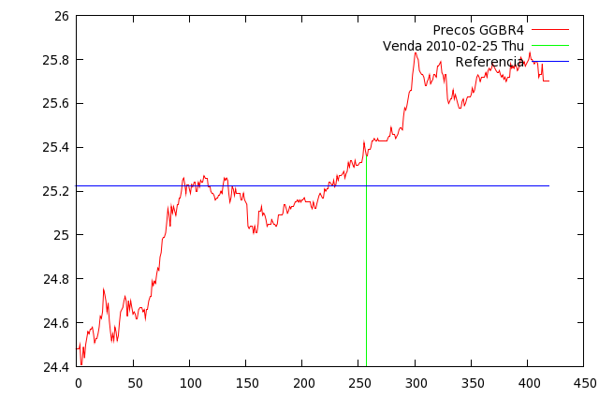
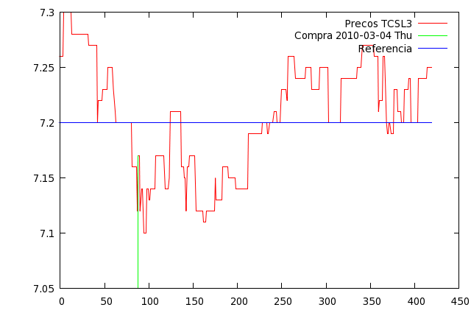
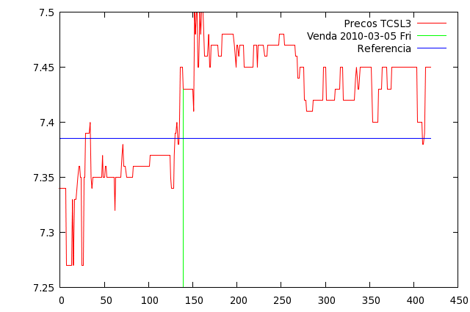

2009-12-23 ; 0.025396 ; 0.068559 ; -0.043163; ELET6 - capital = R$40938.86

2009-12-30 ; 0.027793 ; 0.136973 ; -0.109180; LAME4 - capital = R$41997.81

2010-01-06 ; 0.024387 ; 0.062815 ; -0.038427; TCSL4 - capital = R$42941.25

2010-01-13 ; 0.035983 ; 0.084913 ; -0.084913; GOLL4 - capital = R$44403.33

2010-01-20 ; -0.000483 ; 0.061939 ; -0.061939; VALE5 - capital = R$44297.53

2010-01-27 ; 0.025213 ; 0.232553 ; -0.198024; TNLP4 - capital = R$45329.17

2010-02-03 ; -0.001135 ; 0.112995 ; -0.090363; BRFS3 - capital = R$45191.63

2010-02-10 ; -0.024497 ; 0.125572 ; -0.139894; LREN3 - capital = R$43999.76

2010-02-17 ; 0.039849 ; 0.061643 ; -0.061643; GOLL4 - capital = R$45667.84

2010-02-24 ; -0.016284 ; 0.112995 ; -0.079292; BRFS3 - capital = R$44838.12

2010-03-03 ; 0.035525 ; 0.048221 ; -0.048221; GGBR4 - capital = R$46344.27

2010-03-10 ; 0.036262 ; 0.088431 ; -0.088431; TCSL3 - capital = R$47935.17

2010-03-17 ; -0.021964 ; 0.058099 ; -0.031141; TCSL3 - capital = R$46792.25

2010-03-24 ; -0.010516 ; 0.073653 ; -0.066193; POMO4 - capital = R$46211.73

2010-03-31 ; 0.000000 ; 0.083971 ; -0.083971; BBAS3 - capital = R$46211.73

2010-04-07 ; 0.000000 ; 0.126957 ; -0.126957; ITUB4 - capital = R$46211.73

2010-04-14 ; 0.045175 ; 0.060483 ; -0.060483; GOLL4 - capital = R$48209.58

2010-04-21 ; -0.024240 ; 0.084209 ; -0.091649; LREN3 - capital = R$46950.48

2010-04-28 ; 0.009452 ; 0.080346 ; -0.080346; LREN3 - capital = R$47304.63

2010-05-05 ; 0.000000 ; 0.099358 ; -0.099358; PETR3 - capital = R$47304.63

2010-05-12 ; 0.049217 ; 0.143743 ; -0.109804; ELET3 - capital = R$49540.73

2010-05-19 ; 0.030232 ; 0.061563 ; -0.061563; CNFB4 - capital = R$50942.92

2010-05-26 ; 0.048008 ; 0.119866 ; -0.039908; BRKM5 - capital = R$53289.49

2010-06-02 ; 0.033933 ; 0.062352 ; -0.062352; GOAU4 - capital = R$54994.78

2010-06-09 ; -0.010399 ; 0.085241 ; -0.099698; TNLP4 - capital = R$54318.96

2010-06-16 ; 0.006163 ; 0.099358 ; -0.099358; PETR3 - capital = R$54550.20

2010-06-23 ; 0.020915 ; 0.099021 ; -0.099021; PSSA3 - capital = R$55586.37

2010-06-30 ; 0.030800 ; 0.053586 ; -0.027989; BRFS3 - capital = R$57191.19

2010-07-07 ; 0.032860 ; 0.066964 ; -0.022153; BRTO4 - capital = R$58960.03

2010-07-14 ; -0.022822 ; 0.071493 ; -0.071493; TCSL4 - capital = R$57503.72

2010-07-21 ; 0.031381 ; 0.072581 ; -0.072581; KLBN4 - capital = R$59197.26

2010-07-28 ; 0.000000 ; 0.063091 ; -0.063091; KLBN4 - capital = R$59197.26

2010-08-04 ; 0.035274 ; 0.132234 ; -0.071014; BRFS3 - capital = R$61170.93

2010-08-11 ; -0.023465 ; 0.125572 ; -0.129144; LREN3 - capital = R$59620.70

2010-08-18 ; 0.017568 ; 0.112935 ; -0.112935; LIGT3 - capital = R$60553.85

2010-08-25 ; -0.053794 ; 0.084209 ; -0.063980; LREN3 - capital = R$57184.49

2010-09-01 ; 0.025227 ; 0.067697 ; -0.043628; RAPT4 - capital = R$58517.05

2010-09-08 ; 0.030544 ; 0.070313 ; -0.070313; GGBR4 - capital = R$60191.51

2010-09-15 ; 0.015866 ; 0.101373 ; -0.101373; TNLP4 - capital = R$61031.26

2010-09-22 ; 0.009609 ; 0.054175 ; -0.054175; BRKM5 - capital = R$61501.21

2010-09-29 ; 0.030662 ; 0.129608 ; -0.129608; FIBR3 - capital = R$63268.31

2010-10-06 ; 0.031352 ; 0.117154 ; -0.117154; LAME4 - capital = R$65129.81

2010-10-13 ; -0.005253 ; 0.090838 ; -0.064913; PETR4 - capital = R$64664.27

2010-10-20 ; 0.031341 ; 0.070914 ; -0.070914; BRAP4 - capital = R$66566.13

2010-10-27 ; 0.016855 ; 0.052014 ; -0.052014; EMBR3 - capital = R$67560.56

2010-11-03 ; 0.040367 ; 0.145112 ; -0.145112; TCSL4 - capital = R$70156.82

2010-11-10 ; 0.000000 ; 0.106690 ; -0.106690; USIM5 - capital = R$70156.82

2010-11-17 ; 0.032248 ; 0.083971 ; -0.083971; BBAS3 - capital = R$72283.81

2010-11-24 ; 0.000000 ; 0.053693 ; -0.053693; ITUB4 - capital = R$72283.81

2010-12-01 ; 0.009356 ; 0.051750 ; -0.051750; ITSA4 - capital = R$72822.10

2010-12-08 ; 0.036780 ; 0.095352 ; -0.046401; USIM5 - capital = R$75359.62

2010-12-15 ; -0.035219 ; 0.052543 ; -0.068442; GOLL4 - capital = R$72564.85

2010-12-22 ; 0.032801 ; 0.160201 ; -0.125364; GGBR4 - capital = R$74804.95

# **** average_target_return: 0.004677, average_wnn_error: -0.027230

# **** standard_deviation_target_return: 0.014772, standard_deviation_wnn_error: 0.036877

# **** hr_up: 64.15, hr_dn: 0.00, hr: 72.34

# **** capital inicial: R$40000.00 capital final: R$74804.95 retorno acumulado:87.71%

