Kinematic Model of Ackerman Steering Vehicles
June 14, 2011

Relation between the Control Input and Speed of Wheels

Let:
- v denote the linear velocity of the vehicle;
- v_{r} the linear velocity of the right wheel;
- v_{l} the linear velocity of the left wheel;
- ω (omega) the angular velocity of the vehicle;
- φ (phi) the steering angle of the vehicle;
- L the distance between front and rear axles (or wheel base);
- l the distance between left and right wheels.

Figure 1 shows the approximate kinematic model of an Ackerman steering vehicle.
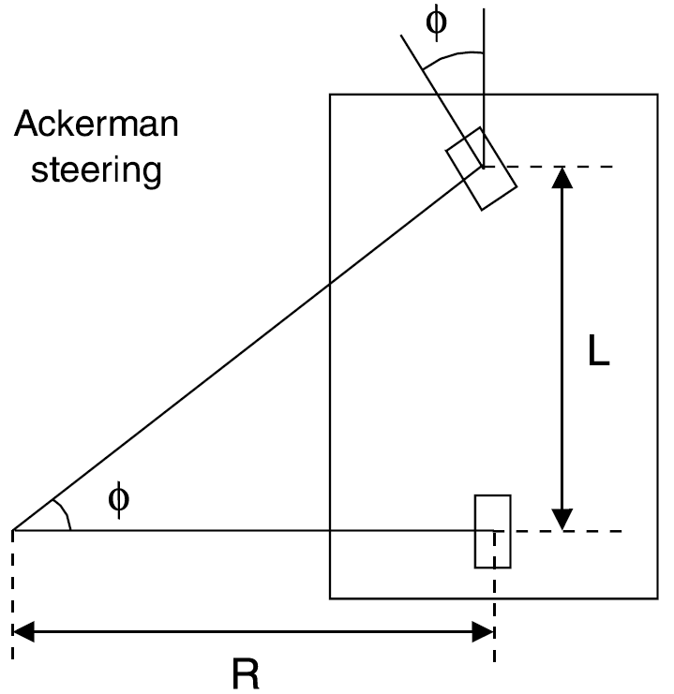
Figure 1: Approximate kinematic model of an Ackerman steering vehicle [SOT03].

The linear velocity of the right wheel, v_{r}, and the linear velocity of the left wheel, v_{l}, can be computed from the linear velocity of the vehicle, v, and the steering angle of the vehicle,φ, as follows. The linear velocity of the vehicle, v, is given by:
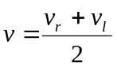 (1)

The angular velocity of the vehicle, ω, is given by:
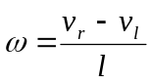 (2)
The steering angle of the vehicle, φ, is given by:
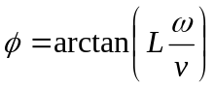 (3)
Isolating v_{r} in Equation 1:
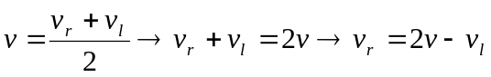 (4)
Isolating v_{r} in Equation 2:
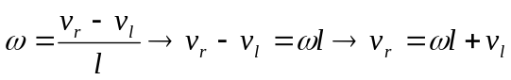 (5)
Isolating ω in Equation 3:
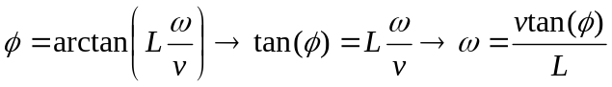 (6)
Equating the Equations 4 and 5 and isolating v_{l}:
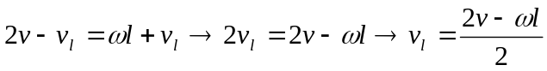 (7)
Substituting the Equation 6 in Equation 7, we finally obtain the v_{l} from v and φ:
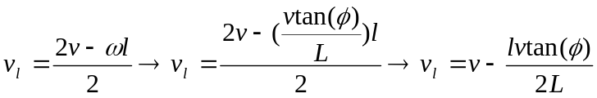 (8)
Isolating v_{r} in Equation 1:
(9)
Substituting Equation 8 in Equation 9, we finally obtain v_{r} from v and φ:
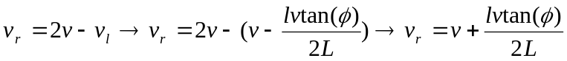 (10)

The steering angle of the vehicle,φ, can be computed from the linear velocity of the right wheel, v_{r}, and the linear velocity of the left wheel, v_{l}, by substituting the Equations 1 and 2 in Equation 3:
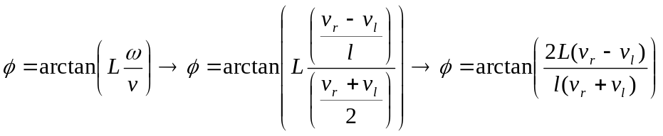 (11)

Dynamics of the Global Position and Orientation Variables

Let:
- (x, y) denote the pose of the vehicle in a global frame of coordinates;
- θ the orientation of the vehicle in a global frame of coordinates;

The dynamics of the global position and orientation variables, (x, y, θ), are given by:
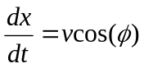 (12)
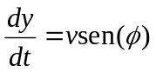 (13)
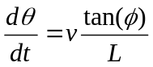 (14)

References

[BON11] Philippe Bonnifait, Pascal Bouron, Paul Crubillé, Dominique Meizel. Data Fusion of Four ABS Sensor and GPS for an Enhanced Localization of Car-like Vehicles. International Conference on Robotics & Automation, pages 1597-1602, 2011.
[SOT03] Miguel Angel Sotelo. Lateral Control Strategy for Autonomous Steering of Ackerman-Like Vehicles. Robotics and Autonomous Systems 45:223-233, 2003.
[XIA] Jizhong Xiao. Mobile Robot Locomotion. Department of Electrical Engineering, City College of New York.

