CIS 102 – Assignment #2 – Fall 2009 Name ______________________________
Developing and Implementing an Algorithm
Enter your answers into this document in bold, and then upload it via Moodle.

You may work with another student on these problems, but each student needs to use the tools in hands-on fashion, enter the information into this document, and turn it in under their own name.

Be sure to save your Raptor and Microsoft Small Basic files on removable media for possible future use.

Part A – Solve a Problem Using Raptor and Microsoft Small Basic
Many parts of this first problem are done for you as an example for other problems in this assignment. You need to complete the parts as indicated below by “TO DO.”

Problem 1: Compute the area of a room given the length and width, that is, allow the user to enter a length and width from the keyboard (could be on separate lines), then compute and display the area of the room on the screen.

Here are the steps we want to follow:

Define the problem – We want to be sure we understand the problem before continuing. An input-processing-output chart will help us.

IPO Chart: We analyze the problem to come up three basic items: input, processing, and output. List in the input and output columns the values coming in and going out, respectively. For the processing column, we want to think about how the input items can be converted to the output items and then write that down.

IPO Chart
Input | Processing | Output
length  width | Input length and width  Multiply length by width to get area  Output area | area

Develop a solution – We want to develop an algorithm to solve the problem. The IPO chart above will be used as a guide.
Flowchart: We design the algorithm in detail and represent it as a flowchart. This has already been done and is shown below. There are two versions of the flowchart. The left one is longer because it shows the “prompt” and “get” steps separately. The right one shows them in one input symbol. We will use the right one for Raptor (because Raptor allows us to combine the “prompt” and “get” operations in one input symbol) and the left one for Microsoft Small Basic.
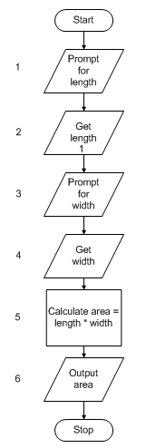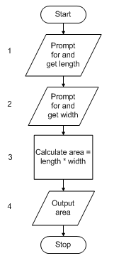
Used for Raptor
Used for MS Small Basic

Test the algorithm – We come up with test cases and check our algorithm by hand to be sure the test cases work. We’ll use two test cases and use the right flowchart. Note that each statement in the flowchart is numbered and corresponds to the numbers in the left column below. We indicate in the desk check table what the values of the variables are after each statement in the algorithm is executed.

Desk Check Table
Statement number | length | width | area
First test case
1 | 20
2 |  | 10
3 |  |  | 200
4 |  |  | output
Second test case
1 | 35
2 |  | 15
3 |  |  | *
4 |  |  | output

We observe that the algorithm was successful on the first test case because the solution is correct.
TO DO: For the second test case, enter the value in the cell designated with an asterisk * above and enter that number here as well: _______________

Implement the algorithm using Raptor – Now that we have the algorithm defined and tested, we implement the algorithm using Raptor which will also document our flowchart. A partially completed Raptor file has been created for this problem. If you are working at home, you will need to install Raptor on your computer if you haven’t already (see the PowerPoint Raptor.ppt). If you are working in the lab room at LCC, Raptor is already installed. Download the file Assign2-Prob1.rap from the Assignments page in Moodle. Double click on the file to load it into Raptor. Compare the flowchart above with the Raptor flowchart. TO DO: The statement inside one of the flowchart symbols is in error. Find it and fix it. You double click a symbol to get access to the statement inside. Then from Raptor’s menu, select “Run>Execute” to Completion. Watch the implemented algorithm execute. When asked, enter the length and width from the first test case. Then run it again and enter the values for the second test case. Use Raptor’s “File>Print to Clipboard” menu option to save the flowchart to the Windows Clipboard. Then paste it into this document immedicately below.

Implement the algorithm using Microsoft Small Basic – We now implement the algorithm using the Small Basic language. Small Basic is installed on the lab room PCs. If you are working at home and haven’t installed it yet, you may do so (see the PowerPoint SmallBasic.ppt). The Small Basic file for this problem has already been created but it is not complete. Its name is Assign2-Prob1.sb. Download it from the Assignments page in Moodle, and double click on it to load it into the Small Basic IDE. TO DO: There is part of one line missing from this program. Look at the flowchart above and the Raptor implementation to decide what is missing and fix it. If you have trouble spotting the missing info, try running the program by clicking the Run button in the toolbar and looking at the error messages. After you fix the problem. Execute the program by clicking on the Run button. When asked, enter the length and width from the first test case. TO DO: Screen print using the Alt-PrintScrn key the output window and insert it immediately below using the MS Word “Edit>Paste” menu option. Run the program again and enter the second test case. Screen print the output window for this case and insert it below as well. Also, screen print the Small Basic code window with the program visible and insert below.

Part B – Using Raptor and Flowcharts
For each of the following two problems, you need to:
- Define the problem – Be sure the problem is well defined for you and you understand what you need to do, otherwise do “information gathering” by re-reading it, reading the text, doing a Google search, or asking the lab aides, other students, or the instructor. Then create an IPO chart.

IPO Chart: First, fill in the Input-Processing-Output (IPO) chart below to create an outline of the algorithm. In the Input column, enter the names of the input items. In the Output column, enter the names of the output items. In the Processing column, indicate what values you need to input and ouput and paraphrase how you intend to convert the input into the output (this is the outline of the algorithm to follow, you may use multiple lines).

IPO Chart
Input | Processing | Output

- Develop a solution

Flowchart: Create the algorithm and represent it with a flowchart using a pencil and scratch paper. You don’t need to turn the scratch paper flowchart in. You will turn in the Raptor flowchart.

- Test the algorithm – Think up two test input cases and desk check them as was done above. This should be a table in this document as shown below. You need to turn in the desk check info.

Desk Check Table
Statement number | Value1 | Value2 | … | ValueN
First test case
Second test case

- Raptor – Use Raptor to implement the algorithm by entering it graphically as a flowchart then run your two test cases. Insert the Raptor flowchart into this document immediately below using the Print to Clipboard technique described above.

Problem 2 – Allow the user to enter two integers from the keyboard (could be on two separate lines) and display on the screen their sum and the difference of the first integer minus the second (sum and difference could be on two separate lines).
Follow the steps described above. To get you started, the IPO chart, flowchart, and partially completed desk check table are given to you below. Complete the desk check table by entering the correct value for the asterisk *.

IPO Chart
Input | Processing | Output
integer1  integer2 | Input integer1 and integer2  Add integer1 to integer2 to get sum  Subtract integer2 from integer1 to get difference  Output sum and difference | sum of integers  difference of integers

Flowchart

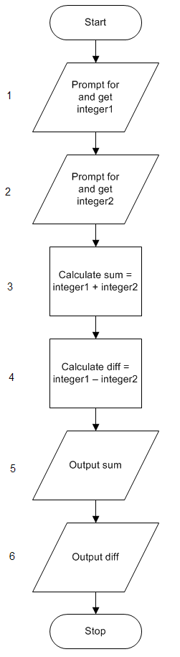

Desk Check Table
Statement number | integer1 | integer2 | sum | diff
First test case
1 | 150
2 |  | 10
3 |  |  | 160
4 |  |  |  | 140
5 |  |  | output
6 |  |  |  | output
Second test case
1 | 35
2 |  | 275
3 |  |  | 310
4 |  |  |  | *
5 |  |  | output
6 |  |  |  | output

To Turn In:
  - Completed desk check table – replace the asterisk * in table above with the correct value
  - Raptor flowchart

Problem 3 – Allow the user to enter a first name followed by a last name from the keyboard (could be on two separate lines) and display the last name followed by the first name with a comma between (all on one line).
Follow the steps described above.
To Turn In:
  - IPO chart
  - Desk check table for two test cases
  - Raptor flowchart

Part C – Using Microsoft Small Basic
Problem 4 – Implement the algorithm for Problem 2 above by writing the code using Microsoft Small Basic, and test the program using your two test cases. Include screen prints immediately below of the Small Basic screens showing the code and that the two test cases ran successfully. To assist, a partially completed Small Basic program called Assign2-Prob4.sb for this problem is available to you from the Assignments page in Moodle. Download it and make this your starting point.

Problem 5 – Implement the algorithm for Problem 3 above by writing the code using Microsoft Small Basic, and test the program using your two test cases. Include screen prints immediately below of the Small Basic screens showing the code and that the two test cases ran successfully.

Part D – Tax Problem using Pseudocode and Microsoft Small Basic
Problem 6 – You are asked to create a program using Microsoft Small Basic that will input a tax rate from the keyboard as a decimal number, and also input the prices of five items as decimal numbers (could be on separate lines). The program should calculate the total price of the items before tax and the tax payable on those items. The tax payable is calculated by applying the tax rate to the total price. The program should output on the screen the total price and the tax payable.

For Problem 6, follow the normal steps, that is:
- Define the problem – You should be sure the problem is well defined for you before going further, otherewise do “information gathering” (see Part B above). Then create an IPO chart to illustrate the basic components you are dealing with and include the IPO chart in this document immediately below.
- Develop a solution algorithm – Create an algorithm but this time represent the algorithm using psuedocode rather than a flowchart. Recall from the classroom discussion that a pseudocode representation of an algorithm is like the statements inside the flowchart symbols, but often it is preferable to expand the minimalist statements in a flowchart symbol when writing pseudocode. Enter the psuedocode into this document immediately below.
- Test the algorithm – Use a desk check table to check the algorithm with two test cases. Include the table in this document immediately below.
- Implement the algorithm by coding it using Microsoft Small Basic, then run the program against your two test cases.
- After it runs successfully, screen print the Microsoft Small Basic window showing your code and screen print the windows that confirm your test cases ran successfully. Insert these screen prints immediately below.

To Turn In:
  - IPO chart
  - Pseudocode
  - Desk check table for two test cases
  - Small Basic window showing code
  - Small Basic windows showing successful execution using your two test cases

Upload this document with your answers in bold via Moodle.

