CIS 102 – Assignment #3 – Fall 2009 Name ______________________________
Data Representation & Selection
Enter your answers into this document in bold, and then upload it via Moodle.

You may work with another student on these problems, but each student needs to use the tools in hands-on fashion, enter the information into this document, and turn it in under their own name.

Part A – Data Represenation
The methods for solving these problems are described and examples given in PowerPoint 05Algor.ppt and the handout Activity03.doc.

Characters

- Convert each of the following characters into its binary representation using the 7-bit ASCII chart handout ASCII.doc, or the one in the PowerPoint 05Algor.ppt both available from Moodle. Then indicate the bit pattern that will be stored for the character in 1-byte of storage.
  - Z = __101 1010_______01011010___________
  - z = __111 1010_______01111010__________
  - + = ___010 1011______00101011___________

- Convert each of the binary representations below found in 1-byte of storage to its equivalent character using the ASCII chart.
  - 01010100 = ___T___
  - 01101111 = ___o___
  - 01110000 = ___p___

Unsigned Integers

- Convert each of these decimal numbers into its unsigned binary equivalent, and assume the binary number is to be stored in 1-byte of memory.
  - 19 = ___00010011______________
  - 51 = ___00110011_____________

- Convert each of the following binary numbers found in 1-byte of storage into its decimal equivalent. Assume they have been stored using the unsigned integer representation.
  - 00001010 = ____10_____
  - 01000001 = ___65______

Signed Positive Integers

- Convert each of the following positive decimal integers into the bit pattern used to store it in 1-byte of storage using the sign-and-magnitude representation.
  - 21 = ___00010101_____________
  - 65 = ___01000001_____________

- Assume each of the following bit patterns has been stored in 1-byte of memory using the sign-and-magnitude format. Convert each to the corresponding decimal integer.
  - 00010000 = __16_____
  - 01111011 = __123_____

Signed Negative Integers

- Convert each of the following negative decimal integers into the bit pattern used to store it in 1-byte of storage using the two’s complement representation.
  - -10 = _____11110110___________
  - -49 = _____11001111___________

- Assume each of the following bit patterns has been stored in 1-byte of memory using the two’s complement format. Convert each to the corresponding decimal integer.
  - 11100011 = ___-29_____
  - 10111100 = ___-68_____

Part B – Selection NOT AREA, SUM & DIFF OF TWO INTEGERS, DISPLAY LASTN THEN FIRSTN, TAX RATE & TOTAL PRICE
Discussion and examples of the methods used for selection in the problems below are in PowerPoint 06Algor.ppt and handout Activity04.doc.

- For each of the problems below, you will want to follow the steps for program development that we have discussed earlier. That is, you should:
  - Define the problem by creating an IPO Chart.
  - Develop a solution algorithm and represent it using pseudocode (not flowcharts for these).
  - Test the algorithm with a Desk Check Table.

So, for each of these problems insert your IPO Chart, pseudocode representation of the algorithm, and your Desk Check Table immediately below the problem statement.

  - Sort Problem: Allow the user to enter three numbers, then sort the numbers into descending sequence and display them on the screen.

Input | Processing | Output
Num1  Num2  Num3 | Ask user for 3 numbers  Sort numbers in descending order  Output numers in descending order | highNum  middleNum  lowNum

- Prompt user for and receive num1
- Prompt user for and receive num2
- Prompt user for and receive num3
- If num1 < num2
- Then flip numbers
- If num2 < num3
- Then flip numbers
- If num1 < num2
- Then flip numbers
- Output: num1 + num2 + num3

Steps | Num1 | Num2 | Num3 | Output
Test 1
1 | 20
2 |  | 30
3 |  |  | 10
10 |  |  |  | 30 20 10
Test 2
1 | 10
2 |  | 20
3 |  |  | 30
10 |  |  |  | 30 20 10
Test 3
1 | 20
2 |  | 10
3 |  |  | 30
10 |  |  |  | 30 20 10
Test4
1 | 30
2 |  | 10
3 |  |  | 20
10 |  |  |  | 30 20 10

  - Tax Problem: Have the user enter a purchase amount and a two-character Pacific coast state code (WA for Washington, OR for Oregon, and CA for California). The program should display the purchase amount followed by the sales tax amount, and then the total amount (sum of purchase and sales tax) all in dollars. The sales tax rates are: Washington 0.065, Oregon 0.0, California 0.0825.
Input | Processing | Output
purchAmt  stateCode | Receive purchAmt and stateCode  Find taxRate based on stateCode  Multiply taxRate by purchAmt to get salesTax  Add salesTax to purchAmt to get total | purchAmt  salesTax  total

- Prompt user for and receive purchAmt
- Prompt user for and receive stateCode
- If stateCode == WA
- Then taxRate = .065
- If stateCode == OR
- Then taxRate = 0.0
- If stateCode == CA
- Then taxRate = .0825
- salesTax = taxRate * purchAmt
- total = salesTax + purchAmt
- Output purchAmt, salesTax, total

Steps | purchAmt | stateCode | taxRate | salesTax | total | Output
Test 1
1 | 10
2 |  | WA
4, 6, 8 |  |  | .065
9 |  |  |  | .65
10 |  |  |  |  | 10.65
11
Test 2
1 | 10
2 |  | OR
4, 6, 8 |  |  | 0.0
9 |  |  |  | 0
10 |  |  |  |  | 10
11
Test 3
1 | 10
2 |  | CA
4, 6, 8 |  |  | .0825
9 |  |  |  | .825
10 |  |  |  |  | 10.825
11

  - Sale Problem: A computer store has a promotion on a new printer. The printer’s normal price is $500, but the store is offering a sale where the customer gets one dollar off for each year of his age. The program should request a customer’s age then validate it to be sure it is greater than zero and less than 150 years. It should output an error message if the age is not within that range. The program should output the original price, the sale amount, and the discounted amount ($500 minus the age) all in dollars.

Input | Processing | Output
userAge | Receive userAge  Check to see if it is within boundaries (0 – 150)  If not in range output error message  If in range output original price, sale amount, and discounted amount | $500  userAge  discAmt

- Prompt user for and receive userAge
- If 0 < userAge < 150
  - Then discAmt = 500 – userAge
  - Output: “$500”, userAge, and discAmt
- Else
  - Output error message

Steps | userAge | discAmt | Output
Test 1
1 | 22
2, 3 |  | 478
 |  |  | output
Test 2
1 | 165
2, 3 |  | Error
 |  |  | Output error message

- Select one of the problems above (any one of them) and implement the solution algorithm using Small Basic. Include the following immediately below.
  - The name of the problem you chose to implement.
  - Small Basic window showing your code.
  - Small Basic windows showing successful execution using at least two test cases.

- Sorter
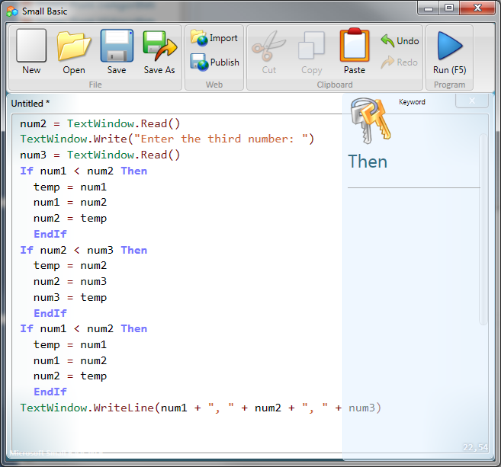
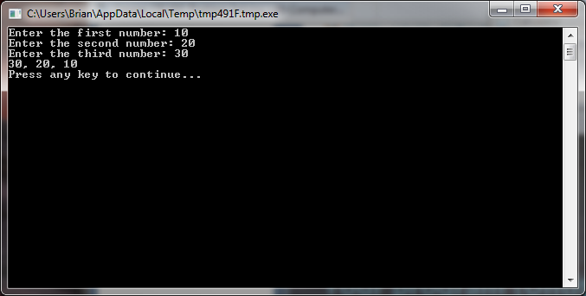
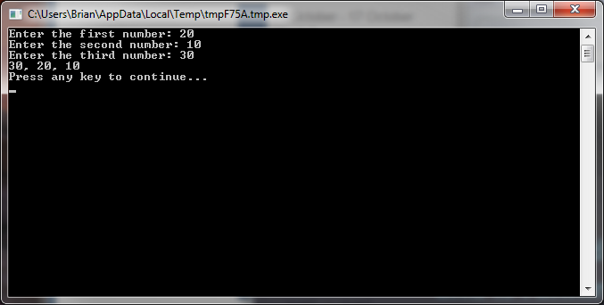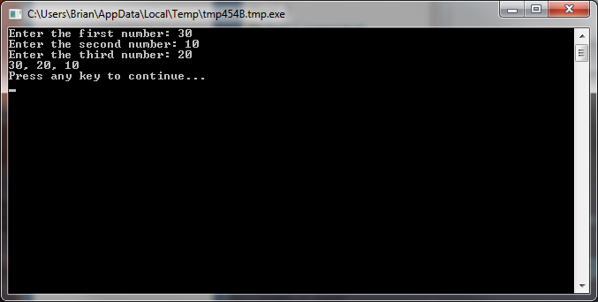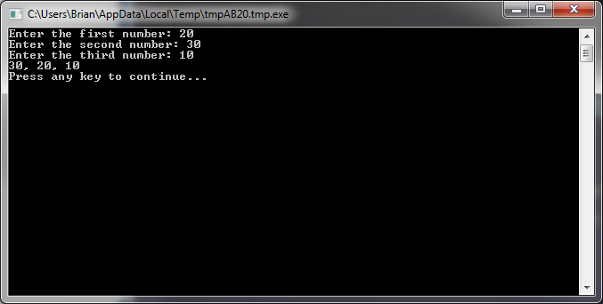

- Sales Tax Finder

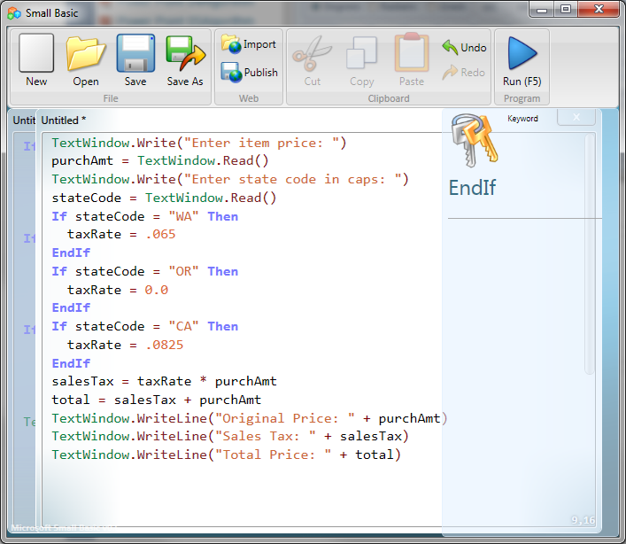
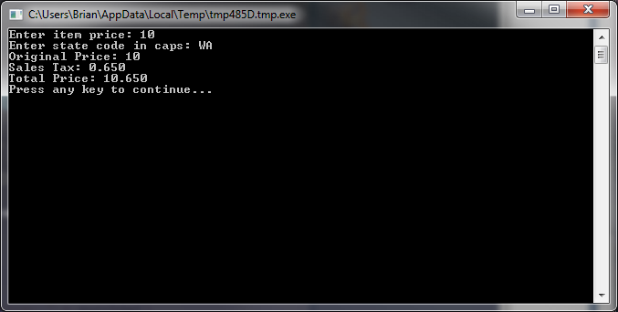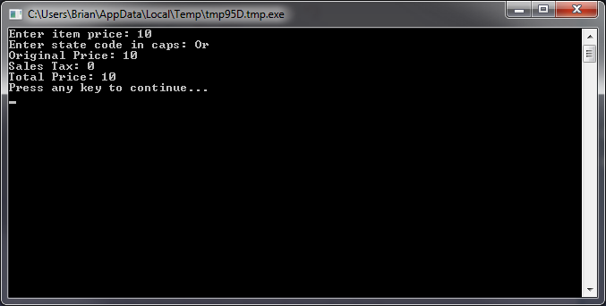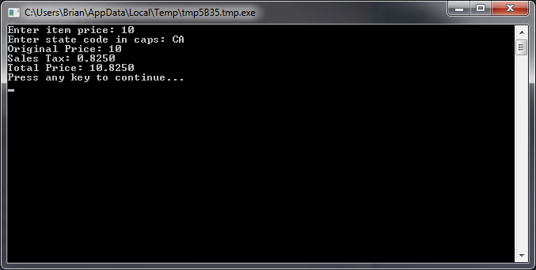

- Sale Problem

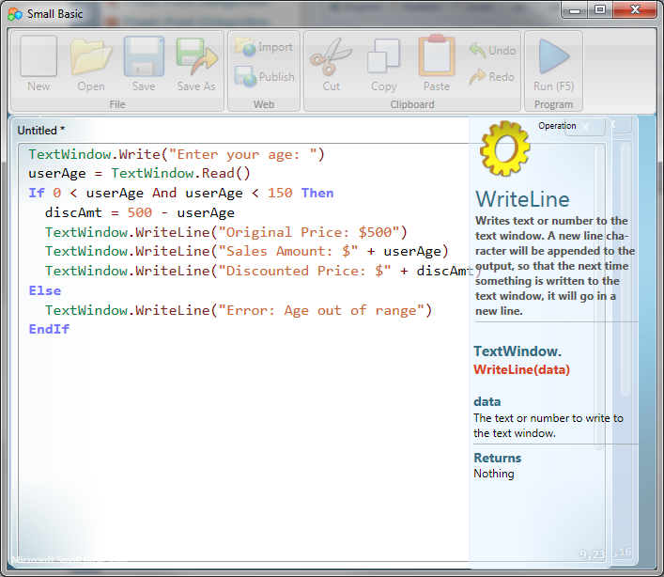
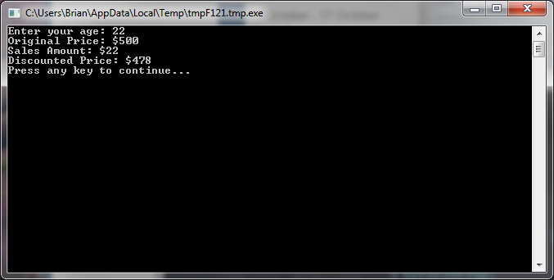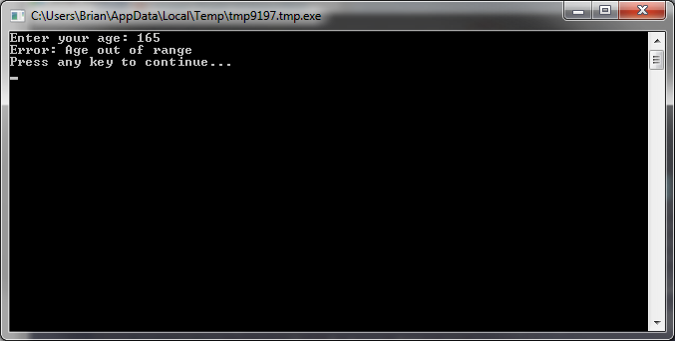
Extra credit for implementing the solution for more than one of the above problems.

Upload this document via Moodle with your answers in bold and the other requested information inserted.

