CIS 102 – Assignment #4 – Fall 2009 (version 10/30/09) Name ______________________________
Repetition & Selection
Enter your answers into this document in bold, and then upload it via Moodle.

You may work with another student on these problems, but each student needs to use the tools in hands-on fashion, enter the information into this document, and turn it in under their own name.

The methods for solving these problems are described and examples given in the Repetition PowerPoint (07Algor.ppt) and the handout Activity05.doc.

Part A – Algorithm and Small Basic (partially completed already)
Salary Problem: The program should request a salary from the user between the range 10,000 and 75,000. If the salary is less than 50,000 calculate and display the new salary as the salary plus 5%. If the salary is greater than or equal to 50,000 display the new salary as the salary plus 3%. The program should validate that the input salary is within the stated range and display an error message if it isn’t, then allow the user to re-enter the salary.

We will follow the steps for program development that we have discussed.

To Do: Where there is an item missing indicated by the *** Missing *** marker, replace the marker with the correct value or statement.

Step 1: Define the Problem – We create an IPO chart to help us to understand what we need to do. By analyzing the language in the problem statement, we see that the nouns (descriptive words) in the problem statement indicate that the input and output are: salary, new salary. We see that the verbs (actions) leading to the definition of the processing are: request, calculate, display, validate, re-enter. From these we create the IPO cart. Notice that the Processing column is only an overview of the processing to be done not the detailed algorithm because at this stage we are defining the problem not solving it.

IPO Chart
Input | Processing | Output
salary | Input salary  If salary is out of range display error message and re-enter  If salary < 50000 then newSalary = salary + (salary * .05)  Else newSalary = salary + (salary * .03)  Display newSalary | newSalary  error message

Step 2: Develop a Solution – Using the IPO chart, we create the algorithm that solves the problem and represent the algorithm using pseudocode.

Pseudocode
1) Initialize constants
2) Prompt for salary
3) Get salary
4) While salary < 10000 Or salary > 75000
5) Display error message
6) Prompt for salary
7) Get salary
8) EndWhile
9) If salary < 50000 Then
10) newSalary = salary + (salary * .05)
11) Else
12) newSalary = salary + (salary * .03)
13) EndIf
14) Display newSalary

Step 3: Test the Algorithm by desk checking it – Before coding the algorithm, we want to be sure it is correct. We choose test cases to check the algorithm by hand by tracking the values in all the variables as the statements execute.

Desk Check Table
Statement number | salary | newSalary | Error msg
First test case
1, 2, 3 | 9000
4, 5 |  |  | output
6, 7 | 76000
8, 4, 5 |  |  | output
6, 7 | 10000
8, 9, 10 |  | 10500
14 |  | output
Second test case
1, 2, 3 | 50000
9, 12 |  | 51500
14 |  | output

Step 4: Implement the Algorithm – Write the Small Basic program that implements the algorithm by converting each statement in the algorithm to a Small Basic statement. Note that we are using constants for several values. Constants are normally defined at the top of a program and they allow the programmer to easily change their values. If literals are used within the program statements instead of constants it is much harder to change these values later. For example, suppose after a month of your program’s use, you are told that the division between the 5% and 3% increase is now 55000 rather than 50000. All you have to do is change the value for the SALARY_DIVISION constant right at the top of the program.

Enter the above code into the Small Basic code window and run it to test your test cases from the Desk Check Table above.

SALARY_LOW = 10000
SALARY_HIGH = 75000
SALARY_DIVISION = 50000
LOW_INCREASE = 0.05
HIGH_INCREASE = 0.03
TextWindow.Write("Enter your salary: ")
salary = TextWindow.ReadNumber()
While (salary < SALARY_LOW ** Missing ** salary > SALARY_HIGH)
TextWindow.WriteLine("Error - invalid salary")
TextWindow.WriteLine("Valid salaries are between " + SALARY_LOW + " and " + SALARY_HIGH)
TextWindow.Write("Enter your salary: ")
** Missing Line **
EndWhile
If salary < ** Missing ** Then
newSalary = salary + (salary * LOW_INCREASE)
Else
newSalary = salary + (salary * HIGH_INCREASE)
EndIf
TextWindow.WriteLine("Your new salary is " + newSalary)

To Do: Include the following immediately below.
  - Small Basic window showing your code.
  - 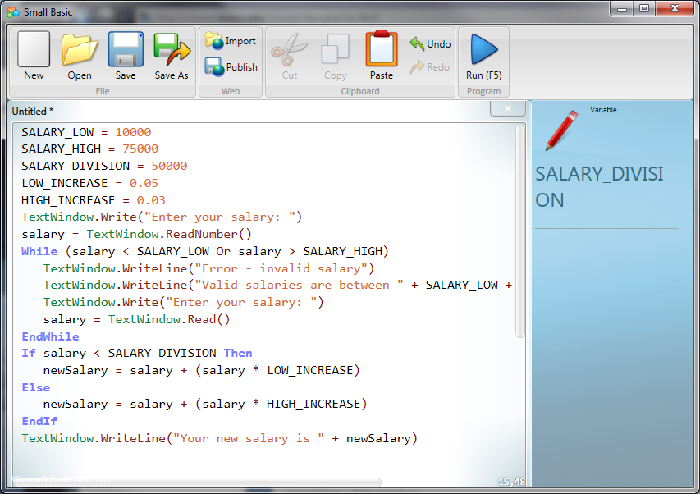
  - Small Basic window showing execution using the test cases.
  - 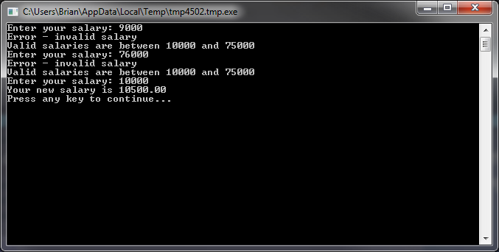
  - 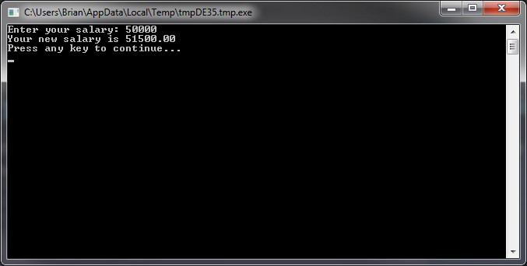

Part B – Algorithm (simple)
Follow the steps for program development for the Email Address Problem. That is, you should:
- Define the problem by creating an IPO Chart.
- Develop a solution algorithm and represent it using pseudocode (not flowcharts for these).
- Test the algorithm with a Desk Check Table.
Insert your IPO Chart, pseudocode representation of the algorithm, and your Desk Check Table immediately below.

Input | Processing | Output
emailAddr | Input emailAddr  Change case of emailAddr to lowercase  Allow user to enter multiple addresses  Display emailAddrLower | emailAddr

- CONTINUE = 1
- While CONTINUE
  - Display “Please enter an address: “
  - Get emailAddr
  - If emailAddr != Q or q
    - Change to all lowercase
    - Display emailAddr
  - Else
    - CONTINUE = 0
    - Display “Program stopped”
- EndWhile

Steps | emailAddr | Terminated
First Case
 | AJ.n.West@gmaiL.Com
6 | aj.n.west@gmail.com
 | Display
 |  | Q
 |  | Display
Second Case
 |  | q
 |  | Display

Email Address Problem: Have the program input an email address in any case (lower, upper, or mixed) then display the name in lowercase. For example, if PublicJQ@Lanecc.Edu is entered display publicjq@lanecc.edu. The program should perform multiple iterations allowing the user to enter several email addresses until he/she enters a q or Q. Use the repetition control structure.

Hint: The problem is similar to one solved in the Repetition Power Point (07Algor.ppt)

Part C – Algorithm (a little more difficult)
Choose one of the problems below. For the problem you choose, insert your IPO Chart, pseudocode representation of the algorithm, and your Desk Check Table immediately below the problem statement.

  - Guess City Problem: Allow the user to enter a city name. If the city name entered is Eugene display the message “You guessed it!” If some other name is entered display the message “That’s not it, try again.” Allow the user to continue entering names until he/she enters Eugene. You should indicate a successful guess no matter what case (upper, lower, mixed) they use to enter the name. Use the repetition control structure.

Input | Processing | Output
cityName | Get cityName  Change cityName to uppercase  If cityName = ‘EUGENE’ Then output “Guess Correct”  Else get new cityName and compare again | “Guess Correct”

- GUESS = 0
- While GUESS = 0
  - Display “Guess a city: “
  - Get cityName
  - Convert cityName to uppercase
  - If cityName = “EUGENE” Then
    - GUESS = 1
  - Else
    - Display “That’s not it, try again.”
- Display “You guessed it!”

Steps | cityName | “Guess Correct”
First Case
 | Springfield
 | SPRINGFIELD
 | Los Angeles
 | LOS Angeles
 | Eugene
 | EUGENE
 |  | Display
Second Case
 | Eugene
 | EUGENE
 |  | Display

Hint: Think about whether there are a known number of iterations in advance, that is, before the program starts, or not. This will let you know whether to use the While loop or the For loop. You may assume that you have available a predefined operation that converts a string to uppercase. This would enable you to convert the input city to uppercase so that you can compare it with “EUGENE” and in this way easily check all the case variations of the input.

  - Successive Integers Problem: Have the user enter an integer then ask if he/she wants following or preceding by entering “f” or “p” respectively. If the user indicates “f” display the ten successive integers starting with the input integer. If the user enters “p” display the ten integers starting with the input integer then the nine preceding integers. For example, if “20” and “f” are entered then display 20 21 22 23 24 25 26 27 29. If “20” and “p” are entered then display 20 19 18 17 16 15 14 13 12 11. Use the repetition and selection control structures.

Input | Processing | Output
Integer  someName | Get integer and “f” or “p”  If f display integer and next 9 numbers  If p display integer and previous 9 numbers | Integer and 9 other numbers

- Display “Enter an integer: “
- Get integer
- Display “(f)ollowing or (p)receding? “
- Get folOrPre
- If folOrPre = “f” Or folOrPre = “F” Then
  - For I = 1 To 10 step 1
    - Display integer
    - Integer = integer + 1
- elseIf folOrPre = “p” Or folOrPre = “P” Then
  - For I = 1 to 10 step 1
    - Display integer
    - Integer = integer -1
- EndIf

Steps | Integer
First Case
 | 20
 | 21
 | 22
 | 23
 | 24
 | 25
 | 26
 | 27
 | 28
 | 29
 | Display all
Second Case
 | 20
 | 19
 | 18
 | 17
 | 16
 | 15
 | 14
 | 13
 | 12
 | 11
 | Display all

Hint: Think about whether there are a known number of iterations in advance, that is, before the program starts, or not. This will let you know whether to use the While loop or the For loop. Also, note that given a number n, if you add i to n letting i range from 0 to 9 wouldn’t you produce the ten successive integers starting at n? Similarly, if you subtract i from n letting i range from 0 to 9 wouldn’t you produce the ten preceding integers? To help you see this, consider the table below:

i | 0 | 1 | 2 | 3 | 4 | 5 | 6 | 7 | 8 | 9
20 + i | 20 | 21 | 22 | 23 | 24 | 25 | 26 | 27 | 28 | 29
20 - i | 20 | 19 | 18 | 17 | 16 | 15 | 14 | 13 | 12 | 11

Part D – Small Basic
Select one of the problems you solved in Part B or Part C above and implement the algorithm using Small Basic. Include the following immediately below.
  - The name of the problem you chose to implement.
  - Small Basic window showing your code.
  - Small Basic windows showing execution using at least two test cases.

Email Problem
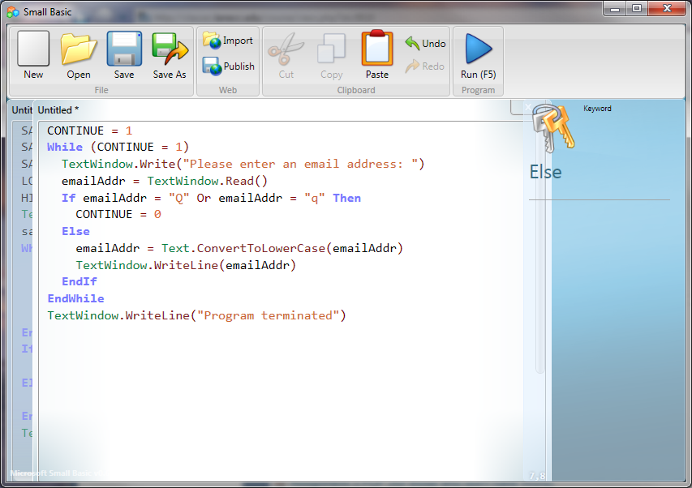
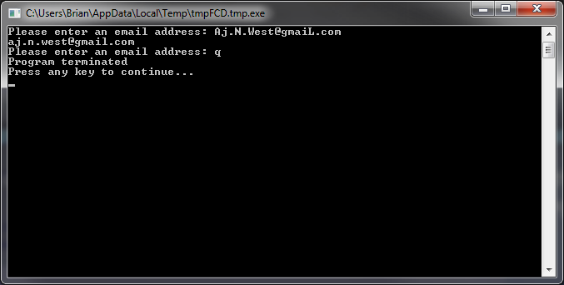
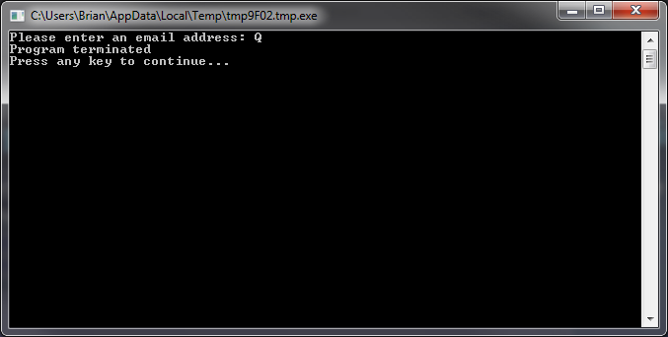

Guessing the city
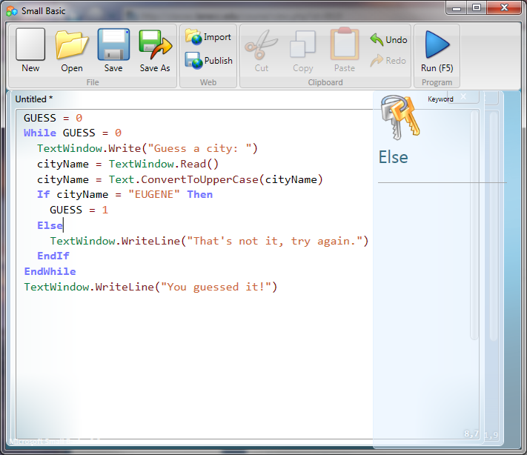
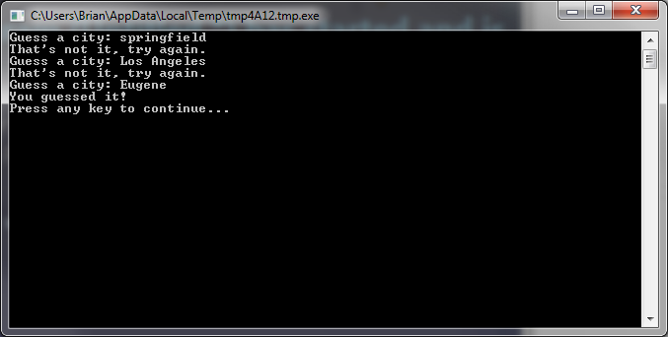
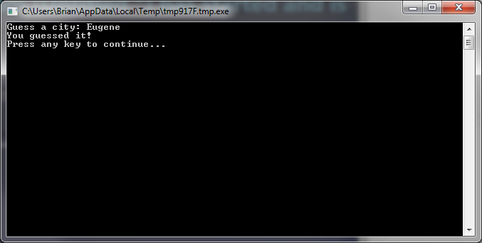

Integer step problem
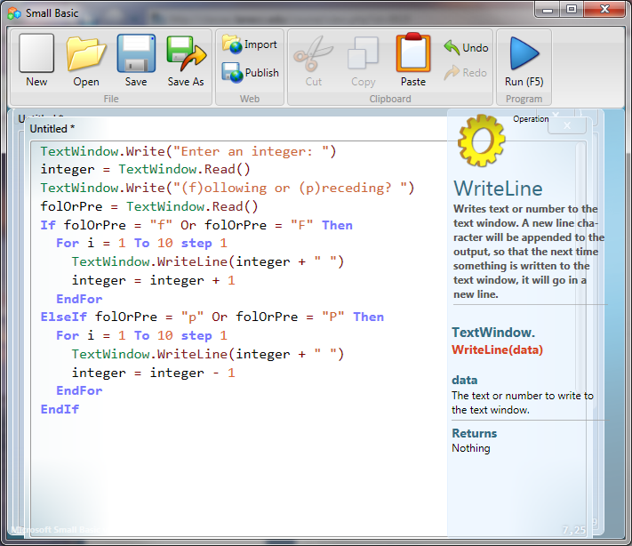
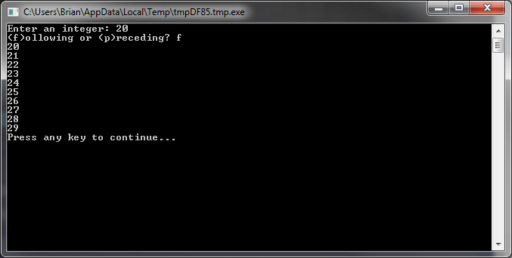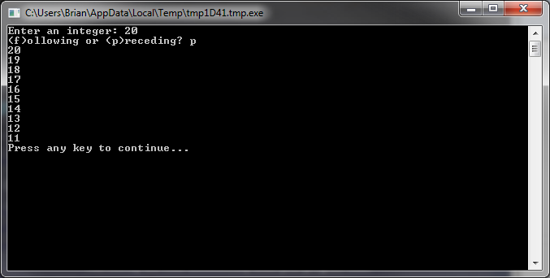

Hint for the Guess City Problem: Recall that there is a ConvertToUpperCase operation in the Text object of Small Basic. If you convert the input city to uppercase then you can compare it with “EUGENE” and easily check all the case variations of the input.

Extra Credit
Extra credit given for solving more of the problems in Parts C and D than are required.

Upload this document via Moodle with your answers in bold and the other requested information inserted.

