CIS 102 Activity 2 – Program Development - Answers

A) Temperature Converter

Problem Statement: Create a program to convert Fahrenheit temperatures to Celsius. The formula for doing this is C = 5 * (F – 32) / 9, where C equals the Celsius temperature and F equals the Fahrenheit termperature.

Step 1: Define the Problem – We want to be sure we understand the problem before we begin working on it otherwise we will need to go into information gathering mode. Let’s use an input-processing-output chart to help us understand what we are to do.

IPO Chart – In an IPO chart, we list the input, overview of processing, and output.

Input | Processing | Output
Fahrenheit | Input Fehrenheit  Calculate Celsius from Fahrenheit  Output Celsius | Celsius

Step 2: Develop a Solution – We use the IPO chart to help us to create a flowchart or pseudocode representation of the detailed solution algorithm. This requires analysis. This has already been done.

- Flowchart or Pseudocode – Detailed representation of the algorithm. Only one type of representation is normally required.

Flowchart: Pseudocode:
1) Prompt for Fahrenheit temperature
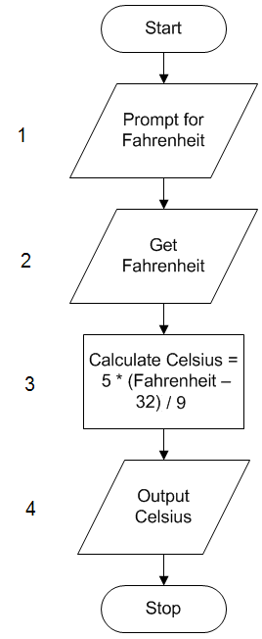
2) Get Fahrenheit temperature
3) Calculate Celsius temperature = 5 * (Fahrenheit – 32) / 9
4) Output Clesius temperature

Step 3: Test the Algorithm by desk checking it – Before coding the algorithm, we want to be sure it is correct. We choose several test cases and check the algorithm by hand.

Desk Check Table
Statement number | Fahrenheit | Celsius
First test case
1
2 | 212
3 |  | 100
4 |  | output
Second test case
1
2 | 32
3 |  | 0
4 |  | output

Step 4: Implement the Algorithm – We code the algorithm using Small Basic to create the desired program, and then run it.

- Launch Small Basic from the menu.
- Enter the following code into the Small Basic editor window:

TextWindow.Write("Enter temperature in Fahrenheit: ")
fahr = TextWindow.ReadNumber()
celsius = 5 * (fahr - 32) / 9
TextWindow.WriteLine("Temperature in Celsius is " + celsius)

- Check the code you entered to be sure it is the same as above.
- Click the Run button in the toolbar to execute the program.
- Enter the Fahrenheit value for the first test case above.
- Compare the output with your desk check table. If it isn’t correct check your code carefully and make the appropriate change(s).
- Close the TextWindow.
- Click the Run button again.
- Enter the second test case value.
- Compare the output with your desk check table. If it isn’t correct check your code carefully and make the appropriate change(s).
- Close the TextWindow.
- Save the program by clicking the Save As button in the toolbar and save the file to your removable media.
- Exit Small Basic.

B) Temperature Converter Modified

Problem Statement: Change the above program to convert Celsius to Fahrenheit. The formula for doing this is F = (9 * C) / 5 + 32, where C equals the Celsius temperature and F equals the Fahrenheit termperature.

Steps 1 through 3: We recognize that these would be the same as the above problem with Fahrenheit and Celsius reversed but with a different formula.

IPO Chart
Input | Processing | Output
Celsius | Input Celsius  Calculate Fahrenheit from Celsius  Output Fehrenheit | Fahrenheit

Flowchart: Pseudocode:
1) Prompt for Celsius temperature
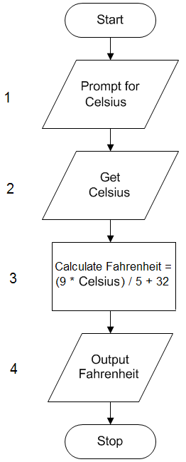
2) Get Celsius temperature
3) Calculate Fahrenheit temperature = (9 * Celsius) / 5 + 32
4) Output Fahrenheit temperature

Desk Check Table
Statement number | Celsius | Fahrenheit
First test case
1
2 | 100
3 |  | 212
4 |  | output
Second test case
1
2 | 0
3 |  | 32
4 |  | output

Step 4: Implement the Algorithm – We change the above program to create the modified program, and run it.

- Launch Small Basic from the menu.
- Click Open in the toolbar and navigate to the program you saved above.
- Make the following changes to your code:

TextWindow.Write("Enter temperature in Celsius: ")
celsius = TextWindow.ReadNumber()
fahr = (9 * celsius) / 5 + 32
TextWindow.WriteLine("Temperature in Fahrenheit is " + fahr)

- Check the code you entered to be sure it is the same as above.
- Click the Run button in the toolbar to execute the program.
- Enter the Celsius value of 100.
- Compare the output with your desk check table. If it isn’t correct check your code carefully and make the appropriate change(s).
- Close the TextWindow.
- Click the Run button again.
- Enter the second test case value of 0.
- Compare the output with your desk check table. If it isn’t correct check your code carefully and make the appropriate change(s).
- Close the TextWindow.
- Save the program by clicking the Save As button in the toolbar and save the file to your removable media.
- Exit Small Basic.

