Enter your answers to the questions into this document in Bold, and include screenprints when asked. You don’t need to submit this assignment.

- Problem statement: Use Excel 2013 to compute the total number of hours and the number of weeks required to finish a landscaping project. Each of the workers are listed below as well as the estimated time required for each part of the project.
  - Time estimates for the project
    - Concrete- sidewalk and raised planters: 50 hours.
    - Grass- preparing the ground and rolling out turf: 30 hours.
    - Trees- purchasing and planting: 20 hours.
    - Shrubs, flowers and ground cover- purchasing and planting: 40 hours
    - Vegetable garden- soil preparation and planting: 35 hours
  - Worker’s time available
    - Bob, concrete worker: 20 hours a week
    - Gwen, gardener: 30 hours a week
    - Jane, Arborist: 10 hours a week
    - Jim, lawn expert: 15 hours a week

- Analysis and planning. If you don’t understand the problem or feel it is ill-defined, invoke “information gathering,” that is, come up with a well-defined problem statement using techniques like the following:
- Talk with other people (for example, other students, the instructor, lab aides)
- Read the text
- Break the problem into subproblems
- Start at a point you first understand
- Persevere

The main steps in planning a spreadsheet are (you don’t need to enter the answers to these questions yet, just think about it):
- What problem do you want to solve? What is the goal and purpose?
Find out how many hours will be spent on the project and how many weeks it will take to finish it.
- What data is needed to solve your problem?
Estimates for hours for each task, and worker availability per week
- What calculations, that is, formulas are required to solve the problem? What is the input and output for these formulas?
For each person, weeks required = total hours / hours available per week
For the whole project, total hours = the sum of hours estimated for each task
- What form should the spreadsheet take, that is, how should it appear?
See below:

Think about these steps then enter the answers to the following questions:

  - Determine what you plan to show in the columns and rows of your spreadsheet.
    - Columns: Task, hour estimate, worker, weekly availability, subtotal hours, weeks
    - Rows: individual work’s info, total hours
  - What formulas will you need? See above
  - What are the input and output values for the formulas above? Estimated hours for each task, Worker availability per week
  - What will the column/row labels be (text that defines the data)? __See above_________
  - What will you use as a title for the spreadsheet? Landscaping project time plan

- Create the spreadsheet to solve the problem using Excel 2013. Screenprint the spreadsheet in normal view and in formulas view and insert the two screenprints immediately below.
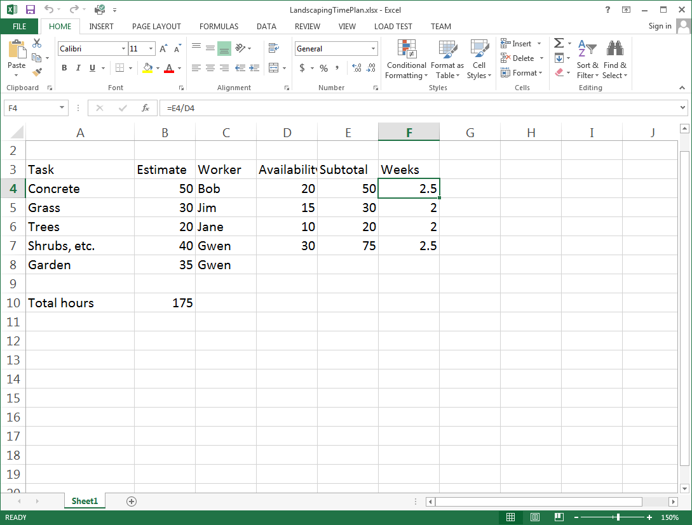
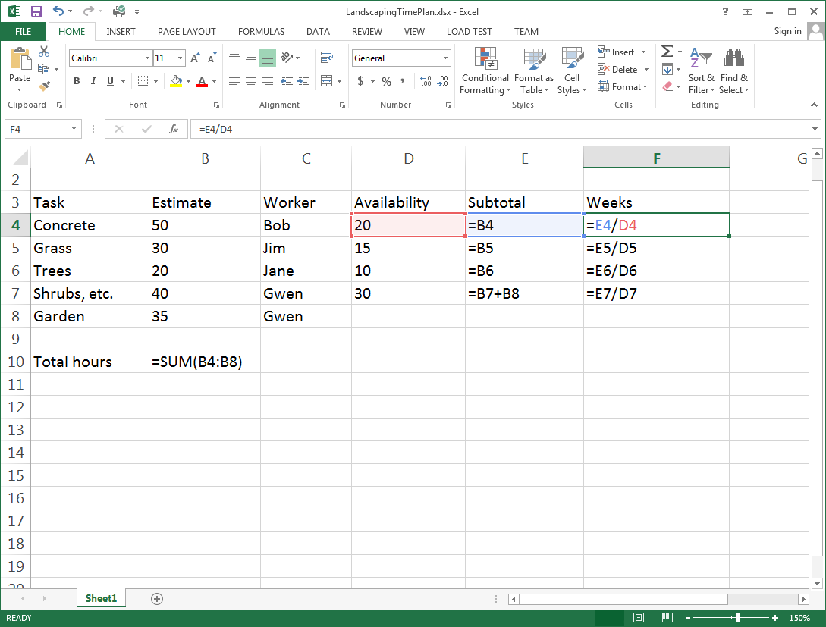

- Now, suppose the estimates were wrong. It actually took 40 hours to finish the lawn and 50 hours to finish the garden. Enter these new values into your spreadsheet to recalculate the total number of hours and the number of weeks it took to finish the landscaping project. Screenprint the result in normal view and insert it immediately below.
