Announcements

* This week’s lab is an “open lab” for working on projects with GTF assistance
* The make-up project is due March 11 at 11:59 pm
* The final exam is Thursday, March 17 at 10:15 am
  + We will review in class on Friday
  + The practice exam will be ready Friday night

Make-up Project Topics

* Look-up tables
* Parallel arrays
* Arrays of objects
  + Find an object in an array by one of its properties:  
    <https://developer.mozilla.org/en-US/docs/Web/JavaScript/Reference/Global_Objects/Array/find>
* Example: write code to translate alphabetic phone numbers to numeric phone numbers.

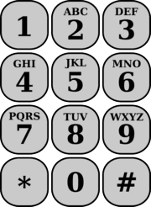

* Convert an object to a JSON string: JSON.Stringify( obj )

Notes on the NATO Phonetic Translator

The translator should translate both letters and numbers. That’s the point of the description of phone numbers that start with letters. The letters should be translated to their phonetic form (not to numbers), and the numbers should be translated to their phonetic form as well.

Reference: <https://en.wikipedia.org/wiki/NATO_phonetic_alphabet>