

Learn to develop Android applications using C# and the Mono for Android framework. Mono is an open-source port of Microsoft .NET. Applications developed using Mono run on Linux, Windows, Mac OS, iOS, or Android.

The prerequisite for the course is two terms of C#, C++, or Java. Follow the link in the QR Code to get more information.

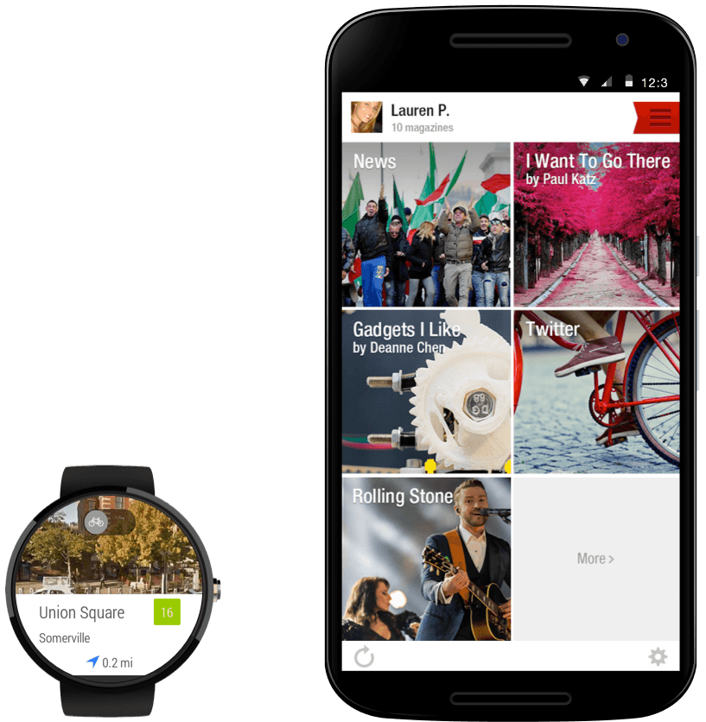

**Ship native Android packages.** Xamarin.Android uses just-in-time compilation for sophisticated runtime optimization of your app’s performance, meaning your app is a native Android APK.

* **Access any Android API, including new form factors.** We bring 100% of Google’s Android APIs to C#, enhancing Java APIs with async support and .NET naming conventions so you feel right at home.
* **Call existing Java code from C#.** Use your existing Java code, frameworks, and custom controls in your Xamarin app using our automatic binding generator.
* **Build Android Wear apps.** With access to 100% API support for Android Wear, create full-featured applications capable of running on Android Wear devices.

**Stay up-to-date with Android.** Xamarin stays up-to-date with the most current APIs from Google, so you can always use the latest features in your apps.