This lab will give you practice creating a multi-screen application. These are the main concepts you will apply:

* Starting a new activity using an Intent object
* Sending information from one activity to another using an Intent object
* Using activity life-cycle call-back methods: onCreate and onResume
* Using an ActionBar with “up” navigation to return to a “parent” activity

Part 1 – Tutorial: Hello Multiscreen Apps

Complete the tutorial, “Hello Multiscreen Apps”, which was also the required reading this week.  
Note: You will need to add a using statement for Android.Content to the first activity in order to use the Intent class.

Part 2 – Group A: 99 Bugs in the Code (or 99 other things of your choice)

1. Add code to the default MainActivity (I’ll call this activity 1)

* Add a button
  + Change its button title to "Take one down".
  + Create an Intent that sends the number 1 to activity 2.
  + Add an appropriate event handler to the button.
* Add a second button
  + Change its button title to "Take two down".
  + Add an appropriate event handler to the button.
  + Create an Intent that sends the number 2 to activity 2. Start Activity 2 using StartActivityForResult
* Add a TextView and the code needed to display a message from activity 2. Get the message using onActivityResult.

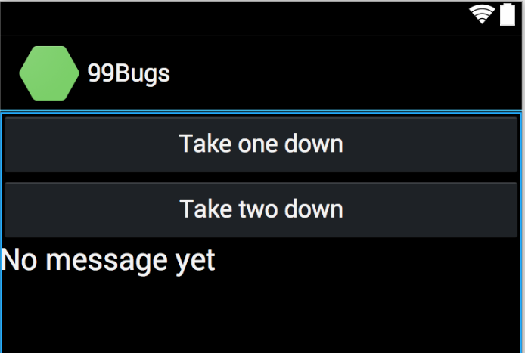

1. Add a second Activity and name it “The code”

* Add a button and a TextView to the second activity.
* The text on this button should be "Patch it around".
* Use an intent to send the message "n little bugs in the code" to activity 1, where n is the number of bugs remaining.
* Add a button event handler and any other code necessary so that tapping a button subtracts one from the total number of bugs left, and sends the message above to the first activity.

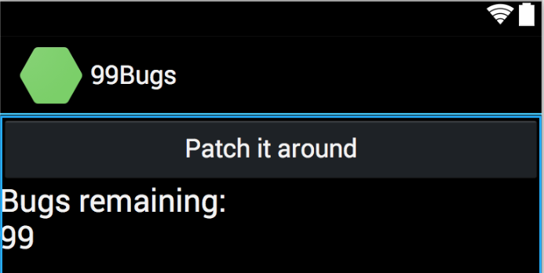

**Submission to Moodle**

Beta Version

Post the following to the Beta + Code Review Forum:

1. For part 1: A document containing screen-shots of the app with each screen-shot labeled. (Please use .docx or .pdf format.)
2. For part 2: A zip file containing your app’s Visual Studio solution folder. (Make your solution smaller by deleting the *obj* and *bin* folders.)  
   Or, optionally, a link to a repository containing your solution source code. You can put the link on the same document with the screen-shots in part 1.
3. A copy of your lab instructions (so your lab partner will know what your requirements were).

Production Version

1. Screen shots (revised if needed, otherwise the same as above)
2. Visual Studio solution (revised if needed, otherwise the same as above)
3. The code review of your work (the one done by your lab partner) with the second column (“Release”) completed by you.