This lab will give you practice creating a multi-screen application. These are the main concepts you will apply:

* Starting a new activity using an Intent object
* Sending information from one activity to another using an Intent object
* Using activity life-cycle call-back methods: onCreate and onResume
* Using an ActionBar with “up” navigation to return to a “parent” activity (groups A and C)

Part 1 – Tutorial: Hello Multiscreen Apps

Complete the tutorial, “Hello Multiscreen Apps”, which was also the required reading this week.

Part 2: Assignment for Group A – Poke a Screen(or poke something of your choice)

Write an app with two activities. Buttons on the first activity’s UI will be used to send one of two kinds of data to the second activity. The second activity will display a message based on the data that was sent.

1. Add code to the default MainActivity

* Add a button with the text “Poke Screen 2”
  + In this button’s event handler, send an intent to screen 2 with a Boolean value set to true.
* Add a button with the text “Say Hi to Screen 2”
  + In this button’s event handler send an intent to screen 2 with the string “Hi from screen 1” (or some message of your own choice).

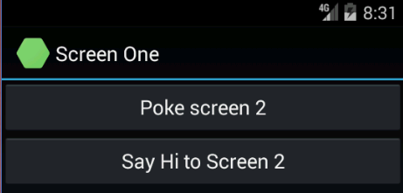

1. Add a second Activity

* Add an ActionBar with an “up” button.
* Add a TextView that displays messages from screen one. This one text view will either display the string sent in the intent or, if the intent contained a Boolean value, it will display “Screen 1 poked you”. (or a message of your choice).

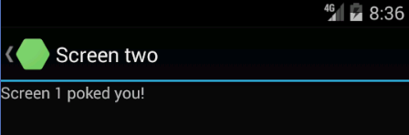

**Submission to Moodle**

Beta Version

Post the following to the Beta + Code Review Forum:

1. For part 1: A document containing screen-shots of the app with each screen-shot labeled. (Please use .docx or .pdf format.)
2. For part 2: A zip file containing your app’s Visual Studio solution folder. (Make your solution smaller by deleting the *obj* and *bin* folders.)  
   Or, optionally, a link to a repository containing your solution source code. You can put the link on the same document with the report on your exercise from part 1.
3. A copy of your lab instructions (so the lab partner who reviews your work will know what your requirements were).

Production Version

1. Items 1 and 2 above, but revised as needed.
2. The code review of your work (the one done by your lab partner) with the second column (“Release”) completed by you.