This lab will give you practice creating a multi-screen application. These are the main concepts you will apply:

* Starting a new activity using an Intent object
* Sending information from one activity to another using an Intent object
* Using activity life-cycle call-back methods: onCreate and onResume
* Using an ActionBar with “up” navigation to return to a “parent” activity

Part 1 – Tutorial: Hello Multiscreen Apps

Complete the tutorial, “Hello Multiscreen Apps”, which was also the required reading this week.  
Note: You will need to add a using statement for Android.Content to the first activity in order to use the Intent class.

Part 2 – Group B – Let’s Make a Deal

1. Add code to the default MainActivity

* Add a button with the text “Door Number 1”
  + In the event handler, send an intent to Activity2 with an int value set to 1.
* Add a button with the text “Door Number 2”
  + In the event handler, send an intent to Activity2 with an int value set to 2.
* Add a button with the text “Door Number 3”
  + In the event handler, send an intent to Activity2 with an int value set to 3.  
      
    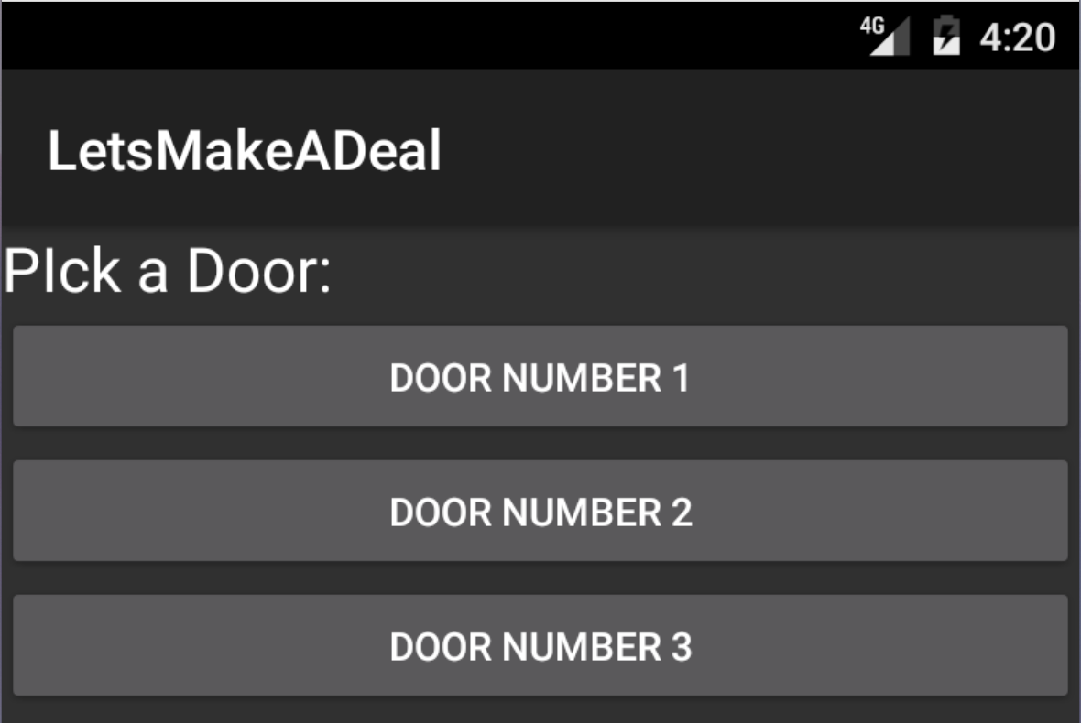

1. Add a second Activity

* Add an ActionBar with an “up” button.
* Add a TextView with the text: “Behind door number __ is a:” using the number from the intent in place of t he blank
* Generate a random number between 1 and 3
  + Based on the random number append the text: “brand new Prius”, “goat”, or “skunk” in the TextView. (You can also make up your own prizes.)  
      
    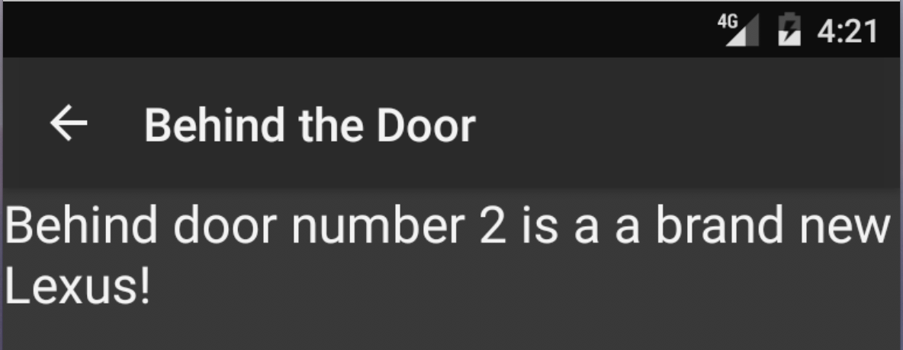

Submission to Moodle

Beta Version

Post the following to the Beta + Code Review Forum:

1. For part 1: A document containing screen-shots of the app with each screen-shot labeled. (Please use .docx or .pdf format.)
2. For part 2: A zip file containing your app’s Visual Studio solution folder. (Make your solution smaller by deleting the *obj* and *bin* folders.)  
   Or, optionally, a link to a repository containing your solution source code. You can put the link on the same document with the screen-shots in part 1.
3. A copy of your lab instructions (so your lab partner will know what your requirements were).

Production Version

1. Screen shots (revised if needed, otherwise the same as above)
2. Visual Studio solution (revised if needed, otherwise the same as above)
3. The code review of your work (the one done by your lab partner) with the second column (“Release”) completed by you.