This lab will give you practice creating a multi-screen application. These are the main concepts you will apply:

* Starting a new activity using an Intent object
* Sending information from one activity to another using an Intent object
* Using activity life-cycle call-back methods: onCreate and onResume
* Using an ActionBar with “up” navigation to return to a “parent” activity

Part 1 – Tutorial: Hello Multiscreen Apps

Complete the tutorial, “Hello Multiscreen Apps”, which was also the required reading this week.

Part 2 – Group C – Let’s Make a Deal

1. Add code to the default MainActivity

* Add a button with the text “Door Number 1”
  + In the event handler, send an intent to Activity2 with an int value set to 1.
* Add a button with the text “Door Number 2”
  + In the event handler, send an intent to Activity2 with an int value set to 2.
* Add a button with the text “Door Number 3”
  + In the event handler, send an intent to Activity2 with an int value set to 3.  
      
    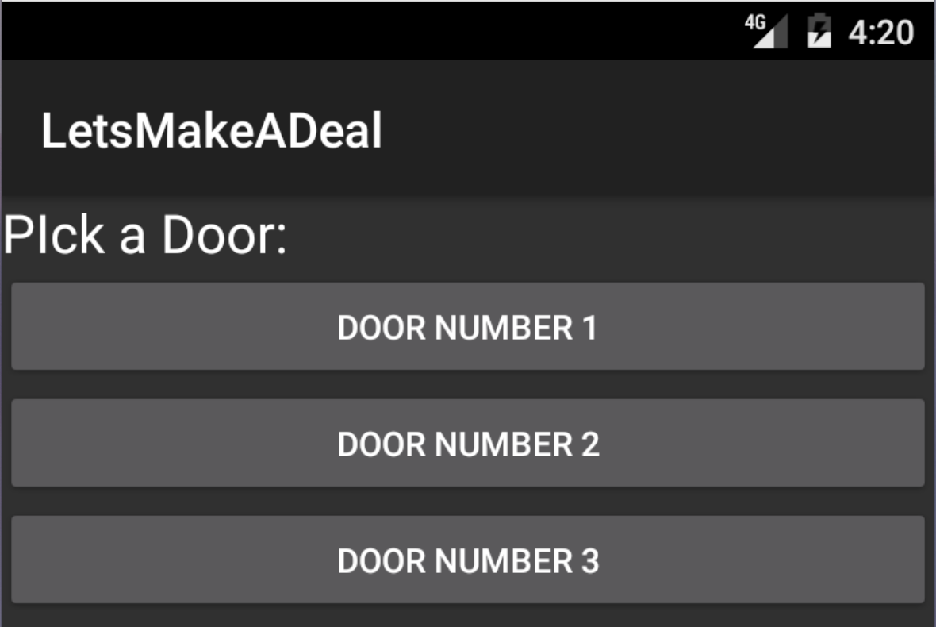

1. Add a second Activity

* Add an ActionBar with an “up” button.
* Add a TextView with the text: “Behind door number __ is a:” using the number from the intent in place of t he blank
* Generate a random number between 1 and 3
  + Based on the random number append the text: “brand new Prius”, “goat”, or “skunk” in the TextView. (You can also make up your own prizes.)  
      
    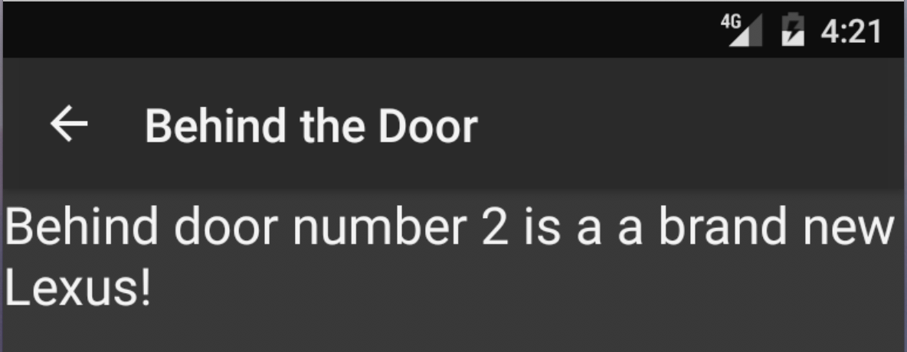

Submission to Moodle

Beta Version

Post the following to the Beta + Code Review Forum:

1. For part 1: A document containing screen-shots of the app with each screen-shot labeled. (Please use .docx or .pdf format.)
2. For part 2: A zip file containing your app’s Visual Studio solution folder. (Make your solution smaller by deleting the *obj* and *bin* folders.)  
   Or, optionally, a link to a repository containing your solution source code. You can put the link on the same document with the report on your exercise from part 1.
3. A copy of your lab instructions (so the lab partner who reviews your work will know what your requirements were).

Production Version

1. Items 1 and 2 above, but revised as needed.
2. The code review of your work (the one done by your lab partner) with the second column (“Release”) completed by you.