This lab will allow you to practice what you learned in the multi-screen tutorial and in class. The main concepts you will apply will be:

* Starting a new activity or resuming an existing activity using an intent
* Managing activity launch mode
* Sending information from one activity to another using an intent
* Using activity life-cycle call-back methods: onCreate, onResume, onNewIntent

**Assignment for Group A – Poke a Screen (or someone or something of your choice)**

1. Modify the default Activity (this is activity 1)

* Modify the existing button
  + Change the button text to "Poke screen 2".
  + Add an Intent that sends the message "Screen 1 poked you" to activity 2.
  + Add an appropriate event handler to the button.
* Add a TextView and the code necessary to display a message from activity 2. (Get the message from the intent sent from activity 2).

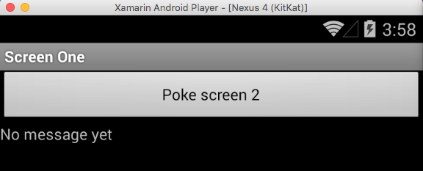

1. Add a second Activity

* Add a TextView that displays messages from screen one.
* Add a second TextView
  + The TextView will display the number of times this screen has been poked.
  + Add the appropriate code to keep track of the count.
* Add a button
  + The title on the button should be "Poke screen 1".
  + Use an intent to send activity one the message "You’ve poked me n times", where n is the number of times this screen has been poked.
  + Add an event handler for the button and any other code necessary so that clicking the button sends the message to the other screen.

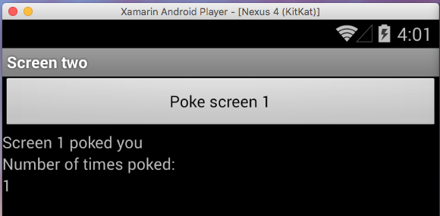

**Assignment for Group B – 99 Bottles of Beer (or another thing of your choice)**

1. Modify the default Activity (this is activity 1)

* Modify the existing button
  + Change its button title to "Take one down".
  + Create an Intent that sends the number 1 to activity 2.
  + Add an appropriate event handler to the button.
* Add a second button
  + Change its button title to "Take two down".
  + Create an Intent that sends the number 2 to activity 2.
  + Add an appropriate event handler to the button.
* Add a TextView and the code needed to display a message from activity 2.

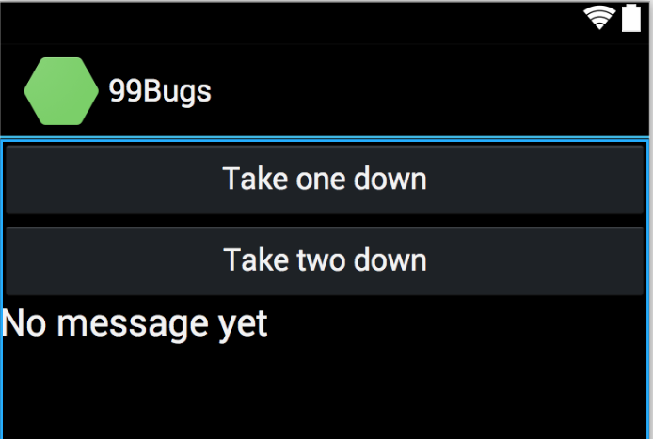

1. Add a second Activity and name it “The wall”

* Add a button and a TextView to the second activity.
* The text on this button should be "Pass it around".
* Use an intent to send the message "n bottles of beer on the wall" to activity 1, where n is the number of bottles remaining.
* Add a button event handler and any other code necessary so that tapping a button subtracts one from the total number of bottles left, and sends the message above to the first activity.

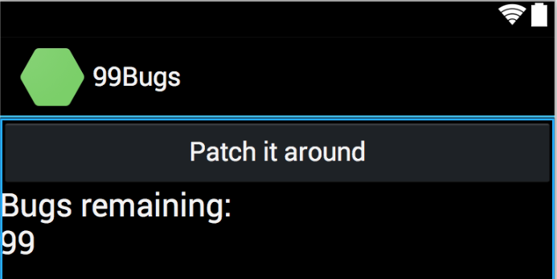

**Notes for Both Groups**

* To avoid creating multiple copies of the same activity, add this to the annotation for your activity classes: LaunchMode = Android.Content.PM.LaunchMode.SingleInstance
* Tapping (clicking) the system back button while in the second activity will cause the second activity to be removed from the back-stack. Then, when you tap the button in the first activity, the second activity will be created again instead of being resumed. This will reset your count and that’s OK. You’ll learn how to solve this using OnSaveInstanceState next week.

Zip the solution (after removing the bin and obj folders) and e-mail it to your code-review partner.