**Introduction**

This lab will help you understand Android activity life-cycle and give you practice saving activity state. The main concepts you will apply will be:

* Using the OnSavedInstanceState callback to store state using a Bundle object
* Retrieving activity state in an activity’s OnCreate method.
* Serializing and deserializing objects using the .NET XmlSerializer class
* Using an Android EditText widget

**Requirements**

Part 1 – Tutorial: Activity Lifecycle

Complete the Xamarin walkthrough, [Saving Activity State](https://developer.xamarin.com/guides/android/application_fundamentals/activity_lifecycle/saving_state_walkthrough/), which is part of the [Activity Lifecycle](https://developer.xamarin.com/guides/android/application_fundamentals/activity_lifecycle/) tutorial, which was also the required reading this week.

Part 2 for Assignment Group A – The “Awesome Quote” App

* Use the starter file posted on Moodle. The starter contains:
  + A quote bank class, preloaded with a collection of quotes.
  + A MainActivity and layout that show a quote.
  + Add a “Next Quote” button that causes the next quote to be displayed when it is tapped.
* Add to, or modify the app so that:
  + The quote and who said it are shown in two separate TextView widgets.
  + Users will be able to add quotes of their own that will be added to the collection of quotes.
    - Add two EditText widgets and a button for entering quotes.
    - When a new quote is entered, show it in the TextViews at the top.
    - Clear the EditText widgets after the edit button is tapped to enter the new quote.
* Implementation requirements:
  + Use the XmlSerializer class to save the object of the above class.
  + A file containing a class that is preloaded with hard-coded quotes and that can have more quotes added will be provided.
* See screen-shots of the UI below:
  + When the app is first started, it will display the first quote in the list.

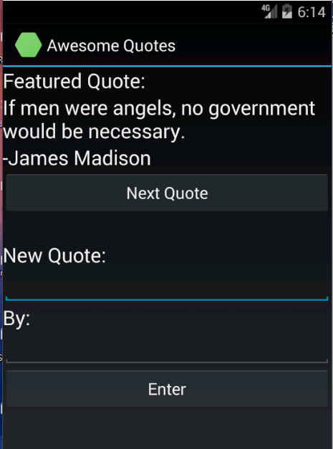

* + Clicking the “Next Quote” button will show the next quote in the list.

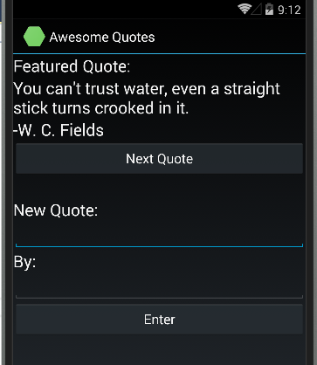

* + Rotating the device should not cause the first quote to be shown again; it should keep showing the current one, even if it’s a new one that was entered by the user.

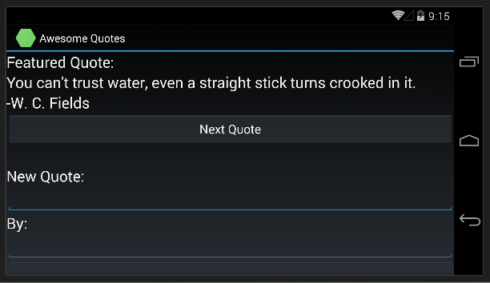

**Submission to Moodle**

Beta Version

Post the following to the Beta + Code Review Forum:

1. For part 1: A document containing screen-shots of the app with each screen-shot labeled. (Please use .docx or .pdf format.)
2. For part 2: A zip file containing your app’s Visual Studio solution folder. (Make your solution smaller by deleting the *obj* and *bin* folders.)  
   Or, optionally, a link to a repository containing your solution source code. You can put the link on the same document with the report on your exercise from part 1.
3. A copy of your lab instructions (so the lab partner who reviews your work will know what your requirements were).

Production Version

1. Items 1 and 2 above, but revised as needed.
2. The code review of your work (the one done by your lab partner) with the second column (“Release”) completed by you.