**Introduction**

This lab will help you understand Android activity life-cycle and give you practice saving activity state. The main concepts you will apply will be:

* Using the OnSavedInstanceState callback to store state using a Bundle object
* Retrieving activity state in OnCreate
* Serializing and deserializing objects using the XmlSerializer class
* Using an EditText widget

**Requirements**

Part 1 – Tutorial: Activity Lifecycle

Complete the Xamarin walkthrough, [Saving Activity State](https://developer.xamarin.com/guides/android/application_fundamentals/activity_lifecycle/saving_state_walkthrough/), which is part of the [Activity Lifecycle](https://developer.xamarin.com/guides/android/application_fundamentals/activity_lifecycle/) tutorial, which was also the required reading this week.

Part 2 for Assignment Group B – The “Who Said It” Quiz App

Write a quiz app that will show the user a quote and ask them who said it.

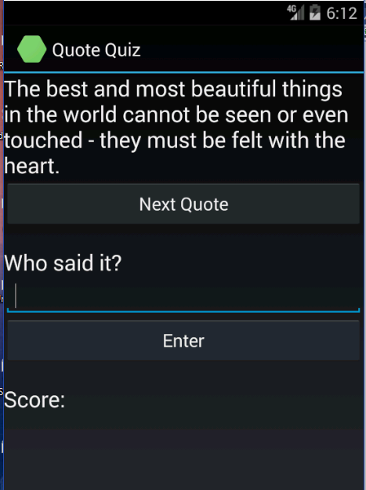

* + The user will be able to type the name of the person and then click enter. The app will show whether they are right or wrong. If they are wrong it will show the right answer.
  + All the questions can be hard-coded.
  + Rotating the device should not cause a new quote question to be shown; it should keep showing the same one.
* The app will display a count of right and wrong answers.
  + There will be a button to reset the count and start the quiz over.
  + The count of right and wrong answers will not be lost when the device is rotated.
  + A file containing a class that is preloaded with hard-coded quotes and that can have more quotes added will be provided.

**Submission to Moodle**

Beta Version

Post the following to the Beta + Code Review Forum:

1. For part 1: A document containing screen-shots of the app with each screen-shot labeled. (Please use .docx or .pdf format.)
2. For part 2: A zip file containing your app’s Visual Studio solution folder. (Make your solution smaller by deleting the *obj* and *bin* folders.)  
   Or, optionally, a link to a repository containing your solution source code. You can put the link on the same document with the report on your exercise from part 1.
3. A copy of your lab instructions (so the lab partner who reviews your work will know what your requirements were).

Production Version

1. Items 1 and 2 above, but revised as needed.
2. The code review of your work (the one done by your lab partner) with the second column (“Release”) completed by you.