This lab will help you understand Android activity life-cycle and give you practice saving activity state. The main concepts you will apply will be:

* Using the OnSavedInstanceState callback to store state using a Bundle object
* Retrieving activity state in OnCreate
* Serializing and deserializing objects using the XmlSerializer class
* Using an EditText widget

Part 1 – Tutorial: Activity Lifecycle

Complete the Xamarin walkthrough, [Saving Activity State](https://developer.xamarin.com/guides/android/application_fundamentals/activity_lifecycle/saving_state_walkthrough/), which is part of the [Activity Lifecycle](https://developer.xamarin.com/guides/android/application_fundamentals/activity_lifecycle/) tutorial, which was also the required reading this week.

Part 2 for Assignment Group C – Quote Rating App

* Make an app that displays quotations.
  + Preload the app with a collection of quotes—at least four.
  + Users will be able to tap a “Next Quote” button see the next quote in the collection.
  + Users will be able to enter comments and a rating.
  + If a quote already has a comment and rating it will be displayed below the quote  
    (You only need to accommodate one comment and rating, not a list of them.)
* Implementation requirements and notes:
  + Use the XmlSerializer class to save the object instantiated from the QuoteBank class.
  + A file containing the QuoteBank class that is preloaded with hard-coded quotes will be provided. You will need to add to it to accommodate comments and ratings.
  + Store the rating and quote in separate properties you add to QuoteBank
* Persistence of comments and ratings
  + A quote and rating that has already been entered should continue to be displayed after the device is rotated.
  + The comment and rating should be displayed again after clicking the system back button to quit the activity and then selecting the activity from recent activities and restarting it.
  + The comment and rating should still be shown for this quote if you click the “Next Quote” button repeatedly until it is shown again.
* See screen-shots of the UI below:

The app UI should show something similar to this when it first starts:

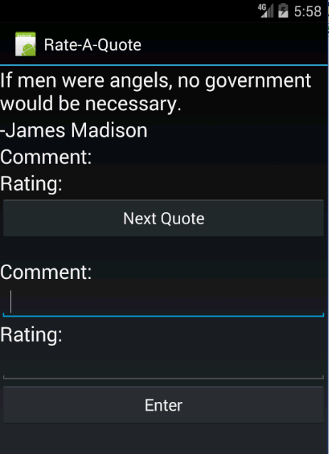

A user will be able to enter a quote like this:

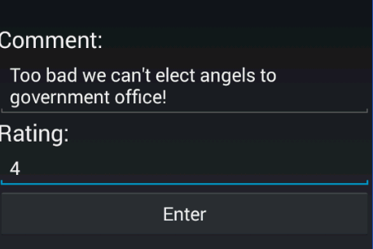

And it should look something like this after the user clicks enter:

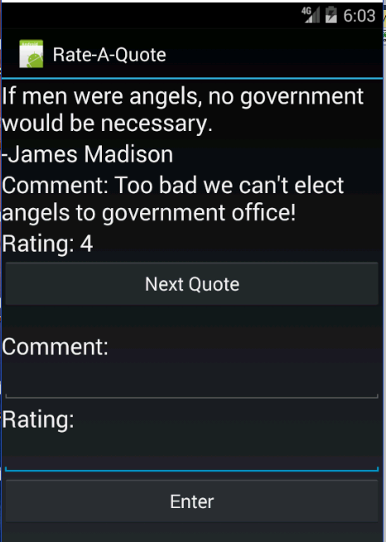

**Submission to Moodle**

Beta Version

Post the following to the Beta + Code Review Forum:

1. For part 1: A document containing screen-shots of the app with each screen-shot labeled. (Please use .docx or .pdf format.)
2. For part 2: A zip file containing your app’s Visual Studio solution folder. (Make your solution smaller by deleting the *obj* and *bin* folders.)  
   Or, optionally, a link to a repository containing your solution source code. You can put the link on the same document with the report on your exercise from part 1.
3. A copy of your lab instructions (so the lab partner who reviews your work will know what your requirements were).

Production Version

1. Items 1 and 2 above, but revised as needed.
2. The code review of your work (the one done by your lab partner) with the second column (“Release”) completed by you.