This lab will help you understand Android activity life-cycle and give you practice saving activity state. The main concepts you will apply will be:

* Using the OnSavedInstanceState callback to store state using a Bundle object
* Retrieving activity state in OnCreate
* Serializing and deserializing objects using the XmlSerializer class
* Using an EditText widget

Part 1 – Tutorial: Activity Lifecycle

Complete the Xamarin walkthrough, [Saving Activity State](https://developer.xamarin.com/guides/android/application_fundamentals/activity_lifecycle/saving_state_walkthrough/), which is part of the [Activity Lifecycle](https://developer.xamarin.com/guides/android/application_fundamentals/activity_lifecycle/) tutorial, which was also the required reading this week.

Part 2

for Assignment Group A – The “Awesome Quote” App

* Make an app that displays quotations. Preload the app with a collection of quotes (at least four).
  + Show the quote and who said it in two separate TextView widgets.
  + Add a “Next Quote” button that causes the next quote to be displayed when it is tapped.
* Users will be able to add quotes of their own that will be added to the collection of quotes.
  + Add two EditText widgets and a button for entering quotes.
  + When a new quote is entered, show it in the TextViews at the top.
  + Clear the EditText widgets after the edit button is tapped to enter the new quote.
* Implementation requirements:
  + Use the XmlSerializer class to save the object of the above class.
  + A file containing a class that is preloaded with hard-coded quotes and that can have more quotes added will be provided.

When the app is first started, it will display the first quote in the list.

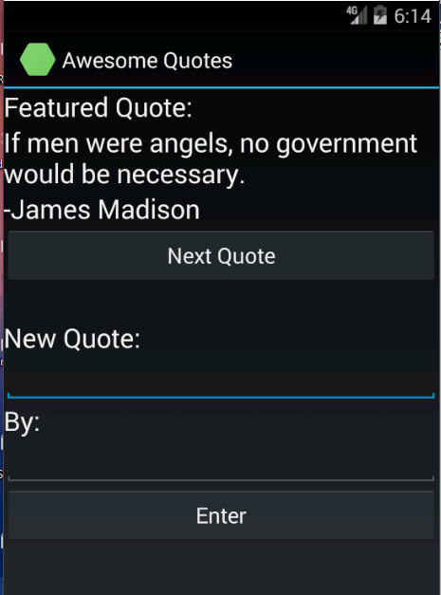

Clicking the “Next Quote” button will show the next quote in the list.

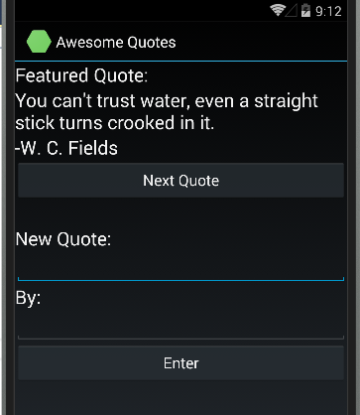

Rotating the device should not cause the first quote to be shown again; it should keep showing the current one, even if it’s a new one that was entered by the user.

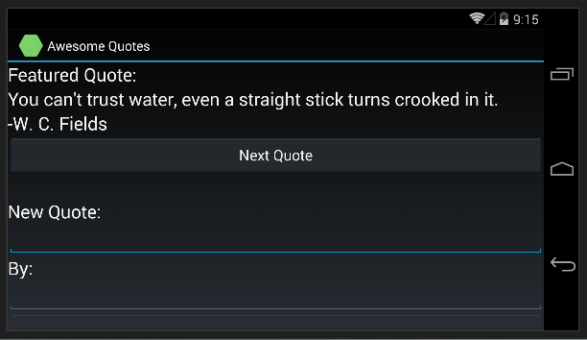

for Assignment Group B – The “Who Said It” Quiz App

Write a quiz app that will show the user a quote and ask them who said it.

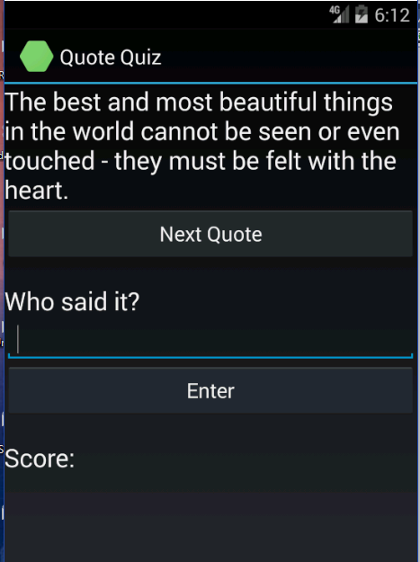

* + The user will be able to type the name of the person and then click enter. The app will show whether they are right or wrong. If they are wrong it will show the right answer.
  + All the questions can be hard-coded.
  + Rotating the device should not cause a new quote question to be shown; it should keep showing the same one.
* The app will display a count of right and wrong answers.
  + There will be a button to reset the count and start the quiz over.
  + The count of right and wrong answers will not be lost when the device is rotated.
  + A file containing a class that is preloaded with hard-coded quotes and that can have more quotes added will be provided.

for Assignment Group C – Quote Rating App

* Make an app that displays quotations.
  + Preload the app with a collection of quotes—at least four.
  + Users will be able to tap a “Next Quote” button see the next quote in the collection.
  + Users will be able to enter comments and a rating.
  + If a quote already has a comment and rating it will be displayed below the quote  
    (You only need to accommodate one comment and rating, not a list of them.)
* Implementation requirements and notes:
  + Use the XmlSerializer class to save the object instantiated from the QuoteBank class.
  + A file containing the QuoteBank class that is preloaded with hard-coded quotes will be provided. You will need to add to it to accommodate comments and ratings.
  + Store the rating and quote in separate properties you add to QuoteBank
* Persistence of comments and ratings
  + A quote and rating that has already been entered should continue to be displayed after the device is rotated.
  + The comment and rating should be displayed again after clicking the system back button to quit the activity and then selecting the activity from recent activities and restarting it.
  + The comment and rating should still be shown for this quote if you click the “Next Quote” button repeatedly until it is shown again.

The app UI should show something similar to this when it first starts:

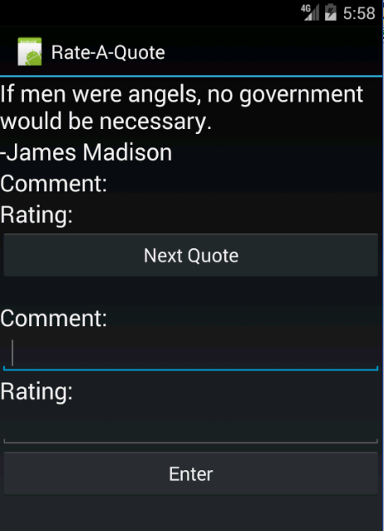

A user will be able to enter a quote like this:

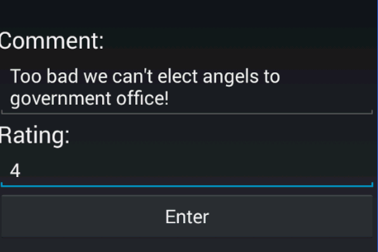

Which should look like this after the user clicks enter:

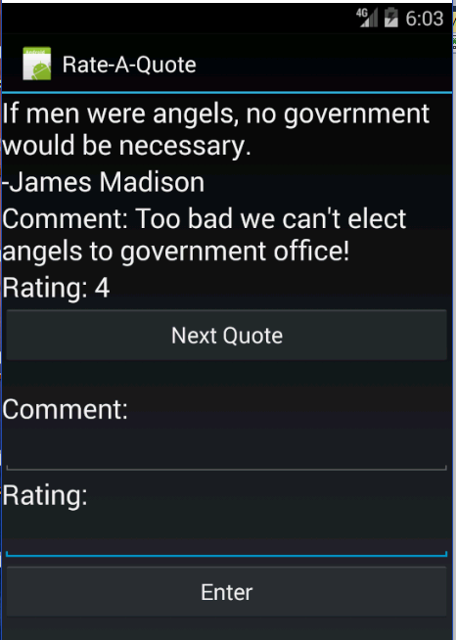

----------------------------------------------------------------------------------------------------------------------------------

**Submission to Moodle**

Beta Version

Post the following to the Beta + Code Review Forum:

1. For part 1: A document containing screen-shots of the app with each screen-shot labeled. (Please use .docx or .pdf format.)
2. For part 2: A zip file containing your app’s Visual Studio solution folder. (Make your solution smaller by deleting the *obj* and *bin* folders.)  
   Or, optionally, a link to a repository containing your solution source code. You can put the link on the same document with the report on your exercise from part 1.
3. A copy of your lab instructions (so the lab partner who reviews your work will know what your requirements were).

Production Version

1. Items 1 and 2 above, but revised as needed.
2. The code review of your work (the one done by your lab partner) with the second column (“Release”) completed by you.

Note: Find out if there is some replacement for OnNonConfigurationChange