Overview

This lab will give you practice using fragments to adapt your app to different screen sizes and/or orientations.

Part 1: Xamarin Guide: Fragments

Either write the app described in the code walk-through, or download the code (there is a zip file on this week’s Moodle page) and experiment with it as you read the walk-through. Take screen shots showing how fragments are arranged differently in response to different screen orientations or size.

Note: the original walk-through used different screen sizes to load different fragments. My version (the one posted on Moodle) uses different orientations to load different fragments.

Xamarin Guide: Fragments, code walk-through: <https://developer.xamarin.com/guides/android/platform_features/fragments/fragments_walkthrough>

Part 2, Group B: Little Pig – A 6-sided die, landscape orientation only

Refactor your Pig game to use fragments. Fragment 1 will be an opening screen that displays instructions and asks the players for their names. It will have a “Start Game” button that launches the Activity containing Fragment 2.

Fragment 2 will contain the UI for game-play. The actual player’s names will be displayed above each score. The “New Game” button on this fragment will launch the Activity containing Fragment 1 (taking the user back to opening screen).

Fragment behavior and implementation:

* On a small screen only one fragment will be displayed at a time.
* On a large screen, both fragments will be displayed side-by-side.
  + Lock the orientation to Landscape for large screens
* For the layouts that hold your fragments, use linear layouts.
* Load the fragments statically by specifying them in AXML.

Fragment 1 Fragment 2

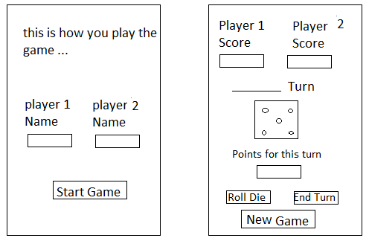

Submission

*Beta Version*

Post the following to the Beta + Code Review Forum:

1. For part 1: A document containing screen-shots of the tutorial app with each screen-shot labeled. (Please use .docx or .pdf format.)
2. For part 2: A zip file containing your app’s Visual Studio solution folder. (Make your solution smaller by deleting the *obj* and *bin* folders.)  
   Or, optionally, a link to a repository containing your solution source code. (You can put the link on the same document with the screen-shots for part 1.)
3. A copy of your lab instructions (so the lab partner who reviews your work will know what the requirements were for your app).

*Production Version*

1. Items 1 and 2 above, but revised as needed.
2. The code review of your work (the one done by your lab partner) with the second column (“Release”) completed by you.