Overview

This tutorial gives you practice working with:

* Linear UI layouts
* Relative UI layouts
* Loading either a layout with widgets arranged for landscape orientation or one with an arrangement for portrait depending on which way the device is rotated.

Part 1: Rotation Tutorial

The tutorial for this lab doesn’t guide you through building a project, but source-code for the app described in the tutorial is available. Download the code from GitHub, build it, and run it. Put in break-points so you can see what is happening at various points in the code when you start the app or rotate it. Take at least two screen-shots showing the app with different orientations.

Tutorial: <https://developer.xamarin.com/guides/android/application_fundamentals/handling_rotation/>

Tutorial source code:   
<https://github.com/xamarin/monodroid-samples/tree/master/ApplicationFundamentals/RotationDemo/RotationDemo>

Part 2, Group C: Double Pig – Two die, Relative layouts with nested linear layouts

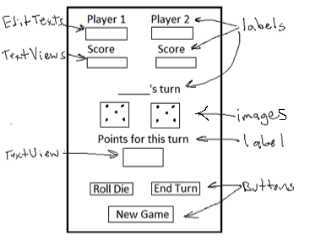

The “Double Pig” version will have two die on the UI instead of one. Two players will take turns rolling two die as many times as they wish or until they roll double ones. When they roll double ones, the “Roll Die” button should be disabled, re-enable it when the next player starts their turn. Their score for the turn is the sum of their rolls unless they get double ones, then it’s zero. Players keep taking turns rolling until someone gets to 100. If the player rolling first reaches 100, the second player may still take their turn. The player with the highest score wins. For both orientations, landscape and portrait, Arrange the widgets using relative layouts with nested linear layouts. (You don’t need to put all the widgets in linear layouts, just the ones where it simplifies the layout)

Submission

*Beta Version*

Post the following to the Beta + Code Review Forum:

1. For part 1: A document containing screen-shots of the tutorial app with each screen-shot labeled. (Please use .docx or .pdf format.)
2. For part 2: A zip file containing your app’s Visual Studio solution folder. (Make your solution smaller by deleting the *obj* and *bin* folders.)  
   Or, optionally, a link to a repository containing your solution source code. (You can put the link on the same document with the screen-shots for part 1.)
3. A copy of your lab instructions (so the lab partner who reviews your work will know what the requirements were for your app).

*Production Version*

1. Items 1 and 2 above, but revised as needed.
2. The code review of your work (the one done by your lab partner) with the second column (“Release”) completed by you.