Create an app for playing a modified version of the dice game "Pig". Here is an example of the traditional game: <http://cs.gettysburg.edu/projects/pig/piggame.html>

The UI for your game should be similar to the one shown below:

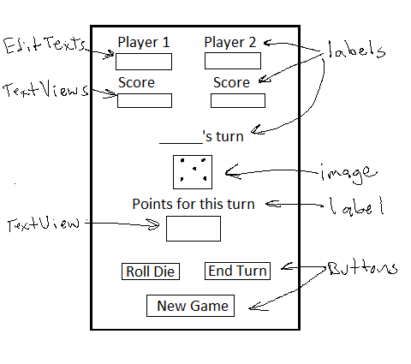

* Use a Frame Layout to hold a background image for the app (you can provide your own image).
* Images are provided for the 6 or 8 sides of the die.
* Provide different layouts for landscape and portrait orientation
* Use the names entered in the editable text views for Player 1 and Player 2 to display the name of the player whose turn it is.
* Write a separate Pig class that will contain the logic for the game.

**Group A: Big Pig – An 8-sided die, relative layout for portrait, linear for landscape**

The “Big Pig” version of the game is a dice game with 2 players and one die, but it is an 8-sided die. Each player rolls the die as many times as they wish or until they roll an 8. Their score for the turn is the sum of their rolls unless they get an 8, then it’s zero. When they roll an 8, the “Roll Die” button should be disabled, re-enable it when the next player starts their turn Players keep taking turns rolling until someone gets to 100. If the player who had the first roll reaches 100, the second player may still take their turn. The player with the highest score wins.

* Portrait orientation: Arrange the widgets using a Relative Layout.
* Landscape orientation: Arrange the widgets using nested Linear Layouts.

**Group B: Little Pig – A 6-sided die, Linear Layouts for portrait and relative for landscape**

The “Little Pig” version is basically the traditional game of "Pig". Two players will take turns rolling one die as many times as they wish or until they roll a 1. When they roll a 1, the “Roll Die” button should be disabled, re-enable it when the next player starts their turn. Their score for the turn is the sum of their rolls unless they get a 1, then it’s zero. Players keep taking turns rolling until someone gets to 100. If the player rolling first reaches 100, the second player may still take their turn. The player with the highest score wins.

* Portrait orientation: Arrange the widgets using nested Linear Layouts. (Try to avoid more than one level of nesting).
* Landscape orientation: Arrange the widgets using a Relative Layout.

**Both Groups**

Zip the beta version of the solution (after removing the bin and obj folders) and e-mail it to your code-review partner.

After getting a code review, revise your code and upload it to Moodle.