**Purpose:** This lab will give you practice using fragments to adapt your app to different screen sizes

**Pig Game v2**

Refactor your Pig game to use fragments. Fragment 1 will be an opening screen that displays instructions and asks the players for their names. It will have a “Start Game” button that launches the Activity containing Fragment 2. Fragment 2 will contain the UI for game-play. The “New Game” button on this fragment will launch the Activity containing Fragment 1 (taking the user back to opening screen). On a small screen only one fragment will be displayed at a time. On a large screen, both fragments will be displayed side-by-side. Create Activity AXML layouts for two screen sizes and both orientations.

Fragment 1 Fragment 2

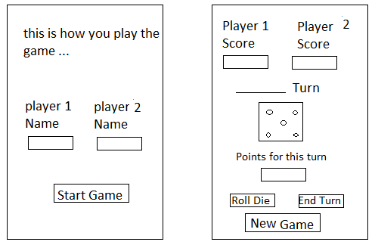

**Group A: Big Pig - eight-sided die**

Modify your current landscape layout to make the two new fragment UI AXML layouts (i.e. your fragments will use relative layouts). Use the Activity AXML layouts to statically load the fragments.

**Group B: Little Pig – six-sided die**

Modify your current landscape layout to make the two new fragment UI AXML layouts (i.e. your fragments will use linear layouts for the UI). Use the Activity AXML layouts to statically load the fragments.

**Options**

* Modify your Lab 2 (Multiscreen) app to use fragments instead of modifying your Pig game.
* Load fragments programmatically (see MathFlashCards.v3) instead of statically.

**Both Groups**

Zip the beta version of the solution (after removing the bin and obj folders) and e-mail it to your code-review partner. After getting a code review, revise your code and upload it to Moodle.