Part 1: Phoneword

Translating a phone word to a phone number: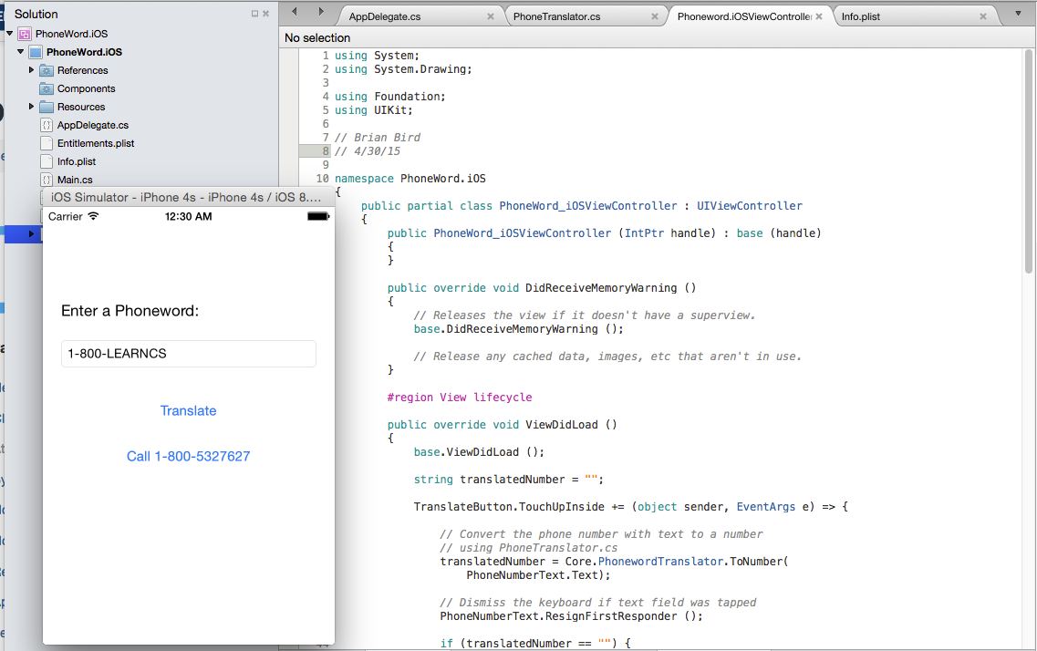

Making a call: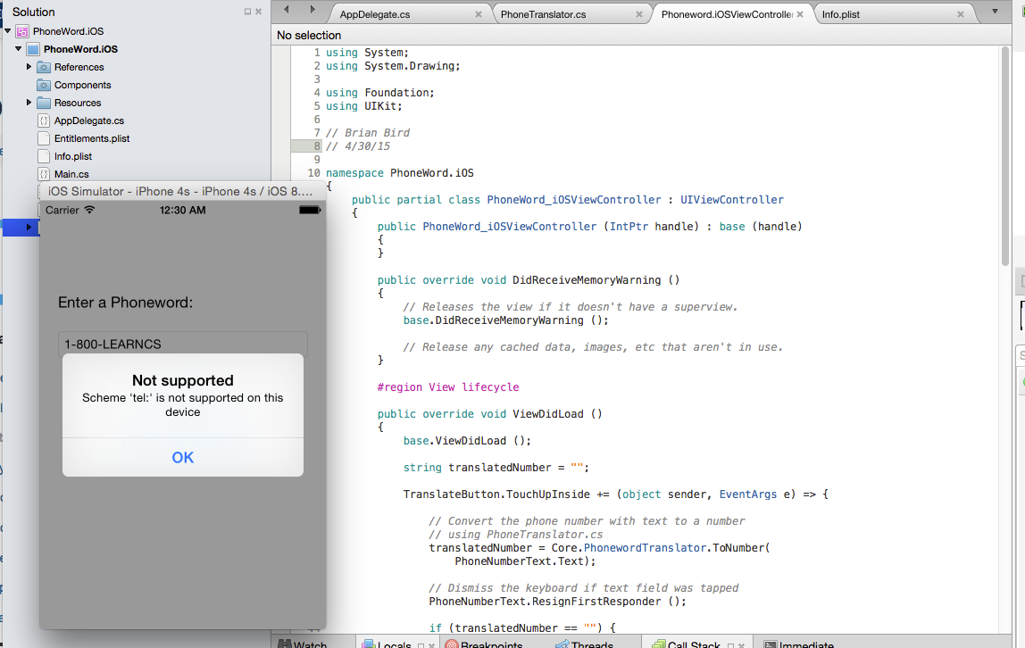

Part 2: Roman Numeral Calculator

Converting from an arabic number to roman numerals: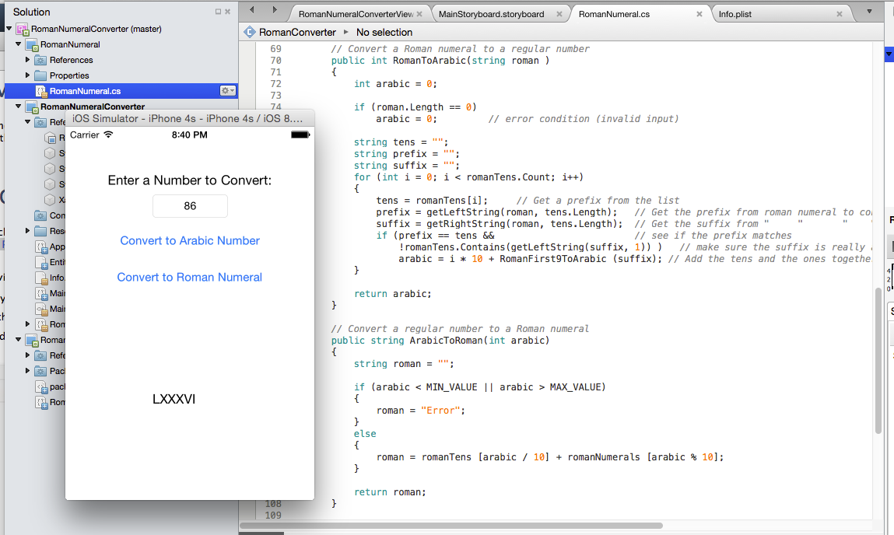

Converting from roman numerals to an arabic number: