Topic: Multiple Post Handlers and Post Handler Parameters
- Review due dates
- Do a code review of someone’s lab 3

OnPost Method

Demo
Roman Numeral Calculator
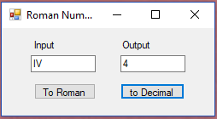
- Multiple buttons
  - Handle with parameters
    - In .cshtml
      - Input elements need a name and value attribute (or value entered)
<button type="submit" name="convertTo" value="Roman" />
    - In .cshtml.cs
      - The parameter name must match the element name, the value specified will be passed.
public void OnPost(string convertTo)
  - Handle with multiple OnPost methods
    - Use two forms
      - In .cshtml
        - <form asp-page-handler="Roman" method="post">
      - In .cshtml.cs
        - public void OnPostRoman()
  - Use different handlers for each button
<input type="submit" asp-page-handler="JoinList" value="Join" />
- Drop-down list

<select>
<option value="volvo">Volvo</option>
<option value="saab">Saab</option>
<option value="opel">Opel</option>
<option value="audi">Audi</option>
</select>

