1. Go to [portal.Azure.com](https://portal.azure.com) and sign in using your LCC e-mail address.
2. Click on the “?” button.  
     
   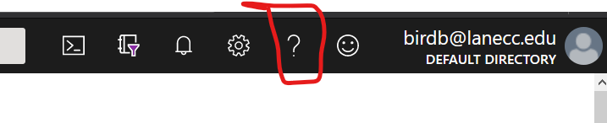
3. Select “Help + Support”.  
     
   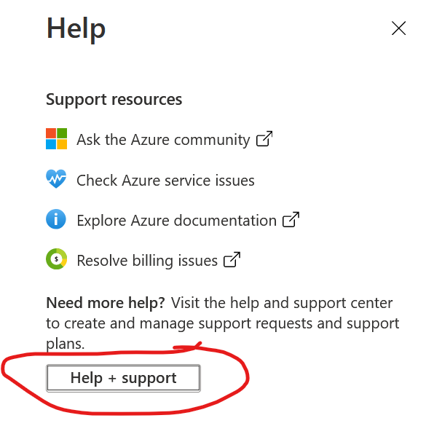
4. Select “New Support Request”.  
     
   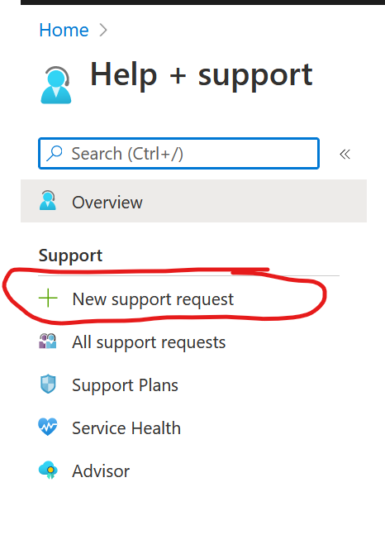
5. Select “Subscription Management” as the issue type.  
   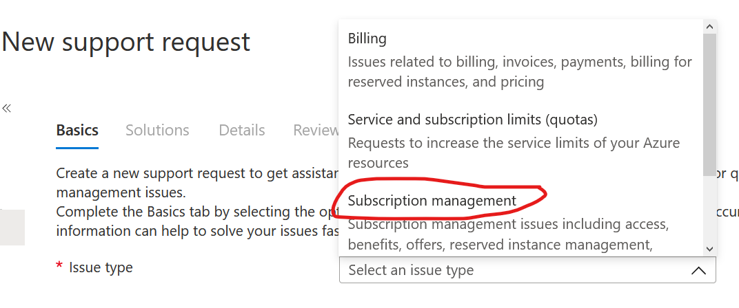
6. Select the entries shown below and give a brief summary of the issue, click “Next: Solutions >>” to go to the next screen.  
     
   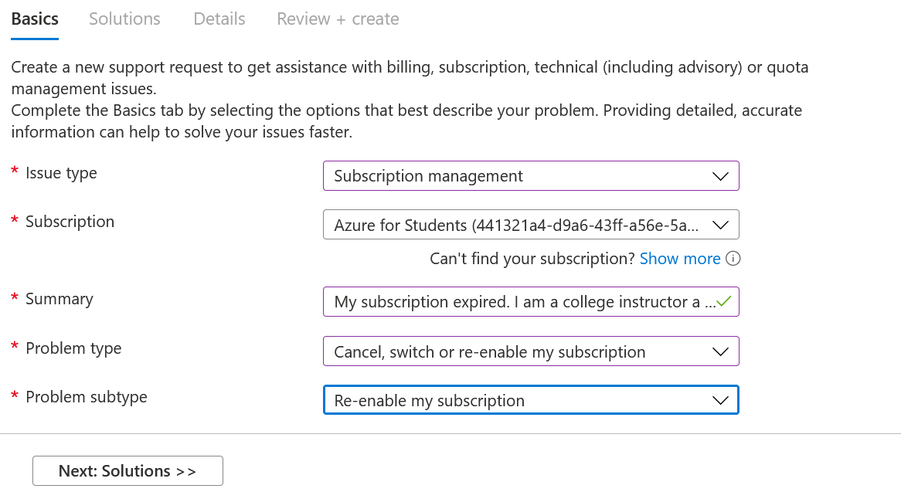
7. Skip to the next screen by clicking “Next: Details >>”  
     
   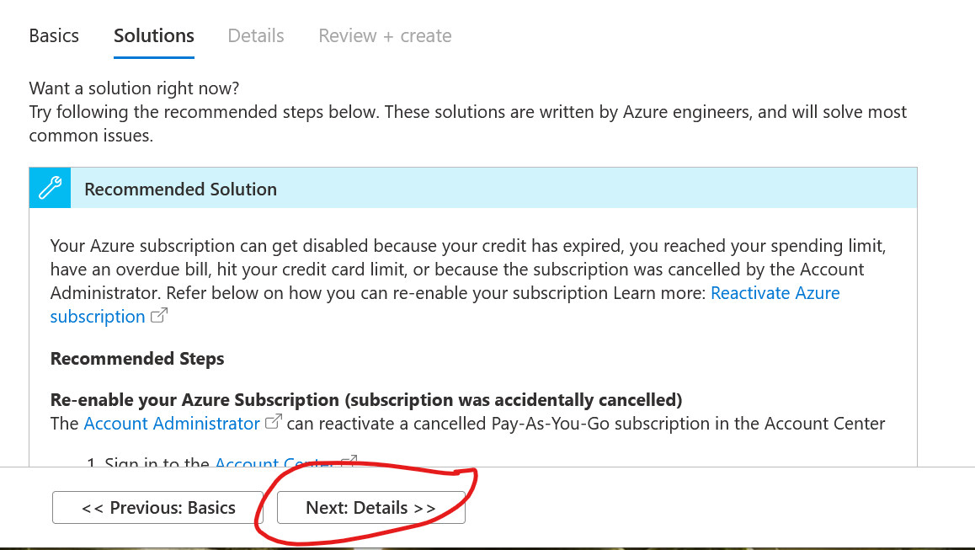
8. Enter the date of the issue, subscription ID, and write your request.  
     
   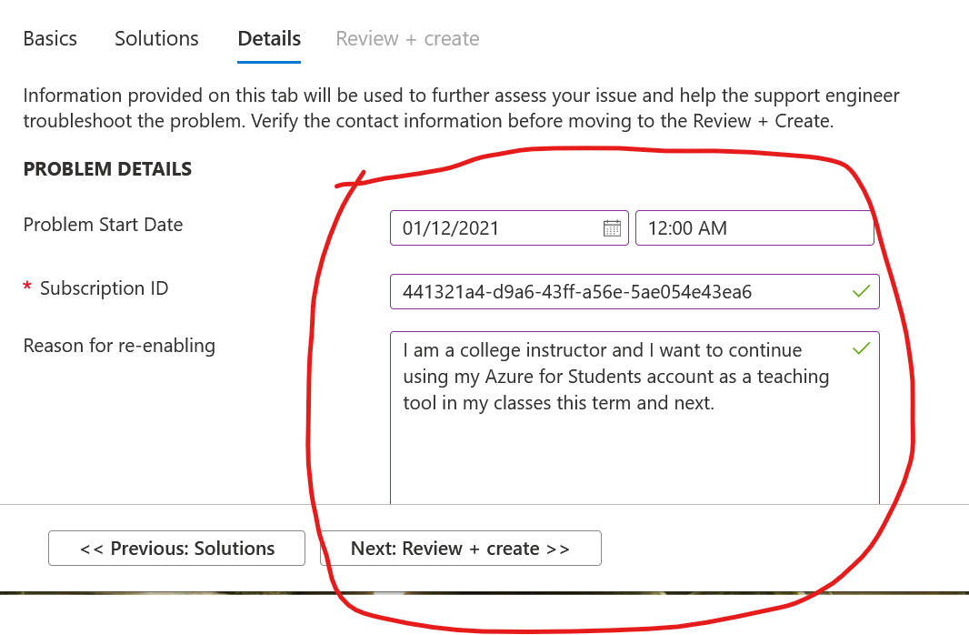
9. Click “Create”. You’re done!  
     
   