Roadmap for Completing Implementation Plan for a Second
Radio Telescope for GAVRT 03-03-05

Peter Poon JPL

A. Review Sections 1 – 5 of previous version of
Implementation Plan (attached)

Assignees: All

Due Date:

B. As a result of revie, update the following action items to include ADDITIONAL action items if appropriate and to include DUE DATES

Important: Due Dates, once agreed to by the assignees, become Commitment Dates

- LCER (Dave MacLaren, Bob McCleod, Kim):
Provide updated figure: Growth of GAVRT…

Due date:

  - LCER: Provide updated numbers

Due date:

  - Mike Klein/LCER

Provide written input on planned uses of DSS-28
Frequency utilization, spectroscopy etc.

Due date:

  - Art Freiley/ Div 33

Provide updated DSS-28 System Design

Due date:

  - Art Freiley / LCER

Provide written inputs on DSS-28 Sustaining

Due date:

  - Art Freiley/ LCER

Provide written inputs for DSS-28 Quality Assurance Plan

Due date:

- All

Revise the Table of Contents for 4.0

Due date:

- Art Freiley/ Div 33

Provide updated NASA/JPL cost estimates and schedule

Due date:

4.0 LCER

Provide LCER cost estimates and schedule

Due date:

- Mike Kein/ Peter Poon/ LCER

Provide written inputs for Recommendations

Due date:

Consider Additional Action Items with Assignees and
Due Dates

C. Decide dates and types (internal, external) of Review of
Completed Implementation Plan

Assignees: All

Due Date:

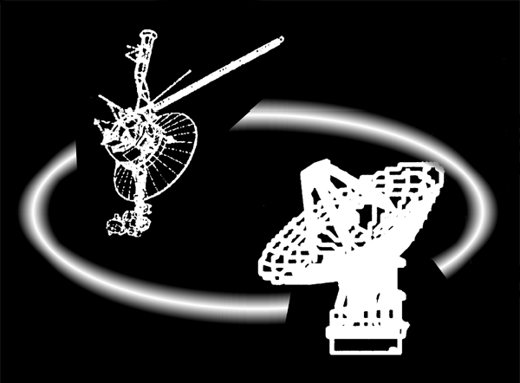

Deep Space Mission System

Implementation Plan
for
a second Radio Telescope for
Goldstone Apple Valley
Radio Telescope Project

Draft 03-03-05

Prepared by :

Arthur Freiley JPL Antenna Service System Development Engineer

Michael Klein JPL DSN Science Office Manager

David MacLaren LCER (Please supply title)

Robert McCleod, LCER (Please supply title)

Peter Poon JPL Telecommunications and Mission Systems Manager

Shirley Wolff JPL DSMS Education and Public Outreach Coordinator
Table of Contents

Please review for content only. Correct formatting will be done later.

1.0 Overview 2
1.1 Purpose/Objectives 3
1.2 Why DSS-28 is the candidate 3
1.3 Reviews 4
2.0 Partnership between NASA/JPL and LCER 5
2.1 Success and Growth of GAVRT 5
2.2 Benefits of adding DSS-28 to the GAVRT Science Education Partnership 6
2.3 Planned uses of DSS-28 …………………………………………………………6
2.4 Benefits to Education/Educational Outreach 6
3.0 DSS-28 Implementation 9
3.1 DSS-28 Implementation System Requirements 9
3.1.1 The Radio Telescope instrument shall: 9
3.1.2 The Radio Telescope central controller shall: 9
3.1.3 The Frequency and Timing Subsystem shall: 11
3.1.4 Future capability Upgrade Requirements 11
3.2 DSS-28 System Design 11
3.3 DSS-28 Documentation Plan 12
3.4 DSS-28 Operations Concept 12
3.5 DSS-28 Sustaining 13
3.6 DSS-28 Quality Assurance Plan 13
4.0 DSS-28 Cost Estimate and Schedule 14
4.1 Implementation Cost Estimate and Schedule (Goldstone and LCER) 14
4.1.1 NASA/JPL Cost Estimate and Schedule 14
4.1.2 LCER Cost Estimate and Schedule 14
4.2 Sustaining Cost Estimate and Schedule (Goldsone and LCER) 14
4.2.1 NASA/JPL Cost Estimate and Schedule 14
4.2.2 LCER Cost Estimate and Schedule 14
4.3 Integrated Cost Estimate 14
4.4 Integrated Schedule 14
5.0 Recommendations 15

Please review for content only. Correct formatting will be done later.

1.0 Overview
(Peter Poon)

The Goldstone Apple Valley Radio Telescope (GAVRT) project is a highly successful partnership between NASA/Jet Propulsion Laboratory (JPL), and Lewis Center for Educational Research (LCER). The focus of the partnership is science education, outreach, and support of the missions of NASA/JPL and LCER.

The GAVRT mission is to research, develop and deliver educational programs locally, nationally and globally addressing multiple learning styles that stimulate curiosity in, and communicate the relevancy of science and technology to everyday life for students, teachers and parents. This vision is particularly responsive to the last two of the three elements of NASA’s mission:

“To understand and protect our home planet
To explore the Universe and search for life
To inspire the next generation of explorers
. . . as only NASA can”

Through the GAVRT partnership, educators, scientists and technologies are working together to give pre-college students across the country the opportunity to experience scientific discovery and not just read about it. With each pass of a planet or quasar, GAVRT students join the ancient family of explorers who have gazed into the night sky since the beginning of time to understand their place in the universe.

The GAVRT project officially began in October 1996 with the signing of a formal Memorandum of Understanding (MOU #96-720-85) involving JPL, LCER and the Apple Valley Unified School district. The agreement is one of equal partnership with no funding changing hands among the three organizations. From that beginning GAVRT has grown from a relatively small educational project to an international program. New science/education programs involving thousands of new students and dozens of new teachers are added every year. The rate of growth is planned to accelerate in the next few years as a result of a new partnership between the LCER and the Department of Defense Education Activity (DoDEA) that began in 2002.

The LCER is now providing GAVRT training and support for teachers from dozens of DoDEA American schools stateside and overseas schools in addition to the trainings for public and private schools in the U.S. The number of teachers and schools participating in the GAVRT partnership is growing dramatically… (SEE Figure ____: Growth of GAVRT ……..)

Program growth is also being realized in the GAVRT curriculum, which is expanding each year. As new curriculum projects are introduced, requests for new technical capabilities are being made.

The Lewis Center is we predict a fully subscribed DSS 12 antenna by June of 2006. A second radio telescope (DSS-28) will be necessary to support the continued growth of students and teachers involved in the GAVRT program and to accommodate the need for new microwave feeds and receivers to support new science-education projects such as microwave spectroscopy.

Since DSS-28 is crucial to support the growth of the GAVRT program, and since DSS-28 needs major upgrades to make it operational, implementation planning for DSS-28 is essential, and is presented in this document. As the project progresses, DSS-28 implementation planning will be continually updated.

1.1 Purpose/Objectives

Implementation of a second radio telescope (DSS-28) is an expansion of the existing partnership between NASA/Jet Propulsion Laboratory (JPL) and Lewis Center for Educational Research (LCER). Throughout this document, “a second radio telescope” and DSS-28 will be used interchangeably.

The purpose of a second radio telescope implementation plan is to provide and document the planning for the implementation of DSS-28 in order to convert it to the student-operated, remotely-controlled Radio Telescope.

The specific objectives are as follows:

(a) Provide a description of the design of DSS-28.

(b) Provide a schedule for the implementation of DSS-28.

(c) Delineate the funding, implementation, operations, and maintenance responsibilities of NASA/JPL and Lewis Center for Educational Research.

(d) Provide the cost and workforce estimates for the implementation of DSS- 28 for NASA/JPL and LCER.

- Provide the cost and workforce estimates for the recurring operations and maintenance costs for DSS-28 for NASA/JPL and LCER.

1.2 Why DSS-28 is the candidate

DSS-28 is the candidate for the following reasons:

(a) Available

DSS-28 was constructed under the sponsorship of the U.S. Army as a limited R&D facility. It was transferred to NASA/JPL/ Goldstone for safekeeping with a 5-year option to resume their R&D activity. The 5-year option has already expired. DSS-28 is now available for instrumentation and for future use by LCER.

(b) Will be fully utilized by GAVRT.

DSS-28 is a one-of-a-kind antenna which was not designed for Deep Space Network (DSN) purposes. It has not been instrumented, and the antenna has become NASA’s responsibility. Because of the rapid growth of GAVRT, DSS-28 will be an excellent candidate as a supplementary radio telescope which will be fully utilized by GAVRT.

(c) Meets GAVRT requirements including low maintenance costs

- Beam Wave-Guide (BWG) design is ideally suited to provide multiple frequency receive capability and provides easy access to make equipment changes to support a broad range of science -curriculum projects.
- Antenna surface precision allows use to 32 GHz
- Infrastructure for technical support and maintenance is already in place
- Antenna is only ten years old

1.3 Reviews

The DSS-28 implementation effort belongs to the R&D category.

(a) An informal R&D planning review will be conducted jointly for the JPL Interplanetary Network Directorate (I ND) and the Lewis Center for Educational Research (LCER).

(b) Informal peer reviews will be held weekly or biweekly.

(c) Informal implementation status reviews will be held once every three months. More frequent implementation status reviews may be conducted on an as-needed basis.

2.0 Partnership between NASA/JPL and LCER
(Mike Klein/LCER Bob McLeod/Dave MacLaren)

On October 25, 1996 a memorandum of Understanding (MOU) was established between the California Institute of Technology Jet Propulsion Laboratory and the Apple ValleyUnified School District (AVUSD). At that time the AVUSD operated the Science and technology Center (STC). The MOU agreed “to provide for setting up the STC for remote use of the Goldstone Apple Valley Radio Telescope for research experiments by students, for teacher training, for curriculum development, and to provide for the parties’ joint mathematics, and technology education” (III. Purpose, MOU # 96-720-85). In 1997 JPL and the Lewis Center for Educational Research (formally STC) delivered “Jupiter Quest”, the first in-depth science/education program of the GAVRT partnership. A renewal MOU, signed between Caltech/JPL and LCER on July 14, 1999 (MOU # 99-720-149), will be in effect until September 28, 2003. A new MOU is currently being written to extend the agreement for another 5-years and reference to this proposal is included.

2.1 Success and Growth of GAVRT
(LCER – Bob McLeod/Dave MacLaren)

The original GAVRT partnership has evolved over the years and now includes students, teachers, scientists, and engineers from around the world. In the last five years, the LCER has trained 131 teachers in 82 schools from 20 states, including five DoD Education Activity schools overseas. Over 11,000 students have remotely controlled DSS-12. The MOU was renewed on July 14, 1999. See Figure 1, growth chart showing student growth numbers:

Students actively engaged - approximately 25,000 by 2004/05

students exposed to GAVRT - approximately 100,000 by 2004/05

(Placeholder for FIGURE 1)

A major objective of the GAVRT project is to improve scientific literacy among America’s school children. All curricula developed for GAVRT aligns with state and national educational standards as well as parallels NASA themes. GAVRT data has made significant contributions to NASA scientific database and NASA missions (i.e. Cassini JMOC, Galileo JMOC).

The LCER has a research department studying the affects of GAVRT on students (accepted future publication, Science Scope, The Goldstone Apple Valley Radio Telescope, Mary Ibe, et. al.) Based on the results of the pre and post surveys, students who participate in the JupiterQuest program generally exhibit an increase in their feelings of scientific efficacy. Student/teacher weekly telecons with scientists has become a key factor in building the collaboration between education and the scientific community.

2.2 Benefits of adding DSS-28 to the GAVRT Science Education Partnership
(Mike Klein/LCER – Bob McLeod/Dave MacLaren)

Need text inputs here:

- Addition of second antenna will allow GAVRT to support the expanding number of schools in the program
- Addition of DSS-28 will proved access to new microwave frequencies enabling GAVRT students to participate in new science-education programs that include
  - Quasar Variability Study: to study the variability of radio emission powered by enormous black holes in distant quasars
  - Astrobiology: to study pre-biotic chemistry via microwave spectroscopy of interstellar molecules
  - Jupiter Icy Moon Orbiter: Expand on current Jupiter Quest microwave observations of the Jupiter and its radiation belts.
  - SETI: to provide follow-up observations of signals detected by SETI observing programs (GAVRT is included in the proposal being written by SETI Institute/ UC Berkeley/JPL proposal)

- DSS-28 Implementation plan will include opportunities for a limited number of students from local High Schools and Secondary Engineering Schools in some of the engineering work.
  - Undergraduate engineering students might participate in specific engineering tasks, working with mentor engineers at JPL.
  - High school students might participate in the engineering acceptance tests working with JPL and LCER staff and mentor undergraduate engineering students.

- Addition of DSS-28 will allow the above without impacting current GAVRT programs
- LCER ops center is capable of operating two GAVRT Radio Telescopes simultaneously
o Current growth projections involving more students and schools require another antenna online by 2005
o Redundancy necessary to sustain existing and future GAVRT programs
Future NASA Mission collaborations require different hardware capabilities

2.3 Planned uses of DSS-28 (i.e. frequency utilization, spectroscopy, interferometry, etc.)
(Mike Klein/LCER – Bob McLeod/Dave MacLaren)

2.4 Benefits to Education/Educational Outreach
(LCER/Shirley Wolff)

GAVRT is more than outreach; it is a science education partnership. Nevertheless, the GAVRT partnership includes close cooperation with NASA E/PO endeavors. With the appointment of Sean O’Keefe as NASA Administrator, more emphasis is being placed on the importance of education in all of NASA’s mission and program outreach.

A statement endorsing the importance of education now appears in NASA’s mission statement –

To understand and protect our home planet
To explore the Universe and search for life
To inspire the next generation of explorers
. . . as only NASA can

NASA has recently elevated education to an enterprise activity with a new Associate Administrator, Adena Loston, being appointed to head up Code N, handling Education programs.

NASA’s Office of Space Science has long held that to attract the next generation of scientists and engineers we need to capture the interest of students at a young age and excite them about science. What more exciting topic than space – and what more exciting experience than actually producing in the classroom real scientific data to be used by NASA scientists.

The Goldstone Apple Valley Radio Telescope (GAVRT) project aligns closely with NASA Enterprise goals by providing students direct participation in research using NASA facilities and interacting with NASA-sponsored scientists. The GAVRT project incorporates many of the features proven to be successful in classroom educational programs. GAVRT is curriculum based, meeting both National and State Science Standards. GAVRT teachers receive an intensive 5-day training on radio astronomy; controlling the antenna, and implementing a 2-3 week or semester-long curriculum based on GAVRT capabilities. Once the teacher returns to the classroom, the relationship with GAVRT personnel continues as they receive curriculum support and guidance during their scheduled antenna runs. Students in the GAVRT program have the opportunity for direct interaction with scientists either in person or through teleconferences.

Based on the results of pre and post surveys during a recent evaluation, students who participate in the GAVRT program generally exhibit an increase in their feelings of scientific efficacy. The largest area of growth in this preliminary study occurred in the students’ perceived increase in their ability to debate scientific topics. Students also expressed an increase in their feelings of efficacy associated with the value they placed on the work they produced in science and on being trusted to use sophisticated scientific equipment. Other benefits stated by surveyed students were an increase in their ability to use scientific equipment, and to think scientifically. A paper by LCER Researcher, Mary Ibe, is scheduled for future publication in the National Science Teacher’s Association’s “Science Scope”.

GAVRT offers a unique experience for students to observe objects in the Solar System and beyond using radio astronomy; to collect and analyze data from these observations; and to submit their data to NASA for incorporation into research by NASA scientists. The importance of the benefits of student participation at this level cannot be over emphasized.

3.0 DSS-28 Implementation

3.1 DSS-28 Implementation System Requirements
(P. Poon/A. Freiley/C. Stelzried/LCER)

The design and implementation of DSS-28 shall respond to the following requirements:

3.1.1 The Radio Telescope instrument shall:

(a) Operate in S, X, C and Ku frequency bands.
- Requirement S, X, C ,Ku (ART’s TABLE)
- Ability to expand to 4-24 GHz for SETI and Spectroscopy in future
- Operate at S- and X-Band to duplicate the functions and capabilities of DSS-12 to supplement the operations and to act as back up and extend the capability.
- Operate at C- and Ku-Band to extend the operating capabilities to new band and enable new and expanded science operation and opportunities.

(b) Receive simultaneous dual polarization signals right circularly polarized (RCP) and left circularly polarized (LCP).

(c) Provide an instantaneous bandwidth of >= 100 MHz.

(d) Utilize uncooled HEMT low-noise amplifiers (LNAs).

(e) Provide antenna pointing knowledge to 0.1 of the half-power beamwidth at the highest frequency (14 GHz) – (Blind pointing & Precision pointing)

(f) Provide the capability of antenna pointing offset and offset rates in AZ-EL, HA-DEC, and galactic coordinates.

(g) Provide single coordinate tracking rates up to 0.25 deg/sec.

(h) Incorporate a calibration system, including an ambient load and noise diodes.

(i) Provide telescope data outputs of total power and/or noise-adding radiometer (NAR) j) include a spectrum analyzer, and additionally provide an IF output with an option for connectivity to the Goldstone R&D spectrum analyzers (the Wide Band Spectrum Analyzer, and the Channelized Signal Processor) for future spectral analysis observations

3.1.2 The Radio Telescope central controller shall:

(a) Provide a telescope control and display workstation for integration into the Remote Operations Console at the LCER, and which includes all capabilities required for safe operation of the Telescope antenna, the scheduling, configuration, and control of telescope observations, and the control, recording, and display of both observational data and Telescope monitor and control data.

(b) Provide an equivalent Local Operations Console workstation located within the Telescope facility at GDSCC for local system test and maintenance.

(c) Incorporate the capability to limit the single coordinate antenna slew rates to a specified value to protect the lifetime of the antenna.

(d) Monitor wind speed and direction at the Telescope antenna; stow the antenna if wind limits are exceeded for a specified time; display the wind speed and direction at the Remote Operations workstation.

(e) Provide site surveillance TV video and display at the LCER Operations Console.

(f) Provide commanded and actual antenna position data, and display on the Operations Consoles.

(g) Provide a Telescope antenna Emergency Stop (E-STOP) switch at the GDSCC Signal Processing Center (SPC-10) control room.

(h) Provide an external data interface at the LCER Operations Console workstation which provides 1) both telescope monitor and control data and observational data for transmission to participating science classrooms; and 2) provides for receipt and processing of necessary control parameters and directives from the classroom for the control of the Telescope observations.

(i) Provide for the output, capture, and transfer of both observational data and Telescope monitor and control data:

(1) Observational data shall include

- total output samples or NAR output samples

- antenna actual position

- antenna position error

- subreflector actual position

- subreflector position error

(2) Telescope monitor and control data shall include:

- weather data (wind speed and direction, ambient temperature, humidity)

- cone temperature

- spectrum analyzer display data

- subsystem mode and status information including loss of time code

(j) Tag all data with YR/DOY/UT time tags to a precision of 10 msec.

(k) Transmit all data in real time to the Operations Console “in control” for telescope monitor and control, recording, and display.

3.1.3 The Frequency and Timing Subsystem shall:

(a) Provide necessary timing outputs for Telescope antenna controls, and for data time-tagging.

(b) Utilize the existing 1pps/5MHz timing signals from the SPC-10 Frequency and Timing Subsystem (FTS).

3.1.4 Future capability Upgrade Requirements

The implementation of DSS-28 should allow for accommodating future capability upgrades, e.g. physical layout, frequency band, room for feeds and instruments. The following future capability upgrades will be considered as funding and resources permit:

(a) Cooled LNAs

(c) Antenna boresight telescope/ video camera, with remote display for educational purposes

(d) Accommodate future possible acquisition of Search of Extraterrestrial Intelligence (SETI) feed with ultrawide band, e.g., 4 – 22 GHz

(e) Spectroscopic observations

3.2 DSS-28 System Design

Text + 3/4 Diagrams
(A. Freiley/D. Rochblatt/C. Stelzried/LCER)

The proposed DSS-28 system consists of 4 major equipment groups, the antenna structure and reflector optics, the feeds and radiometers, the station controller and the communications links between the station and the LCER control center. Figure A shows the major functional elements of the system and the connection to the existing DSS-12 antenna and the LCER center.

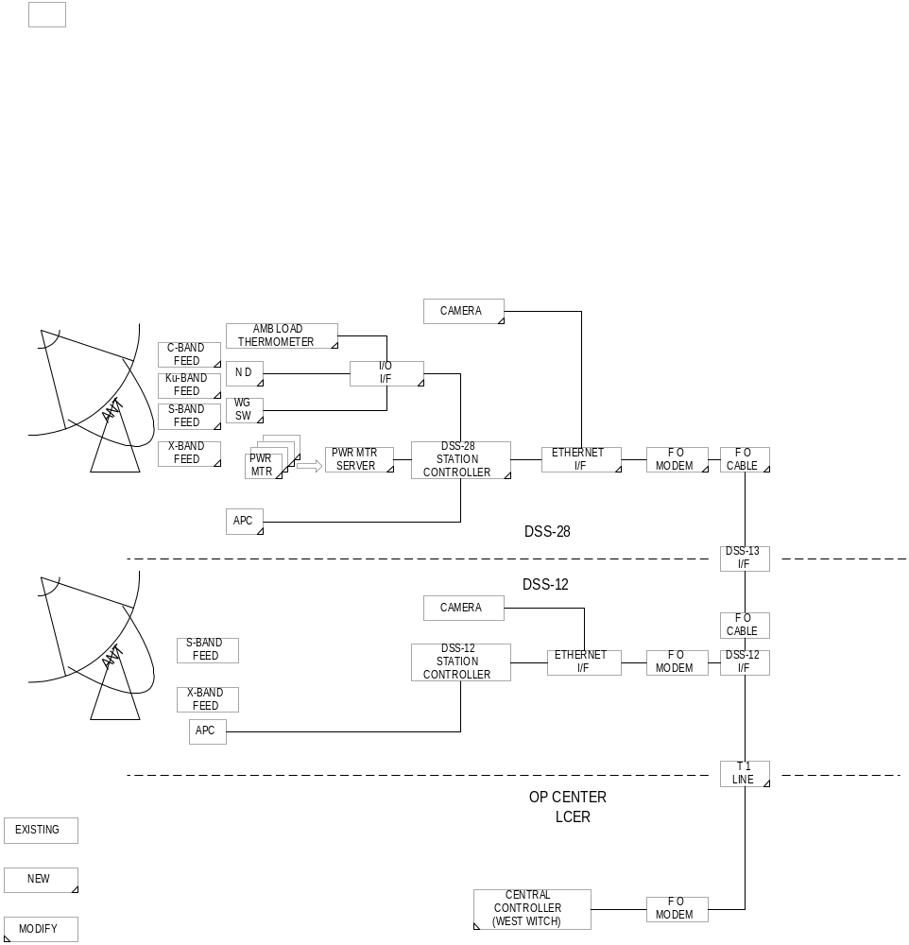
Figure A: System functional block diagram

3.2.1 Antenna Structure and Reflector Optics

The DSS-28 antenna is an existing reserve asset in the DSN and has stood unused for many years. It is a basic Beam Waveguide (BWG) design with an above ground pedestal. The antenna optics differ from the other DSN BWG antennas in that the first optical focus is located at the lower end of the beam waveguide tube (Figure B). The original polarization grid and offset reflector will be removed from the lower end of the beam waveguide tube to open the tube to the new pedestal optical reflector (Figure C). The pedestal will be divided into 4 quadrants. Each quadrant can accommodate up to 2 feeds. Each feed will be coupled to the main reflector through a combination of dichroic and flat plates and a center ellipsoid reflector. This center reflector will rotate to direct the secondary focus to the fed or feeds in the selected quadrant.

In the early 1990s JPL built 2 identical above ground 34m BWG antennas (later to be known as DSS-27 and 28) for a special development task. The task completed both antennas and conducted preliminary antenna testing at each site. Shortly after the testing phase the task was discontinued and the antenna assets were given to the DSN with a MOU providing for future access if the necessity developed. The DSN was to maintain the assets in good working order for a smooth resumption of development if the option was exercised.

Since that time the DSN has converted DSS-27 for S-Band operation and has used DSS-28 as replacement spares for DSS-27. Assemblies and elements have been used to replace failed units on the operational sister station DSS-27, and DSS-28 has been left in a non-operating condition contrary to the original MOU.

XXX (TBS) XXXXX

Figure B: DSS-28 Optical diagram
FEEDS and RADIOMETERS:

The initial plan includes designs that can accommodate 4 quadrants with up to 2 feeds each. The center ellipsoidal reflector will be used to switch between the 4 quadrants.

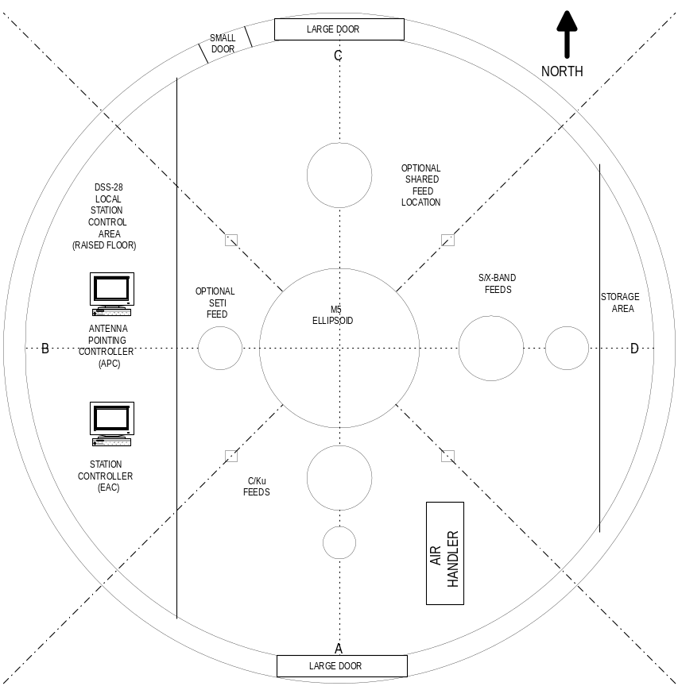
Figure C: Pedestal Layout

3.2.2

Quadrant A will contain the S/X feed systems and would be optically combined using a dichroic and flat plate reflector system to combine the beam and direct them to the center ellipsoid reflector.

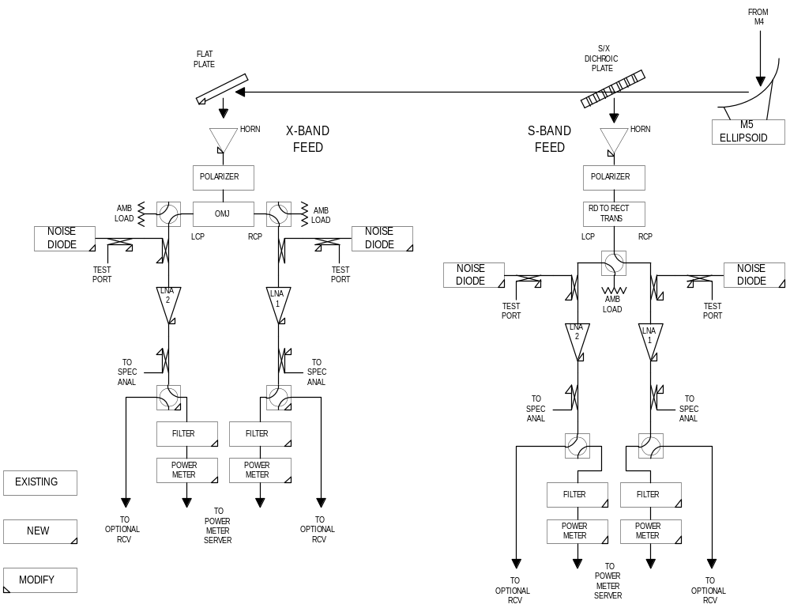Figure D: S/X Feed system functional block diagram

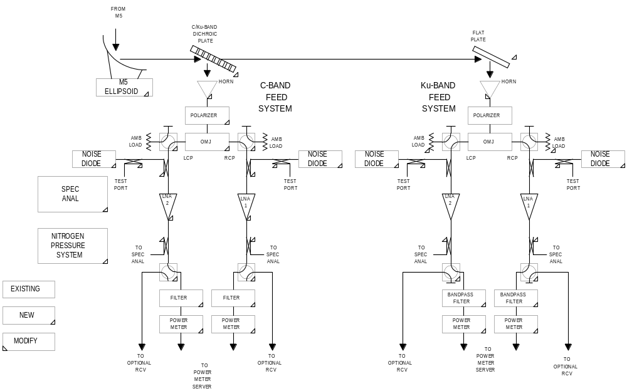

Figure E: C/Ku Feed system functional block diagram

3.2.3 Station Controller

3.2.4 Communication Links

(A. Freiley/D. Rochblatt/C. Stelzried/LCER)

3.3 DSS-28 Documentation Plan

DSS-28 is an R&D effort. No formal documentation is required except for the DSS-28 Implementation Plan which will be continually updated. There should be sufficient documentation for fabrication and assembly, taking advantage of expert R&D support personnel at Goldstone. Informal DSS-28 operations manuals will be generated on an as-needed basis.

Cassini-Jupiter Microwave Observing Campaign: TMOD and GAVRT Support Plan TMOD No. 801-004, Issue date May 1, 2000, JPL D-18956.

- Sufficient documentation to fabricate, assemble and trouble shoot the system—taking advantage of expert R&D support personnel at Goldstone.

3.4 DSS-28 Operations Concept
(LCER – Bob McLeod//Dave MacLaren)

Need to reorganize this section (A) What LCER will do (B) What JPL will do.
Consider; OPS, SCI, curriculum, technical support.

In collaboration with the DSN Science Office at JPL, the Lewis Center for Educational Research (LCER) will provide experienced staff to coordinate, schedule and remotely operate DSS-28. Radio astronomers from the GAVRT project will provide advice and support the planning and analysis of observations and the effective use of the antenna. JPL and Honeywell will provide sustaining support to DSS-28 for required modifications, repair, and maintenance. This support will be planned as level-of-effort work within the definition and scope of existing tasks.

Staffing at the Lewis Center will be increased to accommodate a 5/16 schedule. Training programs will ensure that all antenna operators are certified in the operation of both the beam waveguide and Ha/Dec type of antenna. Training for expanded Preliminary Data Processing will be increased to support the growth of new programs.

The telecommunications network at LCER will be expanded to accommodate the increased number of schools connecting to GAVRT. Additional Control Consoles will be activated for the operation of DSS-28. Software needed for the schools to control DSS-28 will be developed, tested and implemented by LCER as needed.

The LCER will control the tracking schedule requests for DSS-28 as it currently does for DSS 12. The observation plans and requests will be integrated into a weekly schedule and distributed to all requestors, other interested parties, and to GDSCC operations for information. LCER will also coordinate with GDSCC to integrate any required GAVRT maintenance periods into the weekly schedule.

LCER will select teachers with GAVRT training and perform detailed planning for the ground-based observations in response to approved science requirements. The selected schools will develop their experimental observation request by preparing an approved Sequence of Events (SOE). LCER provides all necessary assistance to the students and teachers as needed both prior to and during any tracking sequence.

Using the Remote Operations Console at the LCER Operations Control Center (in Apple Valley), a trained GAVRT Operator will conduct or monitor the scheduled observation. The Operator will ensure that the antenna is properly configured and safely operated, while the observation data are properly captured and recorded. Following the successful completion of the observation, the Operator will configure the antenna for the next scheduled observation, or ensure that the antenna is safely stowed.

In the event of an aborted tracking session due to weather or antenna problems, LCER will re-schedule the track. LCER will notify GDSCC of any antenna problems that cannot be resolved from the Remote Operations Console. GDSCC will respond by repairing/clearing the problem on a best-efforts basis and notify the LCER Operator.

LCER will make observational data available to schools via their web site. Students will retrieve the data, perform their teacher lead analysis, and return the results to LCER. LCER will prepare “preliminary data spreadsheets” for DSN Science Team analysis and review, and maintain an archive of all observational data sets, which can also be made available to science classrooms as examples, or for additional analyses.

3.5 DSS-28 Sustaining
- Freiley/LCER – Bob McLeod/Dave MacLaren)

3.6 DSS-28 Quality Assurance Plan
- Freiley/C. Stelzried/LCER – Bob McLeod/Dave MacLaren)

Need text inputs here

- Research and Analysis of effects of student population
- Operations
- Curriculum scientific accuracy
- Teacher/student statistical information

4.0 DSS-28 Cost Estimate and Schedule

4.1 Implementation Cost Estimate and Schedule (Goldstone and LCER)

4.1.1 NASA/JPL Cost Estimate and Schedule
(A. Freiley/C. Stelzried)
(B.
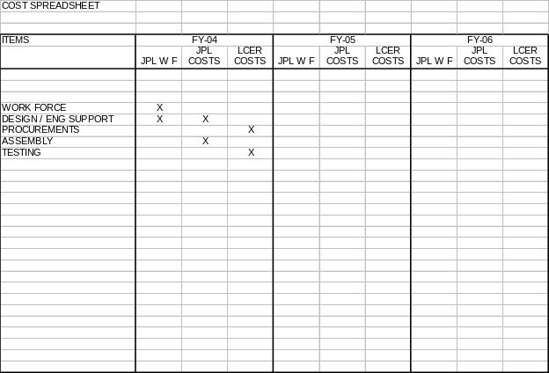

4.1.2 LCER Cost Estimate and Schedule
(LCER – Bob McLeod/Dave MacLaren)

4.2 Sustaining Cost Estimate and Schedule (Goldsone and LCER)

4.2.1 NASA/JPL Cost Estimate and Schedule
- Freiley/C. Stelzried)

4.2.2 LCER Cost Estimate and Schedule
(LCER – Bob McLeod/Dave MacLaren)

4.3 Integrated Cost Estimate
(M. Klein/P. Poon/A. Freiley/(LCER – Bob McLeod/Dave MacLaren)

4.4 Integrated Schedule
(M. Klein/P. Poon/A. Freiley/(LCER – Bob McLeod/Dave MacLaren)

5.0 Recommendations
(M. Klein/P. Poon/(LCER – Bob McLeod/Dave MacLaren)

APPENDICES

Appendix A. Detailed Cost Spreadsheets

Placeholder for spreadsheets

Appendix B. Detailed Schedule

Placeholder for detailed schedule

