Gustavo De Leon 17085

Luis Esturbán 17256

REDBLACK TREE

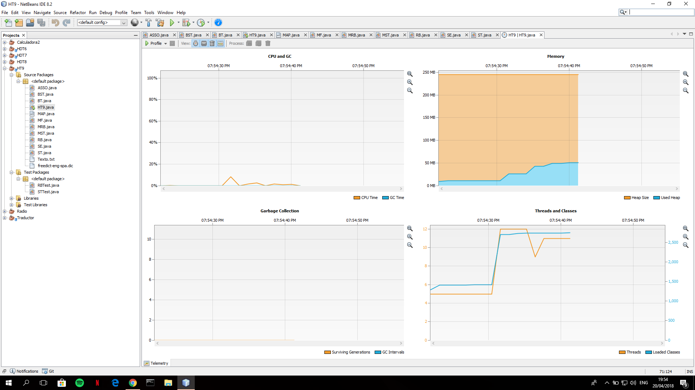

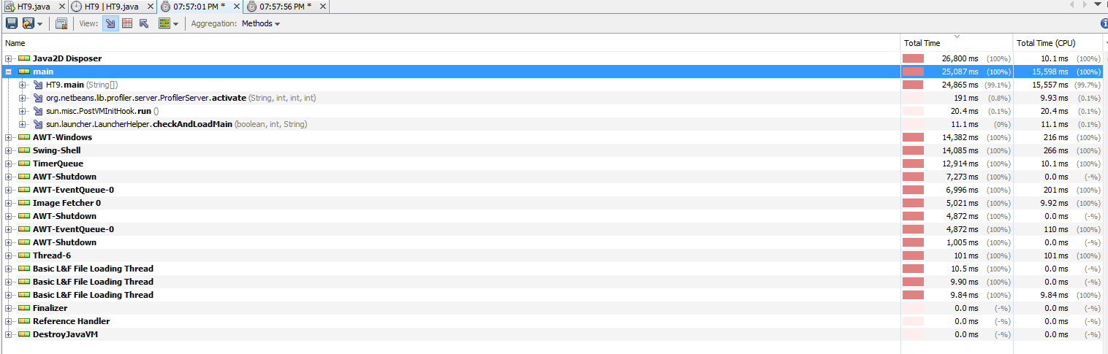

SPLAY TREE

