How to push code to Repo:
Fork the repo:
  - Click on Fork. If not create “ create a new one” Else use existing
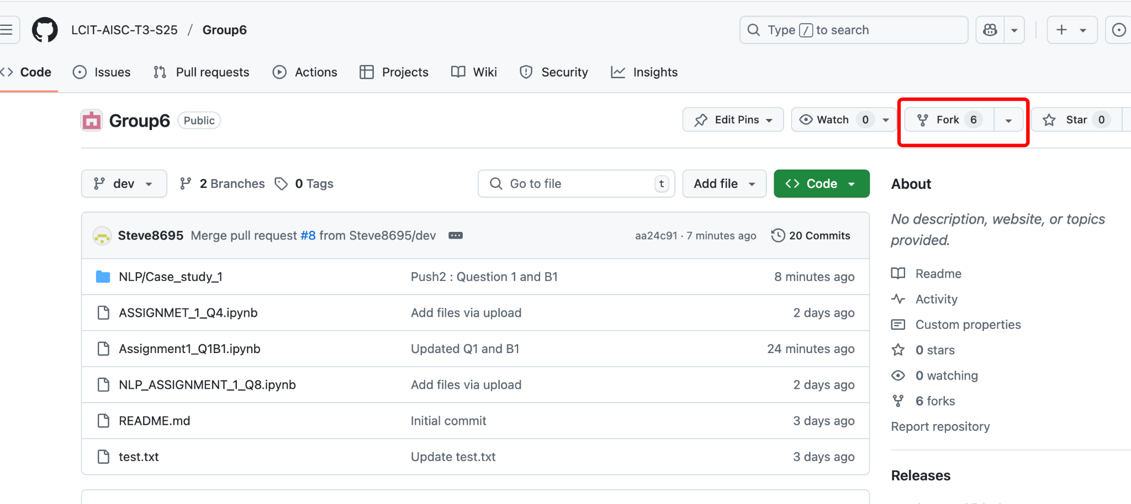
  - 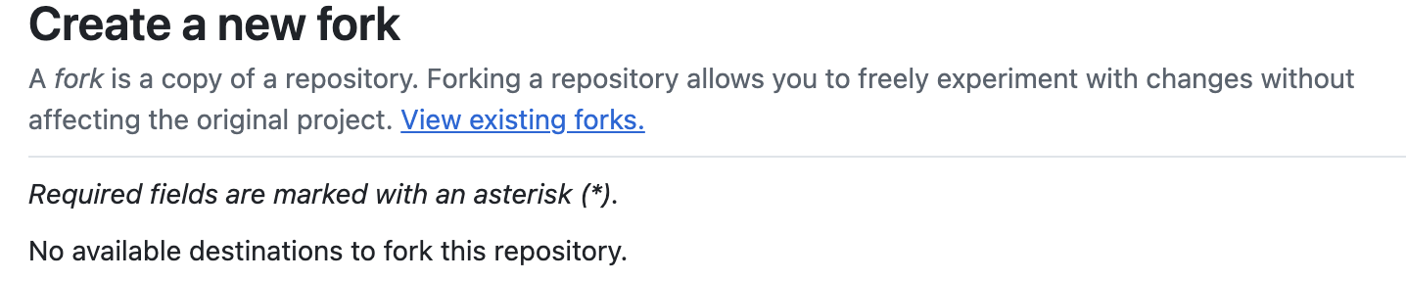
  - If using existing always “Sync Fork” to get the recent changes in the repo
  - 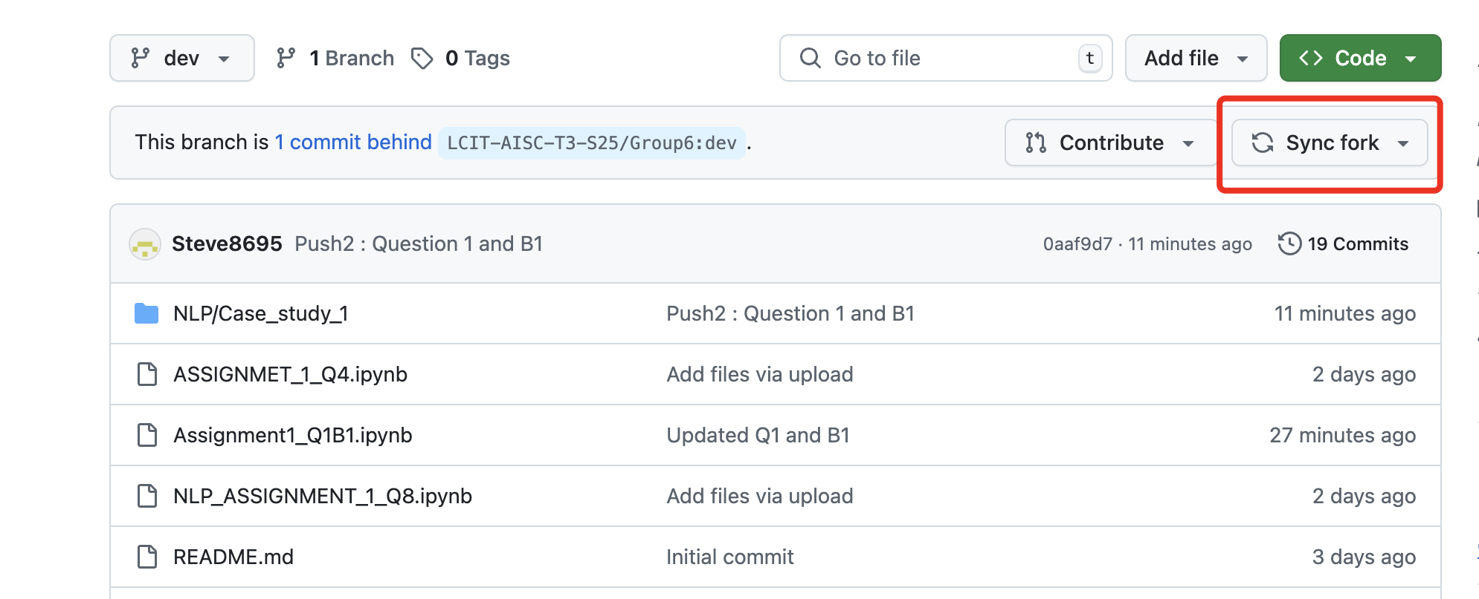
Once you synced the changes Push the code under respective repo (i.e for case Study1 push under NLP/Case_study_1.

Note: This will be the format carried out for all the respective courses.

