Filtering and Faceting Research

Basic Concept of Elastic Search Video:
https://www.youtube.com/watch?v=lE2ierfITxw

Other Reference of Basic Concept:
Reference: https://www.educative.io/courses/elasticsearch-fundamentals-indexing-and-querying-data/elasticsearch

What is Elasticsearch?
Elasticsearch is an open-source search engine that provides the ability to store, search, and analyze business data. Whether this data is textual, numerical, geospatial, structured, or unstructured, we can refer to Elasticsearch as a NoSQL database because it stores data in an unstructured (JSON) way. Still, unlike most NoSQL databases, Elasticsearch focuses more on search capability and the ability to analyze data using aggregation queries.
Elasticsearch was developed using the Java programming language with the help of the Lucene library. It contains built-in RESTful APIs that help send and respond to requests.

Why use Elasticsearch?
Firstly, the most important feature that Elasticsearch provides is the ability to efficiently apply full-text search on a large volume of data, as compared to relational and non-relational databases, which do not provide an efficient way to use this search technique.
Full-text search is a technique that searches for documents or databases, not only for titles but also for content, and returns the result based on a score that attaches to each document. For example, if we search for the word “science” in an article dataset, the full-text search will return articles that contain the word “science,” words that have a similar meaning to “science,” and articles that contain words closely matching it.
Here are other reasons for using the Elasticsearch datastore:
- It has a high-performance, scalable, and distributed architecture that helps perform speedy search requests on a large volume of data.
- Elasticsearch allows us to search for various data types such as textual, numerical, geospatial (GeoQuery), structured, and unstructured data types.
- Elasticsearch provides aggregation requests that help us explore trends and patterns in our data.
- It provides the ability to handle typos in the search.
Press+to interact

Uses of Elasticsearch
Elasticsearch is mainly used for the following two reasons:
- Search: Elasticsearch’s full-text search functionality makes it an excellent choice for many companies to use it as a search engine. Elasticsearch can be used to power searches on websites and perform a Google-like search for a website’s content. Companies like Amazon, GitHub, and Stack Overflow use Elasticsearch on their platform to power their search results. Additionally, Elasticsearch provides a feature called fuzzy search that allows us to find an instance that approximately matches the searched text. This helps Elasticsearch handle user typos in the search.
- Analytics: Elasticsearch can perform real-time analytics on large volumes of data. It offers aggregation capabilities, such as histograms, statistical summaries, and geospatial analysis, which can be used to extract insights from data.

Many companies use Elasticsearch for search and analytic tasks. Here are some of them:
- LinkedIn: LinkedIn uses Elasticsearch to index and search its extensive database of user profiles and provide real-time analytics for its professional networking platform.
- Netflix: Netflix uses Elasticsearch to power its recommendation engine and provide real-time analytics for its streaming service.
- Wikipedia: Wikipedia uses Elasticsearch to index and search its vast collection of articles and provide real-time website analytics.
- Adobe: Adobe uses Elasticsearch to index and search customer data and provide real-time analytics for its marketing and customer experience management platforms.
- Datadog: Datadog is a company that provides a platform for monitoring and analytics. It uses Elasticsearch to store and analyze metrics data, such as performance and system metrics, and provide real-time analytics capabilities.

Elasticsearch architecture
Elasticsearch is a distributed, open-source search and analytics engine designed for handling large volumes of data. Its unique architecture allows for real-time search and analytics, making it a popular choice for applications such as logging, full-text search, and business intelligence. One of the key features of Elasticsearch’s architecture is its use of a distributed data model, which allows for horizontal scalability and high availability.
Node
A node is a single instance (physical or virtual server) of Elasticsearch, and each node has its unique ID and name. Also, a node belongs to only one cluster.

Elasticsearch node
Cluster
A cluster is a collection of one or multiple nodes distributed across separate machines that work together to accomplish a common goal. Nodes in each cluster are assigned to one or various roles, e.g., holding data.
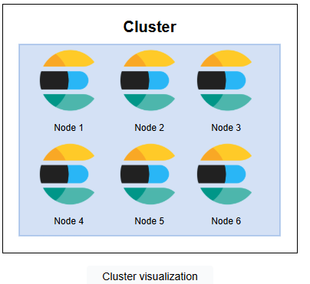
Document

The document is a JSON format object stored in the Elasticsearch index under a unique ID. Here is an example:
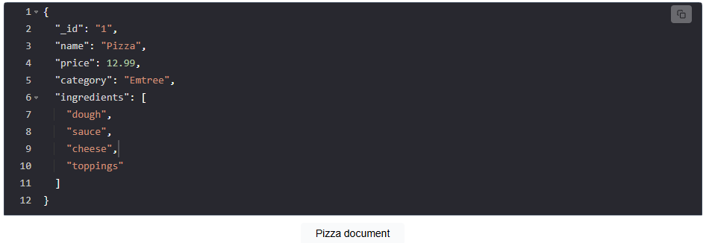
Index
An index is a collection of documents that have similar characteristics. For example, the documents below show dish and actor indices, which have two documents each.
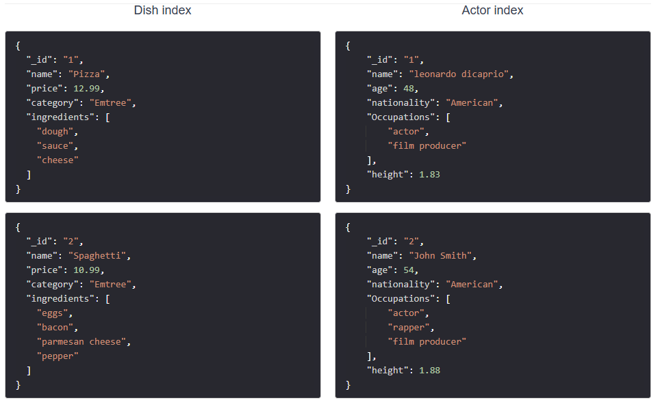

Shard
A shard represents a partition of an index’s data. Each shard contains a subset of the index’s documents and is stored on a single node in the cluster. When we create an index, it is created with one shard by default, but we can configure it to have multiple shards that are distributed across different nodes.
Sharding is the process of dividing an index into smaller parts (shards) and distributing them across nodes in the cluster. This enables Elasticsearch to scale horizontally by adding more nodes to the cluster and allows for parallel processing of search requests across multiple shards.
The visualization below demonstrates the distribution of the dish and actor indices across three shards that are spread across three different nodes.
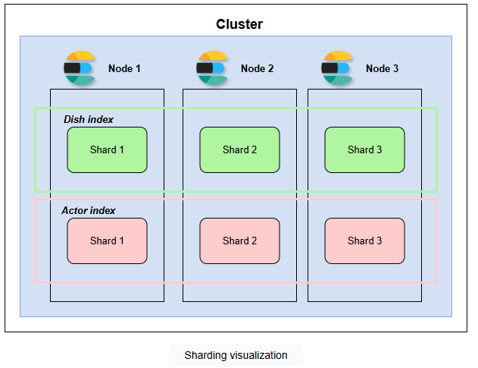
The following are the benefits of using sharding in Elasticsearch:
- Improved performance: By distributing data across multiple shards, search and indexing operations can be parallelized, resulting in improved performance.
- Increased capacity: Sharding allows Elasticsearch to scale horizontally, allowing it to handle larger volumes of data.
- Improved flexibility: Sharding allows Elasticsearch to distribute data across different hardware or infrastructure, providing flexibility in terms of resource allocation.
Replicas
A replica is a copy of a shard. Replicas are used to provide high availability and improve fault tolerance. When a shard has one or more replicas, if the primary shard fails or becomes unavailable, one of the replicas can be promoted to primary to ensure that the index remains available for search and indexing operations.
Replicas can also be used to scale search performance. For example, when a search request is made, it can be executed on all shards (including replicas) in parallel, which improves search performance.
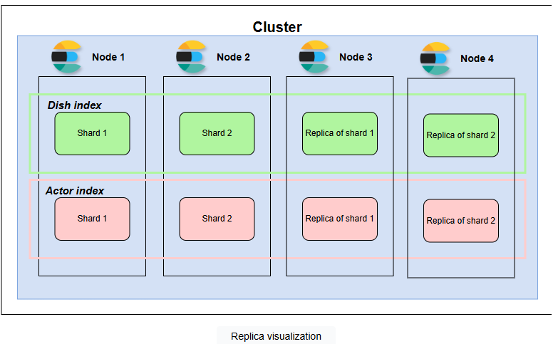

Elasticsearch vs. RDBMS
There are some similarities between Elasticsearch and traditional databases (RDBMS). The following points explain the similarities and differences between Elasticsearch and RDBMS terms:
- Cluster vs. database: In RDBMS, databases are used interchangeably and represent a set of schemas and several tables. In Elasticsearch, the set of indices available is grouped in a cluster.
- Index vs. table: The table is a collection of rows. On the other hand, an index is a collection of documents.
- Document vs. row: Documents and rows represent data stored in the index and table, respectively. Rows tend to be more restricted, but documents are more flexible.
- Field vs. column: Both fields and columns represent individual data attributes within a structured data model.
- Shard: This is the same in both Elasticsearch and RDBMS.
- Replica: This is the same in both Elasticsearch and RDBMS.

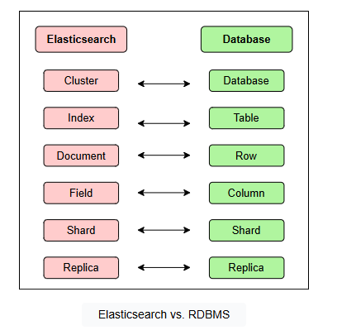

Using Chatgpt for examples with fundamentals and code.

Prompt:
How can i use faceting and filtering in my job application Applicant dashboard?

Faceting and filtering are essential techniques in dashboards—especially in a Job Application Applicant Dashboard—to help users easily explore, narrow down, and understand large volumes of data. Here's how you can use both effectively:

✅ 1. What is Faceting?
Faceting means breaking data into multiple views based on a field (like job title, location, company, status, etc.). It allows users to see counts and categories at a glance.
🔧 Example Use Cases:
- Job Status Facets: Show counts of jobs by status (e.g., Applied: 12, Interview: 3, Rejected: 5)
- Location Facets: Group jobs by location (e.g., Toronto: 15, Remote: 8)
- Company Facets: Show which companies you've applied to the most
🔍 UI Components:
- Sidebar or top bar with multi-selectable checkboxes
- Bar charts or donut charts showing category proportions

✅ 2. What is Filtering?
Filtering allows users to narrow the visible data based on selected criteria.
🔧 Example Use Cases:
- Filter to see only jobs applied in the last 30 days
- Filter by job title containing "Data Analyst"
- Filter by application status (e.g., only Pending or Interview)
- Filter by salary range or application source (e.g., LinkedIn, Indeed)
🔍 UI Components:
- Dropdowns
- Sliders (for salary or date range)
- Search bars (for keywords like company or job title)
- Toggle buttons (e.g., Remote only)

🧠 Integration Ideas for Your Dashboard
Let’s say you are using Streamlit (based on your JobMate project):
🖼️ Dashboard UI

import streamlit as st
import pandas as pd

# Load your application data (assumed to be from MongoDB or CSV)
df = pd.read_csv("applications.csv") # Replace with MongoDB fetch

# Sidebar filters (Facets)
status = st.sidebar.multiselect("Filter by Status", df["status"].unique())
location = st.sidebar.multiselect("Filter by Location", df["location"].unique())
company = st.sidebar.multiselect("Filter by Company", df["company"].unique())

# Keyword search
search_keyword = st.sidebar.text_input("Search by Job Title")

# Apply filters
filtered_df = df[
(df["status"].isin(status) if status else True) &
(df["location"].isin(location) if location else True) &
(df["company"].isin(company) if company else True) &
(df["job_title"].str.contains(search_keyword, case=False) if search_keyword else True)
]

st.dataframe(filtered_df)

📊 Bonus: Use Elasticsearch for Advanced Faceting/Filtering
If your data grows large:
- Store applications in Elasticsearch
- Use Elasticsearch aggregations for dynamic facets
- Streamlit + Elasticsearch + Facets = lightning-fast filtering

🎯 Benefits to Applicants
- ✅ Easily track application status
- ✅ Discover top companies or job types applied to
- ✅ Quickly locate jobs with high priority (e.g., interviews)
- ✅ Monitor application patterns and improve strategy

If you're using MongoDB, I can show you how to implement faceting using aggregation pipelines. Want that example too?

Great! Here’s how you can implement faceting and filtering using MongoDB aggregation pipelines for your Job Application Applicant Dashboard (especially useful if you’re using pymongo in Python or MongoDB Atlas).

🗂️ Use Case Scenario
Let’s say your MongoDB collection looks like this:
{
"job_title": "Data Analyst",
"company": "Amazon",
"location": "Toronto",
"status": "Interview",
"source": "LinkedIn",
"date_applied": ISODate("2025-06-01")
}

✅ Goal: Use MongoDB Faceting and Filtering
- Show counts by status, location, and company (facets)
- Allow filtering by date, status, location, keyword, etc.

🧩 MongoDB Aggregation Pipeline Example (with Faceting)
from pymongo import MongoClient
from datetime import datetime

client = MongoClient("mongodb://localhost:27017") # or Atlas URI
db = client["jobmate"]
applications = db["applications"]

# Filter parameters from UI
status_filter = ["Interview", "Pending"]
location_filter = ["Toronto"]
search_keyword = "Analyst"
date_from = datetime(2025, 5, 1)

# Aggregation pipeline
pipeline = [
{
"$match": {
"status": {"$in": status_filter},
"location": {"$in": location_filter},
"date_applied": {"$gte": date_from},
"job_title": {"$regex": search_keyword, "$options": "i"}
}
},
{
"$facet": {
"by_status": [{"$group": {"_id": "$status", "count": {"$sum": 1}}}],
"by_location": [{"$group": {"_id": "$location", "count": {"$sum": 1}}}],
"by_company": [{"$group": {"_id": "$company", "count": {"$sum": 1}}}],
"applications": [{"$limit": 100}] # to display in the table
}
}
]

results = list(applications.aggregate(pipeline))[0]

# results["by_status"] will contain counts by status
# results["applications"] contains filtered job apps

📊 Sample Output Structure
{
"by_status": [
{"_id": "Interview", "count": 3},
{"_id": "Pending", "count": 2}
],
"by_location": [
{"_id": "Toronto", "count": 5}
],
"by_company": [
{"_id": "Amazon", "count": 2},
{"_id": "Google", "count": 1}
],
"applications": [ ... full docs here ... ]
}

🎨 Integration with Streamlit

import streamlit as st
import pandas as pd

# Display facets
st.sidebar.markdown("### Job Application Filters")
st.sidebar.write("Status", results["by_status"])
st.sidebar.write("Location", results["by_location"])
st.sidebar.write("Company", results["by_company"])

# Display filtered applications
df_apps = pd.DataFrame(results["applications"])
st.dataframe(df_apps)

✅ Benefits of MongoDB Faceting
- 🔥 Real-time insights without multiple round trips
- 📊 Helps build powerful dashboards like in ATS systems
- 🧠 Can be expanded to include salary, industry, etc.

Prompt:
apply elastic search too
Perfect! Let’s now integrate Elasticsearch for powerful faceting + filtering in your Job Application Applicant Dashboard.

🧠 Why Elasticsearch?
Elasticsearch is a full-text search engine and analytics powerhouse. It’s ideal for:
- 🔍 Fast keyword search (e.g., job title, company)
- 📊 Real-time faceting (aggregations)
- ⚡ Filtering large datasets instantly

🔧 Setup Assumptions
- Your job applications are indexed in Elasticsearch (index: applications)
- You're using Python + elasticsearch client
- Each job document contains:

{
"job_title": "Data Analyst",
"company": "Amazon",
"location": "Toronto",
"status": "Interview",
"source": "LinkedIn",
"date_applied": "2025-06-01"
}

✅ Elasticsearch Query with Filtering + Faceting
from elasticsearch import Elasticsearch

es = Elasticsearch("http://localhost:9200") # or your cloud endpoint

# Define filters
status_filter = ["Interview", "Pending"]
location_filter = ["Toronto"]
search_keyword = "Analyst"

query_body = {
"query": {
"bool": {
"must": [
{"match": {"job_title": search_keyword}},
{"terms": {"status.keyword": status_filter}},
{"terms": {"location.keyword": location_filter}}
]
}
},
"aggs": {
"by_status": {"terms": {"field": "status.keyword"}},
"by_location": {"terms": {"field": "location.keyword"}},
"by_company": {"terms": {"field": "company.keyword"}}
},
"size": 100 # Limit number of results shown
}

response = es.search(index="applications", body=query_body)

# Extract results
hits = [hit["_source"] for hit in response["hits"]["hits"]]
by_status = response["aggregations"]["by_status"]["buckets"]
by_location = response["aggregations"]["by_location"]["buckets"]
by_company = response["aggregations"]["by_company"]["buckets"]
📊 Streamlit Integration Example
import streamlit as st
import pandas as pd

# Show Facets
st.sidebar.subheader("Status Breakdown")
for b in by_status:
st.sidebar.write(f"{b['key']}: {b['doc_count']}")

st.sidebar.subheader("Location Breakdown")
for b in by_location:
st.sidebar.write(f"{b['key']}: {b['doc_count']}")

st.sidebar.subheader("Company Breakdown")
for b in by_company:
st.sidebar.write(f"{b['key']}: {b['doc_count']}")

# Show Filtered Results
df = pd.DataFrame(hits)
st.dataframe(df)

🎁 Bonus: Add Auto-Suggest and Date Filters
You can extend the query to support:
- 🔎 Auto-suggest using completion field
- 📆 Date filtering using range on date_applied
- 🧲 Fuzzy search (for typos)

✅ Summary of Tech Stack
Feature | MongoDB | Elasticsearch
Simple CRUD + Schema | ✅ Excellent | ❌ Not ideal
Filtering | ✅ Efficient | ✅ High speed
Faceting | ✅ via Aggregations | ✅ via Aggregations
Full-text Search | ❌ Basic | ✅ Industry Standard
Scalable for Search | ❌ Medium | ✅ Very High

Would you like me to help you write a wrapper class that can toggle between MongoDB and Elasticsearch backend for your app?

Prompt:
update the streamlit integration to flask

Here’s how to update the Streamlit dashboard integration to a Flask web app that uses Elasticsearch for faceting and filtering your Job Application Applicant Dashboard.

✅ Flask + Elasticsearch Dashboard
🧱 Project Structure
job_dashboard/
├── app.py
├── templates/
│ └── dashboard.html
└── requirements.txt

📦 requirements.txt
Flask
elasticsearch
pandas
Install via:
pip install -r requirements.txt

🔧 app.py (Flask Backend)
from flask import Flask, render_template, request
from elasticsearch import Elasticsearch
import pandas as pd

app = Flask(__name__)
es = Elasticsearch("http://localhost:9200") # Use your Elastic URL if hosted

@app.route("/", methods=["GET", "POST"])
def dashboard():
# Default filters
keyword = request.form.get("keyword", "")
status_filter = request.form.getlist("status")
location_filter = request.form.getlist("location")

# Elastic Query
query_body = {
"query": {
"bool": {
"must": [
{"match": {"job_title": keyword}} if keyword else {"match_all": {}},
{"terms": {"status.keyword": status_filter}} if status_filter else {"match_all": {}},
{"terms": {"location.keyword": location_filter}} if location_filter else {"match_all": {}}
]
}
},
"aggs": {
"by_status": {"terms": {"field": "status.keyword"}},
"by_location": {"terms": {"field": "location.keyword"}},
"by_company": {"terms": {"field": "company.keyword"}}
},
"size": 100
}

# Fetch from Elasticsearch
response = es.search(index="applications", body=query_body)
hits = [hit["_source"] for hit in response["hits"]["hits"]]
df = pd.DataFrame(hits)

# Facet data
facets = {
"status": response["aggregations"]["by_status"]["buckets"],
"location": response["aggregations"]["by_location"]["buckets"],
"company": response["aggregations"]["by_company"]["buckets"]
}

return render_template("dashboard.html", data=df.to_dict(orient="records"), facets=facets,
selected_status=status_filter, selected_location=location_filter, keyword=keyword)

if __name__ == "__main__":
app.run(debug=True)

🎨 templates/dashboard.html (Jinja Template)
<!DOCTYPE html>
<html>
<head>
<title>Applicant Dashboard</title>
<style>
body { font-family: Arial; padding: 20px; }
.facet { margin-bottom: 20px; }
table, th, td { border: 1px solid black; border-collapse: collapse; padding: 5px; }
</style>
</head>
<body>

<h2>Job Application Dashboard</h2>

<form method="post">
<input type="text" name="keyword" placeholder="Search Job Title" value="{{ keyword }}">

<div class="facet">
<strong>Status:</strong><br>
{% for s in facets.status %}
<label>
<input type="checkbox" name="status" value="{{ s.key }}" {% if s.key in selected_status %}checked{% endif %}>
{{ s.key }} ({{ s.doc_count }})
</label><br>
{% endfor %}
</div>

<div class="facet">
<strong>Location:</strong><br>
{% for loc in facets.location %}
<label>
<input type="checkbox" name="location" value="{{ loc.key }}" {% if loc.key in selected_location %}checked{% endif %}>
{{ loc.key }} ({{ loc.doc_count }})
</label><br>
{% endfor %}
</div>

<button type="submit">Apply Filters</button>
</form>

<hr>

<h3>Filtered Job Applications</h3>
<table>
<thead>
<tr>
<th>Job Title</th><th>Company</th><th>Location</th><th>Status</th><th>Date Applied</th>
</tr>
</thead>
<tbody>
{% for row in data %}
<tr>
<td>{{ row.job_title }}</td>
<td>{{ row.company }}</td>
<td>{{ row.location }}</td>
<td>{{ row.status }}</td>
<td>{{ row.date_applied }}</td>
</tr>
{% endfor %}
</tbody>
</table>

</body>
</html>

🚀 Run Your Flask App
python app.py
Visit: http://localhost:5000

🧠 Next Enhancements
- Add date range filter
- Add company filter
- Add pagination or export to Excel
- Switch between MongoDB and Elasticsearch as data source

Would you like a MongoDB version of this Flask dashboard too for fallback or hybrid use?

