LUTHERAN CHURCH IN MALAYSIA · LCM FINANCE
For a Signing Officer
Bishop, Treasurer or Secretary. A voucher reaches you once the ministry has verified it, Finance has reviewed it and the General Manager has approved it — so what is in front of you is only ever waiting on your signature.
Contents
Right-click here and choose Update Field to build the contents.

Getting in
The app lives at one address. There is no password to remember and none to lose — you sign in either with your church Google account, or with a link emailed to you.
finance-pv.vercel.app
Open it in any browser, on a phone or a computer. Bookmark it the first time and you will not have to type it again.
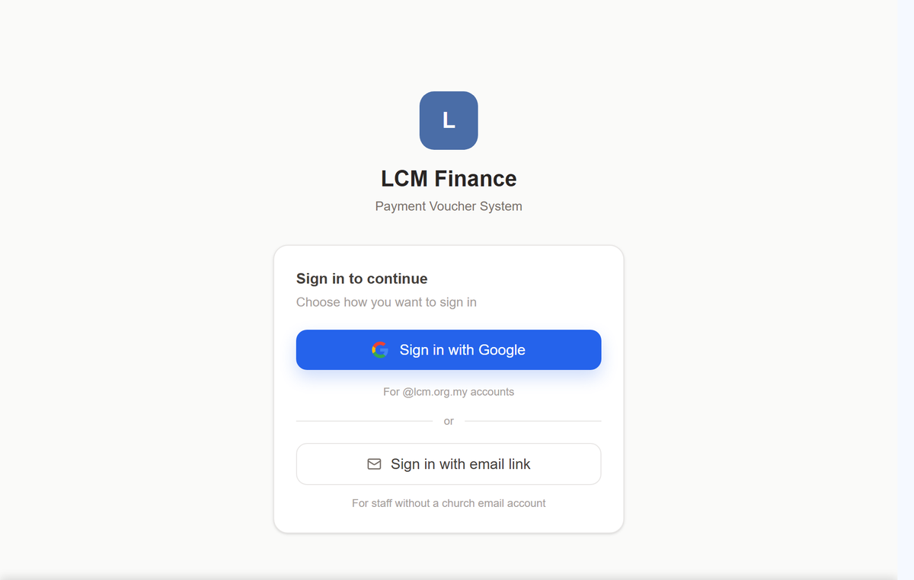
The sign-in screen. Which button is yours depends only on whether the church has given you an @lcm.org.my mailbox.
1 Sign in with Google — if you have an @lcm.org.my address. One tap, the same as opening your church email. Nothing to type.
2 Sign in with email link — if you do not. Type the address the church holds for you, and a link arrives in your inbox. Click it and you are in. The link is yours alone and stops working once used, so do not forward it.
Nothing arrives? Check that the address the church has for you can actually receive email. A mailbox that was never really set up is the usual reason a link never comes — ask the HQ office to correct it, rather than asking for the link again.

The first time
You do not create an account and you do not wait for one. Sign in, and the system records your address as a Guest — enough to claim money back and to read the church directory. Your proper role is set by the HQ office, usually the same day. If the app looks emptier than this guide describes, that is why: ask them to set your role, then sign in again.

Finding your way
Everything is reached from the list down the left. On a phone it is behind the menu button at the top.
The few things you do most often sit at the top of that list, not nested inside anything, so they are one tap from wherever you are. Everything else is grouped: open a group and its pages appear underneath it.
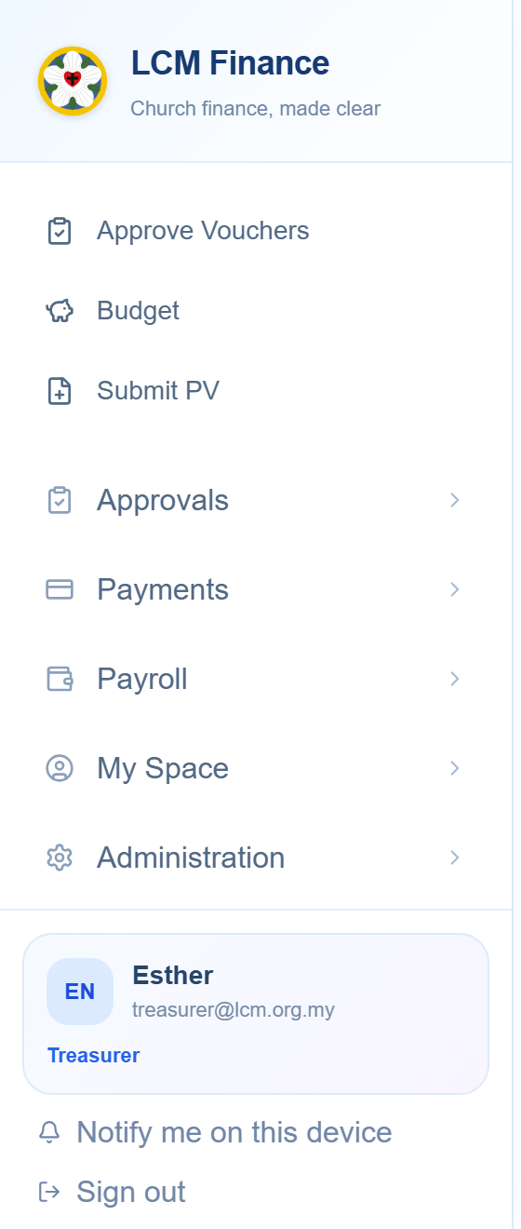
You will not see every group in this picture. The list is built from what your role may do, so what is missing is simply not yours.
Your name is at the foot of that list, with your role under it. If the role shown there is wrong, nothing else in the app will behave the way this guide describes — check it first, and ask the HQ office to correct it.

Signing a voucher
Open Approve Vouchers, at the top of the left-hand list. What is there is waiting on your signature and nothing else.
You will not see a voucher that is still with the ministry, with Finance or with the General Manager. By the time one reaches you it has been verified by the EXCO, reviewed by Finance and approved by the General Manager — and the voucher itself shows you each of those, with the name and the date.
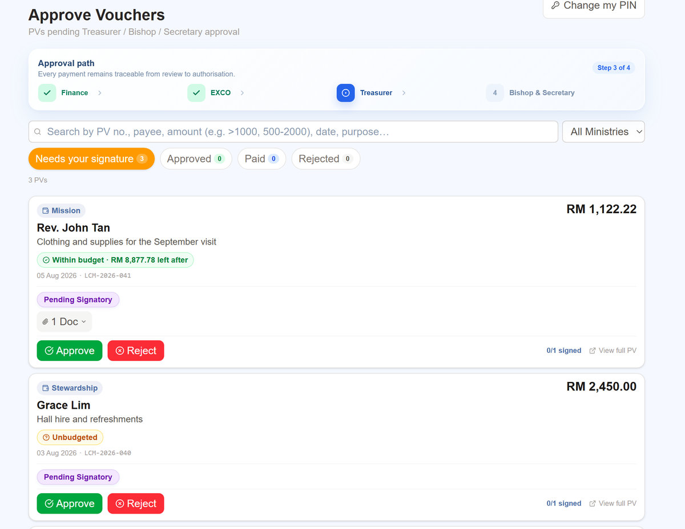
Four tabs, each with a count. The band across the top says how far a voucher has come and what is left — here, step 3 of 4. Everyone in this picture is invented.
- Read the purpose and the amount, and open the receipts with the Docs button if you want to see them.
- Check the budget. The green or amber chip says whether it fits — tap it and it opens, naming the exact budget line and showing what is approved, what is spent, what is committed and what would be left if you sign.
- Approve or reject. Both ask for your PIN. A rejection asks for a reason, which goes back to whoever raised it.

How many signatures
Up to RM30,000 the Treasurer alone is enough. Above that it takes two officers, any two of the Bishop, the Secretary and the Treasurer. The voucher tells you which it is and how many signatures it already has.
Nobody signs their own payment. If a voucher pays you, or you were the one who raised it, the app will not offer you the buttons — another officer signs it instead. That is not a fault.

Your PIN
Signing asks for a four-digit PIN that is yours alone. Set it, or change it, from Change my PIN at the top right of the same page. It is deliberately separate from how you sign in: signing in says who you are, and the PIN says you meant it.

Approving leave
Open Approve Leave, at the top of the left-hand list. What is waiting on you is at the top; what is waiting on somebody else is below it, so you can see where an application has got to without it being your turn.
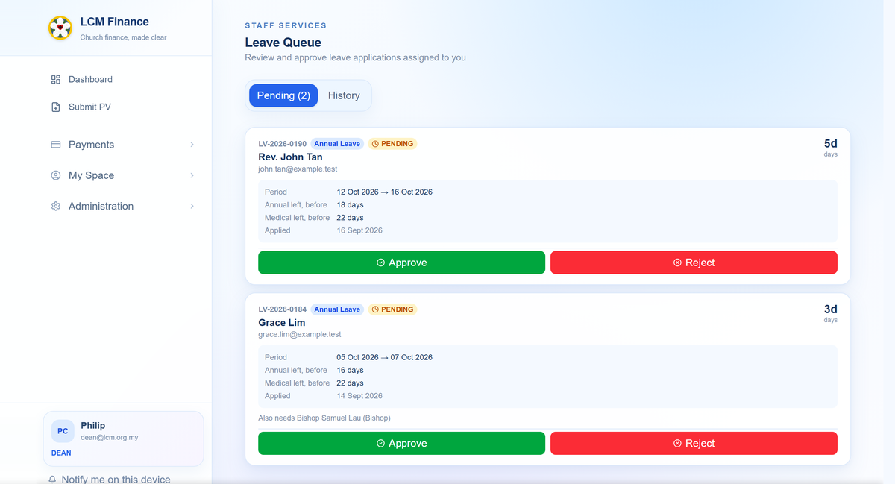
The queue an approver sees. Everyone in this picture is invented.
- Open the application. It shows the dates, the reason, the balance the person had when they applied, and the chain of who must sign.
- Sign it — with your finger or your mouse — or reject it with a reason.

The order matters
Leave is signed in order, not all at once. Office staff go to the General Manager first and then to the Bishop; a pastor goes to their Pastor in Charge and then the Dean; a head pastor to the Dean and then the Bishop; a Dean to the Bishop alone.
If it is not your turn yet the application will say so and the buttons will not be there. Nothing is lost — you will be emailed when it reaches you.
Nobody approves their own leave, whatever office they hold. The chain skips you and goes to the person above.

The budget
Open Budget. You see the ministries you are entitled to see — your own, or all of them.
Each ministry’s budget is a list of lines, one per project or activity. For each line: what was approved, what has been spent, what is committed but not yet paid, and what is left. The colour is a quick read — green has room, amber is close, red is over.
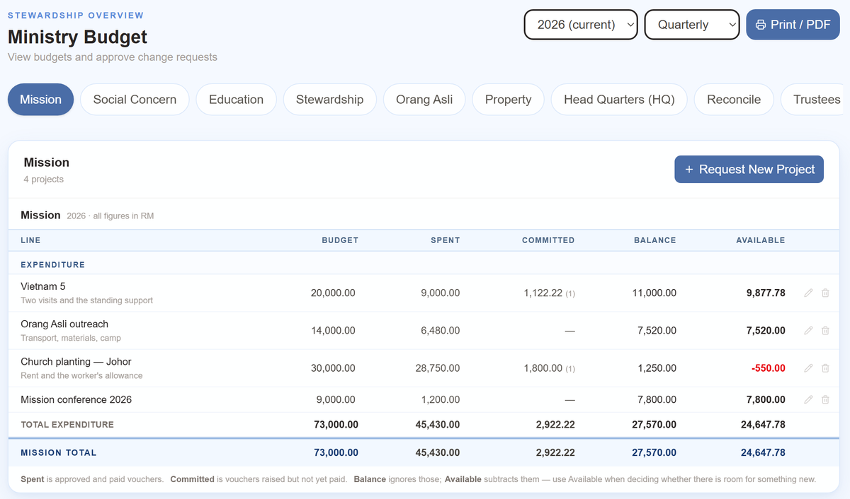
One row per project. Balance ignores what is committed; Available subtracts it, which is the figure to use when deciding whether there is room for something new. Church planting here has RM1,250 left on paper and is RM550 short once the voucher already in the chain is counted. Every figure in this picture is invented.
A voucher is tied to a budget line by its project name. That is why the ministry and project on a claim matter: a claim with no project is spending the budget cannot see, and it will show as Unbudgeted wherever it appears.

Approving a budget
A ministry’s proposed budget, and its requests to amend one during the year, come to the Treasurer.
Open Budget. Proposals waiting on a decision are listed at the top, whatever ministry they come from, so you do not have to go looking ministry by ministry.
- Read the lines and the papers attached to them.
- Approve the budget, and it becomes the figures everybody else sees; or send it back with a reason, and the ministry revises it.
An amendment asked for mid-year works the same way, and says what is being changed and why. Until you approve it, the ministry’s page keeps showing the figures that were agreed — a request does not quietly become a budget.

Claiming money back
Anyone can be owed money by the church — a volunteer who bought refreshments, a pastor who paid for petrol. Claiming is not something only staff may do, so Submit PV is in everybody’s list.
- Open Submit PV, at the top of the left-hand list.
- Say which ministry it belongs to. This is the field people get wrong. It decides whose budget the money comes out of and who has to verify it, so if you are unsure, ask that ministry’s EXCO Member before you send it.
- Say what it is for, in a few plain words. “Petrol, Orang Asli outreach, 12–14 Sept” is a good purpose. “Claim” is not.
- Add each item and its amount. The total adds itself — do not type it.
- Attach the receipts. Photograph them with your phone; the form takes pictures as readily as files. A claim without receipts comes back to you.
- Say how you want to be paid, and check the account number twice. That is the figure hardest to put right once the money has gone.
- Sign at the bottom with your finger or your mouse, and send it.
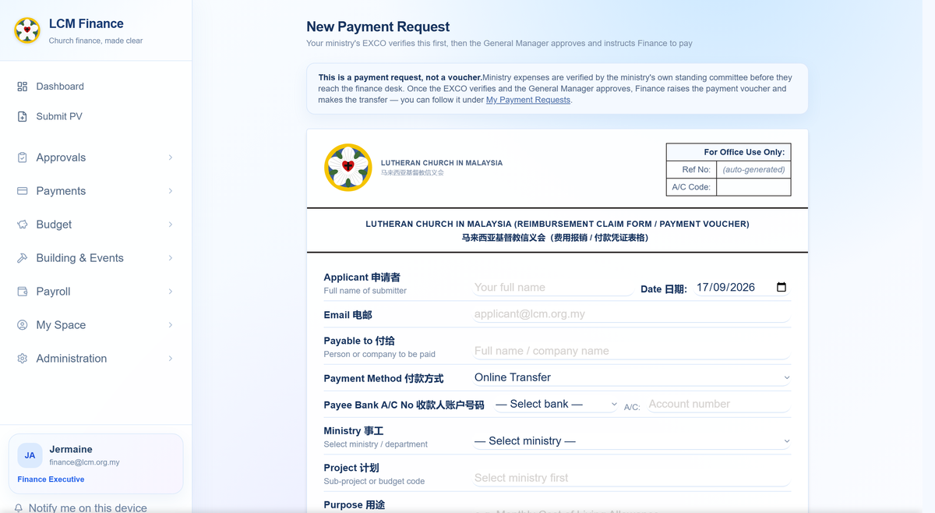
The form on a computer. On a phone it becomes one column with the same fields in the same order — nothing is left out of the small version.

What happens after you send it
You do not have to chase it. The claim goes to the ministry’s EXCO Member, then to Finance, then to the General Manager, then to the officers who sign. You can see where it has reached at any time under My Submissions, and whoever it is waiting on is named there.
You will be told, not left wondering. Each step emails you as it happens. If a claim is sent back, the reason is on it — correct that one thing and send it again rather than starting afresh.

The church directory
Who the pastors are, which congregation sits in which district, and who currently holds each office.
Open The Church in the left-hand list, then Church Directory for the districts and congregations, or Elected Offices for who holds what. Both are there to be read; neither asks anything of you.
Something out of date? Tell the HQ office rather than working around it. The directory is what the app uses to decide who approves your leave and where a claim is routed, so a wrong entry there quietly sends things to the wrong person.

Applying for leave
Open My Space → My Leave. Your balance is on the first tab; applying is on the second.
- Check the balance first. It shows what you are entitled to this year, what you have taken and what is left, for each kind of leave.
- Choose the kind of leave and the dates. The number of days works itself out; you do not count them.
- Say why, briefly. For medical leave, attach the certificate.
- Sign at the bottom and send it.
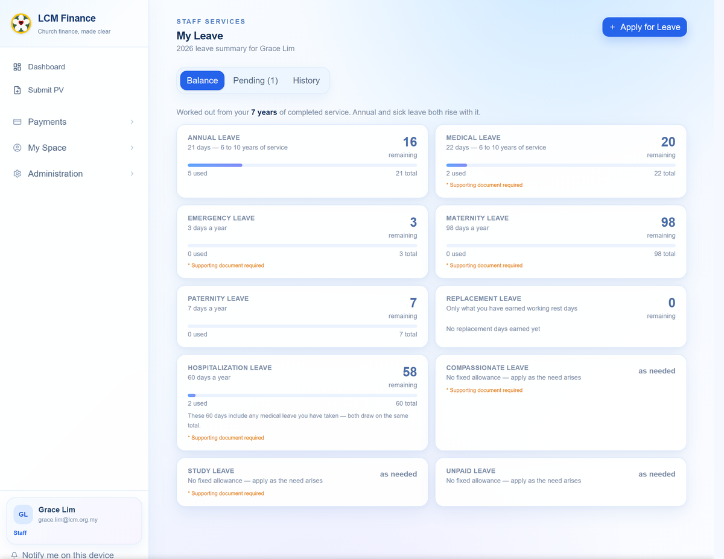
Everyone in this picture is invented. Your own balances are private to you and to those who approve your leave.

Who has to sign
The form tells you before you send it, and the application tells you afterwards how far it has got — who has signed, and who it is now waiting on.
Annual leave is asked for seven days ahead. That is the church’s rule, not the app’s; it will let you apply later than that, and the person approving it will see that you did.

Your payslip
My Space → My Salary. Every month the church has paid you, with the payslip for each.
Open a month to see what made it up — basic pay, allowances, EPF, SOCSO and the rest — and download the payslip as a PDF if you need it for a bank or a landlord.
Only you see this. Your pay is not visible to your EXCO Member, to the signing officers, or to anyone else who happens to be senior to you. If a figure looks wrong, the Finance Executive is the person to ask.

If something is not right
Three things go wrong often enough to be worth saying plainly.

The app shows less than this guide describes
Your role is probably not set yet, or is set to the wrong one. Your name and role are at the foot of the left-hand list. Ask the HQ office to correct it, then sign in again.

You pressed save and nothing happened
Tell somebody rather than pressing it again. A save that does not happen, with no error, usually means the record is not yours to change — and it is worth knowing about rather than working around.

Something has been waiting for days
Open it. Whatever it is waiting on is named on the item itself, with the step it has reached. For a payment request there is a Remind button that emails the person it is sitting with — use it rather than wondering.
The whole system, in one document. This guide covers your part of it. The full LCM Finance Handbook describes everything — every role, every stage, the rules behind the approval limits — and the HQ office can send it to you.

Prepared for the Lutheran Church in Malaysia. This guide covers signing payment vouchers, and the budget line behind each one — the rest of the system is in the full LCM Finance Handbook, which the HQ office can send you. Anything unclear here is worth saying so: a step that needed explaining twice is a step written badly.

