LUTHERAN CHURCH IN MALAYSIA · LCM FINANCE & HR
For the Building & Event Manager

Getting in
finance-pv.vercel.app
Open it in any browser, on a phone or a computer. Bookmark it the first time and you will not have to type it again.
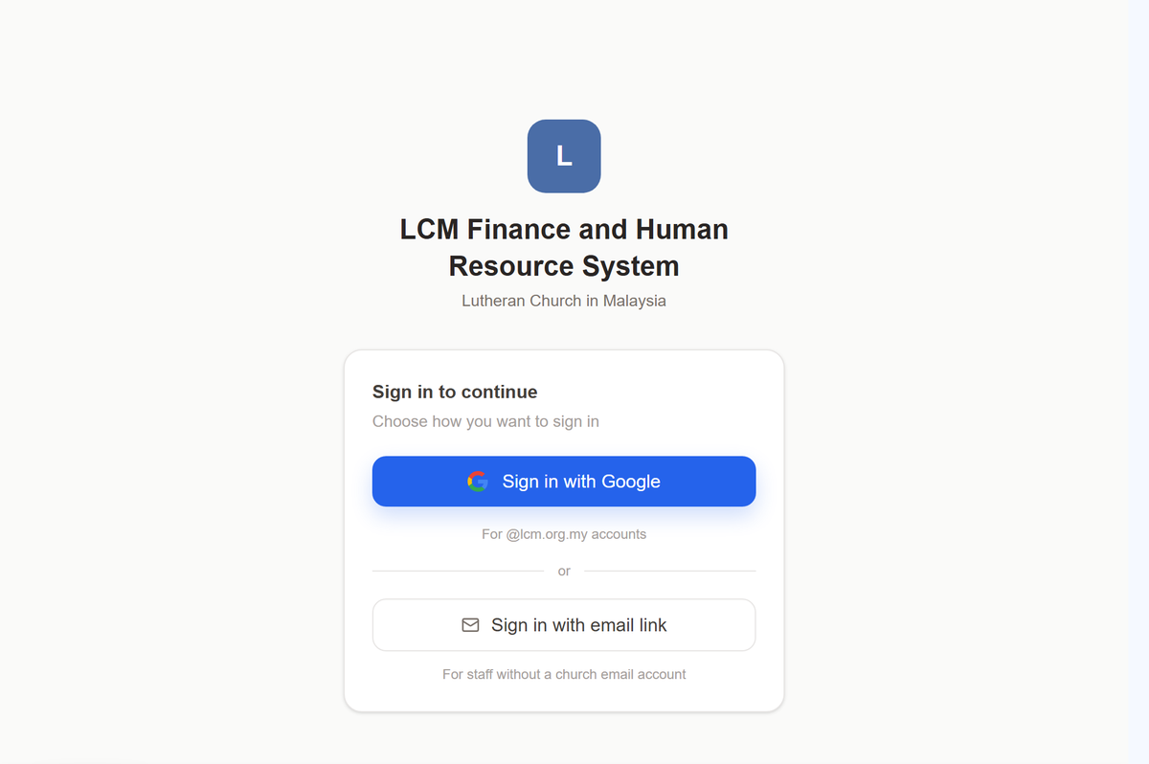
This is what you will see.
- Press Sign in with Google.
One tap, the same as opening your church email. Nothing to type.
- Use your @lcm.org.my Google account.
That is the address the church knows you by, and the one your approvals are recorded against.
No @lcm.org.my address? Contact the LCM team and they will grant access to the personal email address you prefer to sign in with. This is usually the case for volunteers, who serve the church without being employed by it. Once they have granted it, sign in with Google using that address.

If the app looks emptier than this guide describes
Your role has not been set yet. Signing in gets you through the door; what you may do once inside is recorded by the HQ office, usually the same day. Ask them to set it, then sign in again.

Finding your way
Everything is reached from the list down the left. On a phone it is behind the menu button at the top.
The few things you do most often sit at the top of that list, not nested inside anything, so they are one tap from wherever you are. Everything else is grouped: open a group and its pages appear underneath it.
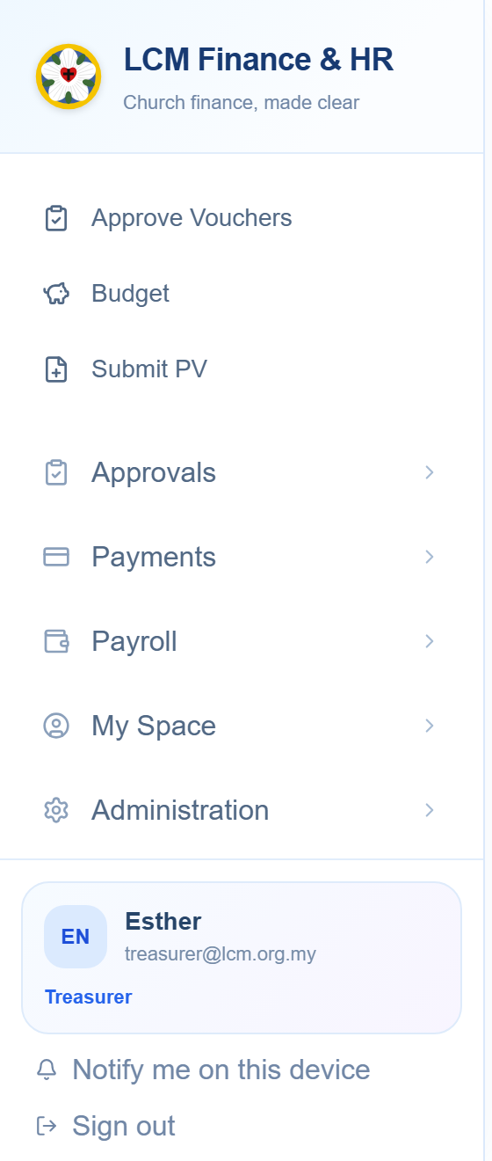
You will not see every group in this picture. The list is built from what your role may do, so what is missing is simply not yours.
Your name is at the foot of that list, with your role under it. If the role shown there is wrong, nothing else in the app will behave the way this guide describes — check it first, and ask the HQ office to correct it.

Building and event vouchers
The property side has its own entries, under Building & Events in the left-hand list.

A BAM voucher goes to the BAM Committee rather than to a ministry EXCO, and then follows the same path as any other: Finance, the General Manager, the signing officers.

Claiming money back
Anyone can be owed money by the church — a volunteer who bought refreshments, a pastor who paid for petrol. Claiming is not something only staff may do, so Submit PV is in everybody’s list.
- Open Submit PV, at the top of the left-hand list.
- Say which ministry it belongs to. This is the field people get wrong. It decides whose budget the money comes out of and who has to verify it, so if you are unsure, ask that ministry’s EXCO Member before you send it.
- Say what it is for, in a few plain words. “Petrol, Orang Asli outreach, 12–14 Sept” is a good purpose. “Claim” is not.
- Add each item and its amount. The total adds itself — do not type it.
- Attach the receipts. Photograph them with your phone; the form takes pictures as readily as files. A claim without receipts comes back to you.
- Say how you want to be paid, and check the account number twice. That is the figure hardest to put right once the money has gone.
- Sign at the bottom with your finger or your mouse, and send it.
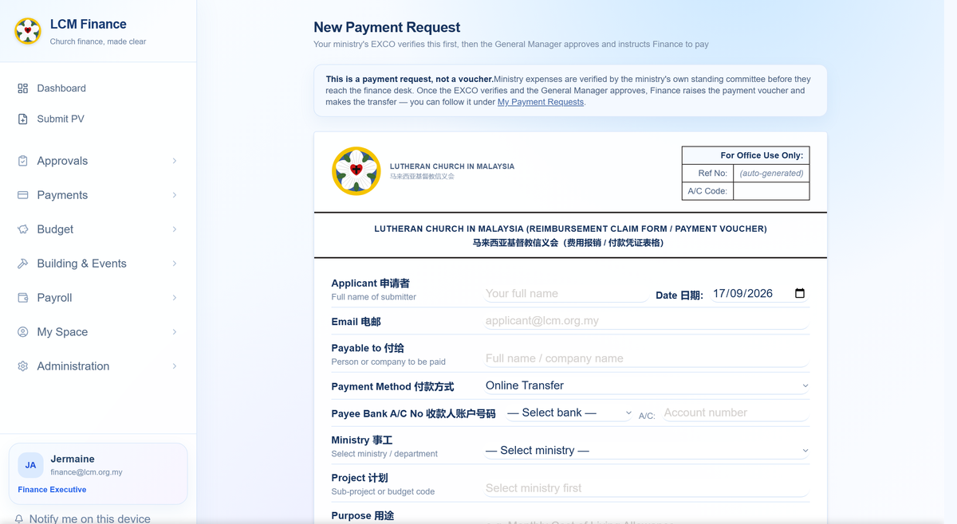
The form on a computer. On a phone it becomes one column with the same fields in the same order — nothing is left out of the small version.

What happens after you send it
You do not have to chase it. The claim goes to the ministry’s EXCO Member, then to Finance, then to the General Manager, then to the officers who sign. You can see where it has reached at any time under My Submissions, and whoever it is waiting on is named there.
You will be told, not left wondering. Each step emails you as it happens. If a claim is sent back, the reason is on it — correct that one thing and send it again rather than starting afresh.

The church directory
Who the pastors are, which congregation sits in which district, and who currently holds each office.
Open The Church in the left-hand list, then Church Directory for the districts and congregations, or Elected Offices for who holds what. Both are there to be read; neither asks anything of you.
Something out of date? Tell the HQ office rather than working around it. The directory is what the app uses to decide who approves your leave and where a claim is routed, so a wrong entry there quietly sends things to the wrong person.

Applying for leave
Open My Space → My Leave. Your balance is on the first tab; applying is on the second.
- Check the balance first. It shows what you are entitled to this year, what you have taken and what is left, for each kind of leave.
- Choose the kind of leave and the dates. The number of days works itself out; you do not count them.
- Say why, briefly. For medical leave, attach the certificate.
- Sign at the bottom and send it.
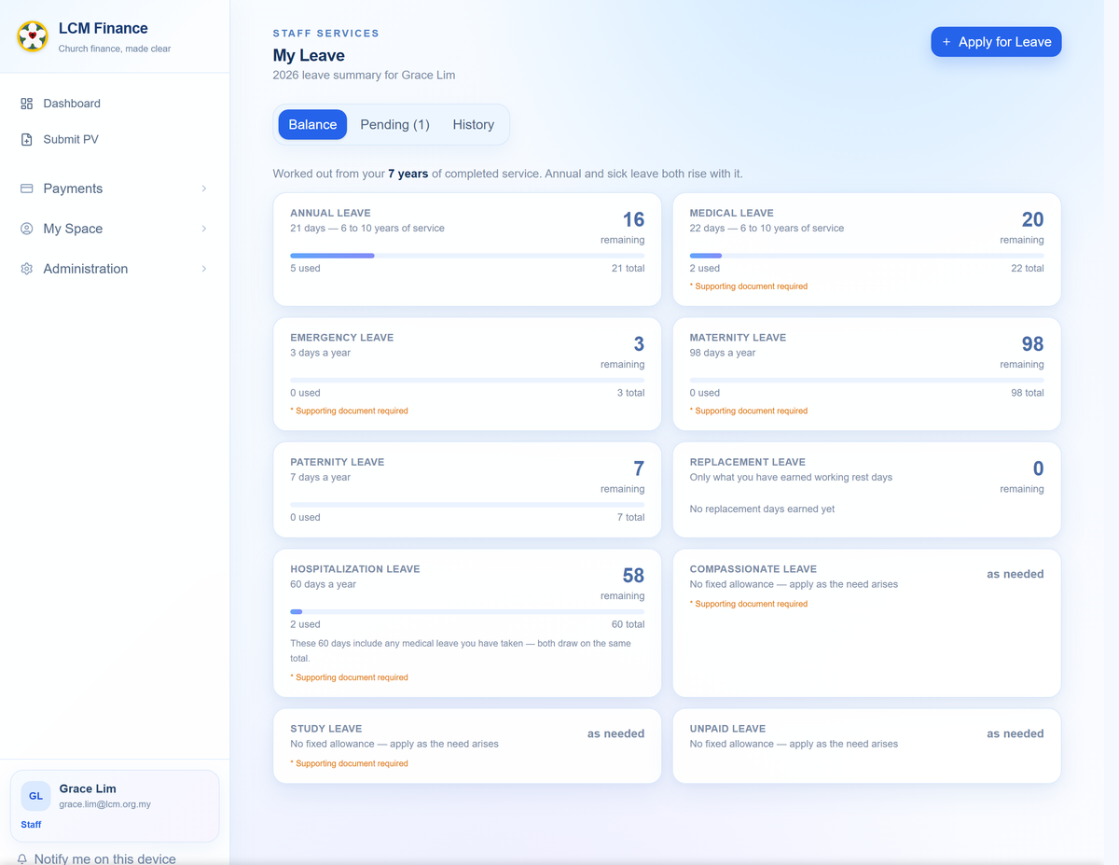
Everyone in this picture is invented. Your own balances are private to you and to those who approve your leave.

Who has to sign
The form tells you before you send it, and the application tells you afterwards how far it has got — who has signed, and who it is now waiting on.
Annual leave is asked for seven days ahead. That is the church’s rule, not the app’s; it will let you apply later than that, and the person approving it will see that you did.

Your payslip
My Space → My Salary. Every month the church has paid you, with the payslip for each.
Open a month to see what made it up — basic pay, allowances, EPF, SOCSO and the rest — and download the payslip as a PDF if you need it for a bank or a landlord.
Only you see this. Your pay is not visible to your EXCO Member, to the signing officers, or to anyone else who happens to be senior to you. If a figure looks wrong, the Finance Executive is the person to ask.

If something is not right
Three things go wrong often enough to be worth saying plainly.

The app shows less than this guide describes
Your role is probably not set yet, or is set to the wrong one. Your name and role are at the foot of the left-hand list. Ask the HQ office to correct it, then sign in again.

You pressed save and nothing happened
Tell somebody rather than pressing it again. A save that does not happen, with no error, usually means the record is not yours to change — and it is worth knowing about rather than working around.

Something has been waiting for days
Open it. Whatever it is waiting on is named on the item itself, with the step it has reached. For a payment request there is a Remind button that emails the person it is sitting with — use it rather than wondering.
The whole system, in one document. This guide covers your part of it. The full LCM Finance & HR Handbook describes everything — every role, every stage, the rules behind the approval limits — and the HQ office can send it to you.

Prepared for the Lutheran Church in Malaysia. This guide covers building and event vouchers, worksheets, bookings and facility income — the rest of the system is in the full LCM Finance & HR Handbook, which the HQ office can send you. Anything unclear here is worth saying so: a step that needed explaining twice is a step written badly.

